



United Nations Development Programme
Country: Indonesia
Project Document for projects
financed by the various GEF Trust Funds

Project title:
Enhancing Readiness for the Transition to Electric Vehicles in Indonesia (ENTREV)
Country:  Indonesia | Implementing Partner (GEF Executing Entity):  Ministry of Energy and Mineral Resources (MEMR) |  | Execution Modality: National Implementation Modality (NIM)  (full NIM)
Contributing outcome: UNSDCF/CPD (2021-2025) – Outcome 2 – Institutions and people contribute more effectively to advance a higher value-added and inclusive economic transformation.
Output 2.3. Low emission and climate-resilient objectives addressed in development plans and policies to promote economic diversification and green growth

UNDP Social and Environmental Screening Category: Substantial |  | UNDP Gender Marker:  GEN-2
Atlas Award ID:  00136657 |  | Atlas Project/Output ID:  00127474
UNDP-GEF PIMS ID number:  6333 |  | GEF Project ID number:  10641
LPAC meeting date: 26 October 2022
Last possible date to submit to GEF:  03 January 2022 |  | Latest possible CEO endorsement date:  03 June 2022
Project duration in months: 48
Planned start date:  1 January 2023 |  | Planned end date:  31 December 2026
Expected date of Mid-Term Review to ERC:  1 January 2025 |  | Expected date of Terminal evaluation report to ERC:  1 October 2026

Brief Project Description:
Indonesia faces a significant increase in fossil fuel-powered land transportation, leading to increase in the greenhouse gases (GHGs) emissions under the energy sector, and local environmental issues like air pollution and noise pollution. With total number of motorcycle and cars of 150 million (2022), transportation is the second highest contributor to the greenhouse gases emission in the energy sector after power generation. Issuance of the Presidential Regulation No 55/2019 on Acceleration of Battery-Based Electric Vehicles (BEVs) supports the development of electric vehicles (EVs) as part of an overall transition from a fossil fuel-based transport sector to a cleaner transport sector. However, Indonesia's market diffusion of BEVs is still in the infant stage, and the EV ecosystems need to be strengthened. The EV ecosystems encompass policies, charging infrastructure, transport operators, EV technology providers, and EV users. ENTREV project aims to support the Government of Indonesia and key stakeholders in the BEV ecosystem for policy, institutional, technical & socio-environmental compliance readiness to transition towards electric mobility and to demonstrate innovative business models for the market adoption of two and four wheelers BEVs. The objective will be achieved through three (3) project component activities, namely: (1) Development of institutional framework and strategy for BEVs industry and charging infrastructure to enhance national market uptake; (2) Demonstration of early BEVs market development through pilot activities on BEV ecosystem development and facilitation of public-private investment in 4-wheeler charging stations (including one unit with solar-PV as source of electricity) and battery swap stations for 2-wheelers in DKI Jakarta, West-Java and Bali Provinces; and (3) Development of BEV knowledge products, capacity building, two-wheelers conversion technology to EV, and environmental standards for EV-battery management. By the end of four years, ENTREV project is expected to result in lifetime direct GHGs emission reduction of 473,800 tCO2 from the demonstration activities and the number of utilized BEVs; and indirect emission reduction of 6.1 million tCO2 ends from continue utilization and increase number of BEVs in 10 years after the project ends.

Financing Plan
GEF Trust Fund |  | USD 1,816,500
UNDP TRAC Resources |  | USD 50,000
- Total Budget administered by UNDP |  | USD 1,866,500
co-financing
- Total confirmed co-financing to this project not administered by UNDP |  | USD 31,423,747
- Grand-Total Project Financing (1) + (2) |  | USD 33,290,247
Signatures
Signature:  Dadan Kusdiana  Director General for Electricity-in-charge  Ministry of Energy and Mineral Resources | Agreed by  Implementing Partner | Date/Month/Year:
Signature:  Norimasa Shimomura  Resident Representative | Agreed by  UNDP | Date/Month/Year:

Table of Contents

1. Table of Contents 3
List of boxes 5
List of acronyms and abbreviations 6
2. Development Challenge 8
2.1 Context and global significance 8
2.2 Baseline situation and problem analysis 10
3. Strategy 16
3.1 Theory of change: approach to address barriers and challenges 16
3.2 Relevance to national priorities 19
3.3 Relevance to the SDGs and alignment with GEF priorities 20
4. Results and Partnerships 21
4.1 Expected results 21
4.2 Partnerships 34
4.3 Risk and assumptions 36
4.4 Stakeholder engagement and South-South cooperation 40
4.5 Gender equality and Women’s Empowerment 43
4.6 Innovativeness, sustainability, and scaling up 44
5. Project Results Framework 45
6. Monitoring and Evaluation (M&E) Plan 50
7. Governance and management arrangements 53
8. Financial Planning and Management 57
9. Total Budget and Work Plan 60
10. Legal context 63
11. Risk management 63
Mandatory ANNEXES 66
Annex A. Project map 67
Annex B. Multi-Year Work Plan 68
Annex C. Monitoring Plan 70
Annex D. UndP RISK REGISTER 74
Annex E. Additional budget information 78
Annex F. Baseline analysis 81
F.2 Vehicle transport in Indonesia 85
F.3 Electric vehicle policy and planning 86
F.4 Electric vehicles and the power grid 94
Annex G. GEF core indicators; Demonstration projects and GHG emission reduction 98
G.1 Demonstration activities 98
G.2 Estimations of direct and consequential GHG emission reduction 105
G.3 GEF core indicators 108
Annex H. overview of Project staff and technical consultancies 109
Annex I. Gender analysis and action plan 115
I.1 Gender mainstreaming analysis 115
I.2 Gender action plan (GAP) 120
Annex J. Stakeholder engagement plan 123
Annex K. UNDP Social and environmental safeguards procedure (SESP) 126
Annex L. Procurement plan 143
Annex M. Agreements (co-financing letters) 144
Annex N. GEF 7 Taxonomy 145
Annex O. Environmental and sOCIAL MANAGEMENT FRAMEWORK (ESMF) 146
Annex P. HACT MICRO ASSESSMENT 147
Annex Q. GEF BUDGET TEMPLATE 151
Annex R. PROJECT QUALITY ASSURANCE (PQA) DESIGN AND APPRAISAL STAGE 152

List of boxes

Box 1 Number of registered 2-wheel and 4-wheel vehicles in Indonesia 8
Box 2 Greenhouse gas emissions, Indonesia 9
Box 3 Total cost of ownership 14
Box 4 Theory of change: challenges and causes 16
Box 5 Theory of change: results and impacts 18
Box 6 Link of ENTREV support areas with national EV targets 19
Box 7 Link of ENTREV with SDGs 20
Box 8 Demonstration of EV vehicles in selected areas – Jakarta Province 29
Box 9 Global e-mobility program with outcomes and indicators 36
Box 10 Project risks, including impact and probability, and mitigation measures 37
Box 11 Role of Indonesian stakeholders in the Project 41
Box 12 Monitoring and evaluation plan and budget 52
Box 13 Project organization structure: Full NIM with Government as Implementing Partner 54
Box 14 Co-financing and sources 57
Box 15 Global electric car stock (2019) 80
Box 16 Electric cars 81
Box 17 Global car sales projection up to 2030 82
Box 18 Global passenger car stock projections 82
Box 19 Demand-side incentives and other policy instruments 83
Box 20 Global car sales projection up to 2030 83
Box 21 Fuel cost benefits of electric cars 84
Box 22 Sales of 4-wheelers and 2-wheelers in Indonesia 85
Box 23 Employment in automotive industry 85
Box 24 Quantitative vehicle targets, automotive industry roadmap 86
Box 25 Automotive industry roadmap 86
Box 26 Acceleration of battery electric vehicle program for road transportation, PR55/2019 87
Box 27 Sales tax rates for four-wheel vehicles 88
Box 28 Electric car and buses models and manufacturers 89
Box 29 Electric two-wheelers models and manufacturers 89
Box 30 Experience with electric motorcycles in China and India 90
Box 31 Timeframe with milestones for battery industry 91
Box 32 Bluebird’s roadmap for electric vehicles 92
Box 33 NEP and NDC targets 93
Box 34 CO₂ emissions of ICE and electric vehicles 95
Box 35 Overview of pilot and monitoring activities supported by ENTREV 98
Box 36 CO₂ emissions reduction and cost estimates of reduction with charging 4-wheeled vehicles in hybrid grid-solar charging stations 98
Box 37 CO₂ emissions reduction and cost estimates of reduction with charging 2-wheeled vehicles in battery swap stations 101
Box 38 Budget for monitoring of ENTREV-supported charging infrastructure 103
Box 39 Estimate of cost of hybrid solar-grid fast charging station 104
Box 40 Cost of ownership and operation of electric vehicles versus ICE 104
Box 41 ENTREV direct emission reduction 105
Box 42 ENTREV consequential (indirect) emission reduction calculation 106
Box 43 BEV supply chain 137

List of acronyms and abbreviations

Agency for the Assessment and Application of Technology | Badan Pengkajian dan Penerapan Teknologi (BBPT)
Center for Research and Technology Development on Electricity, New and Renewable Energy and Energy Conservation, MEMR | Pusat Penelitian dan Pengembangan Teknologi Ketenagalistrikan, Energi Baru, Terbarukan dan Konservasi Energi (P3TEK-EBTKE), KESDM
Coordinating Ministry for Maritime Affairs and Investment (CMMAI) | Kementerian Koordinator Maritim dan Investasi
Ministry of Energy and Mineral Resources (MEMR) | Kementerian Energi dan Sumber Daya Mineral (KESDM)
Ministry of Environment and Forestry (MoEF) | Kementerian Lingkungan Hidup dan Kehutanan (KLHK)
Ministry of Industry (MoI) | Kementerian Perindustrian
Ministry of National Development Planning -  National Development Planning Agency | Kementerian Perencanaan Pembangunan Nasional -  Badan Perencanaan Pembangunan Nasional (Bappenas)
Ministry of Research and Technology -  National Research and Innovation Agency | Kementerian Riset dan Teknologi/Badan Riset dan Inovasi Nasional
Ministry of Transportation (MoT) | Kementerian Perhubungan
National Electricity General Plan | Rencana Umum Kelistrikan Nasional (RUKN)
Electricity Supply Business Plan | Rencana Usaha Penyediaan Tenaga Listrik (RUPTL)
National Energy General Plan | Rencana Umum Energi Nasional (RUEN)
National Energy Policy | Kebijakan Energi iNasional (KEN)
Public charging station (EC) | Stasiun Pengisian Kendaraan Listrik Umum (SPKLU)
Public battery exchange station | Stasiun Penukaran Baterai Kendaraan Listrik Umum (SPBKLU)
Sales Tax on Luxury Goods | Pajak Penjualan atas Barang Mewah (PPnBM)
Special Capital Region of Jakarta | Daerah Khusus Ibu (DKI) Kota Jakarta
Statistics Indonesia | Badan Pusat Statisik (BPS)
State Electricity Company | PT Perusahaan Listrik Negara (PLN)
Transfer of Motor Vehicle Title Fee | Bea Balik Nama Kendaraan Bermotor (BBNKB)
Vehicle Tax | Pajak Kendaraan Bermotor (PKB)

µg Microgram
ASEAN Association of South-East Asian Nations
BaU Business as Usual
BCG Boston Consulting Group
BEV Battery Electric Vehicle
BOE Barrels of Oil Equivalent
BSS Battery Swap Station
BUR Biennial Update Report
CDR Combined Delivery Report
CEO Chief Executive Officer
CEO ER CEO Endorsement Request
CO Country Office
CO₂ Carbon Dioxide
CPD Country Programme Document (UNDP)
CSO Civil Society Organization
CS Charging Station
dB Decibel
DGE Directorate-General of Electricity
ERC Evaluation Resource Center (of UNDP)
EV Electric Vehicle
EVCS Electric Vehicle Charging Station
FCEV Fuel-Cell Electric Vehicle
GAIKINDO Association of Indonesia Automotive Industries
GAP Gender Action Plan
GDP Gross Domestic Product
GEF Global Environment Facility
GHG Greenhouse Gas
GIZ Gesellschaft für Internationale Zusammenarbeit (German International Cooperation)
GoI Government of Indonesia
GtCO₂ Gigaton of carbon dioxide (Giga = billion)
HEV Hybrid Electric Vehicle
km kilometer
kWh Kilowatt-hour
ICCT International Council on Clean Transportation
ICE Internal Combustion Engine
ICEV Internal Combustion Engine Vehicle
IDR Indonesian Rupiah (USD 1 = 14,500 IDR
ITDP Institute for Transportation and Development Policy
LCEV Low-Carbon Emission Vehicle
LCGC Low-Cost Green Car
MJ Megajoule (one million Joules)
MRV Measuring, Reporting and verification
MTR Mid-Term Review
NC National Communication
NDC Nationally Determined Contribution
NGO Non-Governmental Organisation
NPD National Project Director
PIF Project Identification Form
PIR GEF Project Implementation Report
PHEV Plug-in Hybrid Electric Vehicle
PLN Perusahaan Listrik Negara
PM Project Manager
PMU Project Management Unit
PPG Project Preparation Grant
ProDoc Project Document
PSC Project Steering Committee
Rp Indonesia Rupiah
QA Quality Assurance
QC Quality Control
RAN-GRK National Action Plan of GHG Emission Reduction
ROE Regional-government Owned Enterprise
RON Research Octane Number
SDG Sustainable Development Goal
SOE State-Owned Enterprise (by central government)
TA Technical Assistance
TCO Total Cost of Ownership
TE Terminal Evaluation
ToC Theory of Change
ToT Trainer of Trainers
TVET Technical Vocational and Educational Training
UNDP United Nations Development Programme
UNEP United Nations Environment Programme
UNFCCC United Nations Framework Convention on Climate Change
USD United States Dollar
V2G Vehicle-to-Grid

Development Challenge

Context and global significance

Road transport and fuel consumption

Indonesia is an archipelago with a land territory of 190 million hectares, containing five big islands (Sumatera, Java, Kalimantan, Sulawesi, and Papua), and about 17,504 other small islands. The total population of this country was an estimated 270 million peoples in 2020 making it the fourth largest populous country. Between 2000 and 2010, Indonesia experienced an average annual population growth rate of 1.49% and between 2010-2020 of 1.25%. The population is projected to reach 296.4 million by 2030 with an average annual growth rate of 0.96% between 2020-2030. The country had a Gross Domestic Product (GDP) of IDR 15,435 trillion in 2020. During 2000-2020, GDP grew at an average of 4.9% annually. Following the successful recovery from the social and economic crisis in 1998-1999, Indonesia has been showing a steadily increasing trend in alleviating poverty. In 2005, the number of people living in absolute poverty has declined from 48.0 million people in 1999 to 35.1 million people and further declined to 27.5 million in 2020. The number of people living in relative poverty has declined from 23.4% in 1999 to 16.0% in 2005 and 10.2% in 2020.

According to the Central Statistical Agency (BPS), there were 133.6 million vehicles in 2019, the largest number being motorcycles with a total of 112.8 million units, followed by passenger cars (15.6 million) and good cars and bus of 5 million and 0.2 million, respectively. Between 2008-2018, the vehicle fleet grew dramatically with almost 10% annually; there were 68 million units more vehicles in 2019 compared to in 2008 (see Box 1). For more information on the vehicle sector in Indonesia, the reader is referred to Annex F.
Box 1 Number of registered 2-wheel and 4-wheel vehicles in Indonesia
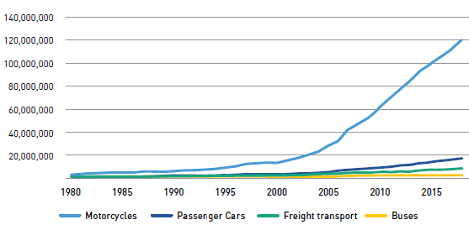

Source: IESR (2020), based on data provided by BPS

Not surprisingly, energy consumption in the transport sector grew by 7.6% annually from 2008-2019. The share of transport in Indonesia’s final energy consumption was 41% (up from 31% in 2008). In absolute terms, energy consumption was 414 million barrels of oil equivalent (BOE), up from 186 million BOE in 2008.

Almost all the energy consumed in the transport sector is in the form of petroleum products, mainly diesel (147 million BOE in 2018) and gasoline (95 million BOE), only about 6% comes from other sources (biofuel, natural gas, electricity). About 90% of the consumption is in land transportation (reflecting the 90% modal share of road transport in overall transport). In passenger transport, most energy is consumed by motorcycles (49%), passenger cars (44%), minibus (3%) and other (4%).

Indonesia became a net importer of petroleum products by 2004 after domestic demand exceeded production. In 2018, Indonesia imported around 50% of the total domestic demand of petroleum products which reach around 74 billion liters.
Transport and greenhouse gas emissions

Indonesia is among the world’s top ten emitters of GHG emissions. Indonesia GHG emissions in 2016 were estimated at 1.45 gigatons of CO₂ (including LULUCF and peat-fire) Approximately 34% of Indonesia’s GHG emissions come from the energy sector (0.54 GtCO₂), of which 0.14 GtCO₂ from transport (0.12 GtCO₂ from road transport), about 25% of total GHG emissions in the energy sector. The road transport system is the main emitter within land transport, comprising cars (11%), motorcycles (82%), buses (1.7%), and freight transport (5.3%)
Box 2 Greenhouse gas emissions, Indonesia
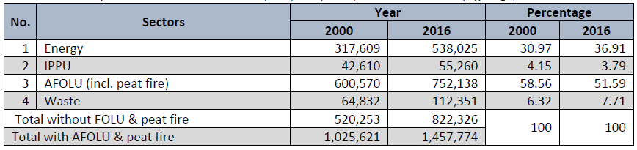
Source: Second BUR. IPPU: industrial processes and product use; AFOLU: agriculture, forestry and other land use

Local air and noise pollution

Air pollution is a problem in big cities, including Jakarta province, the capital of the Republic of Indonesia. The pollution is due to increased human activities, population growth, the increasing number of industries, and transportation. Monitoring of ambient air quality parameters, such as total suspended particles (TSP), sulfur dioxide, nitrogen oxide, carbon monoxide, hydrocarbons, and lead, in Jakarta indicates that the condition is concerning. Transportation is the main source of ambient air pollution in big cities, such as Jakarta. A recent report by ICCT describes the air quality and health impacts of transportation tailpipe emissions in 2015 in a number of countries. Regarding Indonesia, the report mentions that death in 2015 due to particulate matter (PM_{2.5}) and ozone were an estimated 54,000 of which 13% attributable to transport. The PM emissions are associated with transport and periodic biomass burning. A recent study shows that the majority of the average annual PM₂₅ concentrations measured at the Java sites (Bandung, Jakarta, Semarang, and Surabaya) exceeded the Indonesian annual ambient air quality standard (15 µg/m³) and PM_{2.5} in urban areas varies between 11-28 µg/m³.

Indonesian cities are noisy. Daily sounds in Indonesian cities include the engines of motorized traffic and car horns. Noise levels are limited and need to be monitored according to the Ministerial Decree KEP-48/MENLH/11/1996. The Decree regulates standard noise levels in residential areas at 55 dB and office areas at 65 dB, but measurements of noise levels from motor vehicle activity in Jakarta areas have yielded higher levels.

Gender inequality in transport sector

In transportation especially, women have a different travel pattern than men and characterized into inequality. Women have less access to transportation compared to men. Mobility is experienced differently by men and women due to gendered roles. In term of purpose for doing travel, both women and men have various purposes but men travel purposes are dominated for working. Women still have strong relation to domestic roles that is represented by shopping. Related to electric vehicle use, based on UNDP interviews with several 2-wheeler taxi drivers from Gojek regarding driver’s preferences for electric motorbikes, several male drivers said that what is attractive for them to use an electric motorbike is low price, low credits and small down payment. Meanwhile, female driver prefers an electric motorbike as a backup vehicle and have design sufficiently to carry goods. Furthermore, the concerns from other vulnerable groups, such as people with disabilities and low-income groups, need to be assessed, particularly in the design, safety, and affordability of electric vehicles.

Baseline situation and problem analysis

Baseline trends

Indonesia’s greenhouse gas emissions are projected to reach 2.87 GtCO₂ in 2030 (business-as-usual, BaU). Energy is forecasted to become the main contributor to Indonesia’s GHG emissions in the near future. Based on the National Communication’s BaU scenario, the energy sector will start to dominate Indonesia’s GHG emission, surpassing the land-based sector, by 2024 and are projected to reach 1.67 GtCO₂ by 2030. The power generation sector will be the main contributor of GHG emissions in the 2030 BaU with a 48.6% GHG emissions share, followed by manufacturing industries, , household, and commercial with 14.5%, 3.12%, and 0.8% GHG emissions share, respectively (Indonesia NC3, 2016; BUR2, 2018) and the transportation sector with a share of 31.4% (524 MtCO₂). The Government of Indonesia (GoI) submitted the First Nationally Determined Contribution (NDC) and submitted in November 2016 (along with the ratification of the Paris Agreement through Act 16/2016 in October 2016). The NDC set the unconditional reduction target of 29% below business-as-usual scenarios (base year 2010) by 2030 and the conditional reduction target (i.e., with international support) of up to 41%. Particularly, 11% (about 314 Mt CO₂e) to 14% (398 Mt CO₂) emission reduction from the total BAU in 2030 is expected to stem from the energy sector including transport (Indonesia NDC, 2016). The GoI has formulated an NDC Mitigation Road Map as a guideline for both Party stakeholder and non-Party stakeholders to contribute to the achievement of NDC targets through the provision of information on physical targets, timelines, and indications of potential locations for mitigation and adaptation actions.

Indonesia faces a large increase in (urban) fossil fuel-powered land transportation, leading to global environmental (increased GHG emissions) and local environmental (air pollution and noise pollution), which is the development challenge the ENTREV Project aims to address.

Baseline policies

Given the growth of the transport sector, there is an opportunity to build cleaner and more sustainable road transport systems to avoid a significant amount of future GHG emissions. This will help Indonesia to meet its targets of the NDC. The Government seeks to promote the use of low-carbon vehicles, including fuel-efficient gasoline and diesel vehicles (LCGC, low-cost green car) and a range of electric vehicles (HEV, PHEV, BEV, FCEV (see Box 16 in Annex F for a description of the electric vehicle types). Under the Automotive Industry Roadmap (see Box 25 in Annex F), low-emission four-wheel vehicles are expected to reach 400,000 (20% of the vehicle market) by 2025 and 1,200,000 by 2035 (30% of the market) and 2-wheelers will have reached 2 million (20% of the market) by 2025 and 4.5 million in 2035 (30% of the market). This is linked with Indonesia’s industrial development strategies. The Government seeks the development of a domestic electric vehicle (EV) manufacturing industry for both domestic sales and exportation. The efforts will leverage the country’s rich supplies of nickel laterite ore, the primary input in the lithium-ion batteries, enabling Indonesia to become the leader of EV manufacturing within ASEAN.

A set of policies has been issued by the GoI relevant for the implementation of climate mitigations activities in transport:
- Law No 32/2009 on Protection and Management of Environment sets the basis for management of greenhouse gas emission and pollution, while Government Regulation No.41/1999 concerns Control of Air Pollution. Minister of Environment and Forestry Regulation No.12/2010 on Implementation of Air Pollution quality in the regions sets the threshold for the vehicle emission level.
- New Government Regulation No. 30 (2021) on Implementation of road traffic and transportation, in response to Job Creation Law (Omnibus Law), this regulation is the government's effort to encourage the implementation of activities related to Road Traffic and Transportation by providing business facilities to increase investment and include traffic impact analysis, testing, and design of motorized vehicles, operation of terminals, business licensing and subsidies for transportation operations.
- Ministry of Transportation Decree No. 201/2013 aims to mitigate emissions in the transportation sector through a complete "avoid, shift and improve" approach, including fuel substitution from oil to gas and encouragement of using non-motorized vehicles.
- MEMR Regulation No. 12/2015 regulates the provision, utilization, and administration of biofuels.
- Government Regulation No. 41 (2013) differentiates level of taxation for various type of cars, including for low-cost green cars (LCGC), to support fuel conversion, and to increase the domestic production of motor vehicles. Government Regulation No. 14/2015 on National Industrial Development Master Plan Year 2015-2035 prioritizes hybrid and fuel cell technology development in the transport sector

The Presidential Regulation 55/2019 on the Acceleration of Battery Electric Vehicles for Road Transportation Program ("PR 55") supports development and market diffusion in Indonesia of one type of vehicle in particular, namely battery electric vehicles (BEV). Hence, the focus in this Project on supporting the battery electric vehicles (BEVs) by supporting the development and increasing the readiness of the BEV ecosystem and encouraging with fiscal and non-fiscal incentives BEV purchase and use, expecting that time BEV becoming more competitive with ICEV as the market demand increases.

After PR 55/2019, the Indonesian government has issued various derivative regulations related to EV industry and industrial and services sectors, such as the MEMR Regulation No. 13 (2020) on the “Provision of Charging Infrastructure for Battery Electric Vehicles” and the Transport Ministry Regulation No. 45 (2020) on the “Physical Type Testing of Electric-Powered Motorized Vehicles”. In September 2022, Presidential Instruction No.7/2022 on “Utilization of BEVs as operational vehicles for national and sub-national government officials” was issued to create BEV initial market. An important incentive is provided by lower the sales tax on electric vehicles in Government Regulation Number 73 (2019). Other incentives to be provided are a) lowering the ownership transfer fee, b) reduction and exemption of corporate income tax for a certain period (for the EV and related battery and electric motor industries), c) exemption of fees for electricity installation for charging stations, d) exemptions of parking fee charges for EVs, e) relief of electricity charging fees at charging stations, f) funding support for charging station infrastructure development, g) incentive for charging station equipment production, and h) fiscal incentives for research, development and technological innovation. More details on these Regulations are given in Annex F. The GoI expects that with these Regulations to promote the production and use of electric vehicles that 400,000 units of EV will have been rolled out on the streets in 2025. It is expected that the sales of HEV and PHEV will be increasingly market-driven mechanism as these are becoming compatible with ICEV and are not fully dependent on the availability of charging stations, and do not need a whole new EV ecosystem.

By 2030, the national targets of NZE Energy and the National Energy Grand Strategy (GSEN) prepared by MEMR are: two (2) million 4-wheel BEV and 13 million two-wheel BEV in 2030. In 2021 there were 1,760 four-wheel BEV and 216 two-wheeled BEV; 31,859 charging stations and 67,000 battery swap stations. In August 2022, there were 346 units of charging stations and 557 units of battery swap stations; concentrated in greater Jakarta area (Jabodetabek).

MEMR has developed a single gateway monitoring charging station and battery swap station. The proof of concept has been implemented, connected to the charging station system and battery swap station of various business entities. This single gateway monitoring can be used to measure the reduction in greenhouse gas emissions from the amount of electricity used by the BEV from the charging station and battery swap station.

Furthermore, at the three pilot provinces of West Java, Bali and DKI Jakarta, progress have been made in 2022 towards deployment of BEV infrastructure and utilization as following:
Bali Province – local action plan for BEV acceleration. There are 5 pillars (management, infrastructure, HR, marketing, and communication) that may be synergized with the 3 components of ENTREV activities. In 2030 there will be zones for BEV acceleration. Demand data has been identified in the zones, handling of battery waste has been planned from upstream to downstream, however, the brand owners still become the initiator for the participation of local government enterprises (BUMD) and the private sector in the management of charging stations/battery swap stations.
West Java Province – exist plan for BEV development in the province aligns with Provincial Medium-Term Development Plan related to GHG emissions reduction, electricity consumption per capita. Potential BEV development has been identified. Growth centers in Bandung Raya, Cirebon Raya and Bogor-Tangerang-Depok areas. The location of the charging station/battery swap station is important because it is outskirt. The City of Bandung (needs 29 charging stations) and Bekasi (needs 65 charging stations), demand studies have been conducted. Six (6) units of charging station already operational (only in the northern areas of Bandung, Cirebon, Bekasi), 1,462 BEV (1,368 two-wheeled, and 124 units 4-wheeled). In 2023 the provincial government will buy 26 BEVs and require a charging station. For 2 and 4-wheeled BEVs thre is tax reduction based on local regulation. In 2021 started 2-wheel conversion. West Java’s provincial enterprise (BUMD) was assigned to invest in the management of charging stations, and the Governor regulation required for assigning the BUMD.
DKI Jakarta Province: DKI BUMD intends to invest in charging stations and own the charging station assets (business area ownership model). MEMR Regulation No. 13/2020 requires charging station business entities to build charging stations in at least 2 provinces.

Regarding the BEV know-how, capacity building, and battery waste management, the followings progress have been observed in 2022:
- The Ministry of Transportation and MEMR have carried out the conversion process to reduce the consumption of imported fuels. Ten (10) private 2-Wheel Conversion workshops have been certified by the Ministry of Transportation. The certification system is available in accordance with Ministerial Regulation of the Ministry of Transport 65/2020 on Electric Motorcycle Conversion. The Ministry of Transportation has developed a BEV acceleration road map in the land transportation sector. The Vehicle Type Approval application in the Ministry of Transportation has been running for BEV registration and conversion. BEV population status can be monitored in real time. It is a monitoring tool for achieving the BEV road map. Based on the Regulation of Director General of Ministry of Transportation, Electric Vehicle Conversion Testing may be performed on-site at 25 Land Transportation Management Centers (BPTD) of the Ministry of Transportation. But the new vehicle test is only available at the Ministry of Transportation Test Center in Bekasi Cibitung.
- BEV battery waste management, in Annex 9 of Presidential Regulation No. 22/2021 battery waste is categorized as hazardous waste. There is Regulation of MoEF No.6/2021 on Procedure for Hazardous Waste Management, but it is general, not specific for BEV battery. Needs guideline for battery waste management because it is new. Coordination with MoEF and Ministry of Industry is needed. Regulation of MoEF No.4/ 2021 concerning Business List or Activities that must have Environmental Impact Assessment (EIA), listed that battery charging station requires environmental management permit (UPL-UKL).

Having those current progress, the development (long-term) solution promoted in this project is a transition towards electric mobility by the increased use of electric vehicles (EV), in particular, the production, significant use of 2-wheel and 4-wheel battery-based electricity vehicles (BEV) with appropriate EV ecosystem support

Barriers to more widespread introduction of BEVs

The implementation of this long-term solution is hindered by several barriers in technical, regulation, financial, awareness, and knowledge development that are briefly discussed below
- BEV’s price and total cost of ownership (TCO) more expensive than ICEV
One of the biggest hurdles for the introduction of EVs is currently the upfront cost. BEV and TCO prices for four-wheeled vehicles are still relatively higher than ICEV. The cheapest HEV is about USD 37,000, the cheapest PHEV about USD 86,000, and the cheapest BEV about USD 40,000, at least some USD 7000 pricier than gasoline or diesel vehicles. Electric motorcycles cost 1.3-1.35 times as much as fossil fuel-powered counterparts. BEV's price is not the only thing they consider; consumers also consider the total cost of ownership (TCO) of the cars they purchase (see Box 3). A recent LPEM FEB UI study (2019) shows the price of BEV is still much more expensive than ICEV but with the right incentives (such as PPnBm, BBNKB, and reduction of PKB) the TCO of BEV will become more competitive with or even lower than ICEV when used for high-frequency usage (in public transportation such as buses or taxis), although it may not reach competitive in terms of price or TCO for electric vehicles for personal use.
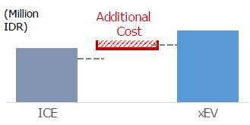
Electric vehicles (xEV) have higher sales price than ICE vehicles:
- HEV: 1.2 times more
- PHEV, BEV: at least 1.5 times more
Source: Institut Otomotif Indonesia (IOI), Prospects and penetration outlook of electric vehicles in Indonesia
- Lack of EV ecosystem and limited charging infrastructure
Private and semi-public charging points refer to charging points installed at home or workplace while public charging points are installed in public places including highways, traffic hotspots, shopping malls, airports, etc. Public charging points are important to extend the range for limited range BEV drivers to allow long-distance drivers. A private charging point is a necessity for BEV owners given that the vehicle is typically parked at the residence for the longest portion of the day; it can also be an alternative for BEV owners for those who don’t have access to a home charging point. By the end of 2020, there were 67 public charging points installed in 37 locations and 9 battery swap stations in 9 locations. Acceleration of the deployment of semi-public and public charging points is a necessary condition for people to use BEV. Range anxiety is important for consumers given the current limited public charging stations.
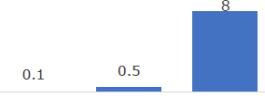

Charging time
- ICE/HEV: refilling takes minutes
- Rapid charging: 0.5 hours
- Normal charging: 8 hours
Source: Institut Otomotif Indonesia
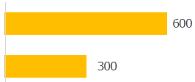

Driving distance range:
- ICE/HEV: 500-600 km per refill
- PHEV/BEV: 300 km per charge
Source: Institut Otomotif Indonesia (IOI),

The state-owned electricity firm PLN has estimated that private and public players would need to invest IDR 54.6 trillion (USD 3.7 billion) to install more than 31,000 commercial charging stations by 2030 to reach the government’s EV goals. Charging infrastructure with appropriate tariffs form part of the EV ecosystem.
The ecosystem does not just mean the charging station and battery switching outlets, but establishes a whole local supply chain for the EV industry, from the manufacturing industry, sales outlets, and maintenance businesses as well as the environmentally friendly recycling and disposal of batteries.
On the raw material side, Indonesia holds a big opportunity by having the largest global nickel reserves (see Annex K for more details on battery production). Nickel is a crucial material for EV’s batteries to increase their energy density. The battery will hold not only an important role in the EV industry but also for renewable energy development. Thus, investment in the battery industry is crucial for promoting an EV industry.
In March 2021, the Ministry of State Owned Enterprises (SOE) established Indonesia Battery Corporation (IBC), a joint venture company consist of four SOEs namely PT Aneka Tambang Tbk (IDX: ANTM), PT Indonesia Asahan Aluminium (MIND ID), PT Pertamina, and PT PLN. It is expected that IBC will synergise with various global companies in the future to operate lithium battery plant for EV. IBC has a plan to pilot and develop the battery swap mechanism in Indonesia. In 2021, IBC plans to pilot battery swap stations that would service about 500 two-wheeled BEVs.
- Production of electric vehicles is limited
Despite the existing ambitious EV Roadmaps, there is no serious local production yet of four-wheel BEV and limited availability of models in the market. Local producers are still struggling as the overall demand is still low, thus hindering sales improvement. However, several ride-hailing platforms have established cooperation with electric two-wheelers companies: Grab with Kymco, and Gojek with Gesits and Viar. There are no domestic facilities to produce 4-wheeled electric cars as of now. Several plans for investments have been announced by several car companies. Two major companies, Hyundai (South Korea) and Toyota (Japan), have committed to invest approximately USD 2 billion and USD 2.8 billion, respectively, to build factories and do production in Indonesia.

- Lack of evidence to support the implementation of policies and plans
Box 3 Total cost of ownership
The total cost of ownership (TCO) can be derived by using the formula: TCO = D + FC + ICB + IC + MR + (T-S), where
- D: depreciation = purchasing price minus resell price of the vehicle
- ICB: interest paid on borrowing (vehicle loan, bank loan) if paid for with loan
- FC: fuel cost = fuel consumption (unit per km) * fuel price (per unit) * total km driven (during ownership period)
- OC: other operating cost, such as parking fees, toll, road fees
- IC: insurance cost
- MR: maintenance and repair cost (incl. battery substitution) in the ownership period
- T: government taxes (e.g., import duty, PPnBM)
- S: government subsidy
This gives the consumer TCO. A social TCO can be calculate by adding social or environmental cost, such as the cost of GHG emissions. The Institute for Economic and Social Research, Faculty of Economics and Business, Universitas Indonesia (LPEM-FEB UI) has done a study on Estimating the Total Cost of Ownership (TCO) of Electrified Vehicle in Indonesia (2020). The calculation starts with assuming that purchasing prices of HEVs is about 1.2 and of PHEV and BEV about 1.5 times higher than of ICEVs. EVs become more economical depending on the annual mileage. At 10,000 km per year, the TCO of xEVs are relatively high, but at 18,000 km, HEVs become compatible with ICEV. At 25,000 km, BEVs become more competitive. Of course, the numbers shift in favor of BEVs if fuel cost increase. The analysis also shows that the TCO is very dependent on battery replacement cost and the recycle or reuse from the batteries. Lowering taxes (e.g., PPnBM) in combination with some subsidy and higher fuels can shift the TCO of PHEV and BEV towards competitiveness with ICEV.
The policy regarding the acceleration of the battery-based electric motor vehicle program is a recent policy that has been enacted as of August 2020. Under the policy a number of regulations are planned. Recently, the policy on charging station standard have been issued under MEMR Ministry Regulation 13/2020. Plug-ins for BEV in charging station has adopted international standards: Type 2 AC Charging (AC Slow), DC Charging CHAdeMO (DC Fast), and DC Charging Combo Type CCS2 (Combo Slow AC & Fast DC). However, various stakeholders, both within the government (central and local government), producers (industry), and consumers still are not fully aware of or do not fully comprehend these regulations which may hinder the actual implementation of the policy and regulations aiming to support development of the electric car ecosystem and encouragement of the BEV market.

- Lack of knowledge, awareness, and demonstration
A vehicle is considered as one of the most expensive purchases by individuals or households, often equal to months or years of income, and will last for many years. In general, the consumer wants a vehicle that is affordable, safe, comfortable, and reliable for travel and meets many practical needs. For all these reasons, consumers generally will undertake lengthy research and take safe decisions to choose a vehicle. In general, there is lack of customer awareness and knowledge about BEV advantages, existing incentives, and features which pose barriers to BEV adoption. There is a lack of demonstration and pilot projects with EVs (like taxis) and EV public charging, combined with campaigning and promotion stressing benefits.

- Issues in sustainable battery production, waste management and recycling

Battery electric vehicles are predicted to be the future driving solution, especially in cities because they do not produce air pollution and have the potential to reduce greenhouse gases. However, battery production and disposal have environmental impacts that need to be carefully managed. When the battery life has run out (usually between 6-10 years, depending on the number of charging cycles it undergoes), the used battery will become waste. Battery waste is dangerous and damages the environment. Battery waste contains heavy metals and hazardous substances such as mercury, manganese, lead, nickel, and lithium which can pollute water and soil and can harm the human body.

Globally, lithium-ion batteries (LIBs) are the dominant electricity storage technology for applications requiring high energy density. There are two main options for extending the useful life of Li battery materials. One approach is to reuse or recondition used battery packs for use in “second life” applications. At the end of their first (EV) life, many batteries will still retain over 75–80% of their original capacity and could, therefore, be used in less demanding applications. The other option is recycling. However, the recycling of larger EV Li-batteries is at an infant stage. There are only a limited number of recycling factories worldwide. Right now, there is one large battery recycling company in Indonesia, PT Indonesia Puqing Recycling Technology (in Morowali, Sulawesi) that can produce battery-grade materials through the recycling process of used batteries.

More regulation is needed and a good monitoring, verification and enforcement (MVE) system to be established, so that the waste of lithium batteries from electric cars does not become a new problem, following the bad example set by lead-acid battery recycling. Maybe up to 70% of used lead acid batteries are recycled in the informal sector. In Indonesia, more than 200 illegal used lead acid battery (ULAB) smelters are currently operating that emit lead and other metal particulates into the air which can be carried downwind and deposited in soil and surface water, potentially causing severe health problems.
Box 4 Theory of change: challenges and causes
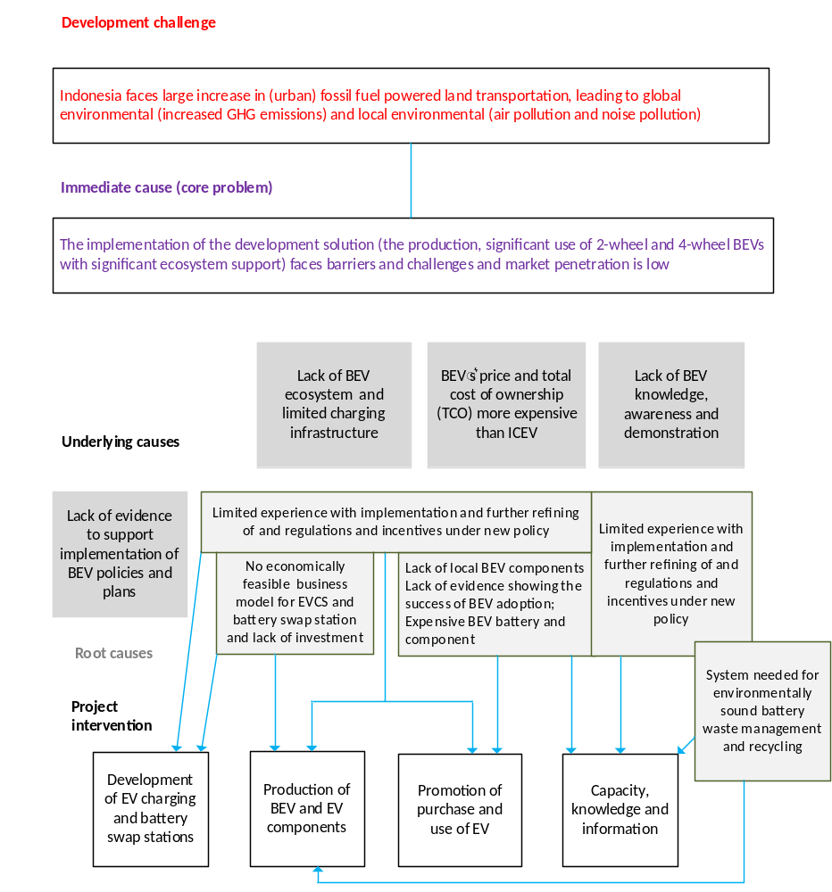

Strategy

The project’s objective is “to support Government of Indonesia and key stakeholders in policy, institutional & technical readiness to transition towards electric mobility and to demonstrate innovative business models in the transport sector that will lead to GHGs emissions reduction”.

Theory of change: approach to address barriers and challenges

The project seeks to achieve this objective through integrated activities targeting barriers and their underlying causes by achieving several outcomes that are grouped into three project components:

Component 1 Institutional framework and strategy for battery electric vehicle industry and charging infrastructure
1. BEV ecosystem (EV production and charging infrastructure) strengthened in response to national market uptake
Component 2 Demonstration of early BEV market development
2. Local policy and early market development promoted with demonstrated BEVs and charging infrastructure in selected regions
Component 3 Knowledge products and capacity building for scaling up and environmental standard for EV-battery management
3. Capacity of key stakeholders built and knowledge shared on BEV to officials, manufacturers, and potential BEV buyers and safeguards development

An electric mobility ecosystem comprises five essential components, a) national and local government (policymakers and administrators), b) infrastructure (charging and battery swap station operators, utilities, battery recycling), c) transport operators (bus, taxi, ride-hailing), d) EV and technology providers (EV manufacturers and vendors, battery suppliers, workshops/repair) and, last but not least, e) EV owners and EV transport users. Each component of the ecosystem has its opportunities and risks. The common success factor for all components is to ensure that bankable business models can be developed. An ecosystem approach helps to improve the adoption of electric vehicles by ensuring that enabling components of the network are in place, including charging infrastructure and power generation and distribution systems, which are essential for adoption.

Box 5 shows the dynamic strategy aspects of the theory of change, i.e., how the Project’s strategy and outcomes address the challenges and gaps to the market penetration of battery electric vehicles (BEVs), as discussed in Section 2.2. The ENTREV project will provide incremental support to the government in a wide consultative process with stakeholders, to enhance the capacity of national/sub-national policymakers and procuring expertise for various activities to put in place readiness measures and appropriate incentives for scaling up EV deployment beyond 2025. Such a set of supportive regulations is crucial to provide an incentive for the industry and to encourage domestic demand, in addition to the incentives already provided under PR No. 55/2019 and derivative regulations. Creating domestic EV demand is a crucial task to attract more investment and to achieve a clean transports transition. The Project will facilitate pilot implementation and advance business models to attract private sector investment in EV manufacturing and infrastructure and EV fleet operation.

ENTREV will prioritize the support for developing the electric motorcycle market through the development of battery swap business models and the ICEV to BEV conversion program as well as support for the four-wheeler electric car market by providing promotional support for BEV market penetration for early adopters such as those for government fleets and public retailing transport services (e.g., TransJakarta, Bluebird, Grab and Gojek Taxi). To develop the BEV ecosystem, ENTREV also supports the preparation of the electric car ecosystem through charging stations, where possible charged by renewable energy. The availability of charging infrastructure will be a crucial aspect to grow EV demand. The Project will support demonstration projects with charging stations in cooperation with PLN and public transport providers. The monitoring at the demo sites will help to assess the mobility patterns of the EV users, either public transportation or private vehicle, revenue stream generated, and environmental impacts
Box 5 Theory of change: results and impacts
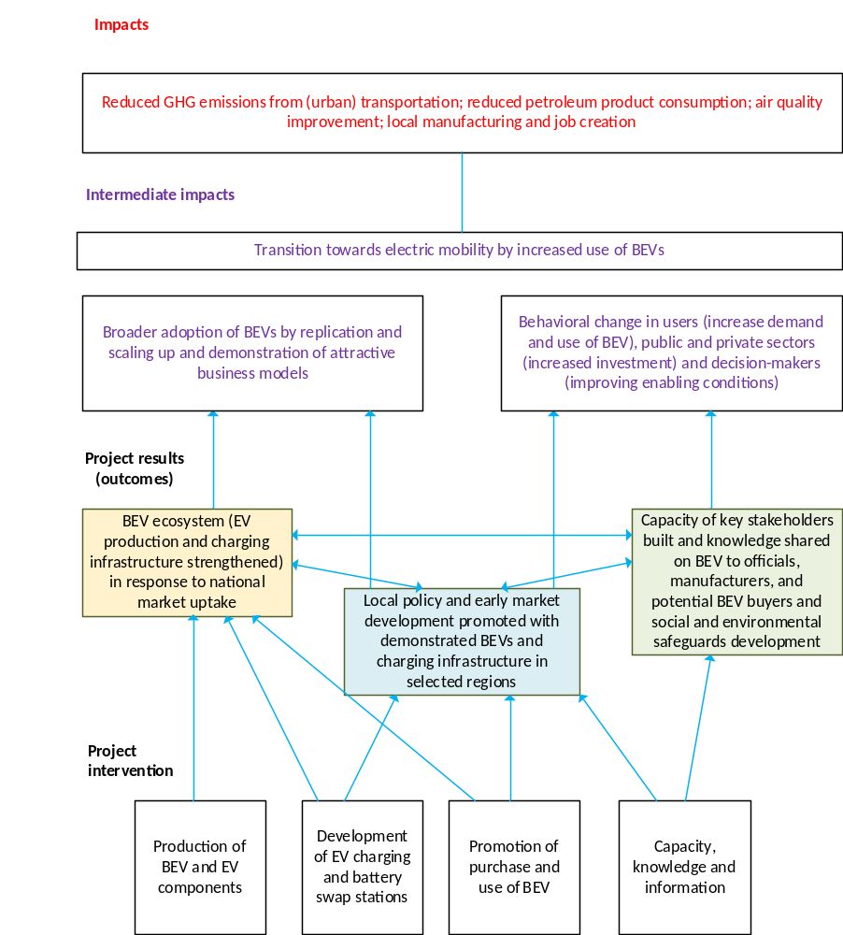
Intervention area | National level – ENTREV outputs | Local level – ENTREV outputs
 | Outcome 1 | Outcome 2
Development of charging stations and battery swaps (infrastructure) | 1.1 Business models and financing option elaborated and implemented for charging stations (SPBKLU) battery swap stations (SPKLU)  1.2 National policies and standards for battery swap stations (SPKLU) and charging stations (SPBKLU) improved and implemented | 2.1 Local policies and regulations developed to stimulate BEV infrastructure investment and purchase and use of BEVs
 |  | 2.2 Deployment of BEV charging stations and battery swap stations in pilot regions
Production of BEV and EV components (supply) | 1.3 Program to promote domestic manufacturing of BEV and their components
Promotion of purchase and use of BEV (demand) | 1.4 Options assessed for purchase and trade-in, preferential loans and second- hand market for four and two-wheelers | 2.1 Local policies and regulations developed to stimulate BEV infrastructure investment and purchase and use of BEVs  2.3 Financing schemes set up for BEV two and four-wheelers utilization in pilot regions
 | Outcome 3
Capacity, knowledge and  information | 3.1 Capacity built in BEV industry (repair-shops) and research institutes.  3.3 Programs to address social, gender, environmental and safety employment issues related to BEV, including environmentally sound battery waste management | 2.4 Local clearinghouses and programs implemented to promote purchase and use of BEV two and four-wheelers
Capacity, knowledge and  information | 3.2 Results of demonstration in pilot locations disseminated widely for replication

Relevance to national priorities

In 2020, Government of Indonesia issued Presidential Regulation No.18/2020 on National Medium-Term Development Plan (RPJMN) for 2020-2024. The regulation set direction for Indonesia’s development with Seven Development Agenda. The National Development Agenda No 5 on Strengthening infrastructure to support economic and basic service development and Agenda No 6 on Strengthening the environment and improving resilience against natural disaster are relevant development strategy to the ENTREV project. Align with these two agendas, the project will contribute to meet the RPJMN’s targets to acheive number of battery-based electric vehicles (BEV) charging stations (SPKLU) and battery-swap (SPBKLU) infrastructure. Furthermore, the BEVs infrastructure is expected to accelerate adoption of BEVs in the country, which will result in reduction of GHG emissions and bringing down fuel importation cost.

With the above design, the ENTREV Project is addressing institutional and policy barriers by speeding up the practical implementation of the Presidential Regulation 55/2019 on the Acceleration of Battery Electric Vehicles for Road Transportation Program ("PR 55") and will be supported by various governmental and ministerial derivative Regulations, as described in Section 2.2. PR No. 55/2019 provides a set of regulations for (1) Domestic BEV industry acceleration program, (2) Incentive provision, (3) Charging infrastructure and tariff, (4) Technical regulation, (5) Environmental protection.
Government Regulation No.79/2014 on National Energy Policy provides the direction of national energy management to achieve energy independence and national energy security to support national sustainable development. In particular, it focuses on re-establishing Indonesia’s energy independence by re-directing energy resources from export to the domestic market and aims to rebalance the energy mix towards indigenous energy supplies. This includes minimizing oil consumption whilst increasing the exploitation and consumption of renewables and coal,and optimizing gas production and consumption. Specific targets regarding the share of renewable energy in the energy mix of not less than 23% in 2025 and at least 31% in 2050 provided that its economically viable; and an electrification rate of around 100% by 2020.
Box 6 Link of ENTREV support areas with national EV targets

Type of vehicle | Key support from ENTREV | National and other policy targets
2-wheel electric vehicles  a. Battery-based electric vehicles (BEV motorbike)  b. Conversion from ICE to BEV motorbike | Ecosystem development towards market driven, market penetration:  1. Charging station business & battery swap  2. Manufacturing of EV and EV components  3. Demonstration in selected areas  4. Knowledge & technical capacity building. | MoI:  2025: production 2-EV: 2.0 million; sales: 1.8 million  2035: production 2-EV: 4.5 million; sales: 3.9 million  (note: production – sales = export).
4-wheel vehicles:  Battery-based electric vehicles (BEV cars) |  | RUEN:  2,500 BEV by 2025, 4.2 million (2050)  711,900 hybrid (2025); 8.05 million (2050)  1,000 CS (SPKLU), 10,000 (in 2050)  MoI:  2025: production LCEV: 400,000, sales: 338,000  2035: production LCEV: 1.2 million, sales: 750,000  PLN charging  2025: CS (SPKLU): 2460 for 35,000 EV (PHEV, BEV)  2030: CS: 7146 for 73,500 EV
Battery production |  | 2025: 354 MWh; 2029: 11,561 MWh
Sources:
Prospect & penetration outlook EV in Indonesia, IOI, PowerPoint 1st International Li-ion Battery Workshop
Update on EV charger station development, PLN, PowerPoint (Sep 2020)
Roadmap on Low-carbon emission vehicle, MoI, Indonesia-Japan Automotive Seminar (2019)
A transition towards low carbon transport in Indonesia, IESR (2020)
Role of electric vehicles in road transport, IESR (2020)

Indonesia’s Nationally Determined Contribution (NDC) outlines the commitment to reduce emissions by 29% of BAU by 2030 and 41% with international support. Particularly, 11% (about 314 million tons of CO_{2-eq} (MtCO₂) to 14% (398 MtCO₂) emission reduction from the total BAU in 2030 is expected to stem from the energy sector including transport (Indonesia NDC, 2016).
The National Energy General Plan (RUEN) (Presidential Regulation No. 22/2017) sets out the energy management plan which constitutes the application of energy policy across sectors to achieve the targets of National Energy Policy (KEN). RUEN serves as a reference document for the development of, inter alia, national and local government planning documents General Plan of National Electricity (RUKN) and Electricity Supply Business Plan (RUPTL). The RUEN mandates a reduction in energy intensity by 1 percent annually from 2015 to 2025 and reductions in the final energy consumption by 17% and 39% by 2025 and 2050 respectively. Regarding transport, the RUEN aims to reduce the dependency on oil in the transportation sector to 83.5% in 2025 and 72.9% in 2015.

Relevance to the SDGs and alignment with GEF priorities

The ENTREV Project fits the GEF Climate Change Focal Area Strategy – Objective #1 - “Promote innovation and technology transfer for sustainable energy breakthroughs”, in particular through the entry point of “Electric drive technologies and electric mobility”. The seventeen Sustainable Development Goals (SDGs) were adopted in 2015 by the international community, including Indonesia, as part of the UN 2030 Agenda for Sustainable Development. The project will develop solutions, support financially and technically to shift to energy efficiency and transform to clean energy and zero-carbon development and at the same time opening the livelihood opportunities for poverty eradication. With its focus on low-emission vehicles, the Project will contribute directly to several SDG targets.
Box 7 Link of ENTREV with SDGs

SDG indicator |  | Related ENTEV impact
 | Ensure healthy lives and promote well-being for all at all ages  3.1: By 2030, substantially reduce the number of deaths and illnesses from hazardous chemicals and air, water and soil pollution and contamination | Reduction of harmful emissions at local level reducing associated health impacts (i.e., respiratory diseases, deaths)  Noise reduction
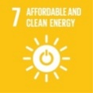 | Ensure access to affordable, reliable, sustainable and modern energy for al  7.3: By 2030, double the global rate of improvement in energy efficiency | Provision of a suitable model to support use of clean energy in the passenger transport subsector, switching from fossil fuel use
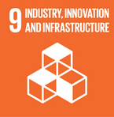 | Build resilient infrastructure, promote inclusive and sustainable industrialization and foster innovation  9.2: Promote inclusive and sustainable industrialization and, by 2030, significantly raise industry’s share of employment and gross domestic product | Support innovation and industrial development  Reduction of fossil fuels import
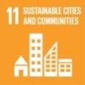 | Make cities and human settlements inclusive, safe, resilient and sustainable  11.2: By 2030, provide access to safe, affordable, accessible and sustainable transport systems | Improvement of air quality at urban level and availability of low-carbon transport modes
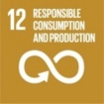 | Ensure sustainable consumption and production patterns  12.2: By 2030, achieve the sustainable management and efficient use of natural resources | Support Indonesia in developing demand for a more sustainable transport and the production thereof
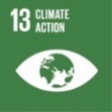 | Take urgent action to combat climate change and its impacts  13.2: Integrate climate change measures into national policies, strategies and planning | Reduction of GHG emission associated with reduced fossil fuel use in transport sector

Results and Partnerships

Expected results

This section describes in detail activities under each output of the three components of the Project. For a description of partner organizations, see Section 4.4 and Annex J. This includes a description of the linkages to the UNEP Global Program on “Supporting the Shift to Global Electric Mobility”, ENTREV’s parent program, described in Section 4.4. The results framework in Section 5 shows both the project outcomes and indicators as well as how the ENTREV progress indicator corresponds with indicators of the Global Program.

Component 1 Institutional framework and strategy for battery electric vehicle industry and charging infrastructure

Outcome | Outputs
1. BEV ecosystem (EV production and charging infrastructure) strengthened in response to national market uptake  EoP Targets Outcome 1:  [1] Updated roadmap and business models for charging station and battery swap station for new and conversion BEV.  [2] Government/private investment for 3,850 charging stations and 14,000 battery swap stations facilitated (national). | - Business models and financing option elaborated and implemented for charging stations (SPKLU) battery swap stations (SPBKLU)  Target Y4: Business models and financing options for charging stations/battery swap stations are developed and disseminated to stakeholders to encourage investment.  - Recommendation on national policies and standards for battery swap stations (SPKLU) and charging stations (SPBKLU) developed.  Target Y4: Recommendations for policy and standards for charging stations and battery swap stations.  - Program to promote domestic manufacturing of BEV and their components adopted and implemented  Target Y4: The BEV local component database is documented and promoted to BEV ecosystem potential investors.  - Options assessed for purchase and trade-in, preferential loans, and second-hand market for four and two-wheelers ICE to BEV  Target Y4: Innovative schemes to encourage BEV purchases are produced and disseminated to stakeholders.

Under this outcome, Project activities aim to enhance readiness for the development of charging infrastructure with economically viable business models being rolled out that can provide affordable charging to two and four-wheel EV users, thus building the confidence of infrastructure providers and potential EV users. The Project will also promote the local manufacturing of EV and EV products in response to growing national market uptake, in particular by strengthening linkages and technical capacities on EV among Indonesian universities/research institutions and the manufacturing sector. This Outcome is linked with Outcome 3 of the Global e-Mobility Program (see Section 5). The human right based and gender equality approach will be used in the process of business model development.

Output 1.1 Business models and financing option elaborated and implemented for charging stations (SPBKLU) battery swap stations (SPKLU)

Activities:

1.1.1 Develop and promote business models for charging stations, including financial models
- Business models will be elaborated for the private-sector operation of charging stations, including Excel-based financial models that show income projections and potential profitability and consideration of social and environmental risk management measures and sustainability.
- Outreach may involve focused group meetings or video conferences. To prepare for promotion efforts, identify businesses appropriate to running such charging stations businesses (especially those with land) to target in outreach efforts. Environmental and socially sustainable practices in running charging stations business to be included in outreach information.

1.1.2 Conduct assessment on business models for charging stations using renewable energy sources (e.g., solar PV) based on reliable statistics on electric vehicles
- Compile statistics on installed charging and swapping stations (from PLN, local government, private, others);
- Carry out an assessment to determine standards, costs, and availability of devices for renewable energy charging stations.

1.1.3 Develop and promote business models for battery swap stations
- Carry out an overall cost-benefit analysis of a battery swap program. Determine viability of such a program. In assessing the viability, consider the option of users having one battery that they are responsible for along with a slot for incorporating an additional battery from a battery swap station to be changed out when needed;
- Conduct analysis of institutional structure for the national battery swap system (including possible provision of batteries by a single entity and distribution by multiple private sector partners)
- Determine business models for private entity involvement, including financial analysis (to show if this will be profitable for them) and prepare the design of a public-private battery swap system.
- Conduct viability assessment of the designed battery swap systems for electric motorcycles and scooters and determine a business model for operationalizing the swap system. Based on findings, prepare the design for the battery swap systems.
- Review existing policy on 2-wheelers selling package to allow exclusion of batteries in the sale of the electric 2-wheeler. The existing policy from the Ministry of Industry (MoI) regulates that an EV motorbike has to include the battery when sold. If instead batteries can be rented at swap stations, this can positively affect the TCO (total cost of ownership).
- Identify environmental management measures needed to ensure the sustainable operation of battery swap stations, including protocols for battery storage and recycling and disposal of expired batteries.

Indicative activities to be discussed further during Inception workshop with stakeholders

1.1.4 Prototyping battery swap station for conversion of ICE motorcycle with Ministry of Energy.
1.1.5 Digitalization in the BEV sector, the use of fintech in end-user payments, in collaboration with Financial Service Authority (OJK).
1.1.6 Development of policy recommendation on fiscal incentive for EVs battery purchase to reduce BEV total cost of ownership (TCO) in the early stage of market.

Output 1.2 Recommendation on national policies and standards for battery swap stations (SPKLU) and charging stations (SPBKLU) developed

Activities:

1.2.1 Develop and adopt uniform standards for swappable e-motor scooter batteries and 4-wheeler batteries.
Draft standards and promote to policy makers (National Standard Body or BSN). Determine the process to ensure standards are adhered to and inform relevant departments. Publicize the standards to relevant organizations involved in manufacturing or importing relevant equipment. Support to the issuance of mandatory standard of BEV batteries and other components for 2 and 4 wheelers BEV and readiness of testing facilities.

1.2.2 Review, observe and provide feedback to battery swap policy and home charging
- Conduct assessments and observation to the implementation of battery swap policy.
- Provide input on policy interventions in the form of a policy brief paper as feedback to the government.
- Develop online-based, integrated monitoring platform for SPKLU business concessions
- Develop BEV home charging safety standard and application measures (electricity tariff zonation, smart meter V2X)

1.2.3 Adjust MoI EV Roadmap and PLN charging stations Roadmap
- Updated MoI EV Roadmap and PLN EVCS Roadmap based on latest statistics (activity 1.1.2), information on cost of charging stations, and TCO calculations of activity 1.4.2

Indicative activities to be discussed further during Inception workshop with stakeholders

1.2.4 Facilitate discussions with National Standardization Agency (BSN), Ministry of Industry, and BRIN regarding (a) battery standardization for battery swap stations; (b) preparation of national standardization of two-wheeled charging stations (two-wheeled charging stations); and c) national standardization of inter-operability between charging stations (roaming charging).

Output 1.3 Program to promote domestic manufacturing of BEV and their components adopted and implemented

Activities:

1.3.1 Support development and implementation of new and existing policies that directly incentivize domestic and green manufacturing of all-electric BEVs and their components
- Assess and provide draft policy to support domestic manufacturers by reducing cost for the importation of key BEV components (battery, motor, and inverter) and providing tax incentives to domestic component industries. This will include updating PMK 105 to include BEV key components to receive tax exemption (tax holiday) and other fiscal incentives (reduction or exemption of import duty). Adopt policy, determine implementation process, inform and train those responsible for implementation, promote to companies, and implement.
- Identify policy measures and incentives to strengthen green manufacturing of BEV and BEV components.
- Work to ensure process and responsibility for implementing existing BEV and BEV component manufacturing incentive policies are delineated, promoted to manufacturers interested in coming to Indonesia for longer-term investment.
- Assess and provide draft incentives to the nickel-refining industry for battery-grade product production, including reduced nickel royalty and reduced electricity price incentives. Propose an appropriate implementation process. Train relevant entities in their role in implementation and promote to relevant commercial entities.
- Assess and provide new/ additional draft incentive policies to attract foreign manufacturers to establish joint ventures for BEV car manufacturing and BEV battery manufacturing for both two and four-wheelers (in particular, attracting a low-end BEV car manufacturer will be a priority). Propose an appropriate implementation process, train relevant entities in implementation, and promote policy to priority potential foreign partners.
- Carry out assessment and propose measures to reduce the cost of doing business in Indonesia for foreign investors in the BEV and BEV component industry. This may include the reduction of unnecessary red tape and various incentives while not reducing environmental protection.

1.3.2 Liaison and exchange facilitated between manufacturers, universities/institutes, and investors/financiers
- Facilitate liaison between universities/ technical institutes and BEV and BEV component manufacturers for the formation of R&D partnerships that will benefit from the super-R&D tax incentive and increase local content. As a first step, determine relevant research areas of universities/ research institutes and their synergies with manufacturers, e.g., R&D related to enhancing the greening potential and sustainability of BEV.
- Facilitate exchange between Indonesian manufacturers of BEV components and all-electric BEVs with international companies so that joint venture relationships that accelerate scale-up, sustainability, and cost reduction are achieved. This may include delegations to visit international partners, facilitation of remote discussions, or invitation of potential partners to visit Indonesia for discussions. Priorities for this exchange should include battery makers, low-end BEV cars (for which there is as of yet no domestic manufacturing and for which imports are mainly high end), and nickel refining to achieve battery-grade products.
- Facilitate liaison between domestic all-electric BEV and component manufacturers and potential investors and financiers. As a first step, determine a list of relevant investors and financiers.

Indicative activities to be discussed further during Inception workshop with stakeholders

1.3.3 Prototyping Battery Swap by facilitating cooperation with national battery manufacturers and component manufacturers to reduce the price of battery components in conversion motorcycle.

Output 1.4 Options assessed for purchase and trade-in, preferential loans, and second-hand market for four and two-wheelers

Activities:

1.4.1 Carry out analysis on battery life and conduct foundation setting work for the development of second-hand BEV market
- Research and provide information on the potential lifetimes of batteries associated with various e-motor scooters and BEV cars in the market. Based on battery life and other findings (such as those regarding maintenance costs and cost of replacement batteries), estimate the value of BEVs (both e-motor scooters and BEV cars) on the second-hand market.
- Develop a website for the sale of second-hand e-motor scooters and BEV cars. In addition to serving as a platform to connect buyers and sellers, the website should include additional information from the above analyses, including what to expect in terms of the additional lifetime of batteries, etc. It should also include information on how to carry out (or commission) a diagnosis of the battery in a second hand-BEV the reader is considering buying.

1.4.2 Carry out TCO (total cost of ownership) calculations for e motor-scooters and BEV cars as compared to their respective ICEV equivalents and based on reliable statistics
- Compile statistics on sales and stock of electric vehicles (BEV, PHEV, HEV) and sales prices (from statistics office, government agencies, car producers and importers, customs, Police dept.)
- For the e-motor scooters, carry out TCO analysis, comparing ICEV motor-scooters (new and less fuel-efficient older models) with different models of e-motor scooters.
- TCO analysis will be carried out for different models of BEV cars vis-à-vis one another and in comparison, with other types (BEV, PHEV, ICEV, etc.). For both e-motor scooter and BEV car TCO work, an analysis will make use of findings on battery life (activity 1.4.1) and potential for second-hand market carried out (see statistics improvement, activity 1.1.2)
- Dissemination of TCO analysis results to EV users and owners and other stakeholders (linked with Activity 3.2.2)

1.4.3 Options assessed for purchase and trade-in, preferential loans, and second-hand market for four and two-wheelers
- Analyze the need for added BEV fiscal incentives for BEV owners and users. Considering the TCO work done on BEV cars (Activity 1.4.2), determine whether an increase in BEV car purchase incentive is needed to stimulate the purchase of BEV cars. If an increase is needed, it might be achieved by a higher reduction or even elimination of annual registration tax. In addition, consider a corporate tax reduction for taxis, rideshare, and other companies that adopt BEV cars for a certain proportion of their fleet.
- Draft a proposal for a system with incentives for the purchase of second-hand BEV motor scooters and second-hand BEV cars as well as an attractive trade-in system from ICEV to BEV (both two and four-wheelers)
- Prepare to brief selected policies and discuss with relevant policymakers at national and/or local levels. Adopt revised BEV car incentive policy or policies at national and/or local levels as relevant, develop the process for implementation, inform and train responsible units, publicize policy revisions, and implement.

Indicative activities to be discussed further during Inception workshop with stakeholders
1.4.4 Ease of administration for registration of conversion motorcycle in collaboration with the Ministry of Transportation.
1.4.5 Carry out assessment and impact analysis on VAT exemption for purchasing nationally produced BEVs.

Component 2 Demonstration of early BEV market development

Outcome | Outputs
2. Local policy and early market development promoted with demonstrated BEVs and charging infrastructure in selected regions  EoP Targets Outcome 2:  [1] Piloted charging station (SPKLU) and battery swap stations (SPBKLU) with local governments, MEMR and the private sector.  SPKLU: 1 charging station in DKI, 0 or 7 charging stations in West Java, 1 charging station with solar PV at MEMR.  SPBKLU: 12 units in DKI, 12 units in Bali, 12 or 5 units in West Java including piloting battery swap station with solar panels as a power source.  2] Three (3) local regulation recommendations to support BEV.  [3] Three (3) BEV Clearing Houses/Information & Promotion Centers at the Sub-national Level. | 2.1 Recommendations developed for local policy and regulations to stimulate BEV infrastructure investment and the purchase and use of BEV.  Target Y4: At least one local regulation recommendation developed to promote BEV.  2.2 Deployment of BEV charging stations, battery swap stations, conversion of ICE motorcycle, and BEV monitoring system in pilot regions in collaboration with private sectors.  Target Y4: MEMR Single-Gateway System for Monitoring Charging Station and Battery Swap Station.  2.3 Financing schemes set up for BEV two and four-wheelers utilization in pilot regions  Target Y4: Publication of 2-wheel and 4-wheel BEV financing schemes in pilot areas  2.4 Local clearinghouses and programs implemented to promote the purchase and use of BEV two and four-wheelers  Target Y4: Operational of IT-based Clearing House in three pilot provinces

This component will raise awareness among local policymakers, the private sector, and the general public on the central government’s strategy in transitioning towards electric vehicles through demonstration of electric vehicles implementation in the Jakarta Bali, and West Java areas . The Project will also facilitate preparation for the establishment of “EV knowledge clearinghouses”.

Output 2.1 Recommendations developed on local policies and regulations developed to stimulate BEV infrastructure investment and purchase and use of BEVs

Activities:

2.1.1 Prepare, advocate planning and policies to promote investment in BEV infrastructure
- Prepare draft regional government policies for Jakarta, Bali, and West Java that will stimulate the establishment and sustainability of BEV charging stations. One such policy may be for the regional government to require charging stations in commercial building parking lots. Others, such as local tax breaks, may also be considered. Liaise with decision-makers and revise preferred policies to have these formulated for approval by the Governor. Determine the process for policy implementation, liaise with departments responsible for implementation and ensure they are prepared for their duties. Promote incentives in national and regional policies to suitable private sector entities) that have available land for charging stations and that may be interested;
- Prepare geographic analysis that shows, for each of Jakarta and Bali (and West Java), critical Phase 1 target locations for public charging stations. Plans should indicate the proposed type of charger that would make the most economic sense at each location. Promote the geographic charging plan to the private sector entities.

2.1.2 Prepare and advocate local policies in promoting BEV purchase/use, such as:
- limiting the number of licenses issued each year for new ICEV
- Conducting analysis, provide draft policy and briefing, to limit the number of licenses issued each year for new ICEV motor scooters (e.g., via a lottery method or a method of very high-priced licenses) in Jakarta and Bali (and West Java), as a means of pushing end-users purchasing new motor scooters to purchase e-motor scooters.
- Conducting analysis, provide draft policy and briefing, and liaise with national and Jakarta and Bali (and West Java) local decision-makers. Adopt and develop the process for implementation, inform and train responsible units, publicize policy, and implement.
- fiscal and non-fiscal incentives for the purchase of BEVs and financial support program for retiring old ICEV motor scooters
- Conducting analysis, provide draft policy and briefing, and liaise with Jakarta and Bali (and West Java) policy decision-making regarding fiscal and non-fiscal incentives for the purchase of BEVs, especially tax reduction measures. Adopt and develop the process for implementation, inform and train responsible units, publicize policy, and implement.
- Conducting analysis, provide draft program structure and briefing subsidy/grant/coupon program for retiring old ICEV motor scooters (e.g. older than a certain age, such as 10 years) that would be used for the purchase of new e-motor scooter. Liaise with national and Jakarta and Bali (and West Java) policy and program decision-makers. This program will also consider potential environmental impacts and management measures for retiring of ICEV scooters. Adopt and develop the process for implementation, inform and train responsible units, publicize policy, and implement.
- prohibiting ICE two-wheelers in the city center or main roads in the Central Business District (CBD) in pilot project cities. Bali government has regulated the prohibition of ICE two-wheelers in CBD. The Jakarta government has allowed electric vehicles to pass roads that apply odd-even policy during peak hours. These policies can be expanded in broader areas in pilot cities.

Indicative activities to be discussed further during Inception workshop with stakeholders

2.1.3 In Bali Province:
- Facilitating Training and Certification of ICE motorcycle Conversion workshops.
- Study on the Development of End-User Demand for Battery Swap Station. Including incentives/regulations needed to encourage the Battery Swap Station market.
2.1.4 In West Java Province: Facilitation of discussions to recommend the assignment of BUMD as a charging station manager in collaboration with PLN, including the preparation of business canvas.
2.1.5 In DKI Jakarta: Facilitation of discussions on MEMR Regulation 13/2020 related to the requirements of the Charging Station Business Entity with a minimum requirement of 2 provinces.

Output 2.2 Demonstration of BEV charging stations and battery swap stations in pilot regions

Activities:
2.2.1 Purchase and install public charging stations for BEV and set up in-house battery swap for e-motor scooter fleets of government at selected sites (Jakarta, Bali, and West Java)
- Purchase and install (based on analysis of Output 1.1) public charging stations in cooperation with partners that own land with excess space. Proposed sites are at MEMR facilities in Jakarta (that have already solar rooftop PV installed, which can provide part of the energy of the EV fast-charging station (SPKLU)) as well as a second EV charging station at a location (without being equipped with a PV rooftop) located at the CNG Station owned by the DKI Jakarta Government.
- Set up battery swap stations for government and public e-motor scooter fleets. It is planned that 36 public battery swap station (SPBKLU) will be distributed, powered by normal chargers. One unit of SPBKLU contains 12 batteries cabinets. The 36 swap station locations will be distributed as 24 SPBKLU consisting of @ 12 batteries cabinets in DKI Jakarta Province, 8 SPBKLU consisting of @ 12 batteries cabinets in West Java Province, and 4 swap station consisting of @ 12 batteries cabinets in Bali Province. More details on the proposed demo/pilot activities are provided in Annex G. ENTREV will only invest in provision of battery cabinets for charging and engagement of service provider or operator. The batteries will be provided by the operator, not by the Project.More details on the proposed demo/pilot activities are provided in Annex G. GEF INV support is budgeted at USD 394,000 (for 2 EV fast-charging stations and 36 battery-swap stations) with INV co-financing (from MEMR, West Java government, and PLN) of an estimated USD 13,400,000 (for electric vehicles and charging infrastructure).

2.2.2 Develop partnerships with private-sector entities and install charging stations for BEV and set up battery swap for e-motor scooter with private sector entities in selected sites
- Advice on installing public charging stations in cooperation with commercial buildings partners (that own land with excess space) for post-project implementation
- Develop partnerships for private-sector-owned public battery swap outlets. This cooperation will be with the private sector entities as a means of extending the swap network initiated by Pertamina. This preliminary private sector involvement will set the stage for greater scale-up that will be needed to achieve the scale envisioned once the nation’s motor scooter fleet is largely electrified. The private sector’s co-financing letters (i.e., Bluebird, Grab, Gojek) have expressed their commitment publicly to change their fleet to electric vehicles.

2.2.3 Support demonstration of the conversion of 2-wheeled ICE to BEV
- In collaboration with research center P3TEK, EBTKE at the Ministry of Energy currently has initiated the conversion of ICE 2 wheelers to BEV. The Project will support P3TEK KESDM in the implementation of a pilot on the conversion of ICE motorbikes to BEV with a capacity of 110 CC. This will inform the formulation of an ICE to BEV Motorcycle Conversion Guidebook. For this reason, P3TEK will provide training and certification to conversion workshops. Thus, P3TEK is expected to become a Certification Body for the conversion of ICE, motorcycles to BEV. Cost of conversion is considerably high IDR 14,500,000/unit and ways will be explored to make conversion compatible.
- MEMR-P3TEK will provide INV co-financing of USD 160,000 (see Annex G).

2.2.4 Carry out monitoring of Jakarta, Bali, and West Java demos and disseminate results
- Prepare reports on results of demos, including achievements and lessons learned on, for example, including cost savings of BEVs, revenues of charging stations and battery swap stations, environmental and social impacts, and technical issues with both BEVs and charging stations
- Disseminate reports on Jakarta and Bali (and West Java) BEV demos widely nationwide, but with special focused efforts on the six priority target replication cities identified in Activity
- MEMR will provide USD 160,000 INV co-financing for monitoring equipment and supporting activities, while GEF INV support is USD 239,000.

Indicative activities to be discussed further during Inception workshop with stakeholders

2.2.5 In Bali and West Java Province: Developing a mechanism for cooperation with the private sector/BUMD to set up charging station/battery swap station.
2.2.6 In West Java Province:
- Facilitate discussions on the preparation of battery standardization for battery swaps and business models for business entities' investment in battery swap stations.
- Facilitate demonstration of investment for charging stations (7 locations) in addition to battery swap stations.
- Facilitate discussion on Presidential Regulation 30/2020 regarding the limitation of the price of goods for local governments to allow for the purchase of BEV.

Box 8 Demonstration of EV vehicles in selected areas – Jakarta Province

“Demonstration for BEV Early Market Development” in Jakarta Province is important to be carried out as a learning tool for related stakeholders as well as promotion of the benefits of using BEV for the community, so that it can be replicated in other provinces. The selection of DKI Jakarta Province as one of the provinces for the Demonstration for BEV E is related to the commitment of the DKI provincial government to improve its air quality by providing various fiscal and non-fiscal incentives as well as infrastructure and facilities for BEV users.

The Demonstration for BEV Early Market Development involves a number of activities, including a) procurement of SPKLU and SPBKLU infrastructure*⁾ and b) test runs with BEVs using the infrastructure. The number of commitments to the use of BEV for each institution was obtained based on discussions and input provided during the project formulation (PPG) phase. Investment in charging station and battery swap station will be provided by the Provincial Government of DKI Jakarta, PT PLN (Persero) as the national entity responsible for charging station and battery swap station infrastructure, as well as interested business entities, including business entities as targets, namely ride hailing, taxi.

The use of BEV is aimed at Central Government, SOEs, DKI Jakarta Province and ROEs, ride hailing, and taxi. The demonstration projects are intended to include data loggers for the use of BEV, either E-Car or E-Scooter, which is used by the central/regional government and SOEs/ROEs or as passenger transportation. Data loggers are important since up to there has not been any monitoring and evaluation of the use of BEV in Indonesia. With the results of the pilot projects evaluation publication, it is expected it will encourage public interest in purchasing and using BEV. The Project, through its Outputs 2.5 and 3.2, will help disseminate the demo results and promotion of BEV in general through the use of BEV can be done through TV, radio, print media, online media, biker groups, and others.

These activities are linked with a number of regulations that are planned such as a framework for the optimization of BEV utilization in DKI Jakarta. The Project will support under Outputs 2.1 and 2.2 the formulation of such regulations, which can be combined into 1 regional policy framework or developed separately, depending on the internal policies of each local government. For DKI Jakarta, three 3 policies planned related to a) prohibiting the use of ICE motorcycle on the main route, b) fiscal and non-fiscal incentives and financial support for retiring of ICE motorcycle, and c) restriction on the sale of ICE motorcycle.

The Project will provide assistance to MEMR in preparation of the ToR and other documents for the tendering process for selecting a supplier (or suppliers) for the supply and installation and construction of civil works for the super-fast charging stations and for the battery swap stations. During Project implementation, all Project activities providing direct financial support to investments (GEF INV) under this Output will begin with an initial step where the PMU, in consultation with key stakeholders, will prepare a “Project Investment Plan”. This plan will finalize, via detailed financial, technical, legal, procurement and operational assessments, the Project’s approach to providing GEF INV support to procurement activity. The plan will address the key principles detailed below. This plan will be submitted for clearance to UNDP (CO and BPPS NCE), and then shared with Project Board, for approval. The key principles to be considered are:
o Ensure that the level of GEF INV support for private sector beneficiaries is determined on the principle of minimal concessionality or, in other words, that the GEF INV is used as efficiently as possible. In practice, during implementation, this will nearly always involve a step in the GEF INV financial mechanism where a financial analysis of the investment opportunity will be performed;
o Ensure that the design of the mechanism to provide GEF INV support in the particular sector safeguards financial resources against potential wrongdoing. For example, this may involve checks-and-balances, committees, and multiple individuals, on key decisions. Quoted cost of investments should be checked against market prices.
o Ensure that any GEF INV to the private sector recipients is done on a competitive process to identify the recipients;

After the Project ends, ownership will a) remain with MEMR (charging facility in MEMR building), b) transferred to Jakarta local government (other 4-wheel vehicle charging facility) and c) transferred to companies in a transparent bidding process (battery swap stations)

*⁾ SPKLU: Stasiun Pengisian Kendaraan Listrik Umum (public electric vehicle charging station)
SPBKLU: Stasiun Penukaran Baterai Kendaraan Listrik Umum (public electric vehicle battery exchange station)
Output 2.3 Financing schemes set up for BEV two and four-wheelers utilization in pilot regions

Activities:

2.3.1 Assess the benefit of preferential loans to purchase BEV cars and e-motor scooters
- Assess the benefit of preferential loans for taxi and ride-sharing companies to purchase BEV cars and e-motor scooters. This may also include a risk insurance mechanism to protect companies against the early failure of the BEVs.

2.3.2 Propose financing schemes and facilitate matchmaking between financiers
- Consultation with financial institutions to discuss their interest, the possibilities and their appetite to enter this market
- Provide advisory support on possible financing schemes and facilitate matchmaking between financiers and BEV-using companies in purchasing and operating e-motor scooters and cars, such as ride-sharing, taxi, and delivery companies.
- Provide advisory support on possible financing schemes and facilitate matchmaking between financiers and local government in purchasing and operating e-motor scooters (units with high daily mileage) and all-electric shuttle buses.

Indicative activities to be discussed further during Inception workshop with stakeholders
2.3.3 In West Java and Bali province: conduct study of Market Development Strategy by targeting BEV end-users.

Output 2.4 Local clearinghouses and programs implemented to promote the purchase and use of BEV two and four-wheelers

Activities:

2.4.1 Develop at least one clearinghouse (info exchange and provision platforms) in each pilot region serving private and other interested parties
  - The clearinghouse is established at a local public entity that provides information and advice on electric vehicles, charging options, national and local regulations and available incentives. The Project will support bringing the clearinghouse staff up to speed and promote the clearinghouse needs of the private sector by gathering and systematizing useful information on the status of BEV and charging related policies, procedures, business models, financing, partners, and actions (in Indonesia in general and the target region in particular).
  - Organize awareness campaigns for the general public, reach out to appropriate private sector entities, and support these and other entities regarding Indonesia’s BEV and (charging) infrastructure on a one-to-one and as-needed basis. The aim is to enable supporting local (regional) private sector entities and providing coordination with both domestic, national, and international parties.

Indicative activities to be discussed further during Inception workshop with stakeholders

2.4.2 Prototyping of IT-Based Wall-Room which provides access to local governments to monitor the Charging Station/Battery Swap Station Dashboard and calculate GHGS Emission. Integrated with MEMR Single Gateway Monitoring (Note: It is expected that there is a hardware wall/monitoring room at MEMR/Pusdatin and local gov).

2.4.3 In West Java province:
- Facilitate local government’s access to information on VTA (vehicle type approval) of the Ministry of Transportation and the integrated platform for the location and status of charging stations/battery swap stations (single gateway MEMR).
- Kit provided to vocational schools as service providers for after-sales services (maintenance) of electric vehicle conversion, in collaboration with the Pusdiklat KEBTKE & P3TEK Center.

Component 3 Knowledge products and capacity building for scaling up and environmental-friendly battery use

Outcome | Outputs
3. Capacity of key stakeholders built and knowledge shared on BEV to officials, manufacturers, and potential BEV buyers and safeguards development  EoP Targets Outcome 3:  [1] 100,000 people (40% women) received information about BEV  [2] 60 people received ToT on BEV servicing (20% women)  [3] 6 cities replicate pilot activities  [4] Battery waste management guideline developed  [5] Lessons learned on BEV in Indonesia | 3.1 Capacity is built in the BEV industry (repair-shops) and research institutes  Target Y4: 60 people received ToT on BEV servicing (20% women)  3.2 Promotional activities conducted, results of demonstration in pilot locations disseminated and knowledge exchange between countries on e-mobility facilitated.  Target Y4: 100,000 people (40% women) received information about BEV.  3.3 Programs to address social, gender, environmental, and safety employment issues related to BEV adoption are developed (including battery use and disposal)  Target Y4: Recommendations for environmental policy narratives related to the BEV ecosystem and battery waste management guidelines.

The project will foster knowledge and information exchange based on lessons learned during its implementation at the national level and within the EV Global Program network. Development of programs for managing batteries and subcomponents at the end of their life will be conducted (to ensure environmental sustainability) as well for addressing gender and social aspects. Outcome 3 is cross-cutting and the outputs will also provide an input to and inform Outcomes 1 and 2.

Output 3.1 Capacity is built in the BEV industry (repair-shops) and research institutes

Activities:

3.1.1 Build gender-sensitive capacity development in vehicle repair shop technicians on BEV and conversion from ICE to BEV (E-scooters) to address unemployment issues from the transition to BEV

(So that they are skilled in maintenance and repair of e-motor scooters, e-bicycles, and all-electric cars, as well as in the conversion of ICEV motor scooters and bicycles into e-two wheelers)
• Conduct a skill needs assessment
- Prepare a handbook and training videos on BEV repair and conversion in Indonesia. Post videos on one or more online platforms.
• Train technical personnel in BEV repair and conversion (with a focus on the three pilot regions, Jakarta, West-Java, and Bali). Trainees will include staff of taxi, ride-hailing, and delivery companies as well as personnel of motorcycle and auto repair workshops. Training sessions should ensure a strong representation of women trainees.
• Design and administer competency tests to trainees to determine whether they have mastered materials. Provide a certificate of accomplishment to those that achieve mastery.
• Prepare a plan for re-skilling of ICEV and ICEV component workers to enter BEV and BEV component industry to the extent the BEV-related industries can absorb them. Prepare a plan for the transition of excess ICEV workers to transition to other fields. Encourage female participation in the training/re-skilling programs

3.1.2 Develop BEV related curriculum and courses for high schools and universities
- Conduct capacity building and ToT needs assessment
- Prepare BEV curriculum for high school and university levels, working with universities (about 6 key universities), research institutes (LIPI, BPPT, and P3TEK EBTKE), and industry (Gesit, Toyota, Honda, and Hyundai). The curriculum will include training handbooks and training videos as well as opportunities for hands-on engineering lab experiences. It will also include mastery tests.

Indicative activities to be discussed further during Inception workshop with stakeholders
3.1.3 Capacity Building for policy makers, high officials regarding BEV and budget prioritization.
3.1.4 Training and Certification for motorcycle conversion shops and Vocational High Schools. Assisting human resources capacity building, completeness of test equipment according to the requirements of Minister of Transportation Regulation No. 65/2020.

Output 3.2 Promotional activities conducted, results of demonstration in pilot locations disseminated and knowledge exchange between countries on e-mobility facilitated.

Activities:
3.2.1 Develop two-way international BEV knowledge exchange between Indonesia and the rest of the world through UNEP-led Global Program on E-mobility
- Hold and attend E-mobility workshops and site visits
- Collect, package, and translate into Indonesian relevant information from the parent project’s BEV knowledge exchange platform.
- Research relevant case studies of international experience and carry out cross-country analyses as needed to provide insights for a specific policy, process, planning, and business models issues related to Indonesia’s BEV ecosystem development.
- Ensure that key ENTREV knowledge products, especially demo monitoring reports and lessons learned and capacity building handbooks are shared globally via the parent project’s knowledge exchange platform

3.2.2 Create a program of promotion of the use of BEV in various media
(In the target regions of Component 2, and as part of national-level efforts to promote the use and purchase of BEVs)
- Identify those government departments/ organizations that are likely to drive the most vehicle miles per day and thus have the greatest cost savings with BEVs and focus promotion on these organizations.
- Provide information on BEV TCO analyses (see Output 1.4) to taxi, ride-hailing, and delivery companies. Also, provide guidance on battery care and charging, the ease and low cost of maintenance, flood resistance and safety, and durability as part of the promotion of BEVs to these companies. Hold workshops on all-electric BEV adoption for taxi, ride-hailing, and delivery companies and organize an all-electric BEV exhibition for them.

3.2.3 Identify six priority cities for replication for additional scale-up and conduct outreach
- Identify six priority cities for replication of the demos (Outcome 3) and to other institutions and neighborhoods in Jakarta, Bali, West Java (or other areas) for additional scale-up.
- Conduct outreach to relevant parties in the six priority target cities for replication of successes in Jakarta (and other project focus areas (see Component 2) on BEV programs and confirm which cities will participate, aiming for a minimum of four cities to eventually initiate replication by the end of ENTREV.

Output 3.3 Programs to address social, gender, environmental, and safety employment issues related to BEV adoption are developed (including battery use and disposal)

Activities:
3.3.1 Mapping of the (battery) electric vehicle industry and components and assessment of social and environmental impacts
- As several of the Environmental & Social impacts identified in the Social and Environment Screening (SESP, see Annex K) are indirect impacts of the project associated with inherent impacts related to the life-cycle of BEV, a strategic environmental and social assessment of electric vehicle industry in Indonesia (with a focus in BEVs) will be conducted as one of the early activities of the project, looking at the life-cycle of batteries (including resource extraction, manufacturing and battery disposal). This strategic assessment will inform relevant decision-making, policies, guidelines related to BEV expansion in Indonesia. Therefore, while the assessment will inform components of the project, the scope of the assessment is expected to be useful beyond activities proposed in this project as it can, e.g., lead to recommendations for strengthening sustainability of the nickel extraction required for EVs. The resulting “framework” of safeguards for the BEV sector in Indonesia will include a roadmap for activities to be put in place by national partners.
- The assessment will consider potential environmental impacts of retired BEV battery use including the potential impact of discarded batteries (if not reused/ recycled), re-manufacturing, secondary use of retired BEV batteries (such as for off-grid power), and recycling after the secondary use life is exhausted as well as human rights, environmental issues related to the extraction of raw materials for the batteries.
- The assessment will also consider potential social (incl. gender and employment) impacts and opportunity for women participation in jobs by giving priority to women for accessing the new jobs linked to EV (driving, maintenance and management; operation of charging stations and swap stations) in particular in the companies and government entities associated with the project pilots. The assessment will provide recommendation that will facilitate further streamlining of policies to facilitate the access of women to jobs and the consideration in working conditions the consideration of gender‐sensitive working conditions (e.g., for flexible working hours) and gender-sensitive management plans in commuting (priority setting at parking places, and bike‐sharing and public taxis).

3.3.2 Establishing guidelines on BEV safety and water (flooding) protection
- Carry out needed assessments, including assessment of water impacts on all-electric vehicles in the case of flooding and fire risks. Develop measures to prevent safety and reliability issues, such as waterproof encasement of batteries.
- Get guidelines adopted, determine implementation process, train implementers, and promote these to both manufactures and potential users as needed. Concerning fire safety, train first responders in dealing with accidents involving BEV batteries

3.3.3 Develop and implement a program for the retiring of BEV batteries, optimizing retired battery value, and minimizing environmental impacts
- Determine financially viable and environmentally and socially sustainable (informed by activity 3.3.1) business models for re-manufacturing, re-use, and recycling as inputs to the plan and marketplace efforts described in the subsequent sub-activity.
- Develop national plan and marketplace for remanufacturing and/or secondary use of retired BEV batteries (immediately after they are retired from vehicles), such as for off-grid power, and plan for the use of retired BEV batteries after no longer appropriate for secondary use. Design marketplace platform to facilitate the buying and selling of batteries at both of these two stages. Secondary use may include a combination with solar PV for off-grid village power applications (e.g., such as in the case of conversion from diesel to solar PV).
- Draft, organize discussion and revision and promote adoption of retired BEV battery policy to support the foregoing plan.
- Publicize the retired BEV battery policy and program. Develop the process for implementation with relevant institutions identified and trained in their responsibilities.
- Develop and implement measures to identify and close down “illegal recyclers” (that often do not actually recycle the batteries they collect).

Indicative activities to be discussed further during Inception workshop with stakeholders
    - Facilitating policy study for recommendations on handling battery waste, synergizing with MoEF, Ministry of Industry and Ministry of Transportation to encourage circularity of battery products.
    - Discussion with MoEF regarding BEV battery waste management and battery swap stations.
    - Discussion with MoEF regarding the implementation of environmental documents for charging stations and battery swap stations in accordance with MoEF Regulation 4/2021 and a new proposal related to charging stations that utilize battery energy storage system (BESS).

Partnerships

The proposed project is a child project under the GEF-supported program “Global Programme to Support Countries with the Shift to Electric Mobility”, led by UN Environment, with the objective to support countries to design and implement electric mobility programs as part of an overall shift to sustainable, low carbon transport sector. The program focuses on all road transport modes, including 2/3 wheelers, cars, and buses, and is designed around four components:

1) Global thematic platforms and policy materials;
2) Regional hubs and training;
3) Country project implementation (child projects); and
4) Tracking progress and facilitating replication.

An overview of the role of the main project co-financiers and project partners is given below:

Main project partner and co-financier | Roles in the implementation of EV project
MEMR  Directorate General of Electricity (DGE) and Directorate general of New and Renewable Energy and Energy Conservation (DG-NREEC) | The project will work closely with the DG of Electricity (DGE) and DG of New and Renewable Energy and Energy Conservation (DG-NREEC) of Ministry of Energy and Mineral Resources MEMR. As the project’s Implementing Partner, MEMR c.q DGE, will provide overall leadership and strategic direction and guidance to the project; Review the project’s progress in monthly meetings held.; Chair the PSC for making consensus-based strategic, policy & management decisions for the project. MEMR will provide a senior official as the National Project Director (NPD). MEMR contributes with cash and in -kind co-financing of USD 18,566,311
Regional governments | The project will work closely with DKI Jakarta government (Bappeda) to develop a demonstration project of BEV in Jakarta and with local governments of West Java and Bali. The West Java Provincial Government has confirmed cash and in-kind co-financing of USD 1,600,000
PT. Perusahaan Listrik Negara (PLN) | The national power utility PT PLN is responsible for determining charging tariff and electricity supply in general. In the project, PPT PLN will technically and financially support the establishment of charging stations (with in-kind and cash co-financing of USD 800,000)
Research and Development Center for Electricity (P3TEK) | P3TEWK, a government agency under MEMR, will lead the activities on enhancement of technical capacities in conversion of conventional two-wheelers to the battery-based electric motorcycle (contributing USD 457,436 in cash and in-kind co-financing)

Some of the partners will provide in-kind and/or in-cash co-financing of which the details are explained below. Risks associated with the realization of co-financed activities and amounts will be included in the project risk register and monitored accordingly (see Box 10 and Annex D).

Co-financing source | Co-financing type | Co-financing amount (USD) | Included in project results
MEMR, Directorate General of Electricity (DGE) | in-kind | 2,600,311 | No
MEMR, Directorate-General of New and Renewable Energy and Energy Conservation (DG-NREEC) | in-kind | 4,384,000 | No
 | Public investment | 11,582,000 | No
MEMR, Research and Development Center for Electricity, New and Renewable Energy, and Energy Conservation Technology (P3tek-KEBTKE) | in-kind | 50,000 | No
 | Grant | 407,436 | No
West Java Provincial Government | in-kind | 222,000 | No
West Java Provincial Government | Grant | 1,378,000 | No
Indonesia State Electricity Company (PLN) | in-kind | 200,000 | No
Indonesia State Electricity Company (PLN) | Public investment | 600,000 | No
UNDP | Grant | 50,000 | No
Grab | Equity Investment | 10,000,000 | No
TOTAL |  | 31,473,747

In-kind co-financing:
- MEMR: for 1) project management (office space and admin support), and 2) support to the project TA activities (and participation of MEMR staff in capacity building, and setting up EV ecosystem policy-planning regulatory framework) and participation in EV project’s events (workshops, seminars) and information gathering (monitoring of pilots/demo activities);
- P3TEK/PLN: In-kind co-financing for the support and participation of P3TEK-KEBTKE staffs in ENTREV project activities;
- W-Java government: kind for facilitating project activities in Component 2 and implementation of local EV-related plans and policies as well as participation in EV project’s events (workshops, seminars);

Cash (grant) co-financing:
- Associated with additional investment in EVCS, BSS and/or EV:
  - MEMR: Estimated grant funding of USD 11,422,000 for the acquisition of EVCS and/or purchase EV and USD 160,000 for the monitoring of demo/pilot projects
  - PLN: Estimated grant of USD 600,000 for charging stations and/or purchasing of EV
  - W-Java government: Estimated in-cash of USD 1,378,000 for investment in EVs ecosystem, including procurement EVs for official vehicles and installation of charging stations
- P3TEK: estimated in-cash support of USD 407,436 for the conversion of conventional two-wheelers to the battery-based electric motorcycle
- UNDP: For facilitating activities in Components 1 to 3 PMU staff and CO staff time participating in project events and technical components.
- Grab: Activities in the form of internal investment of EVs , but not limited to, a) Policy advocacy on Electric Vehicles (EVs) battery standards and Value Added Tax; b) Facilitation of dialogues with government counterparts; c) Promotional activities on EVs; d) Development of secondary market for EVs and its components; and e) Awareness raising on EVs for Grab driver-partners and the public.

One main function of its global component is to generate knowledge and policy materials on selected EV topics to support countries on the ground with the development and implementation of national electric mobility projects. These materials consist of reports and tools to help the development of the policymaking process in the countries, including cost-benefit analyses and compilation of other countries’ best practices in the transition to electric mobility. As one of the child projects, ENTREV, will benefit from the support provided by the global program in form of knowledge exchange, training, and technical support. Experiences and lessons learned from the project’s pilot demonstrations will also be shared through the Global Program.
Box 9 Global e-mobility program with outcomes and indicators

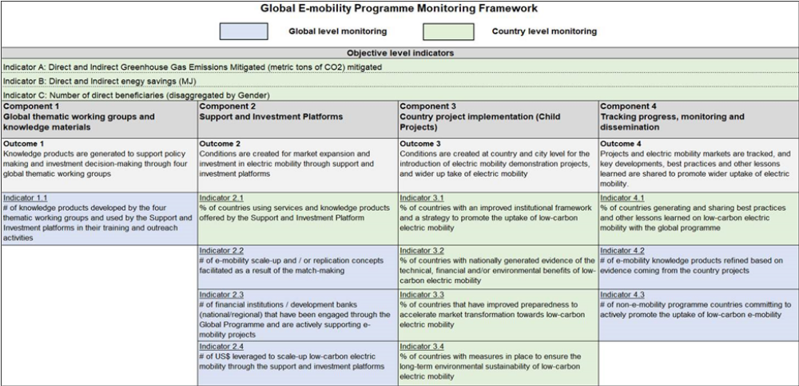

The project will also align with other related planned and ongoing projects in Indonesia to foster knowledge sharing and scale-up of the project. UNDP is leading the UN Partnership for Action on Green Economy (UN-PAGE). Under this initiative, UN-PAGE partners will support the Government of Indonesia in developing a low carbon development plan at the provincial levels. The experience from the proposed project will also be shared through the PAGE regional and global network.

Also, the proposed project will pursue possible collaboration with the GIZ – INDOBUS and GIZ-C40 Cities Finance Facilities (CFF) project aiming to introduce the use of electric buses as their BRTs, which will enable knowledge exchange through the network of GIZ. Collaboration of this proposed project is also envisaged with the actions of ADB’s Sustainable and Inclusive Energy Program (SIEP) on “electric transportation and charging infrastructure”. This project will also collaborate with the Institute for Transportation and Development Policy (ITDP) Indonesia that is implementing the Supporting Jakarta’s Transition to e-Mobility project, funded by the UNEP CTCN (Climate Technology Center and Network), to support e-buses for Transjakarta BRT and electric 2 wheelers. UK Partnering for Accelerated Climate Transitions (UK PACT) is developing a project on upscaling of the Transjakarta electric buses. In this program, the UK PACT and ITDP will team up with the Jakarta Transportation Agency and TransJakarta to build capacity and develop action plans for TransJakarta to reach its fleet electrification target. In a parallel 12-month project, UK PACT and ITDP target Jakarta's motorcycle taxis (2W taxis) to go electric.

Risk and assumptions

The use of electric vehicles needs to be managed properly because it can cause various risks, i.e., social risks, economic risks, and climate change risks. The design of the project’s activities reflects a thorough assessment of these risks shown in the table of Box 10. As per standard UNDP requirements, the National Project Manager will monitor risks quarterly and report on the status of risks to the UNDP Country Office. The UNDP Country Office will record progress in the UNDP ATLAS risk log (see Annex D). Management responses to critical risks will also be reported to the GEF in the annual PIR.

Risks related to COVID 19 crisis
Risk analysis and planned management countermeasures have considered, among other risks, response to the Covid19 crisis. The COVID 19 pandemic can impact the project implementation in different, to some extent opposite, ways. On the one hand BEVs will require fast promotion and awareness-raising activities to attract users as many new technologies. However, the COVID-19 pandemic limits social interaction and restricts community activities. This situation may hinder proposed project activities, mainly involving public participation such as demonstration trials of BEVs, exhibitions, and other promotional events. On the other hand, the economic impact of COVID-19 may shift investment priorities of the individual, government, and companies towards preventing uncertainties. Thus, having a relatively higher cost of ownership, purchasing BEVs may not be prioritized by those potential markets. In addressing the unwanted impact of COVID-19, the proposed project will need to build an innovative promotional strategy that complies with health protocols. Covid19 has been a major disruptive event in the Indonesia public transport sector – similar to other countries – wherein demand for public transport has reduced significantly since the onset of the pandemic, due to fearing of infection on public transport. This could impact communities perceptions of public transport and create a shift to the use of individual 2 and 4-wheelers. An opportunity of the project is the possibility to meet this demand with E-Mobility, and hence enabling post-Covid green recovery. The risk of continued impact of the COVID 19 pandemic on project implementation progress is reflected under Risk 18.

Risks related to Climate Change
Climate change can cause floods, fires, and landslides. In the big cities in Indonesia, the chance of flooding is higher because of limited drainage channels for rainwater disposal and low number of water absorption wells. Land subsidence and sea level rise make the extent of flooding worse in terms of frequency and severity. The location of EV infrastructure should therefore be evaluated for climate vulnerability. As site selection will be part of project implementation, an ESMF will further specify the requirements for site selection (Risk 2). Moreover, the use of BEVs in urban areas is vulnerable to flooding because it may cut off its power supply. Limited common knowledge on the level of BEVs reliability in such flooding situation may cause lower interest among urban people to purchase it. In this context, a comprehensive monitoring system for BEVs would be required, including to demonstrate installation of data logger on the BEVs of participating BEVs owners. This monitoring is to analyze use of the BEVs especially in Jakarta city, especially on the reliability of the BEVs as transport vehicles, in obtaining potential of CO2 emissions reduction from its use, as well as understanding the flood risk of flood to BEVs. This activity is included in the demonstration projects under Output 2.2 (see also Box 8).

Box 10 Project risks, including impact and probability, and mitigation measures

Description | Level | Mitigation Measures
Social and environmental risks (see also Annex K)
1. Potential for the operation of unregulated Electric Vehicle Charging Stations (EVCS) | Low | This risk of unregulated EVCSs is low. First, state utilities like PLN will run charging stations and will comply with government instructions on safety. Second, the risk will be managed through the design of the project, with management measures integrated into the project’s relevant outputs. Additional site-specific management measures will be considered, as needed, as specified in the Environmental and Social Management Framework (to be developed prior to project approval).
2. Inappropriate location of Electric Vehicle Charging Stations (EVCS) could be exposed to impacts of adverse climate change and therefore harmful to people and/or the environment. | Moderate | Environmental and social assessment and due diligence will inform selection of demo/pilot sites to avoid placement of EVCS in hazardous locations or locations that present other environmental and social risks. Requirements for site selection will be further specified in the project ESMF.
3. Risk of limited participation of women in the program | Moderate | Gender analysis has been undertaken and a Gender Action Plan prepared with the aim to involve both women and men in the various activities, without discrimination. However, while the project will endeavor to encourage key players in the urban transport services to incorporate women either as operators, entrepreneurs, etc., the duration of the project may not be long enough to break the socio-cultural dynamics that impede women from participating in the sector.
4. Potential direct and indirect environmental impacts from battery production and disposal. This includes direct environmental risk related to handling batteries that have reached their end-of-life. Also indirect risk of increased impacts related to the resource extraction needed for the batteries (however: the Project will not directly be involved in battery manufacturing) | Substantial | During the project, an assessment of existing standards, laws, and regulations will be undertaken in order to determine the gaps that the project will fill in terms of delivering draft regulations and standards to govern the disposal of batteries and waste from battery manufacturing processes. These will be an important step towards strengthening environmental safeguards. During the Project, the option of “extending” the life of the batteries will be examined for possible inclusion in the aforementioned standards and regulations. The project will include the development of policy guidelines/regulations for the collection, safe disposal/waste management, and recycling of the batteries (see Output 3.3.). A strategic assessment of social and environmental impacts of BEV in Indonesia will be conducted, looking at the life-cycle of batteries (including resource extraction). This strategic assessment will inform relevant decision-making, policies, guidelines, e.g. through assessment of technical and economic aspects of retired BEV battery use including the potential impact of discarded batteries (if not reused/ recycled), re-manufacturing, secondary use of retired BEV batteries (such as for off-grid power), and recycling after the secondary use life is exhausted as well as human rights, environmental issues related to the extraction of raw materials for the batteries. Requirements for the strategic environmental and social assessment will be clarified further in the project ESMF and aligned with UNDP’s SES and related guidance.
5. Potential occupational health and safety risks associated with electric vehicle repair and decommissioning of battery banks and/or vehicles (indirect impact associated with activity 3.3.3) | Moderate | While project labour will not be involved in EV repair or decommissioning, this is identified as an indirect risk of the project. Therefore, as part of project implementation, a capacity assessment of the existing stock of automotive mechanical and electrical technicians will be undertaken to incorporate in the proposed project a component for building the capacity of technicians to enable them to handle the repair and decommissioning of electric vehicles. Also, the project will be designed to include a component for public awareness which will be useful to impress on the general public who will own electric vehicles, the need for taking them to repair shops that have the appropriate equipment and training to handle such cars. The training requirements will also be assessed and training provided to ensure that the operators of the EV charging Stations are sensitized about the risks and safety protocols (component 3). It is expected that electric vehicle dealers will also provide thorough end-user training to avoid accidental injury due to electric shock. The strategic environmental and social assessment will also look at OHS risks related to battery production, maintenance and disposal to inform safeguards and best practice OHS measures in the EV sector.
6. There could be other unforeseen unintended impacts arising from new standards/ regulations to be developed during the project implementation | Low | It is expected that during project implementation, the risk assessment will be re-examined on a regular basis. During the start of project implementation, the scope of including a Grievance Redress Mechanism (GRM) at various levels will also be discussed with the Government of Indonesia. Requirements for subsequent social and environmental screening, assessment, management as well as design of the project GRM will be detailed in the project ESMF.
7. Vulnerable or marginalized groups, might not be involved in project design and therefore not engaged in, supportive of, or benefitting from project activities; | Low | A comprehensive Stakeholder Engagement Plan was developed during PPG that will be updated during project implementation, as needed, to ensure that all key stakeholders are involved during project implementation,
8. Wide adoption of BEV may trigger key mineral mining activities for batteriesy, i.e., nickel, leading to indirect social and environmental impacts. | Low | While the project would not be involved in mining activities or activities at mining sites, this indirect risk would be addressed through the SESA process that the project will support. This will include consultations with Nusantara Indigenous Community Alliance (AMAN) and other affected peoples to build understanding on the BEV value chain and potential risk of key mineral mining activities for EV battery due to increase market demand for BEV. This will be fundamental to the project’s support in helping develop a framework and strategy for BEV in Indonesia. The project will also promote implementation of social and environmental compliance standards in mining areas in cooperation with MoEF.
Other risks (financial, socio-political, grid system)
9. Private sector stakeholders, NGOs, and end-users show a lack of interest. Low demand for vehicle discouraging new  investment; | Moderate | Any potential risk will be mitigated through targeted public awareness and advocacy activities, dissemination of information and consultations, and capacity building, to be implemented under Component 3. In addition, the demonstrations to be undertaken under Component 2 will visibly showcase the technology to present the opportunities and benefits of the proposed technologies, supported by incentive and financing schemes. The project will advise PLN to reduce tariff price based on the result of the demonstration activities of Component 2
10. Incentives and the financial support system are insufficient. | Moderate
11. International prices of petroleum products can fluctuate heavily. This may influence domestic fuel prices to which the risk can be added of fuel subvention (in particular during election times) | Moderate
12. Loss of employment in service of conventional vehicles creates resentment | Low | The project includes actions to facilitate access to EV‐related jobs through training, and a revision of recruitment strategies, taking advantage of the appeal of EV technologies for potential workers (so that they are skilled in maintenance and repair of e-motor scooters, e-bicycles, and all-electric cars, as well as in the conversion of ICEV motor scooters and bicycles into e-two wheelers). The project also takes benefit of the new technology to accelerate the integration of women
13. Wavering interest and reduced participation by national and local government institutions; poor coordination | Low | Relevant government institutions have shown interest in and commitment to the promotion of EVs in Indonesia in several national EV initiatives. To date, the government and local government in the project areas have been proactive in EV policy and planning and setting up. The risks of poor coordination are present but considered too low.
14. Power plants in Java still rely on coal to provide cheap electricity in the country. Therefore, the grid emission factor is still high. Should more coal be used in the near future, the emission reduction calculated will be less. | Low | Study on the use of solar PV rooftop as a source of electricity for BEV in component 1. One demo EV charger will be installed at MEMR facilities with already solar PV installed.
15. Applicable international, national and local norms to prevent the spread of the COVD-19 pandemics, including but not limited to the respect of quarantine periods and social distancing, lead to a delay in project activity implementation | Moderate | By the time the Project activities start with the Inception, the COVID pandemic may have well passed its peak both in Indonesia as worldwide with the largest part of the population vaccinated. Even then, new variants may come up leading to more waves of COVID-19 infections. In such cases, a contingency plan will be made by bringing some activities forward as possible and with meetings held online, where possible. The COVID-19 situation will be taken into account in the Project Inception Report and closely monitored. This assessment will both evaluate the possible negative effects of COVID-19 as well as any “green” opportunities raising. Possible longer-term COVID-19 related risks in relation to transport preferences of the public, changes in the priorities of the government (due to shortage of capital financing) and any other limitations cannot be foreseen as of today.
16. Project partners and co-financiers divert priority and co-funding away from EV, leading to delays in pilot/demo procurement and implementation | Low | The Project will support proponents with proposal formulation and feasibility analysis. Realization of co-financing can be facilitated by a coordinated discussion with MEMR, co-financiers as well as regional governments and private sector (such as taxi operators)
17. Reputational Risk as a result of the potential appeals/protest regarding private sector’s operations (i.e. Grab, Gojek, PLN, Gesit, Viar, Blue Bird, Ezyfast, etc) | Low | In case collaboration will take place upon approval of the UNDP’s due diligence process, reputational risk will be anticipated by issuance of formal agreement between IP and private sector that contain clause on public communication/logo placement rules. Project team will conduct regular media monitoring on targeted private sector partners.
18. Continued Covid-19 pandemic and its impact on global economy and supply chains persist beyond 2021 | Moderate | Monitor Covid-19’s impact on project implementation, and develop a contingency plan with relevant stakeholders to ensure risks of delays are mitigated; monitor progress of procurement of equipment and implementation of demonstration projects to eliminate any possible delays.

Stakeholder engagement and South-South cooperation

Stakeholder engagement

The successful use of electric vehicles requires policy support from various relevant ministries and institutions. The level and support of policies varies between different target markets or consumers who want to be encouraged in ENTREV activities, such as government vehicles, transportation services, motorcycles, and bicycles. How stakeholders are planned to be engaged throughout the project period is indicated in general terms Box 11 below. A detailed Stakeholder Engagement Plan is provided in Annex J. Starting immediately during the inception period, UNDP and MoEF will engage the stakeholders at the Inception Workshop. During the subsequent project implementation, there are opportunities to engage stakeholders at various workshops, seminars, and technical training. Partnership with private sectors will be pursued upon approval of the due diligence process by UNDP (and this may well include additional co-financing commitments in addition to the figures mentioned in Box 14). The involvement of vulnerable groups, such as people with disabilities and low-income group, will be facilitated during project implementation, particularly in the design and affordability of electric vehicles.

Box 11 Role of Indonesian stakeholders in the Project

Stakeholder | General role regarding energy and transport | Role in the project
Government and agencies
Ministry of Energy and Mineral Resources (MEMR) | Develop energy planning and supply, including for the  transport sector | The project will work closely with the Directorate-General of Electricity MEMR, and the DG of New and Renewable Energy and Energy Conservation as the main counterparts.
Ministry of Industry (MoI) | Developing planning for the industrial sector, including automotive manufacturing of vehicles and vehicle components, including batteries | Directorate-General for Metal, Machine, Transportation Equipment, and Electronics Industry is responsible to develop a standard for BEV
Ministry of Transport (MoT) | Construct national transport policy and manage public transport operation and transport infrastructure | Directorate-General for Land Transport is responsible for BEV testing
Ministry for the Environment and Forestry (MoEF) | Preparation of national policy for pollution control and environmental impact management of transport  sector | The project will work closely with the Directorate General for Climate Change on mitigation reporting from BEV development.
Ministry of National Development Planning / BAPPENAS | Construct national development planning, including transport sector | Directorate for Transportation of Bappenas is responsible for deciding national priority programs to be included in national mid-term development planning
Coordinating Ministry of Maritime and Investment | Coordinating several technical ministries, including MEMR and MoEF | Kemenkomarves is the head of the coordination team in charge of coordinating, formulating action plans, resolving obstacles, and supervising the acceleration for the implementation of BEV for road transportation program.
Local governments | Regulate development and regional-level planning, including local transport | The project will work closely with DKI Jakarta government (Bappeda) to develop a demonstration project of BEV in Jakarta and with local government of West Java and Bali
State-owned and private enterprises
PT PLN | PT Perusahaan Listrik Negara is an Indonesian government-owned corporation that has a monopoly on electricity distribution in Indonesia and generates the majority of the country's electrical power | PT PLN is responsible for determining charging tariff, the establishment of charging stations, and electricity supply
PT Pertamina | PT Pertamina (Persero) is a national state enterprise that manages oil and gas mining in Indonesia. Pertamina once had a monopoly on the establishment of gas stations in Indonesia, but this monopoly was abolished by the government in 2001. | PT Pertamina has the mandate to develop batteries y for BEVs and battery swap station in Indonesia
PT IBC | PT Indonesia Battery Company, established in 2021, is expected that IBC will synergize with various global companies in the future to operate lithium battery plant for EV. | PT IBC will pilot and develop the battery swap business
Private enterprises (i.e. BlueBird, Grab, Gojek) | Bluebird is a private taxi company  Grab is a Singaporean ride-hailing company.  Gojek is an Indonesian on-demand multi-service platform and digital payment technology group based in Jakarta that works with a million motorbike driver partners. Blue Bird collaborated with transportation technology company Gojek to deliver Go-Blue Bird which enables customers to request Blue Bird taxis directly in Gojek app | Bluebird, Grab and Gojek fleets have the potential to use BEV. Various companies have EV as part of their business plans (Grab has confirmed its cooperation with ENTREV by means of a co-financing letter)
Ezyfast | Ezyfast is a private company for operating battery swap stations and renting out batteries. | Ezyfast is planning to cooperate with DKI Jakarta Government to install a battery swap station
PT Jakarta Utilitas Propertindo (JUP) | PT JUP is a subsidiary business of PT Jakarta Propertindo (an enterprise owned by the DKI Jakarta government) | PT JUP is going to build several charging stations in Jakarta
Research, universities, CSOs
BPPT | BPPT is the government’s research institute on technology | BPPT has been researching BEVs and charging stations
P3TEK KESDM | P3TEK KESDM is the Ministry of Energy’s research center for renewable energy technology | P3TEK KESDM has been prototyping conversion technology for 2-wheeler ICE to BEV
Civil society and beneficiaries
Indonesian Conservation and Energy Efficiency Society (MASKEEI) | MASKEEI is NGO working on energy conservation and efficiency issue, including in transport sector. | MASKEEI has been campaigning transition to electric vehicles as way to increase energy efficiency in transport sector. MASKEEI will be involved in policy discussion process and advocacy.
Society Renewable Energy Women (SRE Women) | SRE Women is a woman and youth-based CSO with focus on awareness raising, technology and capacity building activities for women in renewable energy. | SRE Women has basis in universities. As students are target beneficiaries of the e-motorbike end-user, SRE Women will be involved in the consultation processes and awareness raising activities.

South-South cooperation

Establishing substantive linkages to the UNEP Global Program on “Supporting the Shift to Global Electric Mobility” will be central to the ENTREV project design. The transfer of knowledge and best practices from South to South, North to South and peer to peer is a core component of the GEF Global Program and will ensure the effective use of funds, both at the country as well as at the global level. The stakeholders of the project will also benefit from interactions with the knowledge hubs/networks created through the proposed national and international events of the Global Program that will be a key resource of information, materials, and capacity development/training. On a project level, ENTREV can be aligned with many of the ongoing UNDP-GEF projects, apart from the Global Program’s child projects, in the areas of low carbon cities’ development, sustainable transportation, and EV initiatives

In their turn, activities of the project will draw knowledge on all key project components that can be channeled into the global programmatic efforts, in Component 3 for international best practices and capacity building and on Component 1 on national interventions and business models to promote EV, while experience and learning through “proof of concept” (Component 2) will be shared with the regional platforms for further feedback and creation of new knowledge.

Gender equality and Women’s Empowerment

The role of gender in the electric vehicle industry and electric vehicle policymakers is still limited. Therefore, we need policies that can promote gender equality starting from the level of policymakers to users of electric vehicles. A gender-sensitive architecture needs to be built in relevant institutional structures, ranging from the management board, strategy committee, management committee, human resources, department, sectoral division, safeguards desk, coordination group, network, to the focal point. The Project is marked as GEN 2, thus the expected results shall include affirmative actions to promote gender equality, such as: (a) business model and financing scheme development shall ensure women can access and benefit from the financial model and financing scheme; (b) outreach and promotion effort specify target for women participants; (c) conduct assessments to identify women and men role in various processes (battery swap, household manufacturing, retiring of batteries) and how the gender equality can be facilitated through project activities; (d) charging stations design and location shall ensure they are accessible and safe for women and people with disability; and (e) promotional activities and products to adhere visual communication guideline to ensure representation, making sure women’s story are captured.

Efficient transport infrastructure is by far an important conduit to spurring the economic development of a city. Transport networks are considered important elements of a country’s infrastructure and key to poverty reduction and promoting equality. Mobility is experienced differently by men and women due to gendered roles. Further economic, social and livelihood status greatly influence the mobility of men and women. Literature indicates that mobility patterns of women are more complex, have inferior access to transportation, and carry a higher travel burden than men. Result expected under Component 2 on Demonstration of BEV market may address this gender problem regarding mobility pattern and access to transportation through issuance of relevant EV local policies to stimulate BEV investment, purchase and use, which will take into account women’s mobility pattern and easiness for access as they are potential users of BEV.

Poverty and not having education push women to work in informal sectors and earn lower wages. Women, sometimes, have to search for jobs as paid labor in their neighborhoods while looking after children. A bad situation in transport will increase the risk to the health and safety of women and children. Given the opportunity for better health, education, employment, etc., women contribute to the well-being of their communities and the nation at large. To achieve balanced and sustainable development recognizing gender needs in transportation has become imperative.

The project is also aiming to reduce the gap between men and women. As much as possible, outputs in the various components are gender-sensitive, facilitating the access of women to the jobs associated with elements of EV (as drivers) and other elements of the EV ecosystem. The project will endeavor to encourage key players in the urban transport services to incorporate women either as operators, entrepreneurs, etc. The project includes actions to facilitate access to EV‐related jobs through training, and a revision of recruitment strategies, taking advantage of the appeal of EV technologies for potential workers (so that they are skilled in maintenance and repair of e-motor scooters, e-bicycles, and all-electric cars, as well as in the conversion of ICE motor scooters and bicycles into e-two wheelers. The project also takes benefit of the new technology to accelerate the integration of women.

Specific recommendations included in the project Gender Action plan (Please refer to Annex I for full details on conducted analysis and action plan). This approach is expected to be sustained after project termination through the inclusion of gender-relevant elements in the national and local governments’ low-carbon mobility policy.

Innovativeness, sustainability, and scaling up

Sustainability

The project’s policy context is characterized by consistent long-term strategies policies on Sustainable Development Goals (PR 59/2017, on Implementation of the SDGs), climate change (Nationally Determined Contribution, 2016), clean energy (PR 22/2017 on National Energy Planning) and promotion of e-mobility (PR 55/2019 on the Acceleration of Battery Electric Vehicles for Road Transportation Program).

The project aims at creating conditions for sustainable EV market growth. Despite the recent advances in EV policy formulation, the EV market in Indonesia is still in a nascent stage. To create more awareness and visibility, the government-led demonstration charging infrastructure is supported, together with local policy-making and fiscal and non-fiscal incentives and facilitation. A key element of the Project’s sustainability is its focus on the private sector as a driving force both on the supply and demand side of the market and here close cooperation with taxi and ride-hailing companies has a central role in the proposal.

The development of the global EV marketplace will have an impact on the prices, demand, and general level of acceptance of EVs. The global EV market offers opportunities, that are linked with Indonesia’s industrial development strategies. The government’s Making Indonesia 4.0 strategy was launched in 2018 and outlines steps to enable the country to capitalize on the evolving trends of manufacturing provided. A key priority of the roadmap includes the development of a domestic electric vehicle (EV) manufacturing industry. Efforts to develop Indonesia’s EV industry center on leveraging the country’s rich supplies of nickel laterite ore, the primary input in the lithium-ion batteries that are used to power EVs. Under the government’s strategy, EVs are expected to comprise 20% of the vehicle market by 2025. Officials have stated that the country’s vast resources of lithium could enable Indonesia to become the leader of EV manufacturing within ASEAN.

A strategic environmental and social assessment of BEV in Indonesia will be conducted as one of the early activities of the project, looking at the life-cycle of batteries (including resource extraction, manufacturing and battery disposal). This strategic assessment will inform relevant decision-making, policies, guidelines related to BEV expansion in Indonesia. The resulting “framework” of safeguards for the EBV sector in Indonesia will include a roadmap for activities to be put in place by national partners. The assessment will consider potential environmental impacts of retired BEV battery use including the potential impact of discarded batteries (if not reused/ recycled), re-manufacturing, secondary use of retired BEV batteries (such as for off-grid power), and recycling after the secondary use life is exhausted as well as human rights, environmental issues related to the extraction of raw materials for the batteries.

Scaling up and innovativeness

The use of electric vehicles (cars, motorbikes, bicycles) is also an innovation in supporting energy security. In 2018, gasoline imports reached 128% of the national gasoline production. Thus, the use of electric vehicles will reduce the consumption of various types of gasoline (RON 88-92). The use of electric vehicles also encourages the development of the national battery industry; whose raw materials are abundantly available in Indonesia. This will encourage employment and add value to the nickel industry, especially if batteries and/or EVs become an export commodity.

As the specific project aims at the introduction of BEV vehicles, the maximum scaling-up potential for four-wheelers can be defined as the total number of LCEV (low-carbon vehicles), as indicated in the Transport Ministry’s Roadmap of Low Carbon Emission Vehicle (2019), which is 30% of the 2.5 million vehicles sold in 2035 = 750,000 LCEVs. Assuming that 18% of the LCEVs are BEV, this implies a maximum sale of 150,000 BEV by 2035. Similarly, the Roadmaps aims at sales of 3.9 million two-wheelers, of which 30% electric by the year 2035. The actual scaling-up will depend on the development of the cost gap between fossil fuel and EV technology, the overall performance of EVs, and the availability of government policies supporting EV acquisition. These estimates have been used to determine the project’s indirect (post-project) emission reduction impacts, by conservatively applying a causality factor of about 30%. The estimation method is explained in Annex G.

Project Results Framework

Outcomes are short to medium-term results that the project makes a contribution towards the longer-term objective and that are designed to help achieve it. Achievement of outcomes will be influenced both by project outputs and additional factors (that are outside the direct control of the project).
This project will contribute to the following Sustainable Development Goal (s):
SDGs 3, 7, 9, 11, 12, 13 (see Box 7) a strategic environmental and social assessment of BEV in Indonesia will be conducted as one of the early activities of the project, looking at the life-cycle of batteries (including resource extraction, manufacturing and battery disposal). This strategic assessment will inform relevant decision-making, policies, guidelines related to BEV expansion in Indonesia
This project will contribute to the following country outcome included in the UNSDCF/Country Programme Document (2021-2025):
Outcome 2 – Institutions and people contribute more effectively to advance a higher value-added and inclusive economic transformation.
Output 2.3. Low emission and climate-resilient objectives addressed in development plans and policies to promote economic diversification and green growth

 | Objective and Outcome Indicators | Baseline  (2022) | Mid-term project  (2024) | End of Project (EoP)  Target ( 2026)
Project Objective:  To support the Government of Indonesia and key stakeholders in policy, institutional & technical readiness to transition towards electric mobility and to demonstrate innovative business models in the transport sector that will lead to GHGs emissions reduction | - Lifetime direct GHG emissions avoided as a result of the project-facilitated increase in the use of BEVs and indirect emission [GEF Core Indicator] | Zero by definition | It is assumed that by mid-term the ENTREV-supported pilots are installed and operating, so direct emission reduction is the same as at EoP | Direct emission reduction (ER) of 473.8 ktCO₂ (see Annex G for details of the calculation), consisting of  - ER from GEF-funded pilot activities: 14.3 ktCO₂ ₍Box 36 and .Box 37)  - secondary direct ER 459.4 ktCO₂ (from co-financed interventions, Box 41)  Indirect emission reduction: 6,123.1 ktCO₂ (see Box 42)
 | - Volume of investment mobilized and leveraged by GEF for low GHG development (co-financing INV) | Expected co-financing for USD 18 million (of which at least USD 1 million INV; see PIF) | ¾ of investment mobilized target is realised (USD 10 million) | Investment mobilized is at least USD 13.4 million (Note: this is part of confirmed cash and in-kind co-financing of USD 18.8 million)
 | - Number of direct project beneficiaries disaggregated by gender (individual people) [GEF core indicator] | N/A | About ¾ of EoP target (241,000 of which 66,000 women) | Total of 321,612 (of which 87,851 women):  - 318,186 passengers  - 3,246 BSS and CS staff  - 180 trained technicians  (see Annex G for calculations; not Including the beneficiaries, mentioned in Indicator 10)

 | Objective and Outcome Indicators | Baseline  (2022) | Target Y1  (2023) | Target Mid-term  (2024) | Target Y3  (2025) | End of Project (EoP) Target  (2026)
 | Component 1 Institutional framework and strategy for battery electric vehicle industry and charging infrastructure
Outcome 1  BEV ecosystem (EV production and charging infrastructure) strengthened in response to national market uptake | - Status and number of updated plans and revised regulations enabling and incentivizing investment in BEV and support infrastructure and on BEV manufacturing | Institutional framework and strategies existing in baseline form:  - MEMR Regulation 13/2020 on the Provision of Electric Charging Station for Electric Vehicle  - National Energy Grand Strategy (DEN-MEMR) sets target for BEV ecosystem. | MEMR Regulation 13/2020 is revisited by the MEMR. | Stakeholders discussion held to review implementation effectiveness of MEMR Regulation 13/2020 on BEV charging infrastructure. | Process to update the roadmap and business model of charging station and battery swap station for new and conversion BEVs started. | Updated roadmap and business model for charging station and battery swap station for new and conversion BEVs.
 | - BEV infrastructure operated by public and private entities and Battery swap station (BSS) infrastructure developed and operated by public and private entities (facilitated by national policies and standards for battery swap stations and charging stations) | Exist 346 units of charging stations and 557 units of battery swap stations (MEMR,July 2022) | 850 charging stations and 1000 battery swap stations (cumulative) | 1,200 charging stations and 1,500 battery swap stations (cumulative) | 2,200 charging stations and 2,500 battery swap stations (cumulative) | Government/private investment for 3,850 charging stations and 14,000 battery swap stations facilitated (national)
Outputs | 1.1 Business models and financing option elaborated and implemented for charging stations (SPBKLU) battery swap stations (SPKLU)  1.2 Recommendation on national policies and standards for battery swap stations (SPKLU) and charging stations (SPBKLU) developed.  1.3 Program to promote domestic manufacturing of BEV and their components  1.4 Options assessed for purchase and trade-in, preferential loans and second- hand market for four and two-wheelers

 | Objective and Outcome Indicators | Baseline  (2022) | Target Y1  (2023) | Target Mid-term  (2024) | Target Y3  (2025) | Target End of Project (EoP)  (2026)
 | Component 2 Demonstration of early BEV market development
Outcome 2  Local policy and early market development promoted with demonstrated BEVs and charging infrastructure in selected regions | 6) Number and type of charging stations (EVCS) and battery swap stations (BSS) established (directly related with ENTREV) | Charging stations (47 units West Java, 63 units Bali, 113 DKI): battery swap station (29 units West Java, 44 units Bali, 250 DKI) Ref.DJK-KMEMR (4 July 2022) | DKI: 1 charging station, 3 battery swap stations; West Java: 4 charging stations, 3 battery swap stations; Bali: 3 battery swap stations | (Cumulative) DKI: 1 charging station, 6 battery swap stations; West Java: 7 charging stations, 5 battery swap stations; Bali: 6 battery swap stations; 1 charging station with solar PV at MEMR | (Cumulative) DKI: 1 charging station, 9 battery swap stations; West Java: 7 charging stations, 5 battery swap stations; Bali: 9 battery swap stations; 1 charging station with solar PV at MEMR | (Cumulative) Piloted battery swap station (12 units in DKI, 12 units in Bali, 5 units in West Java, pilot of a battery swap station with solar panels as a power source) and charging station (1 charging station in DKI, 7 charging stations in West Java, 1 solar PV charging station at MEMR) with the local government, MEMR and the private sector. (Note: to be confirmed, based on the calculation of emission reduction.)
 | 7) Number of supportive regulation and incentive schemes established by local governments | Local regulation no.43/2021 on the acceleration of BEV (West Java); Local Action Plan for the Acceleration of BEV (Bali); Governor's Regulation No. 3/2020 regarding tax incentives for BEV name transfer fees. | N.A | Consultation meeting for regional policy formulation supporting the acceleration of BEV in West Java, DKI, Bali | Local policy recommendations to support BEV acceleration in West Java, DKI, Bali are developed | Three (3) local regulation recommendations supporting BEV.
 | 8) Number of EV clearing houses in each region | No BEV clearing house at pilot provinces | Discussion with stakeholders on the design of clearing house. | Clearing house design completed | Clearing house operational. | Three (3) BEV Clearing Houses/Information & Promotion Centers at the Sub-national Level
Outputs | 2.1 Recommendations developed for local policy and regulations to stimulate BEV infrastructure investment and the purchase and use of BEV.  2.2 Deployment of BEV charging stations and battery swap stations in pilot regions  2.3 Financing schemes set up for BEV two and four-wheelers utilization in pilot regions  2.4 Local clearinghouses and programs implemented to promote purchase and use of BEV two and four-wheelers

 | Objective and Outcome Indicators | Baseline  (2022) | Target Y1  (2023) | Target Mid-term  (2024) | Target Y3  (2025) | Target End of Project (EoP)  (2026)
 | Component 3 Knowledge products and capacity building for scaling up and environmental-friendly battery use
Outcome 3  Capacity of key stakeholders built and knowledge shared on BEV to officials, manufacturers, and potential BEV buyers and safeguards development | 9) Number of people (disaggregated by gender) sensitized by the awareness campaigns through different media and implementation of project activities | General information through the media, not by gender | 10.000 people (40% women) received information about BEV | (Cumulative) 30,000 people (40% women) received information about BEV | (Cumulative) 60,000 people (40% women) received information about BEV | 100,000 people (40% women) received information about BEV
 | 10) Introduced ToT course (including training materials) in TVET institutes on the EV repairing, accessories | 10 private repair shops certified on BEV | 20 people received ToT on BEV servicing (20% women) | (cumulative) 40 people received ToT on BEV servicing (20% women) | (Cumulative) 60 people received ToT on BEV servicing (20% women) | 60 people received ToT on BEV servicing (20% women)
 | 11) Number of cities in which replication of project demos occurs (including possible phase 2 scale up in Jakarta and Bali and West Java) | 3 pilot provinces (DKI, West Java, Bali) | N.A | (cumulative) 2 cities replicate the pilot activity | (Cumulative) 4 cities replicate the pilot activity | 6 cities replicate pilot activities
 | 12) Status of the guidelines on the safe and environment-friendly use of batteries (in EVs) developed and for the producers and consumers | MoEF Regulation No. 6/2021 regarding Hazardous waste (including battery waste) | Discussion with MoEF and Ministry of Industry on battery waste management | Consultation on the preparation of battery waste management guidelines | Recommendation for battery waste management guidelines have been completed. | Battery waste management guideline developed.
 | 13) Lessons learned from the Indonesia project that are shared with the Global Programme | There are no lessons learned on BEV from Indonesia | N.A | Collection of Lessons learned on BEV from Indonesia | Writing and disseminating lessons learned on BEV from Indonesia | Lessons learned on BEV in Indonesia
Outputs | 3.1 Capacity is built in BEV industry (repair-shops) and research institutes  3.2 Promotional activities conducted, results of demonstration in pilot locations disseminated and knowledge exchange between countries on e-mobility facilitated.  3.3 Programs to address social, gender, environmental, and safety employment issues related to BEV adoption are developed (including battery use and disposal)

Correspondence of ENTREV indicators to country-level-relevant indicators in the Global Programme
Global program indicators |  | Correspondence with ENTREV indicators
Indicator A: Direct and Indirect Greenhouse Gas Emissions Mitigated (metric tons of CO₂) mitigated |  | - Lifetime direct GHG emissions avoided and energy substituted as a result of the project-facilitated increase in the use of BEVs
Indicator B: Direct and Indirect energy savings (MJ)
Indicator C: Number of direct beneficiaries (disaggregated by Gender) |  | 3) Number of direct project beneficiaries disaggregated by gender
Component 2 Support and Investment Platforms
Outcome 2  Conditions are created for market expansion and investment in electric mobility through support and investment platforms | Indicator 2.1  % of countries using services and knowledge products offered by the Support and Investment Platform | 8) Number of EV clearing houses in each region
Component 3 Country project implementation (Child Projects)
Outcome 3  Conditions are created at country and city level for the introduction of electric mobility demonstration projects, and wider uptake of electric mobility | Indicator 3.1  % of countries with an improved institutional framework and a strategy to promote the uptake of low-carbon electric mobility | 4) Status and number of updated plans and revised regulations enabling and incentivizing investment in BEV and support infrastructure and on BEV manufacturing  (Note: see baseline situation of Indicator 5 in the above table)
 | Indicator 3.2  % of countries with nationally generated evidence of the technical, financial and/or environmental benefits of low-carbon electric | 5) BEV and BSS infrastructure operated by public and private entities  6) Number and type of charging stations (EVCS) and battery swap stations (BSS) established (linked with ENTREV)  11) Number of cities in which replication of project demos occurs (including possible scale-up in Jakarta and Bali and West Java)
 | Indicator 3.3  % of countries that have improved preparedness to accelerate the market transformation towards low-carbon electric mobility | 7) Number of supportive regulation and incentive schemes established by local governments  9) Number of people (disaggregated by gender) sensitized by the awareness campaigns  10) Introduced ToT courses (including training materials) in TVET institutes on EV
 | Indicator 3.4  % of countries with measures in place to ensure the long-term environmental sustainability of low-carbon electric mobility | 12) Status of the guidelines on the safe and environment-friendly use of batteries (in EVs) developed and for the producers and consumers
Component 4 Tracking progress, monitoring, and dissemination
Outcome 4  Projects and electric mobility markets are tracked, and key developments, best practices, and other lessons learned. | Indicator 4.1  % of countries generating and sharing best practices and other lessons learned on low-carbon electric mobility with the Global Program | 13) Lessons learned from the Indonesia project that is shared with the global programme

Monitoring and Evaluation (M&E) Plan

The project results, corresponding indicators, and mid-term and end-of-project targets in the project results framework will be monitored annually and evaluated periodically during project implementation. If baseline data for some of the results indicators are not yet available, it will be collected during the first year of project implementation. The Monitoring Plan (Annex C) includes details of the roles, responsibilities, and frequency of monitoring project results.

Project-level monitoring and evaluation will be undertaken in compliance with UNDP requirements as outlined in the UNDP POPP and UNDP Evaluation Policy. The UNDP Country Office is responsible for ensuring full compliance with all UNDP project monitoring, quality assurance, risk management, and evaluation requirements. Additional mandatory GEF-specific M&E requirements will be undertaken in accordance with the GEF Monitoring Policy and the GEF Evaluation Policy and other relevant GEF policies. The costed M&E plan included below, and the Monitoring plan in Annex C will guide the GEF-specific M&E activities to be undertaken by this project.

A Mid-Term Review (MTR) is strictly speaking not required for MSP (medium-sized projects). However, given the large size (over USD 1.8 million of GEF funding), UNDP feels a MTR is necessary to be able to support project-level adaptive management. Other M&E activities may be agreed upon during the Project Inception Workshop and, if so, will be detailed in the Inception Report.

Monitoring and reporting requirements:

Inception Workshop and Report: A project inception workshop will be held within 2 months from the first disbursement date, with the aim to:
- Familiarize key stakeholders with the detailed project strategy and discuss any changes that may have taken place in the overall context since the project idea was initially conceptualized that may influence its strategy and implementation.
- Discuss the roles and responsibilities of the project team, including reporting lines, stakeholder engagement strategies, and conflict resolution mechanisms.
- Review the results framework and monitoring plan.
- Familiarize key stakeholders with social and environmental safeguards requirements in place to ensure consistency with UNDP’s SES.
- Discuss reporting, monitoring, and evaluation roles and responsibilities and finalize the M&E budget; identify national/regional institutes to be involved in project-level M&E; discuss the role of the GEF OFP and other stakeholders in project-level M&E.
- Update and review responsibilities for monitoring project strategies, including the risk log; project grievance mechanisms; gender strategy; knowledge management strategy, and other relevant management strategies.
- Review financial reporting procedures and budget monitoring and other mandatory requirements and agree on the arrangements for the annual audit.
- Plan and schedule Project Board meetings and finalize the first-year annual work plan.
- Formally launch the Project.

GEF Project Implementation Report (PIR): The annual GEF PIR covering the reporting period of July (previous year) to June (current year) will be completed for each year of project implementation. Any environmental and social risks and related management plans will be monitored regularly, and progress will be reported in the PIR. The PIR submitted to the GEF will be shared with the Project Board. The quality rating of the previous year’s PIR will be used to inform the preparation of the subsequent PIR.

GEF Core Indicators:
The GEF Core indicators included as Annex G will be used to monitor global environmental benefits and will be updated for reporting to the GEF prior to MTR and TE. Note that the project team is responsible for updating the indicator status. The updated monitoring data should be shared with MTR/TE consultants prior to required evaluation missions, so these can be used for subsequent groundtruthing. The methodologies to be used in data collection have been defined by the GEF and are available on the GEF website.

Independent Mid-term Review (MTR):
The terms of reference, the review process and the final MTR report will follow the standard templates and guidance for GEF-financed projects available on the UNDP Evaluation Resource Center (ERC).

The evaluation will be ‘independent, impartial and rigorous’. The evaluators that will be hired to undertake the assignment will be independent from organizations that were involved in designing, executing or advising on the project to be evaluated. Equally, the evaluators should not be in a position where there may be the possibility of future contracts regarding the project under review.

The GEF Operational Focal Point and other stakeholders will be actively involved and consulted during the evaluation process. Additional quality assurance support is available from the BPPS/GEF Directorate.

The final MTR report and MTR TOR will be publicly available in English and will be posted on the UNDP ERC by January 2025. A management response to MTR recommendations will be posted in the ERC within six weeks of the MTR report’s completion.

Terminal Evaluation (TE):
An independent terminal evaluation (TE) will take place upon completion of all major project outputs and activities. The terms of reference, the evaluation process and the final TE report will follow the standard templates and guidance for GEF-financed projects available on the UNDP Evaluation Resource Center.

The evaluation will be ‘independent, impartial and rigorous’. The evaluators that will be hired to undertake the assignment will be independent from organizations that were involved in designing, executing or advising on the project to be evaluated. Equally, the evaluators should not be in a position where there may be the possibility of future contracts regarding the project being evaluated.

The GEF Operational Focal Point and other stakeholders will be actively involved and consulted during the terminal evaluation process. Additional quality assurance support is available from the BPPS/GEF Directorate.

The final TE report and TE TOR will be publicly available in English and posted on the UNDP ERC by October 2026. A management response to the TE recommendations will be posted to the ERC within six weeks of the TE report’s completion.

Final Report:
The project’s terminal GEF PIR along with the terminal evaluation (TE) report and corresponding management response will serve as the final project report package. The final project report package shall be discussed with the Project Board during an end-of-project review meeting to discuss lessons learned and opportunities for scaling up.

Agreement on intellectual property rights and use of the logo on the project’s deliverables and disclosure of information:
To accord proper acknowledgment to the GEF for providing grant funding, the GEF logo will appear together with the UNDP logo on all promotional materials, other written materials like publications developed by the project, and project hardware. Any citation on publications regarding projects funded by the GEF will also accord proper acknowledgment to the GEF.
Information will be disclosed in accordance with relevant policies notably the UNDP Disclosure Policy and the GEF policy on public involvement.

Monitoring Plan:
The project results, corresponding indicators and mid-term and end-of-project targets in the project results framework will be monitored by the Project Management Unit annually, and will be reported in the GEF PIR every year, and will be evaluated periodically during project implementation. If baseline data for some of the results indicators is not yet available, it will be collected during the first year of project implementation. Project risks, as outlined in the risk register, will be monitored quarterly. A detailed Monitoring Plan table is provided in Annex C.

Box 12 Monitoring and evaluation plan and budget

GEF M&E requirements | Responsible Parties | Indicative costs (USD) | Time frame
Inception Workshop | MEMR  Project Manager (PM) | 5,714 | Within 2 months of the First Disbursement.
Inception Report | PM | None | Within 2 months of the First Disbursement.
Monitoring of indicators in the project results framework | PM  Subcontract | 6,500 | Annually before GEF PIR and/or by contracted party before TE
GEF Project Implementation Report (PIR) | UNDP RTA –CO  PM | None | Annually typically between June-August
Monitoring all risks (UNDP risk register) | UNDP CO  PM | None | On-going.
Supervision and oversight missions | UNDP CO, RTA and BPPS/GEF | None | Annually, troubleshooting and oversight as needed
Final project workshop | MEMR, UNDP CO | 5,000 | Before project closure
Independent Mid-Term Review (MTR) | Independent evaluators | 22,825 | See cover page
Independent Terminal Evaluation (TE) | Independent evaluators | 22,825 | See cover page
TOTAL indicative COST |  | 62,864

Governance and management arrangements

Section 1: General roles and responsibilities in the projects’ governance mechanism

Implementing Partner: The Project will be implemented under the Full National Implementation Modality (Full NIM). The Implementing Partner for this project is Ministry of Energy and Mineral Resources (MEMR). The DG of Electricity (DGE) of Ministry of Energy and Mineral Resources (MEMR) will take responsibility for implementation on behalf of MEMR.

The Implementing Partner is the entity to which the UNDP Administrator has entrusted the implementation of UNDP assistance specified in this signed project document along with the assumption of full responsibility and accountability for the effective use of UNDP resources and the delivery of outputs, as set forth in this document

The Implementing Partner is responsible for executing this project. Specific tasks of the Implementing Partner include:
• Project planning, coordination, management, monitoring, evaluation, and reporting. This includes providing all required information and data necessary for timely, comprehensive, and evidence-based project reporting, including results and financial data, as necessary. The Implementing Partner will strive to ensure project-level M&E is undertaken by national institutes and is aligned with national systems so that the data used and generated by the project supports national systems.
• Risk management as outlined in this Project Document;
• Procurement of goods and services, including human resources;
• Financial management, including overseeing financial expenditures against project budgets;
• Approving and signing the multiyear work plan;
• Approving and signing the combined delivery report at the end of the year; and,
• Signing the financial report or the funding authorization and certificate of expenditures.

Responsible Parties:
No Responsible Parties have been identified during project design.

Project stakeholders and target groups:
An overview of main stakeholders and target groups is given in section 4.4, while Annex J provides details on their involvement in the Project.

UNDP: UNDP is accountable to the GEF for the implementation of this project. This includes overseeing project execution undertaken by the Implementing Partner to ensure that the project is being carried out in accordance with UNDP and GEF policies and procedures and the standards and provisions outlined in the Delegation of Authority (DOA) letter for this project. The UNDP GEF Executive Coordinator, in consultation with UNDP Bureaus and the Implementing Partner, retains the right to revoke the project DOA, suspend or cancel this GEF project. UNDP is responsible for the Project Assurance function in the project governance structure and presents to the Project Board and attends Project Board meetings as a non-voting member.

Section 2: Project governance structure

The UNDP Resident Representative assumes full responsibility and accountability for oversight and quality assurance of this Project and ensures its timely implementation in compliance with the GEF-specific requirements and UNDP’s Programme and Operations Policies and Procedures (POPP), its Financial Regulations and Rules and Internal Control Framework. A representative of the UNDP Country Office will assume the assurance role and will present assurance findings to the Project Board, and therefore attends Project Board meetings as a non-voting member. The Beneficiary Representatives are from related government institutions at national or sub-national level. Where the project’s size, complexity or importance warrants it, the Beneficiary may delegate the responsibility and authority to other personnel with assurance responsibilities. Decision based on consensus is valid if made in a project board meeting that has reached a quorum consisting of senior supplier, executive, and one of senior beneficiary, and is approved by all Members present in the meeting.

Box 13 Project organization structure: Full NIM with Government as Implementing Partner

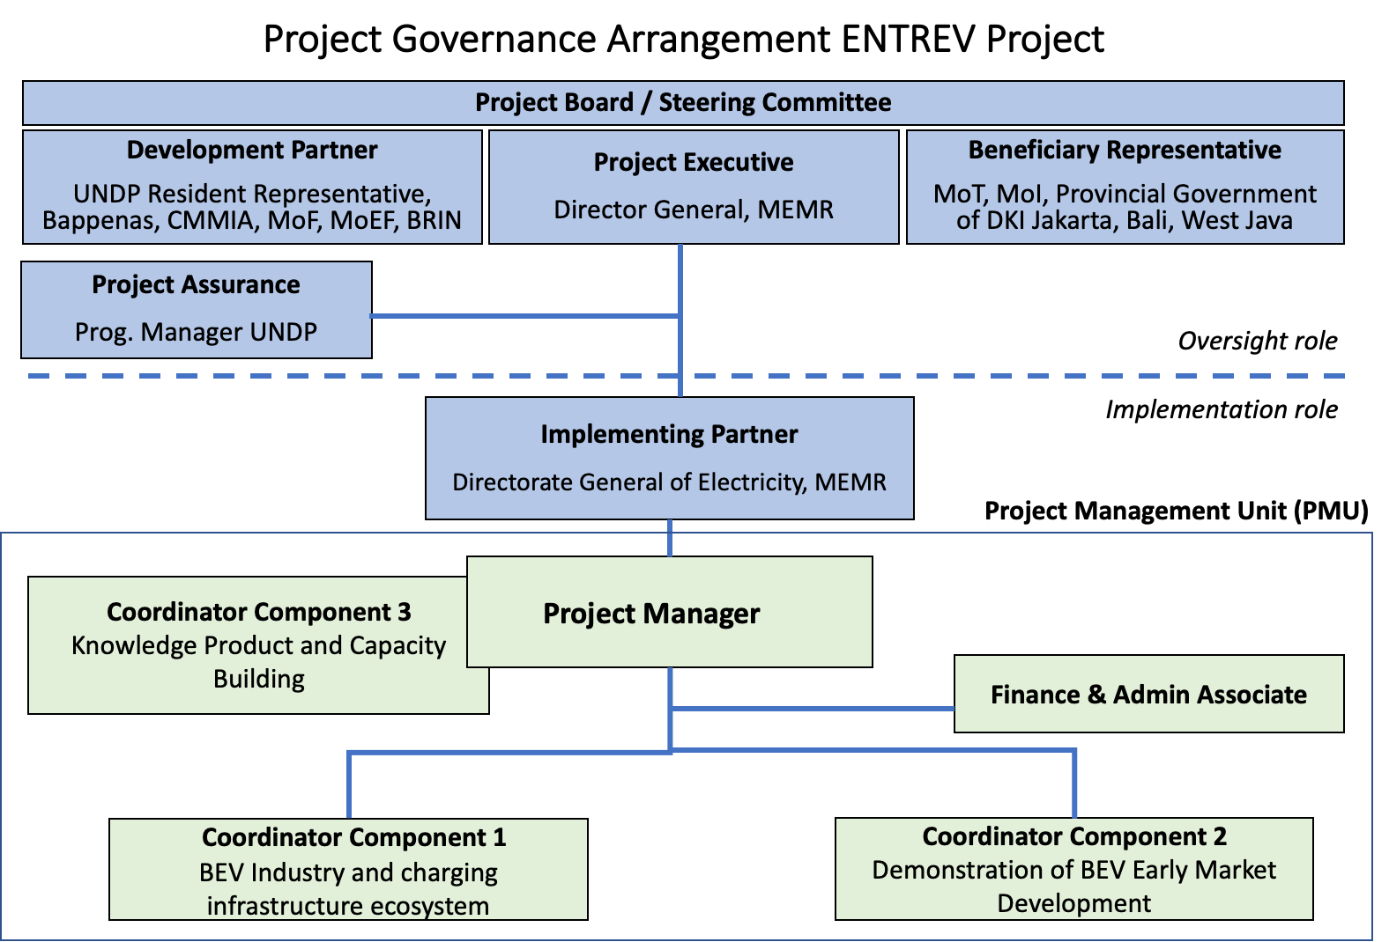

Second line of defense
- Regional Bureau oversees RR and Country Office compliance at portfolio level.
- BPPS NCE RTA oversees technical quality assurance and GEF compliance. BPPS NCE PTA oversees RTA function.
- UNDP GEF Executive Coordinator and Regional Bureau Deputy Director can revoke DOA/cancel/suspend project or provide enhanced oversight.

Section 3: Segregation of duties and firewalls vis-à-vis UNDP representation on the project board:

As noted in the Minimum Fiduciary Standards for GEF Partner Agencies, in cases where a GEF Partner Agency (i.e. UNDP) carries out both implementation oversight and execution of a project, the GEF Partner Agency (i.e. UNDP) must separate its project implementation oversight and execution duties, and describe in the relevant project document a: 1) Satisfactory institutional arrangement for the separation of implementation oversight and executing functions in different departments of the GEF Partner Agency; and 2) Clear lines of responsibility, reporting and accountability within the GEF Partner Agency between the project implementation oversight and execution functions.

In this case, UNDP is only performing an implementation oversight role in the project vis-à-vis our role in the project board and in the project assurance function and therefore a full separation of project implementation oversight and execution duties has been assured.

Section 4: Roles and Responsiblities of the Project Organization Structure:

- Project Board: All UNDP projects must be governed by a multi-stakeholder board or committee established to review performance based on monitoring and evaluation, and implementation issues to ensure quality delivery of results. The Project Board (also called the Project Steering Committee) is the most senior, dedicated oversight body for a project.

The two main (mandatory) roles of the project board are as follows:

- High-level oversight of the execution of the project by the Implementing Partner (as explained in the “Provide Oversight” section of the POPP). This is the primary function of the project board and includes annual (and as-needed) assessments of any major risks to the project, and decisions/agreements on any management actions or remedial measures to address them effectively. The Project Board reviews evidence of project performance based on monitoring, evaluation and reporting, including progress reports, evaluations, risk logs and the combined delivery report. The Project Board is responsible for taking corrective action as needed to ensure the project achieves the desired results.
- Approval of strategic project execution decisions of the Implementing Partner with a view to assess and manage risks, monitor and ensure the overall achievement of projected results and impacts and ensure long term sustainability of project execution decisions of the Implementing Partner (as explained in the “Manage Change” section of the POPP).

Requirements to serve on the Project Board:
- Agree to the Terms of Reference of the Board and the rules on protocols, quorum and minuting.
- Meet annually; at least once.
- Disclose any conflict of interest in performing the functions of a Project Board member and take all measures to avoid any real or perceived conflicts of interest. This disclosure must be documented and kept on record by UNDP.
- Discharge the functions of the Project Board in accordance with UNDP policies and procedures.
- Ensure highest levels of transparency and ensure Project Board meeting minutes are recorded and shared with project stakeholders.

Responsibilities of the Project Board:
- Consensus decision making:
  - The project board provides overall guidance and direction to the project, ensuring it remains within any specified constraints, and providing overall oversight of the project implementation.
  - Review project performance based on monitoring, evaluation and reporting, including progress reports, risk logs and the combined delivery report;
  - The project board is responsible for making management decisions by consensus.
  - In order to ensure UNDP’s ultimate accountability, Project Board decisions should be made in accordance with standards that shall ensure management for development results, best value money, fairness, integrity, transparency and effective international competition.
  - In case consensus cannot be reached within the Board, the UNDP representative on the board will mediate to find consensus and, if this cannot be found, will take the final decision to ensure project implementation is not unduly delayed.
- Oversee project execution:
  - Agree on project manager’s tolerances as required, within the parameters outlined in the project document, and provide direction and advice for exceptional situations when the project manager’s tolerances are exceeded.
- Appraise annual work plans prepared by the Implementing Partner for the Project; review combined delivery reports prior to certification by the implementing partner.
- Address any high-level project issues as raised by the project manager and project assurance;
- Advise on major and minor amendments to the project within the parameters set by UNDP and the donor and refer such proposed major and minor amendments to the UNDP BPPS Nature, Climate and Energy Executive Coordinator (and the GEF, as required by GEF policies);
- Provide high-level direction and recommendations to the project management unit to ensure that the agreed deliverables are produced satisfactorily and according to plans.
- Track and monitor co-financed activities and realisation of co-financing amounts of this project.
- Approve the Inception Report, GEF annual project implementation reports, mid-term review and terminal evaluation reports.
- Ensure commitment of human resources to support project implementation, arbitrating any issues within the project.
- Risk Management:
  - Provide guidance on evolving or materialized project risks and agree on possible mitigation and management actions to address specific risks.
  - Review and update the project risk register and associated management plans based on the information prepared by the Implementing Partner. This includes risks related that can be directly managed by this project, as well as contextual risks that may affect project delivery or continued UNDP compliance and reputation but are outside of the control of the project. For example, social and environmental risks associated with co-financed activities or activities taking place in the project’s area of influence that have implications for the project.
  - Address project-level grievances.
- Coordination:
  - Ensure coordination between various donor and government-funded projects and programmes.
  - Ensure coordination with various government agencies and their participation in project activities.

Composition of the Project Board: The composition of the Project Board must include individuals assigned to the following three roles:

- Project Executive: This is an individual who represents ownership of the project and chairs (or co-chairs) the Project Board. The Executive usually is the senior national counterpart for nationally implemented projects (typically from the same entity as the Implementing Partner), and it must be UNDP for projects that are direct implementation (DIM). In exceptional cases, two individuals from different entities can co-share this role and/or co-chair the Project Board. If the project executive co-chairs the project board with representatives of another category, it typically does so with a development partner representative. The Project Executive is: Director General, Ministry of Energy and Mineral Resources (MEMR).
- Beneficiary Representative(s): Individuals or groups representing the interests of those groups of stakeholders who will ultimately benefit from the project. Their primary function within the board is to ensure the realization of project results from the perspective of project beneficiaries. Often representatives from civil society, industry associations, or other government entities benefiting from the project can fulfil this role. There can be multiple beneficiary representatives in a Project Board. The Beneficiary representative (s) are: Ministry of Transport, Ministry of Industry, Provincial Governments of DKI Jakarta, Bali, and West Java.
- Development Partner(s): Individuals or groups representing the interests of the parties concerned that provide funding, strategic guidance and/or technical expertise to the project. The Development Partner(s) are: UNDP Resident Representative or alternate, National Development Planning Agency (Bappenas), Coordinating Ministry for Maritime and Investment (CMMIA), Ministry of Finance, Ministry of Environment and Forestry, and National Research and Innovation Agency (BRIN).

- Project Assurance: Project assurance is the responsibility of each project board member; however, UNDP has a distinct assurance role for all UNDP projects in carrying out objective and independent project oversight and monitoring functions. UNDP performs quality assurance and supports the Project Board (and Project Management Unit) by carrying out objective and independent project oversight and monitoring functions, including compliance with the risk management and social and environmental standards of UNDP. The Project Board cannot delegate any of its quality assurance responsibilities to the Project Manager. Project assurance is totally independent of project execution.

A designated representative of UNDP playing the project assurance role is expected to attend all board meetings and support board processes as a non-voting representative. It should be noted that while in certain cases UNDP’s project assurance role across the project may encompass activities happening at several levels (e.g. global, regional), at least one UNDP representative playing that function must, as part of their duties, specifically attend board meeting and provide board members with the required documentation required to perform their duties. The UNDP representative playing the main project assurance function is: Programme manager from Environment Unit, UNDP.

- Project Management – Execution of the Project: The Project Manager (PM) (also called project coordinator) is the senior most representative of the Project Management Unit (PMU) and is responsible for the overall day-to-day management of the project on behalf of the Implementing Partner, including the mobilization of all project inputs, supervision over project staff, responsible parties, consultants and sub-contractors. The project manager typically presents key deliverables and documents to the board for their review and approval, including progress reports, annual work plans, adjustments to tolerance levels and risk registers.

A designated representative of the PMU is expected to attend all board meetings and support board processes as a non-voting representative. The primary PMU representative attending board meetings is: Project Manager.

Financial Planning and Management

The total cost of the project is USD 33,290,247. This is financed through a GEF grant of USD 1,816,500 administered by UNDP and USD 31,473,747 in-kind and cash co-financing. UNDP, as the GEF Implementing Agency, is responsible for the oversight of the GEF resources and the cash co-financing transferred to the UNDP bank account only.

Co-financing: The actual realization of project co-financing amounts will be monitored by the UNDP Country Office and the PMU on an annual basis in the GEF PIF and will be reported to the GEF during the mid-term review and terminal evaluation process as follows:

Box 14 Co-financing and sources

Co-financing source | Co-financing type | Co-financing amount (USD)
MEMR, Directorate General of Electricity (DGE) | in-kind | 2,600,311
MEMR, Directorate-General of New and Renewable Energy and Energy Conservation (DG-NREEC) | in-kind | 4,384,000
 | public investment | 11,582,000
MEMR, Research and Development Center for Electricity, New and Renewable Energy, and Energy Conservation Technology (P3tek-KEBTKE) | in-kind | 50,000
 | grant | 407,436
West Java Provincial Government | in-kind | 222,000
West Java Provincial Government | grant | 1,378,000
Indonesia State Electricity Company (PLN) | in-kind | 200,000
Indonesia State Electricity Company (PLN) | public investment | 600,000
Grab | Equity Investment | 10,000,000
UNDP | grant | 50,000
TOTAL |  | 31,473,747
Note: The table includes co-financing (cash and in-kind) confirmed by means of a signed cooperation (co-financing) letter attached as Annex M

Budget Revision and Tolerance: As per UNDP POPP, the project board may agree with the project manager on a tolerance level for each detailed plan under the overall multi-year workplan. The agreed tolerance should be written in the project document or approved project board meeting minutes. It should normally not exceed 10 percent of the agreed annual budget at the activity level, but within the overall approved multi-year workplan at the activity level. Within the agreed tolerances, the project manager can operate without intervention from the project board. Restrictions apply as follows:

Should the following deviations occur, the Project Manager/IP through UNDP Country Office will seek the approval of the BPPS/NCE-VF team to ensure accurate reporting to the GEF. It is strongly encouraged to maintain the expenditures within the approved budget at the budgetary account and at the component level:

- Budget reallocations must prove that the suggested changes in the budget will not lead to material changes in the results to be achieved by the project. A strong justification is required and will be approved on an exceptional basis. Budget re-allocations among the components (including PMC) of the approved Total Budget and Work Plans (TBWP) that represent a value greater than 10% of the total GEF grant.
- Introduction of new outputs/activities (i.e., budget items) that were not part of the agreed project document and TBWP that represent a value greater than 5% of the total GEF grant. The new budget items must be eligible as per the GEF and UNDP policies.
- Project management cost (PMC): budget under PMC component is capped and cannot be increased

Project extensions: The UNDP Resident Representative and the UNDP-GEF Executive Coordinator must approve all project extension requests. Note that all extensions incur costs and the GEF project budget cannot be increased. A single extension may be granted on an exceptional basis and subject to the conditions and maximum durations set out in the UNDP POPP; the project management costs during the extension period must remain within the originally approved amount, and any increase in PMC costs will be covered by non-GEF resources; the additional UNDP oversight costs during the extension period must be covered by non-GEF resources, in accordance with UNDP’s guidance set out in UNDP POPP.

Audit: The project will be audited as per UNDP Financial Regulations and Rules and applicable audit policies. The audit cycle and process must be discussed during the Inception workshop. If the Implementing Partner is an UN Agency, the project will be audited according to that Agencies applicable audit policies. The costs for audit cannot be included under M&E component and budget and must be included under PMC.
Project Closure: Project closure will be conducted as per UNDP requirements outlined in the UNDP POPP. All costs incurred to close the project must be included in the project closure budget and reported as final project commitments presented to the Project Board during the final project review. The only costs a project may incur following the final project review are those included in the project closure budget.
Operational completion: The project will be operationally completed when the last UNDP-financed inputs have been provided and the related activities have been completed. This includes the final clearance of the Terminal Evaluation Report (that will be available in English) and the corresponding management response, and the end-of-project review Project Board meeting. Operational closure must happen at the end date calculated by the approved duration after the Project Document signature or at the revised operational closure date as approved in the project extension. Any expected activity after the operational date requires project extension approval. The Implementing Partner through a Project Board decision will notify the UNDP Country Office when operational closure has been completed. At this time, the relevant parties will have already agreed and confirmed in writing the arrangements for the disposal of any equipment that is still the property of UNDP.

Transfer or disposal of assets: In consultation with the Implementing Partner and other parties of the project, UNDP is responsible for deciding on the transfer or other disposal of assets. Transfer or disposal of assets is recommended to be reviewed and endorsed by the project board following UNDP rules and regulations. Assets may be transferred to the government for project activities managed by a national institution at any time during the life of a project. In all cases of transfer, a transfer document must be prepared and kept on file. The transfer should be done before the Project Management Unit completes their assignments.

Financial completion (closure):
The project will be financially closed when the following conditions have been met: a) the project is operationally completed or has been canceled; b) the Implementing Partner has reported all financial transactions to UNDP; c) UNDP has closed the accounts for the project; d) UNDP and the Implementing Partner have certified a final Combined Delivery Report (which serves as final budget revision).
The project will be financially completed within 6 months of operational closure or after the date of cancellation. Between operational and financial closure, the implementing partner will identify and settle all financial obligations and prepare a final expenditure report. The UNDP Country Office will send the final signed closure documents including confirmation of final cumulative expenditure and unspent balance to the BPPS/GEF Unit for confirmation before the project will be financially closed in Atlas by the UNDP Country Office.
Refund to GEF: Should a refund of unspent funds to the GEF be necessary, this will be managed directly by the BPPS/GEF Directorate in New York. No action is required by the UNDP Country Office on the actual refund from the UNDP project to the GEF Trustee

Total Budget and Work Plan

Total Budget and Work Plan
Atlas Award ID: | 00136657 | Atlas Output Project ID: | 00127474
Atlas Award Title: | Enhancing Readiness for Electric Vehicles (ENTREV Full Size)
Atlas Business Unit | IDN10
UNDP-GEF PIMS No. | 6333
Implementing Partner | Ministry of Energy and Mineral Resources

GEF Component/Atlas Activity | Responsible Party | Atlas Fund ID | Donor Name | Atlas Budgetary Account Code | ATLAS Budget Description | Amount 2023  (USD) | Amount 2024 (USD) | Amount 2025  (USD) | Amount 2026  (USD) | Total (USD) | Budget Note:
Outcome 1: BEV ecosystem (EV production and charging infrastructure) strengthened in response to national market uptake | MEMR | 62000 | GEF | 71200 | International consultants | 10,000 | 10,000 | 2,000 |  | 22,000 |  | 1
 |  |  |  | 71800 | Contractual Services-Imp Partn | 33,120 | 33,120 | 33,120 | 33,120 | 132,480 |  | 2
 |  |  |  | 71300 | Local consultants | 5,000 | 4,250 | 2,000 |  | 11,250 |  | 3
 |  |  |  | 71600 | Travel | 7,500 | 3,500 | 2,500 | 4,640 | 18,140 |  | 4
 |  |  |  | 72100 | Contractual Services-Companies | 10,000 | 30,000 | 30,000 |  | 70,000 |  | 6
 |  |  |  | 72200 | Equipment | 5,000 |  | - |  | 5,000 |  | 7
 |  |  |  | 74200 | Audio Visual&Print Prod Costs |  | 1,000 | 2,000 | 2,000 | 5,000 |  | 23
 |  |  |  | 75700 | Training, Workshops and Confer | 10,000 | 15,000 | 15,000 | 10,122 | 50,122 |  | 9
 |  |  |  |  | Total outcome 1 | 80,620 | 96,870 | 86,620 | 49,882 | 313,992
Outcome 2: Local policy and early market development promoted with demonstrated BEVs and charging infrastructure in selected regionst | MEMR | 62000 | GEF | 71200 | International consultants |  |  | - |  | 0
 |  |  |  | 71800 | Contractual Services-Imp Partn | 33,120 | 33,120 | 33,120 | 33,120 | 132,480 |  | 2
 |  |  |  | 71300 | Local consultants |  | 5,000 | 5,125 |  | 10,125 |  | 5
 |  |  |  | 71600 | Travel | 2,000 | 4,000 | 4,000 | 1,428 | 11,428 |  | 4
 |  |  |  | 72100 | Contractual Services-Companies |  | 88,000 | 88,000 | 88,000 | 264,000 |  | 8,12
 |  |  |  | 72200 | Equipment | 202,000 | 202,000 | - |  | 404,000 |  | 13
 |  |  |  | 74200 | Audio Visual&Print Prod Costs | 2,857 | 2,857 | 2,857 | 1,429 | 10,000 |  | 23
 |  |  |  | 75700 | Training, Workshops and Confer | 15,000 | 30,000 | 10,239 | 20,000 | 75,239 |  | 14
 |  |  |  |  | Total outcome | 254,977 | 364,977 | 143,341 | 143,977 | 907,272
Outcome 3: Capacity of key stakeholders built and knowledge shared on BEV to officials, manufacturers, and potential BEV buyers and safeguards development | MEMR | 62000 | GEF | 71200 | International Consultants |  | 13,750 | - |  | 13,750 |  | 15
 |  |  |  | 71800 | Contractual Services-Imp Partn | 32,766 | 32,766 | 32,766 | 32,766 | 131,064 |  | 2
 |  |  |  | 71300 | Local consultants |  | 4,500 | 4,500 |  | 9,000 |  | 16
 |  |  |  | 71600 | Travel | 10,672 | 21,344 |  | 21,344 | 53,360 |  | 4,17
 |  |  |  | 72100 | Contractual Services-Companies |  | 30,000 | 30,000 |  | 60,000 |  | 18
 |  |  |  | 72200 | Equipment | 1,001 | 3,000 | 999 |  | 5,000 |  | 19
 |  |  |  | 74100 | Professional services | 3,000 | 4,000 | 3,000 |  | 10,000 |  | 26
 |  |  |  | 74200 | Audio Visual&Print Prod Costs | 1,000 | 3,000 | 1,001 |  | 5,001 |  | 23
 |  |  |  | 75700 | Training, Workshops and Confer | 10,000 | 25,000 | 25,000 | 20,061 | 80,061 |  | 21
 |  |  |  |  | Total outcome | 58,439 | 137,360 | 97,266 | 74,171 | 367,236
Monitoring & evaluation | UNDP | 62000 | GEF | 71200 | International Consultants |  | 13,750 |  | 13,750 | 27,500 |  | 20
 |  |  |  | 71300 | Local consultants |  | 4,500 |  | 4,500 | 9,000 |  | 11
 |  |  |  | 71600 | Travel |  | 4,575 |  | 4,575 | 9,150 |  | 29
Monitoring & evaluation | MEMR | 6200 | GEF | 72100 | Contractual Services-Companies |  | 6,500 |  |  | 6,500 |  | 25
 |  |  |  | 75700 | Training, Workshops and Confer | 3,214 | 2,500 | 2,500 | 2,500 | 10,714 |  | 24
Monitoring & evaluation |  |  |  |  | Total outcome | 3,214 | 31,825 | 2,500 | 25,325 | 62,864
Project management | MEMR | 62000 | GEF | 71800 | Contractual Services-Imp Partn | 32,880 | 32,880 | 32,880 | 32,880 | 131,520 |  | 30
 | MEMR | 62000 | GEF | 71600 | Travel | 2,714 | 2,714 | 2,714 | 1,357 | 9,500 |  | 4
 | MEMR | 62000 | GEF | 72500 | Office supplies | 1,625 | 1,625 | 1,625 | 1,625 | 6,500 |  | 27
 | MEMR | 62000 | GEF | 75700 | Training, Workshops and Confer | 1,904 | 1,904 | 1,904 | 1,904 | 7,616 |  | 24
 | UNDP | 62000 | GEF | 74100 | Professional services | 2,500 | 2,500 | 2,500 | 2,500 | 10,000 |  | 22
 |  |  |  |  | Total PM | 41,623 | 41,623 | 41,623 | 40,266 | 165,136
 |  |  |  |  | PROJECT TOTAL | 438,873 | 672,655 | 371,350 | 333,621 | 1,816,500
Project management | UNDP | 04000 | UNDP | 71400 | Contractual Services - Individ | 12,500 | 12,500 | 12,500 | 12,500 | 50,000 |  | 28

Summary of Funds
 | Year 1 (USD) | Year 2 (USD) | Year 3 (USD) | Year 4 (USD) | Total (USD)
GEF funds | 438,873 | 672,655 | 371,350 | 333,621 | 1,816,500
UNDP funds | 12,500 | 12,500 | 12,500 | 12,500 | 50,000
Co-financing (government cash, in-kind) | 6,691,984 | 9,019,890 | 9,019,890 | 6,691,984 | 31,423,747
TOTAL | 7,143,357 | 9,705,045 | 9,403,740 | 7,038,105 | 33,290,247

BUDGET NOTES

Budget note no. | Description
1 | International consultancy on electric vehicle technology and infrastructure to provide advice on work planning, participate in inception phase and provide advice on foreign investment in local manufacturing (USD 22,000, for 8 weeks)
2 | Contractual Services IP: Allocation under technical components for A) National Project Manager USD 163,064 (183 weeks @ 42,693/yr), technical-oriented activities and services, B) USD 232,960 for two technical specialists (for 4 years assignment @ USD 29,120/yr), total: USD 396,024
3 | Local consultancy on A) business and financing models for charging infrastructure (USD 7,875, 4 weeks),) and EV local manufacturing (USD 3,375), total USD11,250
4 | Travel of PMU staffs and hired local consultants for conducting project activities under components 1 (USD18,140), component 2 (USD 11,428), component 3 (partial USD18,360) and Project Management (USD 9,500). Total: USD 57,428; not including EV global program-related travel (see note 17).
5 | Local consultancy – local policies for BEV and infrastructure (USD 10,125) – Comp. 2
6 | Company contracts for implementation of study/assessment/survey under Comp.1 (USD 70,000)
7 | Office equipment for Component 1 (USD 5,000), e.g., computer, printer, modem, etc.
8 | Company contract on national and local EV demand stimulation, financing schemes and BEV incentives under Comp.2 (USD 25,000)
9 | Organization and delivery of workshops/seminars related to activities of Component 1 (at least 9 workshop, USD4,500/workshop plus some related cost e.g interpreters, and printed materials). Total USD 50,122
11 | Local Consultant for MTR and TE (USD 9,000)
12 | Company contract for monitoring and testing of pilot EC/BSS under Comp.2 (USD 239,000)
13 | Office and small IT equipment for Component 2 (USD 10,000) and hardware for demo BSS and EVCS for pilot regions (USD 394,000) as detailed in Annex G
14 | Organization and delivery of workshops/seminars related to activities of Component 2 (estimated 14 workshops x USD4,500/workshop) plus related cost e.g. interpreters, and printed materials), total USD75,239.
15 | International consultancy on battery recycling and international experiences in safe disposal and part of the budget for social-environmental assessments (activity 3.3), total USD 13,750
16 | Local consultancy on gender and social issues (USD 4,500; gender plans and SESP) and for replication and scale-up (USD 4,500) – Comp.3 and social-environmental assessments (activity 3.3), total USD 9,000
17 | USD 35,000 for travel attending events in the framework of Global e-Mobility program
18 | Company contracts for A) capacity building needs assessment and capacity building plan (USD 20,000); B) for design of media campaign and follow-up (USD 25,000); C) battery disposal and recycling (USD 15,000) included social-environmental assessments (activity 3.3), total USD60,000
19 | Office equipment for Component 3, e.g., computer, printer, modem, etc.
20 | International consultants for MTR and TE (USD 27,500).
21 | Organization and delivery of workshops/seminars related to activities of Component 3 (about 2 training at USD 15,000 per training and 9 workshops, USD 4,500/workshop and part of the budget for social-environmental assessments (activity 3.3) plus related cost e.g. interpreters, and printed materials)
22 | Professional services for project auditing
23 | Small equipment (camera, video) for promotional activities and publication materials, total USD20,001
24 | Training, workshops, conference, including project board meeting.
25 | Contract for synthesis M&E indicators
26 | Professional Services for translation, interpretation (USD 10,000)
27 | Office supplies, stationaries for Project Management (USD 6,500).
28 | Support (not oversight) by national project staff, coordination workshops with stakeholders (in 2022)
29 | Travel of M&E consultant to pilot sites (USD 9,150)
30 | Contractual Services IP: Allocation under Project Management Cost (PMC) for Project Management Unit staffs (A) USD 71,156 for Project Finance Assistant (192 weeks over 4 years @ USD 17,789/yr), (B) USD 52,656 for Project Admin Assistant (192 weeks over 4 years @ USD 13,164/yr); and (C) USD 7,708 for National Project Manager (9 weeks @ 42,693/yr) for administrative-managerial tasks. total: USD 131,520

Legal context

The project document shall be the instrument envisaged and defined in the Supplemental Provisions to the Project Document, attached hereto and forming an integral part hereof, as “the Project Document”.

This project will be implemented by the Ministry of Energy and Mineral Resources (“Implementing Partner”) in accordance with its financial regulations, rules, practices, and procedures only to the extent that they do not contravene the principles of the Financial Regulations and Rules of UNDP. Where the financial governance of an Implementing Partner does not provide the required guidance to ensure best value for money, fairness, integrity, transparency, and effective international competition, the financial governance of UNDP shall apply.

The designations employed and the presentation of material on this map do not imply the expression of any opinion whatsoever on the part of the Secretariat of the United Nations or UNDP concerning the legal status of any country, territory, city or area or its authorities, or concerning the delimitation of its frontiers or boundaries.

Risk management

- Consistent with the Article III of the Supplemental Provisions to the Project Document, the responsibility for the safety and security of the Implementing Partner and its personnel and property, and of UNDP’s property in the Implementing Partner’s custody, rests with the Implementing Partner. To this end, the Implementing Partner shall:
- put in place an appropriate security plan and maintain the security plan, taking into account the security situation in the country where the project is being carried;
- assume all risks and liabilities related to the Implementing Partner’s security and the full implementation of the security plan.
- UNDP reserves the right to verify whether such a plan is in place and to suggest modifications to the plan when necessary. Failure to maintain and implement an appropriate security plan as required hereunder shall be deemed a breach of the Implementing Partner’s obligations under this Project Document.
- The Implementing Partner agrees to undertake all reasonable efforts to ensure that no UNDP funds received pursuant to the Project Document are used to provide support to individuals or entities associated with terrorism and that the recipients of any amounts provided by UNDP hereunder do not appear on the list maintained by the Security Council Committee established pursuant to resolution 1267 (1999). The list can be accessed via http://www.un.org/sc/committees/1267/aq_sanctions_list.shtml.
- The Implementing Partner acknowledges and agrees that UNDP will not tolerate sexual harassment and sexual exploitation and abuse of anyone by the Implementing Partner, and each of its responsible parties, their respective sub-recipients and other entities involved in Project implementation, either as contractors or subcontractors and their personnel, and any individuals performing services for them under the Project Document.
(a) In the implementation of the activities under this Project Document, the Implementing Partner, and each of its sub-parties referred to above, shall comply with the standards of conduct set forth in the Secretary General’s Bulletin ST/SGB/2003/13 of 9 October 2003, concerning “Special measures for protection from sexual exploitation and sexual abuse” (“SEA”).
(b) Moreover, and without limitation to the application of other regulations, rules, policies, and procedures bearing upon the performance of the activities under this Project Document, in the implementation of activities, the Implementing Partner, and each of its sub-parties referred to above, shall not engage in any form of sexual harassment (“SH”). SH is defined as any unwelcome conduct of a sexual nature that might reasonably be expected or be perceived to cause offense or humiliation, when such conduct interferes with work, is made a condition of employment, or creates an intimidating, hostile, or offensive work environment.
- a) In the performance of the activities under this Project Document, the Implementing Partner shall (with respect to its own activities), and shall require from its sub-parties referred to in paragraph 4 (with respect to their activities) that they, have minimum standards and procedures in place, or a plan to develop and/or improve such standards and procedures in order to be able to take effective preventive and investigative action. These should include: policies on sexual harassment and sexual exploitation and abuse; policies on whistleblowing/protection against retaliation; and complaints, disciplinary and investigative mechanisms. In line with this, the Implementing Partner will and will require that such sub-parties will take all appropriate measures to:
  - Prevent its employees, agents, or any other persons engaged to perform any services under this Project Document, from engaging in SH or SEA;
  - Offer employees and associated personnel training on prevention and response to SH and SEA, where the Implementing Partner and its sub-parties referred to in paragraph 4 have not put in place its own training regarding the prevention of SH and SEA, the Implementing Partner and its sub-parties may use the training material available at UNDP;
  - Report and monitor allegations of SH and SEA of which the Implementing Partner and its sub-parties referred to in paragraph 4 have been informed or have otherwise become aware, and status thereof;
  - Refer victims/survivors of SH and SEA to safe and confidential victim assistance; and
  - Promptly and confidentially record and investigate any allegations credible enough to warrant an investigation of SH or SEA. The Implementing Partner shall advise UNDP of any such allegations received and investigations being conducted by itself or any of its sub-parties referred to in paragraph 4 with respect to their activities under the Project Document, and shall keep UNDP informed during the investigation by it or any of such sub-parties, to the extent that such notification (i) does not jeopardize the conduct of the investigation, including but not limited to the safety or security of persons, and/or (ii) is not in contravention of any laws applicable to it. Following the investigation, the Implementing Partner shall advise UNDP of any actions taken by it or any of the other entities further to the investigation.
- The Implementing Partner shall establish that it has complied with the foregoing, to the satisfaction of UNDP, when requested by UNDP or any party acting on its behalf to provide such confirmation. Failure of the Implementing Partner, and each of its sub-parties referred to in paragraph 4, to comply with the foregoing, as determined by UNDP, shall be considered grounds for suspension or termination of the Project.
- Social and environmental sustainability will be enhanced through the application of the UNDP Social and Environmental Standards (http://www.undp.org/ses) and related Accountability Mechanism (http://www.undp.org/secu-srm).
- The Implementing Partner shall: (a) conduct project and program-related activities in a manner consistent with the UNDP Social and Environmental Standards, (b) implement any management or mitigation plan prepared for the project or program to comply with such standards, and (c) engage in a constructive and timely manner to address any concerns and complaints raised through the Accountability Mechanism. UNDP will seek to ensure that communities and other project stakeholders are informed of and have access to the Accountability Mechanism.
- All signatories to the Project Document shall cooperate in good faith with any exercise to evaluate any program or project-related commitments or compliance with the UNDP Social and Environmental Standards. This includes providing access to project sites, relevant personnel, information, and documentation.
- The Implementing Partner will take appropriate steps to prevent misuse of funds, fraud or corruption, by its officials, consultants, responsible parties, subcontractors, and sub-recipients in implementing the project or using UNDP funds. The Implementing Partner will ensure that its financial management, anti-corruption, and anti-fraud policies are in place and enforced for all funding received from or through UNDP.

- The requirements of the following documents, then in force at the time of signature of the Project Document, apply to the Implementing Partner: (a) UNDP Policy on Fraud and other Corrupt Practices and (b) UNDP Office of Audit and Investigations Investigation Guidelines. The Implementing Partner agrees to the requirements of the above documents, which are an integral part of this Project Document and are available online at www.undp.org.
- In the event that an investigation is required, UNDP has the obligation to conduct investigations relating to any aspect of UNDP projects and programs in accordance with UNDP’s regulations, rules, policies, and procedures. The Implementing Partner shall provide its full cooperation, including making available personnel, relevant documentation, and granting access to the Implementing Partner’s (and its consultants’, responsible parties’, subcontractors’ and sub-recipients’) premises, for such purposes at reasonable times and on reasonable conditions as may be required for the purpose of an investigation. Should there be a limitation in meeting this obligation, UNDP shall consult with the Implementing Partner to find a solution.
- The signatories to this Project Document will promptly inform one another in case of any incidence of inappropriate use of funds, or credible allegation of fraud or corruption with due confidentiality.
Where the Implementing Partner becomes aware that a UNDP project or activity, in whole or in part, is the focus of investigation for alleged fraud/corruption, the Implementing Partner will inform the UNDP Resident Representative/Head of Office, who will promptly inform UNDP’s Office of Audit and Investigations (OAI). The Implementing Partner shall provide regular updates to the head of UNDP in the country and OAI of the status of, and actions relating to, such investigation.
- UNDP shall be entitled to a refund from the Implementing Partner of any funds provided that have been used inappropriately, including through fraud or corruption, or otherwise paid other than in accordance with the terms and conditions of the Project Document. Such amount may be deducted by UNDP from any payment due to the Implementing Partner under this or any other agreement. Recovery of such amount by UNDP shall not diminish or curtail the Implementing Partner’s obligations under this Project Document.
Where such funds have not been refunded to UNDP, the Implementing Partner agrees that donors to UNDP (including the Government) whose funding is the source, in whole or in part, of the funds for the activities under this Project Document, may seek recourse to the Implementing Partner for the recovery of any funds determined by UNDP to have been used inappropriately, including through fraud or corruption, or otherwise paid other than in accordance with the terms and conditions of the Project Document.
Note: The term “Project Document” as used in this clause shall be deemed to include any relevant subsidiary agreement further to the Project Document, including those with responsible parties, subcontractors, and sub-recipients.
- Each contract issued by the Implementing Partner in connection with this Project Document shall include a provision representing that no fees, gratuities, rebates, gifts, commissions or other payments, other than those shown in the proposal, have been given, received, or promised in connection with the selection process or contract execution, and that the recipient of funds from the Implementing Partner shall cooperate with any and all investigations and post-payment audits.
- Should UNDP refer to the relevant national authorities for appropriate legal action any alleged wrongdoing relating to the project, the Government will ensure that the relevant national authorities shall actively investigate the same and take appropriate legal action against all individuals found to have participated in the wrongdoing, recover and return any recovered funds to UNDP.
- The Implementing Partner shall ensure that all of its obligations set forth under this section entitled “Risk Management” are passed on to each responsible party, subcontractor, and sub-recipient and that all the clauses under this section entitled “Risk Management Standard Clauses” are included, mutatis mutandis, in all sub-contracts or sub-agreements entered into further to this Project Document.

Mandatory ANNEXES

- Project map
- Multi-year work plan
- Monitoring plan
- UNDP Risk register
- Additional budget information
- Baseline analysis
- GEF Core Indicators; Demonstration and GHG emission reduction
- Overview of project staff and technical consultancies
- Gender analysis and action plan
- Stakeholder engagement plan
- UNDP Social and environmental safeguards planning (SESP)
- Procurement plan
- Agreements (co-financing letters)
- GEF 7 Taxonomy
- Environmental abd Social Management Framework (ESMF)
- HACT Micro Assessment
- GEF Budget Template
- Project Quality Assurance (PQA) Design and Appraisal Stage

- Project map

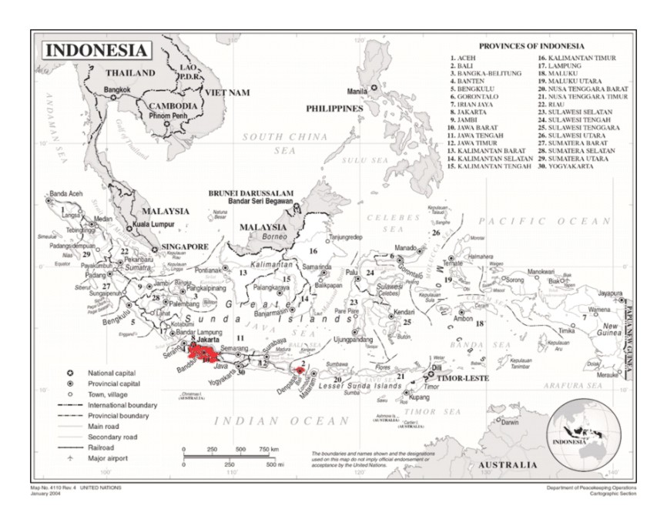
Note: project pilot regions (DKI Jakarta, West Java, Bali) where demonstration projects will be implemented are indicated in red

- Multi-Year Work Plan

Output/activity per outome | Yr1 |  |  |  | Yr2 |  |  |  | Yr3 |  |  |  | Yr4
Output/activity per outome | Q1 | Q2 | Q3 | Q4 | Q1 | Q2 | Q3 | Q4 | Q1 | Q2 | Q3 | Q4 | Q1 | Q2 | Q3 | Q4
Component 1 Institutional framework and strategy for battery electric vehicle industry and charging infrastructure
Output 1.1 Business models and financing option elaborated and implemented for charging stations (SPBKLU) battery swap stations (SPKLU)
1.1.1 Develop and promote business models for charging stations, including financial models
1.1.2 Conduct assessment on business models for charging stations using renewable energy sources
1.1.3 Develop and promote business models for battery swap stations
Output 1.2 Recommendation on national policies and standards for battery swap stations (SPKLU) and charging stations (SPBKLU) improved and implemented
1.2.1 Develop and adopt uniform standards for swappable e-motor scooter batteries and 4-wheeler batteries
1.2.2 Review, observe and provide feedback to battery swap policy and home charging
1.2.3 Adjust MoI EV Roadmap and PLN charging stations Roadmap
Output 1.3 Program to promote domestic manufacturing of BEV and their components adopted and implemented
1.3.1 Policies that directly incentivize domestic manufacturing of all-electric BEVs & components
1.3.2 Liaison and exchange facilitated between manufacturers, universities/institutes, and investors/financier
Output 1.4 Options assessed for purchase and trade-in, preferential loans, and second-hand market for four and two-wheelers
1.4.1 Carry out analysis on battery life and conduct foundation setting work for the development of BEV market
1.4.2 Carry out TCO (total cost of ownership) calculations for e motor-scooters and BEV cars
1.4.3 Options assessed for purchase and trade-in, preferential loans, and market for four and two-wheelers
Component 2 Demonstration of early BEV market development
Output 2.1 Recommendations developed for local policies and regulations developed to stimulate BEV infrastructure investment and purchase and use of BEVs
2.1.1 Prepare, advocate planning and policies to promote investment in BEV infrastructure
2.1.2 Prepare and advocate local policies in promoting BEV purchase and use
Output 2.2 Demonstration of BEV charging stations and battery swap stations in pilot regions
2.2.1 Charging stations for BEV and set up e battery swap for e-motor scooter fleets of government at selected sites
2.2.2 Develop partnerships with private-sector entities and install charging stations for BEV and set up battery swap
2.2.3 Support demonstration of the conversion of 2-wheeled ICE to BEV (P3TEK)
2.2.4 Carry out monitoring of Jakarta, Bali, and West Java demos and disseminate results
Output 2.3 Financing schemes set up for BEV two and four-wheelers utilization in pilot regions
2.3.1 Assess the benefit of preferential loans to purchase BEV cars and e-motor scooters
2.3.2 Propose financing schemes and facilitate matchmaking between financiers
Output 2.4 Local clearinghouses and programs implemented to promote the purchase and use of BEV two and four-wheelers
2.4.1 Develop at least one clearinghouse (info exchange and provision platforms) in each pilot region
Component 3 Knowledge products and capacity building for scaling up and environmental-friendly battery use
Output 3.1 Capacity is built in the BEV industry (repair-shops) and research institute
3.1.1. Capacity development in vehicle repair shop technician on BEV and conversion from ICE to BEV (e scooters)
3.1.2 Develop BEV related curriculum and courses for high schools and universities
Output 3.2 Promotional activities conducted, results of demonstration in pilot locations disseminated and knowledge exchange between countries on e-mobility facilitated
3.2.1 BEV knowledge exchange through UNEP-led Global Program on E-mobility
3.2.2 Create a program of promotion of the use of BEV in various media
3.2.3 Identify six priority cities for replication for additional scale-up and conduct outreach
Output 3.3 Programs to address social, gender, environmental, and safety employment issues related to BEV adoption are developed (including battery use and disposal)
3.3.1 Mapping of the ICEV industry and components and analysis of social and environmental impacts
3.3.2 Establishing guidelines on BEV safety and water (flooding) protection
3.3.3 Develop and implement a program for the retiring of BEV batteries and optimizing retired battery value
Project inception, Monitoring and evaluation

- Monitoring Plan

Monitoring | Indicators and description | Targets and description | Data source and collection; frequency*) | Means of verification | Assumptions
Project Objective:  To support the Government of Indonesia and key stakeholders in policy, institutional & technical readiness to transition towards electric mobility and to demonstrate innovative business models in the transport sector that will lead to GHGs emissions reduction | - Lifetime direct GHG emissions avoided as a result of the project-facilitated increase in the use of BEVs and indirect emission [GEF Core Indicator] | Baseline: Zero by definition  MT: It is assumed that by mid-term the ENTREV-supported pilots are installed and operating, so direct emission reduction is the same as at EoP. Secondary: 1/3 of EoP secondary ER  EoP: Direct emission reduction (ER) of 14.3 ktCO₂ (see Box 36 and .Box 37);  Secondary direct ER 459.4 ktCO2 (Box 41)  Indirect emission reduction: 6,123.1 ktCO2 (Box 42) | Source: progress reports and monitoring of demos (output 2.2); stakeholder and MEMR reports on INV co-financing in BEV, CS and BSS  Frequency:  Detailed assessment as input for MTR, TE and final project reports  Responsibility for data collection: PMU | Project progress reports;  Indicator reporting; MTR and TE reports (M&E);  Annual Implementation reviews (PIR) | Demo projects (BSS and CS) are realized as planned in the three pilot regions.  Secondary ER: INV co-financed in CS/BSS and/or BEV is realized as estimated (in Annex G).
 | - Volume of investment mobilized and leveraged by GEF for low GHG development (co-financing INV) | Baseline: Confirmed co-financing for INV of USD 8.91 million  MT: ¾ of confirmed co-financing is realized (USD 10 million)  EoP: Investment mobilized is at least USD 13.4 million (Note: this is part of confirmed cash and in-kind co-financing of USD 18.8 million) |  |  | Secondary ER: INV co-financed in CS/BSS and/or BEV is realized as estimated (in Annex G)
 | - Number of direct project beneficiaries disaggregated by gender (individual people) [GEF core indicator] | Baseline: N/A  MT: About ¾ of EoP target (241,000 of which 66,000 women)  EoP: Total of 321,612 (of which 87,851 women):  318,186 passengers, 3,246 BSS and CS staff, 180 trained technicians  (see Annex G for calculations; not Including the beneficiaries, mentioned in Indicator 10) | Source: progress reports and monitoring of demos (output 2.2);  Frequency: quarterly and annual project reporting  Responsibility for data collection: PMU | Monitoring reports of demo projects (Output 2.2). Report on socio-econ impacts (Output 3.3). Workshop/training proceedings | Demo projects (BSS and CS) are realized as planned in the three pilot regions. Training and ToT takes places as planned. Con
Outcome 1  BEV ecosystem (EV production and charging infrastructure) strengthened in response to national market uptake | 4) Status and number of updated plans and revised regulations enabling and incentivizing investment in BEV and support infrastructure and on BEV manufacturing | Baseline: PR MEMR 13/020 on the Provision of Electric Charging Station for Electric Vehicle; and MoI Electric vehicle Roadmap Minister of Transportation Regulation No 65/2020 on Conversion or Modification of Internal Combustion Engine Motorbike into Battery-based Electric Motorbike  MT: MoI EV Roadmap an updated using improved statistics)  EoP: Updated MoI EV Roadmap and PLN EVCS Roadmaps; Updated additional incentives for EVCS and BEV use/purchase (as needed) | Official national and local government publications  Frequency: irregular  Responsibility for data collection: Coordinator Component 1 | Government publications; press releases; articles in press and on internet;  Discussion with stakeholders | Sufficient political support to be able to pass proposed (revised, updated or new) regulation by national and local; government entities involved
 | 5) BEV and BSS infrastructure operated by public and private entities (as facilitated by national policies and standards for battery swap stations and charging stations) | Baseline:122 EVCS installed by April 2021 at 83 locations (info: ESDM, 2021); 9 BSS installed (by Grab, Kymco, Ezyfast, Oyiko): 6 in Jakarta South and 3 in Tangeran  MT: 1200 EV CS; 4,000 BSS  EoP: 3,850 by 2025 (EVCS roadmap, PLN); 14,000 BSS (by 2025; SPBLKU Roadmap) | Technical project and progress reports (Component 1); data from statistics agency, MEMR, PLN  Frequency:  collected on as-needed basis for project assessment and EV and CS Roadmap updates; inputs into MTR and TE reports  Responsibility for data collection: Coordinator Component 1 | Project reports; statistics and government reports; private sector-supplied info; Discussion with stakeholders | Data can be made available as necessary by national and local government entities (and without confidentiality issues by private sector) and in a timely fashion for the various assessments
Outcome 2 | 6) Number and type of charging stations (EVCS) and battery swap stations (BSS) established (linked with ENTREV) | Baseline: Jakarta (PT Pertamina installed a charging station at Fatmawati Street in South Jakarta; DKI Jakarta Government installed charging station at CNG station in Perintis Kemerdekaan street; Ezyfast installed battery swap station in MEMR office); PLN has installed charging station in Bluebird pool and Soekarno – Hatta airport  MT: two EVCS and BSS initiated with GEF funding  EoP: EVCS: 2 (demo) and BSS: 36 (demo) (with GEF INV support) | Demo monitoring report (activity 2.2.4); technical reports; project progress reports (incl. TE and MTR)  Frequency:  quarterly and annual reports  Responsibility for data collection: Coordinator Component 2 | Project monitoring reports; Discussion with stakeholders; official publications, press and internet articles; Discussion with stakeholders | There are no changes in local government commitments and private companies to purchase/use of BEV and installation of charging (CS-BSS) infrastructure  Willingness to share data and information with ENTREV by pilot/demo authorities and government and private sector entities in general
Outcome 2 | 7) Number of supportive regulation and incentive schemes established by local governments | Baseline: Jakarta (Governor Regulation No 3/2020 on Tax Incentive Policy on Vehicle Ownership Transfer Fee (BBN-KB) for Battery-Based Electric Motorized Vehicles for Road Transportation); Bali: Governor regulation no 48/2019 on concerning the Use of Battery-Based Electric Motor Vehicles  W-Java: Target to increase the use of BEV by 5% of the total vehicle population in 2025  MT: Report with assessment of EV-related policy issues and options assessed, including incentive and financial support schemes (as appropriate)  EoP: Three provincial EV plans formulated for approval by the Governor (in the provinces where the pilot areas/cities, on the mid-term assessment report) | Official local government publications; project progress reports; Local info clearinghouse  Frequency:  quarterly and annual reports  Responsibility for data collection: Coordinator Component 2 | Official statements and publications; local press and articles; stakeholder discussions
Outcome 2 | 8) Number of EV clearing houses in each region | Baseline: zero per definition  MT: Two clearinghouses setup and operational (W-Java and Dk Jakarta)  EoP: Three clearinghouses set up (one in each pilot region, DK Jakarta, West-Java and Bali) | Entity that implements the info clearinghouse  Local press statements  Frequency:  Quarterly and annual reports  Responsibility for data collection: Coordinator Component 2 | Clearinghouse business plan; Annual reports  ENTREV progress reports; stakeholder discussion | Interest by relevant authority to set up the clearinghouse
Outcome 3 | 9) Number of people (disaggregated by gender) sensitized by the awareness campaigns through different media and implementation of project activities; | Baseline: zero per definition  MT: 50,000 people (40% women)  EoP: 100,000 people (40% women) | ENTREV reporting on public awareness campaign in progress reports  Frequency: duration of the campaign  Responsibility for data collection: Coordinator Component 3/Project manager. | Campaign materials; press releases; articles  surveys | Campaign is well-designed to attract the general public to the message on BEV (CS availability, TCO, price environmental, etc.)
Outcome 3 | 10) Introduced ToT course (including training materials) in TVET institutes on the EV repairing, accessories service, and charging infrastructures and number of certified trainers | Baseline: No special EV ToT course available  MT: ToT courses available at 3 TVET courses available at 3 institutions  EoP: 60 people trained (20 in training organized by Project in pilot city in each focus region of Comp 2) plus 2*60 trained in TVET courses – 20% women | Training institutes and reports  Frequency: duration and timing of ToT course to be determined  Responsibility for data collection: Coordinator Component 3/Project manager. | Stakeholder discussions and beneficiary surveys;  Course materials  ENTREV reporting | Willingness of institutes to set up such a ToT course and interest in the course by prospective students (incl. women)
Outcome 3 | 11) Number of cities in which replication of project demos occurs (including possible phase 2 scale up in Jakarta and Bali and West Java) | Baseline: 0  MT: 3 (cities indicating interest in sacling up)  EoP: 6 (with plans for scaling up, including demos and/or city-level EV plans) | ENTREV reports; city official statements and reports  Responsibility for data collection: Coordinator Component 3/Project manager. | Discussion with city officials; ENTREV staff and progress reports | Willingness of six cities expressed to start demo/incentives/planning for BEV and needed infrastructure
Outcome 3 | 12) Status of the guidelines on the safe and environment-friendly use of batteries (in EVs) developed and for the producers and consumer | Baseline: No regulation on end-of-life battery recovery or disposal  MT: Guideline drafted  EoP: One set of uidelines adopted by the responsible line ministry | ENTREV-commissioned report; official statistics; government and NGO reports  Frequency: two (technical reports) on a) social impacts and gender, b) battery recycling and environmentally safe handling and disposal  Responsibility for data collection: Coordinator Component 3/Project Manager | Government and NGO reports; articles by research institutes and on internet | Willingness of battery manufacturers, sales outlets and EV repair facilities to provide info on batteries and interest in adopting measures for improvement
Outcome 3 | 13) Lessons learned from the Indonesia project that are shared with the Global Programme | Baseline: Zero per definition  MT: Outline of report on lessons learned developed  EoP: 1 final report on lessons learned from Indonesia EV development | Website platform  ENTREV project progress reports  UNEP Global reports and puclications  Frequency: continuous,  Responsibility for data collection: Coordinator Component 3/Project Manager | Info (report) available on ENTEV  UNEP website  workshop proceedings | Responsible entity is willing and capable of compiling and synthesizing lessons learnt
Notes: *) Gender-sensitive indicators. For additional gender-specific indicators, see Annex I. The assumption is that gender mainstreaming is not hindered by resistance from local and national stakeholders.

- UndP RISK REGISTER

Description | Risk Category | Rating (Impact &  Likelihood) | Risk Treatment / Management Measures | Risk Owner
1. Potential for safety risks related to the operation of unregulated Electric Vehicle Charging Stations (EVCS) | Social & environment  (see Annex K) | I=2  L=1  Low | This risk of unregulated EVCSs is low. First, state utilities like PLN will run charging stations and will comply with government instructions on safety. Second, the risk will be managed through the design of the project, with environmental and social management measures integrated into the project’s relevant outputs. Additional site-specific management measures will be considered, as needed, as specified in the Environmental and Social Management Framework (to be developed prior to project approval). | MEMR, PLN, local government
2. Inappropriate location of Electric Vehicle Charging Stations (EVCS) could be exposed to impacts of adverse climate change and therefore harmful to people and/or the environment. | Social & environment  (see Annex K) | I = 3  L = 3  Moderate | The demo/pilot activities will be designed to require Environmental and Social Impact Assessments. | MEMR, PLN, local government
3. Risk of limited participation of women in the program | Social & environment  (see Annex K) | I=3  L=3  Moderate | Gender analysis has been undertaken and a Gender Action Plan prepared with the aim to involve both women and men in the various activities, without discrimination. However, while the project will endeavor to encourage key players in the urban transport services to incorporate women either as operators, entrepreneurs, etc., the duration of the project may not be long enough to break the socio-cultural dynamics that impede women from participating in the sector. | MEMR  UNDP
4. Potential direct and indirect environmental impacts from battery production and disposal.  Potential direct and indirect environmental impacts from battery production and disposal. This includes direct environmental risk related to handling batteries that have reached their end-of-life. Also, indirect risk of increased impacts related to the resource extraction needed for the batteries (however: the Project will not directly be involved in battery manufacturing) | Social & environment  (see Annex K) | I = 4  L = 3  Substantial | During the project, an assessment of existing standards, laws, and regulations will be undertaken in order to determine the gaps that the project will fill in terms of delivering draft regulations and standards to govern the disposal of batteries and waste from battery manufacturing processes. These will be an important step towards strengthening environmental safeguards. During the Project, the option of “extending” the life of the batteries will be examined for possible inclusion in the aforementioned standards and regulations. The project will include the development of policy guidelines/regulations for the collection, safe disposal/waste management, and recycling of the batteries (see Output 3.3.). A strategic assessment of social and environmental impacts of BEV in Indonesia will be conducted, looking at the life-cycle of batteries (including resource extraction). This strategic assessment will inform relevant decision-making, policies, guidelines, e.g. through assessment of technical and economic aspects of retired BEV battery use including the potential impact of discarded batteries (if not reused/ recycled), re-manufacturing, secondary use of retired BEV batteries (such as for off-grid power), and recycling after the secondary use life is exhausted as well as human rights, environmental issues related to the extraction of raw materials for the batteries. Requirements for the strategic environmental and social assessment will be clarified further in the project ESMF and aligned with UNDP’s SES and related guidance. | MEMR  MoI  MoEF
5. Potential occupational health and safety risks associated with electric vehicle repair and decommissioning of battery banks and/or vehicles. | Social & environment  (see Annex K) | I = 4  L = 2  Moderate | While project labour will not be involved in EV repair or decommissioning, this is identified as an indirect risk of the project. Therefore, as part of project implementation, a capacity assessment of the existing stock of automotive mechanical and electrical technicians will be undertaken in order to incorporate in the proposed project a component for building the capacity of technicians to enable them to handle the repair and decommissioning of electric vehicles. In addition, the project will be designed to include a component for public awareness which will be useful to impress on the general public who will own electric vehicles, the need for taking them to repair shops that have the appropriate equipment and training to handle such cars. The training requirements will also be assessed and training provided to ensure that the operators of the Charging Stations are sensitized about the risks and safety protocols (component 3). It is expected that electric vehicle dealers will also provide thorough end-user training to avoid accidental injury due to electric shock. The strategic environmental and social assessment will also look at OHS risks related to battery production, maintenance and disposal to inform safeguards and best practice OHS measures in the EV sector. | MoEF  MoI
6. There could be other unforeseen unintended impacts arising from new standards/ regulations to be developed during the project implementation | Social & environment  (see Annex K) | I = 2  L = 1  Low | It is expected that during project implementation, the risk assessment will be re-examined on a regular basis. During the start of project implementation, the scope of including a Grievance Redress Mechanism (GRM) at various levels will also be discussed with the Government of Indonesia. Requirements for subsequent social and environmental screening, assessment, management as well as design of the project GRM will be detailed in the project ESMF. | MEMR  MOI
7. Vulnerable or marginalized groups, including indigenous people, might not be involved in project design and therefore not engaged in, supportive of, or benefitting from project activities; | Social & environment  (see Annex K) | I = 2  L = 2  Low | A comprehensive Stakeholder Engagement Plan was developed during PPG that will be updated project implementation, as needed, to ensure that all key stakeholders are involved during project implementation, | MENR  UNDP
8. Wide adoption of BEV may trigger key mineral mining activities for batteriesy, i.e., nickel, leading to indirect social and environmental impacts. | Social & environment  (see Annex K) | I=2  L=1  Low | While the project would not be involved in mining activities or activities at mining sites, this indirect risk would be addressed through the SESA process that the project will support. This will include consultations with Nusantara Indigenous Community Alliance (AMAN) and other affected peoples to build understanding on the BEV value chain and potential risk of key mineral mining activities for EV battery due to increase market demand for BEV. This will be fundamental to the project’s support in helping develop a framework and strategy for BEV in Indonesia. The project will also promote implementation of social and environmental compliance standards in mining areas in cooperation with MoEF. | MEMR, UNDP
9. Private sector stakeholders, NGOs, and end-users show a lack of interest. Low demand for vehicle discouraging new investment; | Social-institutional | I=3  L=3  Moderate | Any potential risk will be mitigated through targeted public awareness and advocacy activities, dissemination of information and consultations, and capacity building, to be implemented under Component 3. In addition, the demonstrations to be undertaken under Component 2 will visibly showcase the technology to present the opportunities and benefits of the proposed technologies, supported by incentive and financing schemes. The project will advise PLN to reduce tariff price based on the result of the demonstration activities of Component 2 | MEMR  UNDP
10. Incentives and the financial support system are insufficient. | Financial | I=3  L=3  Moderate |  | MEMR, Finance
11. International prices of petroleum products can fluctuate heavily. This may influence domestic fuel prices to which the risk can be added of fuel subvention (in particular during election times) | Economic | I=2  L=2  Moderate |  | MEMR, PLN
12. Loss of employment in service of conventional vehicles creates resentment | Economic | I=2  L=2  Low | The project includes actions to facilitate access to EV‐related jobs through training, and a revision of recruitment strategies, taking advantage of the appeal of EV technologies for potential workers (so that they are skilled in maintenance and repair of e-motor scooters, e-bicycles, and all-electric cars, as well as in the conversion of ICEV motor scooters and bicycles into e-two wheelers). The project also takes benefit of the new technology to accelerate the integration of women | MoI
13. Wavering interest and reduced participation by national and local government institutions; poor coordination | Political-institutional | I=2  L=3  Low | Relevant government institutions have shown interest in and commitment to the promotion of EVs in Indonesia in several national EV initiatives. To date, the government and local government in the project areas have been proactive in EV policy and planning and setting up. The risks of poor coordination are present but considered too low. | MENR  MoI  MoT  MoEF
14. Power plants in Java still rely on coal to provide cheap electricity in the country. Therefore, the grid emission factor is still high. Should more coal be used in the near future, the emission reduction calculated will be less. | Economic | I=3  L=3  Low | Study on the use of solar PV rooftop as a source of electricity for BEV in component 1. One demo EV charger will be installed at MEMR facilities with already solar PV installed. | MEMR  PLN
15. Applicable international, national and local norms to prevent the spread of the COVID-19 pandemics, including but not limited to the respect of quarantine periods and social distancing, lead to a delay in project activity implementation | Legal | I=3  L=3  Moderate | By the time the Project activities start with the Inception, the COVID pandemic may have well passed its peak both in Indonesia as worldwide with the largest part of the population vaccinated. Even then, new variants may come up leading to more waves of COVID-19 infections. In such cases, a contingency plan will be made by bringing some activities forward as possible and with meetings held online, where possible. The COVID-19 situation will be taken into account in the Project Inception Report and closely monitored. This assessment will both evaluate the possible negative effects of COVID-19 as well as any “green” opportunities raising. Possible longer-term COVID-19 related risks in relation to transport preferences of the public, changes in the priorities of the government (due to shortage of capital financing) and any other limitations cannot be foreseen as of today. | MEMR  UNDP
16. Project partners and co-financiers divert priority and co-funding away from EV, leading to delays in pilot/demo procurement and implementation | Financial | I=3  L=2  Low | The Project will support proponents with proposal formulation and feasibility analysis. Realization of co-financing can be facilitated by a coordinated discussion with MEMR, the three regional governments and private sector (such as taxi operators) | Project partners
17. Reputational Risk as a result of the potential appeals/protest regarding private sector’s operations (i.e. Grab, Gojek, PLN, Gesit, Viar, Blue Bird, Ezyfast, etc) | Political-institutional | I = 2  L=1  Low | In case collaboration will take place upon approval of the UNDP’s due diligence process, reputational risk will be anticipated by issuance of formal agreement between IP and private sector that contain clause on public communication/logo placement rules. Project team will conduct regular media monitoring on targeted private sector partners. | UNDP
18. Continued Covid-19 pandemic and its impact on global economy and supply chains persist beyond 2021 | Environment | I=3  L=3  Moderate | Monitor Covid-19’s impact on project implementation, and develop a contingency plan with relevant stakeholders to ensure risks of delays are mitigated; monitor progress of procurement of equipment and implementation of demonstration projects to eliminate any possible delays. | MEMR  UNDP
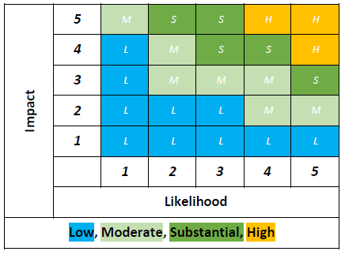

Determination ‘significance’ of risk; P: likelihood; I: impact

- Additional budget information

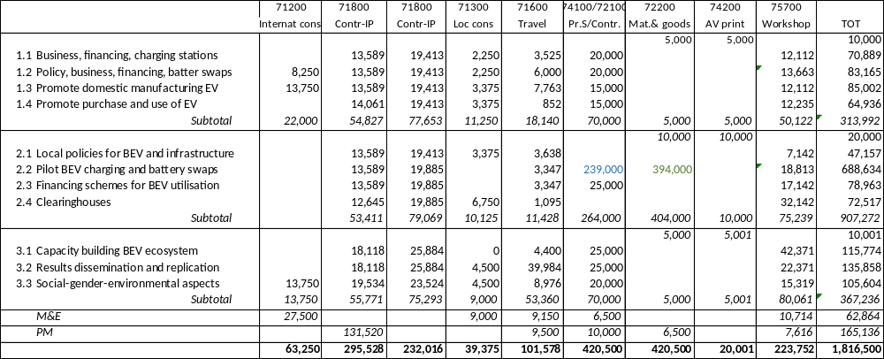Note:
USD 239,00O (output 2.3, line 74100/72100): TA cost of monitoring and testing at demonstration/pilot sites
USD 394,000 (output 2.3, line 72200): INV cost of supporting BSS stations in Jakarta/W-Java/Bali and 2 EVCS in at MEMR/DKI Jakarta (see Annex G for details)
USD 53,600 (output 3.2, line 71600): includes USD 35,000 for travel and DSA to attend Global Program workshops and events

Co-financing table
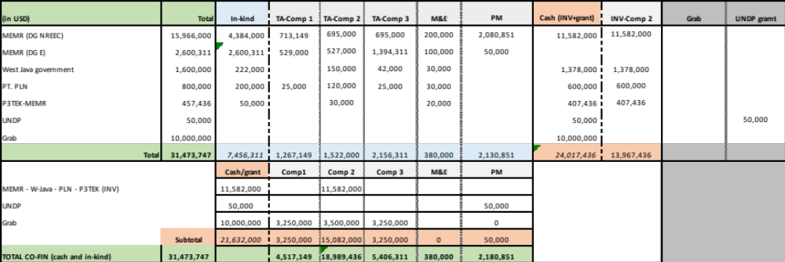

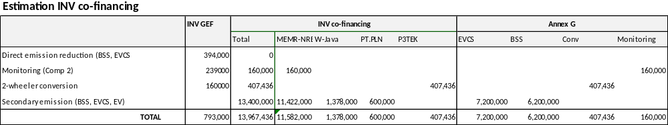

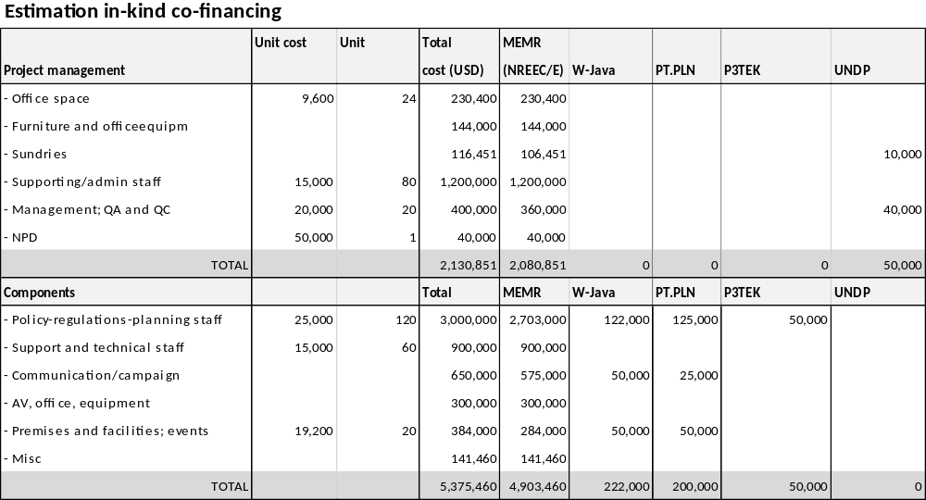

Summary co-financing per contributor

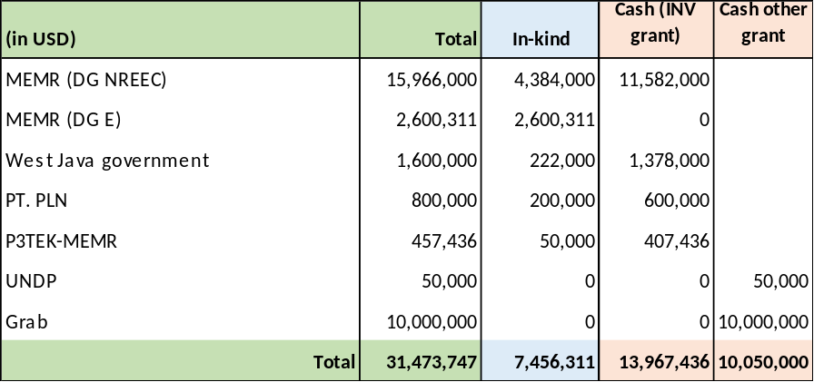

- Baseline analysis

  - Global trends in electric vehicles

According to IEA statistics, global sales of electric cars topped 2.1 million globally in 2019 to boost the stock to 7.2 million electric cars. These numbers refer to passenger electric vehicles (EV) that use batteries for energy storage and must be plugged in to be recharged (BEV) and plug-in hybrid electric vehicles (PHEV) that have both batteries and liquid-fuel storage and refueling systems (see Box 17).
Box 15 Global electric car stock (2019)
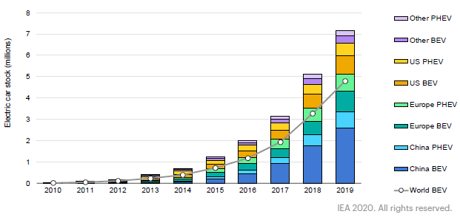
:

The in global stock (see Box 15) has increased rapidly, led by China, the US, Japan and several European countries. This rise is the result of several factors, including strong technological progress, cost reductions (especially batteries), and policy support, including purchase incentives, driving and parking access advantages, and increased public charging infrastructure availability.

Global production volume of PHEVs and BEVs in 2019 was about 2.8 million vehicles still a small share of global car sales. EVs still face obstacles. One is battery cost, which make EV cost much more than the drive systems of today’s internal combustion engine vehicles. Thus, investment cost is higher, although fuel savings will help pay this back, especially for high-mileage drivers. To achieve a tipping point in sales, EVs will likely need to achieve near- parity on a first cost basis with ICE vehicles, and provide sufficient driving range and recharging convenience. The infrastructure for electric-vehicle charging continues to expand. In 2019, there were about 7.3 million chargers worldwide, of which about 6.5 million were private.

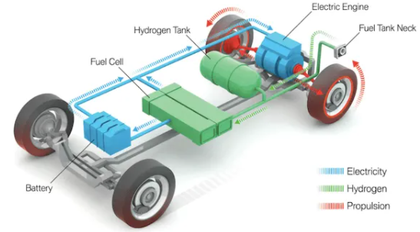
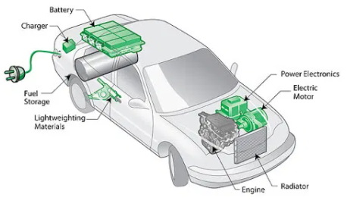
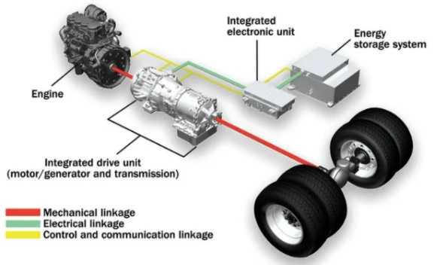
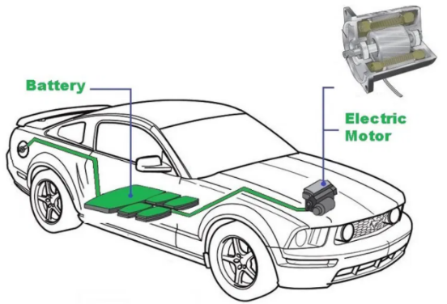
Box 16 Electric cars

The internal combustion engine vehicles (ICEV) run on gasoline or diesel. There are three main types of electric vehicles (EVs), classified by the degree that electricity is used as their energy source.
- BEVs, or battery electric vehicles, are fully-electric vehicles (EVs) with rechargeable batteries and no gasoline engine. Battery electric vehicles store electricity onboard with high-capacity battery packs. Their battery power is used to run the electric motor and all onboard electronics. BEVs do not emit any harmful emissions that come out of the exhaust pipe of traditional gasoline-powered vehicles. BEVs are charged by electricity from an external source.
- Range extension electric vehicles (REx) feature both combustion engine & electric motor but most of
the driving is done by the electric motor only. The internal combustion engine is only there to charge the battery if in case it gets low.
- PHEVs of plug-in hybrid electric vehicles can recharge the battery through both regenerative braking and “plugging in” to an external source of electrical power. The newer PHEV models can go anywhere from 10-40 miles before their gas engines provide assistance.
- HEVs, hybrid electric vehicles, are powered by both gasoline and electricity. The electric energy is generated by the car’s own braking system to recharge the battery. This is called ‘regenerative braking’, a process where the electric motor helps to slow the vehicle and uses some of the energy normally converted to heat by the brakes. You cannot plug the car in to charge the battery. HEVs start off using the electric motor, then the gasoline engine cuts in as load or speed rises. The two motors are controlled by an internal computer, which ensures the best economy for the driving conditions.

Fuel economy for regular engines is measured by the number of litres consumer per 100 kilometres travelled, abbreviated to the commonly seen L/100 km. In the case of EVs, a “litre equivalent” is used taking the electric energy consumption of kilowatt hours per 100 kilometres and converting to a conventional format, where one litre of gasoline is equals 8.9 kilowatt-hours of electricity. When a regular car decelerates, kinetic energy is lost through heat dissipation in the act of friction braking, as the pads come in contact with the rotors. On an EV, pressing the brake pedal causes the electric motor to run in reverse that consequently slows down the wheels, and at the same time recaptures that kinetic energy and sends it back into the battery, a process called regenerative braking.
A fuel cell car (FCV) is a vehicle powered by a fuel cell, which is a device that produces electricity when fed with oxygen and a suitable fuel. The fuel is often hydrogen and then the car is sometimes referred to as a hydrogen fuel cell car (HFCV). Like the BEVs, it does not contain tailpipe and the byproduct is only water. There is no need to plug-in as the fuel cells are recharged by refilling the hydrogen.

Hydrogen infrastructure is far from reality as of now, which is not the case with EV charging infrastructure as it is getting worldwide momentum.

Electric Vehicle (EV) chargers are classified according to the speed with which they recharge an EVs battery. Level 1 EV charging uses a standard household outlet (at the house or office) to plug into the electric vehicle and takes over 6-8 hours to charge an EV for approximately 90-120 km. Level 1 chargers have the capability to charge most EVs on the market. Level 2 charging requires a specialized station, typically found at office buildings, shopping malls and public charging stations and will take about 2-4 hours to charge a battery to 80-120 miles of range. Level 3 charging (DC fast charging) is currently the fastest charging solution in the EV market. Fast chargers can be found at dedicated EV charging stations (along highways or in transportation hubs) and charge a battery up to 140-280 km range in approximately 30 minutes.

However, more and more people are considering purchasing an electric vehicle and an analysis carried out by BCG (see Box 17) estimates that by 2030 the sale of EVs could overtake the sale of conventional vehicles, while in terms of the car fleet, this could happen between 2045 and 2050 (see Box 18). This could happen if governments continue to support electrification with financial and non-financial incentives and, in some regions, by tightening regulations during the next few years. HEV sales will likely see steady high-single-digit growth rates throughout the decade. In the near term, HEV economics are favorable for ridesharing until BEV costs come down. PHEVs appeal to consumers who regularly drive long distances and to single-car owners.
Box 17 Global car sales projection up to 2030

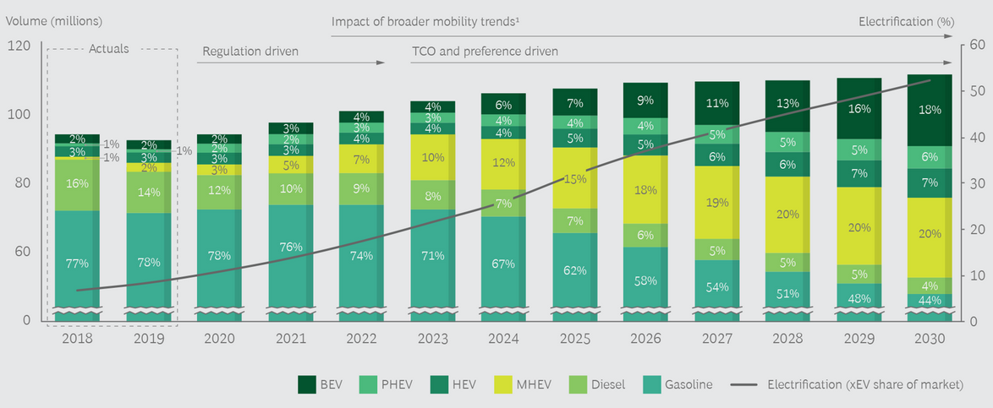
Source: Boston Consulting Group (2020). MHEV: mild hybrid electric vehicle.

An important factor is the total cost of ownership (see Box 3). Once the car is purchased, electricity is cheaper than gasoline, by the kilometer traveled, depending on the prices of electricity and gasoline/diesel in the country. Box 21 gives a calculation example for two electric car models in Indonesia. EVs can provide fuel efficiencies (in final energy terms) that are two to four times higher than a comparable ICE vehicle. The favorable economics of EVs for ridesharing (taxis and ride-hailing services) will contribute to the additional growth of EVs. TCO of EVs is falling because the prices of batteries are decreasing steeply. The BCG analysis expects that, between 2014 and 2030, battery pack prices will have slid more than 80%, from USD 540 to USD 100 per kWh. On a global basis, falling battery prices to lead to a tipping point for BEV TCO by 2022 or 2023.
Box 18 Global passenger car stock projections

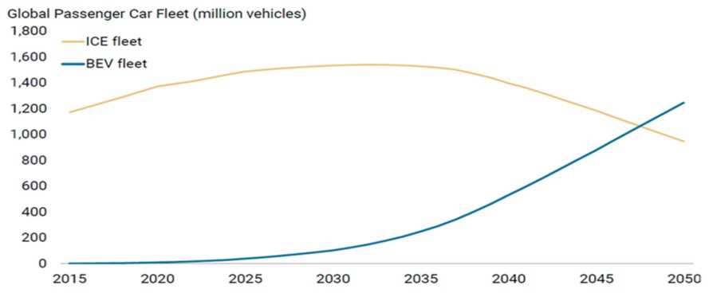
Source: Morgan Stanley Reseach 2017

Battery-electric vehicles provide zero-vehicle emissions driving for both tailpipe CO₂ emission and pollutants. EVs also reduce noise pollution in cities. However, the ‘upstream’ CO₂ emission can be considerable in countries that have electricity grids that are not sufficiently decarbonized. BEVs provide better well-to-wheel emissions. In operation, the average ICE will produce around 120 g/km of CO₂ emissions over its life cycle. At one end of the spectrum, a BEV in Norway produces as little as 0 g/km (assuming 100% use of renewables) while at the other, a BEV in China produces as much as 109 g/km (see Box 20). Also, depending on the vehicle’s region of manufacture and its battery size, producing a BEV can generate up to 60% more CO₂ emissions than producing a comparable ICE. The life-cycle emissions advantage of an EV thus depends on the vehicle’s location, with the country’s degree of reliance on fossil fuels in energy production being the main driver of CO₂ emissions.
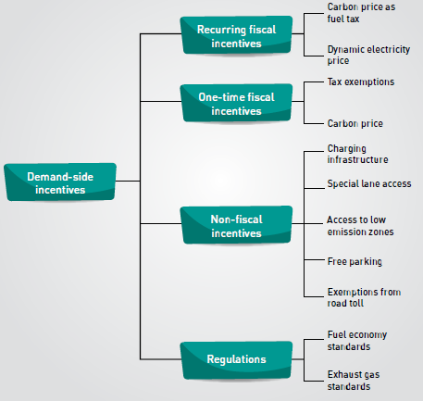
Box 19 Demand-side incentives and other policy instruments

At the national level, the shift to electrification has ramifications for jobs, skills, tax revenues, infrastructure, and the environment. Financial and non-financial incentives remain critical for maintaining the rising sales momentum established in the past several years, until market forces can support EVs on their own Tightening emissions regulations is a second critical issue. Many countries have legislative barriers, such as laws that restrict or regulate installation of charging stations (public and private) or levy and removing such roadblocks will be necessary. Other countries may want to consider measures to promote development of their own battery industries.

Source: The Role of Electric Vehicles in Decarbonizing Indonesia’s Road Transport Sector (IESR, 2020)

Box 20 Global car sales projection up to 2030

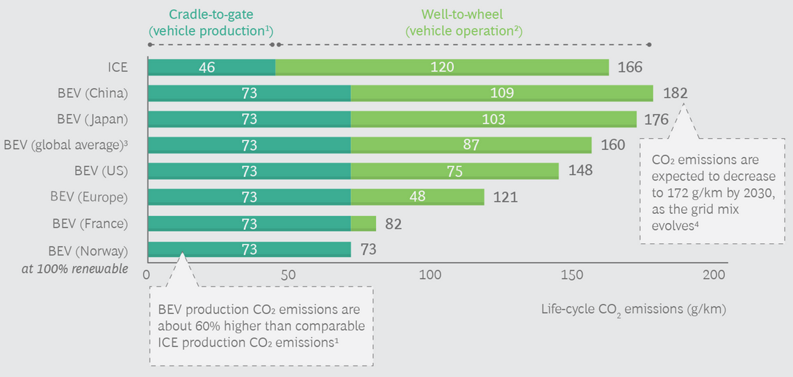
Source: Boston Consulting Group (2020); IEA Tracking Power (2019); ICCT; MDPI Sustainability Journal (2019)
Notes:
1) Average global estimate. Differences between countries will occur depending on manufacturing technque and energy sources used
2) Calculations asssume an electric efficiency of 5.6 km/kWh and include emissions from fuel production and combustion or electricity generation and CO₂ emissions from maintenance (replacement fluids; tires; batteries)
3) At an average carbon intensity of 478 gCO₂/kWh
4) Carbon intensity in China’s grid expected to fall from 605 gCO₂/kWh to 550 gCO₂/kWh

Box 21 Fuel cost benefits of electric cars

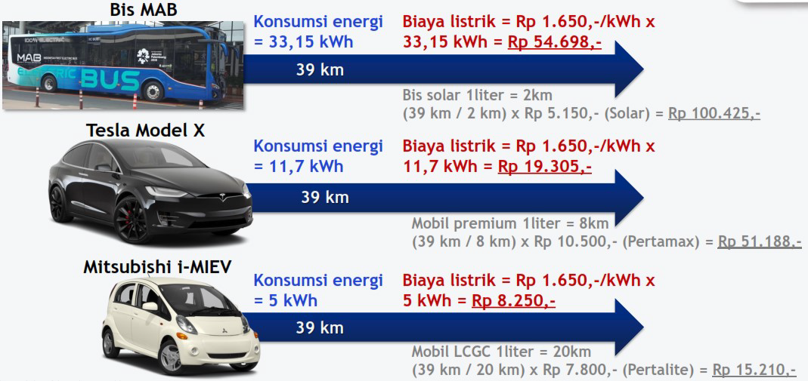
.
Biaya listrik = electricity cost; solar (diesel type), pertamax, pertalite (gasoline types)
Source: Electrifying Road Transportation in Indonesia, PowerPoint, PLN (Nov 2019)

  - Vehicle transport in Indonesia

Automotive and two-wheeler industry

In the period 2013-2019, the country produced about 1.2 million vehicles per year on average, which makes the country the largest producer in ASEAN (about 4 million annually on average) after Thailand (producing about half of ASEAN’s). Domestic sales in the same period were about 1.1 million on average per year, and exports about 0.3 million annually. Indonesia predominantly produces mini or compact passenger vehicles (52%), SUVs, and light pickup trucks under one ton. Most of the vehicles built in Indonesia are from foreign brands, notably Japanese, and produced in the country through a joint venture plant with a local partner or a fully owned plant. Top-selling companies have a large number of sales outlets; in total about 1,500 of which 60% are located in Java and 20% in Jakarta.

Most automobile manufacturers in Indonesia (including passenger car manufacturers and commercial truck manufacturers) are a member of the non-governmental Association of Indonesia Automotive Industries (Gabungan Industri Kendaraan Bermotor Indonesia, GAIKINDO).

Box 22 Sales of 4-wheelers and 2-wheelers in Indonesia
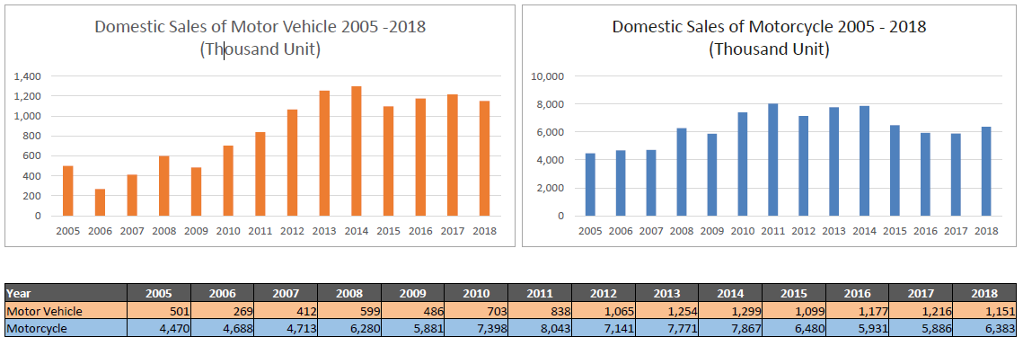
Source: Kementerian Perindustrian, Roadmap of Low Carbon Emission Vehicle, PowerPoint, Indonesia-Japan Automotive Seminar (Jan 2019)
The automotive industry in Indonesia plays an important role in the economic growth of the nation, contributing about 10% percent of the GDP and providing employment to some 1.5 million people.

Indonesia produced 7.8 million two-wheelers in 2014, mainly for domestic use. Honda and Yamaha account for 90% of the market. Scooters accounted for the largest market share in Indonesia's two-wheeler market. With higher ownership (about 3.3 people per unit), the domestic demand is saturated at about 6.4 million annually, but exports grow. In 2019, 7.2 million units were produced, of which 0.8 million for export. In 2019, there were about 106 million two-wheelers in use. The industry in Indonesia employs around 1.5 million workers in various jobs ranging from the assembly industry, first, second, and third-tier component industries, up to employees at the workshop, sales, service, and spare parts.
Box 23 Employment in automotive industry
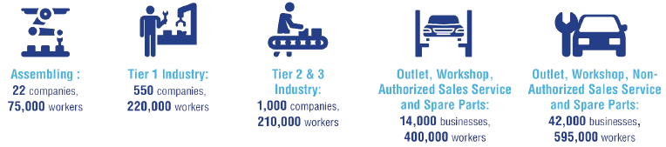
Source: The Indonesian Automotive Industry: An Update (2020), GAIKINDO

  - Electric vehicle policy and planning

Electric vehicle (EV) road map

The Government seeks to promote the use of low-carbon vehicles, including fuel-efficient gasoline and diesel vehicles (LCGC, low-cost green cars) and a range of electric vehicles (HEV, PHEV, BEV, FCEV). This is linked with Indonesia’s industrial development strategies. The government’s Making Indonesia 4.0 strategy was launched in 2018 and outlines steps to enable the country to capitalize on the evolving trends of manufacturing provided by the Fourth Industrial Revolution. These include the application of new digital and automated technologies to improve production processes and service delivery. Key priorities of the roadmap include the development of a domestic electric vehicle (EV) manufacturing industry. Efforts to develop Indonesia’s EV industry center on leveraging the country’s rich supplies of nickel laterite ore, the primary input in the lithium-ion batteries that are used to power EVs. Under the government’s strategy, EVs are expected to comprise 20% of the vehicle market by 2025. Officials have stated that the country’s vast resources of lithium could enable Indonesia to become the leader of EV manufacturing within ASEAN.
Box 24 Quantitative vehicle targets, automotive industry roadmap
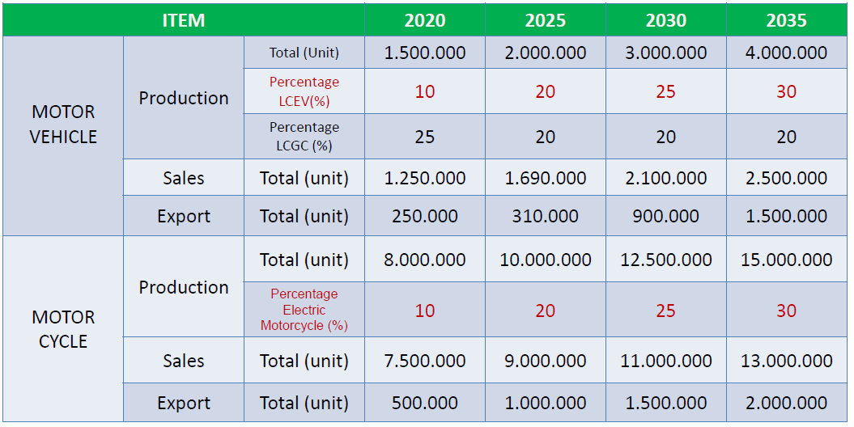
Source: KP, Roadmap of Low Carbon Emission Vehicle (2019)
LCEV: low-carbon emission vehicle, LCGC: low-carbon green car (run of diesel or gasoline). LCEVs include HEV, PHEB, BEV/FCEV and flexy-engine cars (run on gasoline ort diesel blended with ethanol (E100) or biofuel (B100)
Box 25 Automotive industry roadmap

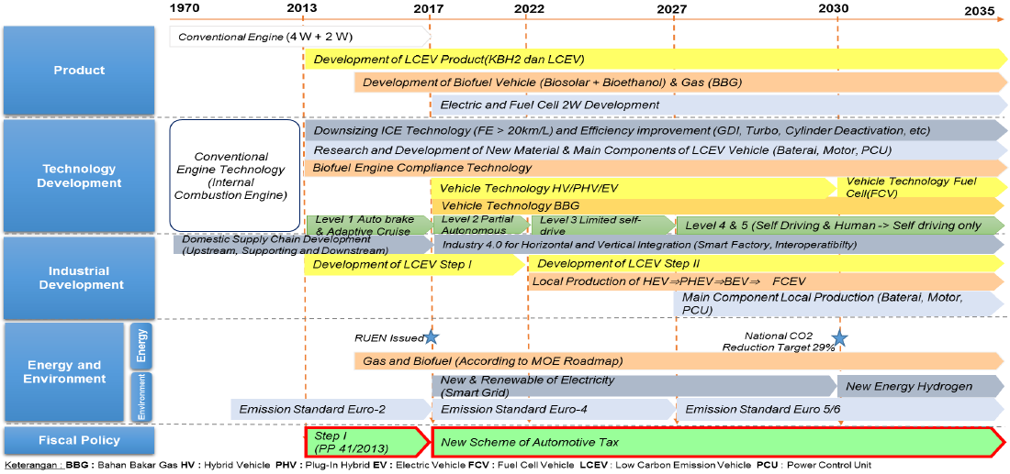

Source: Source: KP, Roadmap of Low Carbon Emission Vehicle, PowerPoint, Indonesia-Japan Automotive Seminar (Jan 2019)
The high number of cars and motorcycles in the road transport sector justifies the need to address passenger vehicles as one of the main contributors to carbon emissions in Indonesia’s transport system. For four-wheel passenger cars, the alternatives are formed by hybrid cars (HEV), plug-in hybrid cars, (PHEV), and battery electric cars (BEV). For two-wheelers (motorcycles, scooters), the alternative is formed by electric motorcycles. Indonesia has set ambitious targets that are summarised in Box 24.

Policies and regulations

The Presidential Regulation 55/2019 on the Acceleration of Battery Electric Vehicles for Road Transportation Program ("PR 55") supports EV development and market diffusion in Indonesia (see Box 26). The Regulation acts as an umbrella legal framework for BEVs, EV battery production, local content requirements, charging stations and possible tax incentives with more derivative regulations to be enacted thereafter

As of December 2019, the Indonesian government has issued various derivative regulations related to the EV industry and industrial and services sectors. For example, MEMR issued Regulation No. 13 (2020) on the “Provision of Charging Infrastructure for Battery Electric Vehicles”. Reg 13 one of the implementing regulations for PR 55 and sets out who can engage in the charging infrastructure business, the different charging infrastructure business models; the applicable electricity tariff; and technical and safety requirements and charging plug standardization. The Ministry of Industry (Permenperin) Regulation Number 27 (2020) concerns “Specifications, Development Roadmap, and Provisions for Calculating Domestic Component Levels of Domestic Motor Vehicles for BEV”. Finally, Permenperin No. 8 (2020) concerns allows EV to be partially dismantled (in IKD Incompletely Knock Down) state or in a Completely Knock Down (CKD) as long as the domestic industry cannot produce the required components. Moreover, until local companies are able to ramp up their production, complete electric vehicles CBU, Completely Built-Up) should be (temporarily) imported. Transport Ministry (Permenhub) Regulation No. 45 (2020) on the “Physical Type Testing of Electric-Powered Motorized Vehicles” lays out all the requirements an electric vehicle must have before it can be sold in Indonesia, including additional testing that does not exist for conventional vehicles such as electric recharging capabilities, insulation, functional safety, and hydrogen emission.
Box 26 Acceleration of battery electric vehicle program for road transportation, PR55/2019

Based on PR 55/2019:
- An “EV” is defined as a vehicle moved by an electric motor using electricity power from battery directly in the vehicle or from outside the vehicle. “Electric motor” itself is defined as an electromechanics equipment which consumes electricity to produce mechanical energy as its driving force. Whereas, “battery” is defined as the source of electricity used to supply electricity in an electric motor. PR 55/2019 divides EV into 2 (two) main categories, a) two wheeled and/or three wheeled EV, and b) four wheeled and/or more EV.
- There are 2 (types) of “EV manufacturers” acknowledged under PR 55/2019, namely 1) EV manufacturing company (EV Industry) and 2) EV components manufacturing company (EV Components Industry).
- EV “charging facilities” consist of “charging stations” having electric power supply, control facilities for current, voltage and communication, and safety and protection system and/or “battery exchange stations” (BEX). Charging activity through charging stations may be done through private electricity installation (for own use) or through “public charging stations (SPKLU). SPKLU will be located in, for example, petrol stations, central and regional government offices, malls, and roadside public parking lots. “Public electricity battery exchange stations” (Stasiun Penukaran Baterai Kendaraan Listrik Umum, SPBKLU), enable members of the public to rent batteries and exchange them when they run out. Other than PLN, Battery Exchange Stations/SPBKLU may also be provided by private business entities.
- A company selling electricity through a ‘charging station’ shall hold an “electricity supply business license” (Izin Usaha Penyediaan Tenaga Listrik or IUPTL) and shall own an “electricity working are” (Wilayah Usaha Penyediaan Tenaga Listrik, WUPTL).
- The electricity tariff imposed by the “charging stations” shall be determined by the Minister of Energy and Mineral Resources. For IUPTL holders the applicable tariff will be the electricity tariff for bulk sales (penjualan curah) multiplied by a ‘Q’ multiplier factor (ranging from 0.8 to two) determined by the Integrated IUPTL holders. For electricity from Integrated IUPTL holders to “private electricity installations” (for non-public transportation), the applicable tariff will be PLN’s standard electricity tariff depending on the category (e.g., residential area with certain installed capacity). For electricity from SPKLU to BEV owners, the applicable tariff will be the electricity tariff for special services multiplied by an ‘N’ multiplier factor (up to 1.5) determined by the IUPTL holders operating the SPKLU.
- Considering the current domestic capability for EV production, the Indonesian Government obliges local content requirement (Tingkat Komponen Dalam Negeri or “local content”) fulfilment for the EV industry or components industry gradually (two-wheeled EVs from 40% in 2019 to 80% after 2026; four-wheeled EVs from 35% to 80% after 2030)
- The above-mentioned entities (EV industry and components industry, charging stations, BEX) as well as R&D institutions, EV transportation companies and individuals may receive “fiscal and non-fiscal incentives”, such as a) exemption of customs duty for import of EV, b) reduction or exemption of ‘sale tax on luxurious goods’, c) reduction or exemption of taxes imposed by the regional or central government, d) exemption of customs duty for (import of) machines, capital goods and equipment for EV investments, e) incentives for the production of equipment for charging stations, f) incentives for parking tariffs determined by the regional government. In addition, the Government also provides non-fiscal incentives for entities and individuals, such as (1) the exemption on the restriction to use certain roads in Indonesia.

Box 27 Sales tax rates for four-wheel vehicles

Type of vehicle | Luxury-Goods Sales Tax (LST) | Tax base (of selling price)
Low-cost green car (LCGC | 15% | 20%
HEV (engine capacity up to 3000 cc) | 15% | 13.33-80%*
HEV (capacity 3000-4000 cc) | 20-30% | 13.33-80%*
Flex engine technology (biofuel) | 15% | 53.3%
PHEV, BEV, FCEV
* depending on type of fuel, fuel efficiency and emission level
Motor vehicles for carrying less than 10 persons have 15-40% LST for < 3000 cc and 40-70% LST for vehicles 3000-4000 cc (depending on fuel efficiency and emission levels). Motor vehicles for carrying 10-15 persons have 15-20% LST for < 3000 cc and 25-30% LST for vehicles 3000-4000 cc (depending on fuel efficiency and emission levels). Vehicles with engine capacity > 4000 cc have 95% LST
Source: https://www2.deloitte.com/content/dam/Deloitte/id/Documents/tax/id-tax-info-nov2019.pdf

Source: The Indonesian Automotive Industry: An Update (2020), GAIKINDO
Until recently, a 40% luxury goods tax was imposed on passenger cars (including electric vehicles), while import duties could be as high as 40 percent. This is one reason that electric vehicles were costing about three times as much as a comparable ICEV (an EV in Indonesia would have been more expensive than in the USA). Government Regulation No. 73 (2019) on Taxable Goods classified as luxury items in the form of motorized vehicles that are subject to the Sales Tax on Luxury Goods (LST, or PPnBM, Pajak Penjualan atas Barang Mewah) which took effect in October 2021 to further encourage the use of energy-saving and environmentally-friendly vehicles. As part of the Regulation, the government regulated the PPnBM rate for four-wheeled electric vehicles (PHEV, BEV, FCV) by setting a tariff of 15% with 0% tax imposition on the selling price (see Box 27).

The Ministry of Home Affairs' Regulation (Permendagri) No. 8 of 2020 concerns the “Reduction of Ownership Transfer of Motor Vehicle Fee (BBNKB)” and Vehicle Tax (PKB). However, it needs further implementing regulations from local governments. For example, the Governor of Jakarta Reg.No. 3/2020, makes battery electric vehicles exempted from vehicle
title transfer fee (BBNKB).

Other fiscal incentives will include the reduction and exemption of corporate income tax for a certain period (for the EV and related battery and electric motor industries), exemption of fees for electricity installation for charging stations, exemptions of parking fee charges for EVs, relief of electricity charging fees at charging stations, funding support for charging station infrastructure development, incentive for charging station equipment production, and fiscal incentives for research, development and technological innovation EV-related and battery-based activities as well as industrial vocations of battery-based components. Non-fiscal incentives include a) ease of import for export purposes and export financing facilities, b) professional competency certification for battery-based, and electric vehicle industry human resources, c) product certification and/or technical standards for battery-based electric vehicle industrial companies and battery-based component industries. MoT Reg. No. 65/2020 legalizes the conversion of conventional motorcycles to electric in public repair shop that is authorized by the government

Baseline activities

Vehicle market and sales target

The country has just begun to enter the field of electric vehicles. There are about 24 types of electric motorcycles, 29 types of electric cars, and 3 types of electric buses (see Box 28). The Indonesian electric vehicle market is highly concentrated at its early growth stage.

As of April 2020, there were less than 2000 BEVs sold in Indonesia and 15,500 units of electric two-wheelers. Currently, the two dominant brands are BYD and Hyundai. In 2019, 101 battery-electric cars were sold in the country (compared to just a couple sold in 2018) with Tesla (model-3) 38 units, BYD 27 units, and Hyundai-Ioniq 22 units. Total market size (based on Jakarta sales) in 2019 for e motorcycle 1947 units, with 1747 e-motor scooters and 200 units e-motorcycles. Dominant brands in electric motorcycles are GESITS (selling 856 units in 2019) and VIAR (selling 617). Mitsubishi is leading in PHEV cars.
Box 28 Electric car and buses models and manufacturers

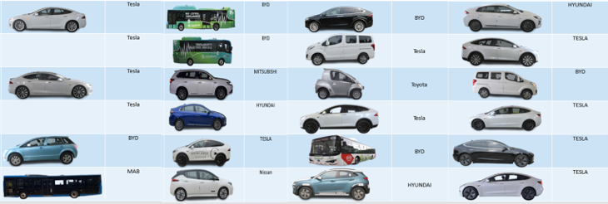
.
Box 29 Electric two-wheelers models and manufacturers

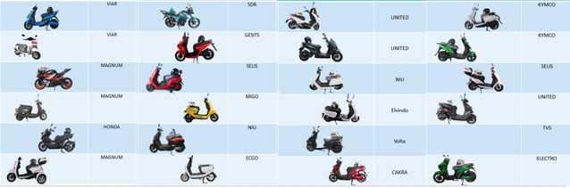
Before 55/2019 were issued, the National Energy Planning / RUEN (Presidential Regulation No 22/2017) set targets by 2025 to apply 2,200 electric vehicles, 2.1 million electric motorbikes, and to build 1000 electric vehicle charging stations. Apart from accelerating the use of electric vehicles, the Ministry of Energy & Mineral Resources (MEMR) will also focus on prioritizing the market of two-wheeled electric vehicles (motorbikes and e-scooters). This policy is decided in consideration to (i) the large population of two-wheeled vehicles (the number of two-wheeled vehicles already being over 120 million units in 2020, and is predicted to reach 150 million units by 2025), (ii) the price of electric motorbikes being competitive with combustion engine (ICE) motorbikes, as well as (iii) the ease of developing infrastructure to support electric motorbikes (battery swaps) compared to the supporting infrastructure of charging stations for electric cars. To that end, MEMR will encourage the penetration of the electric motorcycle market and the escalation of electric motorbikes usage through the conversion program from conventional motorbikes to BEV motorbikes, targeting to reach 100 million units by 2025. In doing this, Indonesia aims to follow the example set by China and India (see Box 30) The Ministry of Industry (MoI) has targeted 20% or about 400,000 units of Electrified Vehicles (Including HEV, PHEV, and BEV) and 2 million electric motorbikes produced and available in the domestic market by 2025. Kemenperin will provide regulations/standards (with BSN) for domestic Industrial development of main EV components and supply chain.
Box 30 Experience with electric motorcycles in China and India

China leads the electric motorcycles market with the largest fleet and annual sales. In late 2019, the stock of electric motorcycles in China was close to 300 million units (Xinhua News, 2019a). Recent data suggests that the annual production of electric motorcycles rose from approximately 33 million in 2018 to 36 million units in 2019 (China Bicycle Association, 2019). 35 Regulations and modest prices have played a major role in the high demand for electric motorcycles. The growth of electric motorcycles has been spurred by two notable policies from the central government. First, in 1999, the government designated electric two-wheelers possessing a low speed and weight as bicycles. This exempted them from registration requirements and permitted them to be driven on bicycle lanes. Second, several urban areas have banned gasoline powered motorcycles from city centres (Cherry, 2010).
The sales of electric motorcycles in India rose from 54 800 units in 2018 to 126 000 units in 2019 (Wadhwa, 2019). India had an estimated fleet size of 0.6 million electric motorcycles in fiscal year36 2018-19 (IEA, 2019b). About 20% of the CO2 emissions and 30% of particulate emissions in India are estimated to be caused by motorcycles (Viswanathan and Sripad, 2019). Recent government policies have taken into consideration the need to electrify the motorcycles fleet. In 2019, the national government proposed a plan to make all motorcycles sales electric ones (up to 150 cubic centimetres) as from March 2025 (Vardhini, 2019). Under the first phase of the Faster Adoption and Manufacturing of Hybrid & Electric Vehicles (FAME I) scheme, 88 models of electric motorcycles were eligible for a subsidy. Until September 2018, around 90% of the beneficiaries under FAME I were lead-acid powered electric scooters. From October 2018, subsidies for lead-acid battery vehicles were discontinued, but incentives for lithium-ion battery vehicles remained. Information has not been obtained regarding the percentage level of annual sales of electric motorcycles that have been achieved by the two countries.
Sources: Mini-Study on EV Vehicles and Manufacturers, by Agus Purwadi (2020), ENTREV PPG consultants team

* depending on type of fuel, fuel efficiency and emission level
Motor vehicles for carrying less than 10 persons have 15-40% LST for < 3000 cc and 40-70% LST for vehicles 3000-4000 cc (depending on fuel efficiency and emission levels). Motor vehicles for carrying 10-15 persons have 15-20% LST for < 3000 cc and 25-30% LST for vehicles 3000-4000 cc (depending on fuel efficiency and emission levels). Vehicles with engine capacity > 4000 cc have 95% LST
Source: https://www2.deloitte.com/content/dam/Deloitte/id/Documents/tax/id-tax-info-nov2019.pdf

Source: The Indonesian Automotive Industry: An Update (2020), GAIKINDO
Battery industry

The development of the EV battery industry ecosystem is very important for the EV program. It can also have a very large economic impact for Indonesia, including a contribution to the national GDP of up to USD 8.5 billion a year, absorbing a workforce of up to 8,000 - 16,000 people, and with potential tax revenue of up to USD 1 billion a year. To realize an integrated EV Battery industrial ecosystem from upstream to downstream, at least an investment of USD 4-6 billion is needed. Industry reports show that sales-weighted battery pack prices in 2019 were an average of USD 156 per kilowatt-hour (kWh), down from more than USD 1,100/kWh in 2010. Some predictions show that in the next 5 years the price of batteries pack will be below 170 USD per kWh and in the next 10 years, it will be below 100 USD per kWh.

For the future trend of lithium battery technology which contains more nickel components (NCM 811) where Indonesia has large nickel reserves, the potential for Indonesia to enter the global battery industry supply chain network will be very strategic. Two industrial estates in Indonesia are designated to facilitate battery-grade mineral processing and nickel production: Morowali Industrial Area (IMIP) in Morowali, Central Sulawesi and Weda Bay Industrial Area (IWIP) in Halmahera, North Maluku. Both locations are strategic for nickel production due to their abundance of nickel deposits, having a total of around 23% of global laterite nickel ore deposit
Box 31 Timeframe with milestones for battery industry
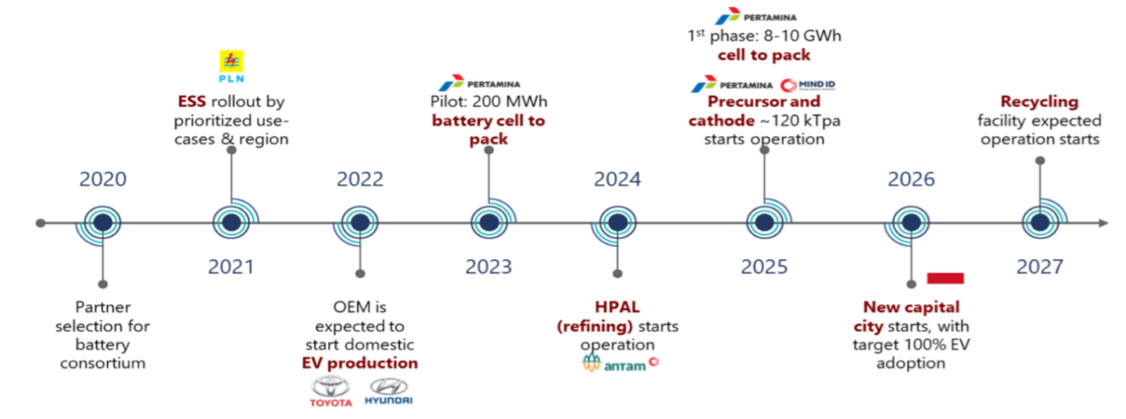

Source: taken from ….
Pertamina is developing a battery value chain with other state-owned enterprises (SOEs) to enhance the value of nickel upstream and also other raw materials. To achieve economies of scale that can compete, cooperation of these SOEs with global players is urgently needed. Several companies in both areas are to produce nickel sulphate and cobalt sulphate as inputs for battery cell production. Two companies in IMIP plan to start production in 2021, one company in IWIP aims for 2023. A domestic company, PT International Chemical Industry, plans to start battery cells production of 256 MWh/year by early 2021. A consortium of SOEs, including MIND ID, Antam, Pertamina and PLN, is also being formed with a target to produce 33 GWh/year of battery cells.

Pilot activities and charging infrastructure

By the end of 2019, the country had built a total of 20 charging stations for electric vehicles which increased to 62 in 2020 and 122 in 83 different locations. Of the 62 charging facilities, 27 were public and 35 were private (blue Bird, Mitsubushi, BMW, Mercedes). The public EV charging infrastructure is led by PT Perusahaan Listrik Negara (PLN), which is a state-owned (also the largest) electricity corporation in the country. PLN conducted three trial runs in Jakarta with the bus operator TransJakarta and had installed about 21 charging units units by the end of 2020. The PLN Roadmap aims at 3,851 by 2025. These can cater to about 114,000 vehicles, so the the planned SPLUs will not be enough to service MoI’s EV Roadmap target of 400,000 electric cars by 2025. More fast and superfast SPLUs will be set up in several locations.

PLN has signed memorandums of understanding with 20 companies to push EV adoption in Indonesia. Thirteen companies are set to provide support with installing charging stations, including the ride-hailing rivals Go-Jek and Grab, toll road operator Jasa Marga, energy company Pertamina, bus operator Transjakarta and Indonesia’s largest private lender, BCA. For example, TransJakarta has announced an ambitious plan to expand its electric bus (e-bus) fleet to 10,000 units over the decade (about 83% of its bus fleet in 2030 would be electric), starting with 100 new electric buses in 2021. The second group, tasked with building electric vehicles, is made up of six international automakers, including China’s DFSK, Japan’s Mitsubishi, Germany’s BMW, and Indonesia’s Gesits. Research is promoted through an agreement with state-owned electronics manufacturer LEN, which will be backed by the Agency for the Assessment and Application of Technology (BPPT) state-owned electronics manufacturer LEN, which will be backed by the Agency for the Assessment and Application of Technology (BPPT).

The taxi operator Blue Bird has put 30 electric taxis into operation and set up 14 charging stations in the taxi pool and 1 at the Soekarno Hatta Airport. The plan was to buy an additional 200 BEV in 2020 as the second phase of this trial, but the trial was postponed due to the COVID-19 situation. Blue Bird has its own ambitious road map for EV introduction (see Box 32).

The right business model still needs to be developed, based on these trials. The price of BEV is still very expensive, although will drop when Government Regulation Number 73 (on PPnBM) becomes effective in 2021. It is still unclear how durable electric cars are and whether a second-hand BEV car market will exist in the future (ICEV cars are sold after 5 years in operation). Bluebird’s BEV is now operating at 450 km (with two charging). In the future, to reduce operational cost, additional EVCSs outside of the pool are required to accommodate the operation of BEV up to 500 km with multiple charging.
The ride-hailing company Grab launched its first fleet of electric vehicles in early 2020, with a pilot testing 20 out of 500 electric taxis. Grab has now built EVCS at two locations, namely in Tangerang City Mall and Aeon Mall. Another EVCS was built at the Soekarno-Hatta International Airport for a pilot with 50 EV cars. Grab also provides monthly EV rental services for government and private institutions.
Box 32 Bluebird’s roadmap for electric vehicles

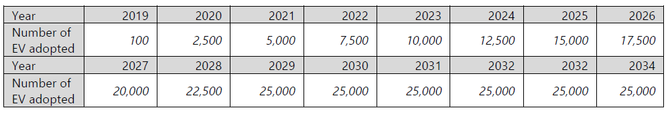
Source: Bluebird presentation at ADB, Indonesia Resident Mission Workshop, 19 February 2019.

* depending on type of fuel, fuel efficiency and emission level
Motor vehicles for carrying less than 10 persons have 15-40% LST for < 3000 cc and 40-70% LST for vehicles 3000-4000 cc (depending on fuel efficiency and emission levels). Motor vehicles for carrying 10-15 persons have 15-20% LST for < 3000 cc and 25-30% LST for vehicles 3000-4000 cc (depending on fuel efficiency and emission levels). Vehicles with engine capacity > 4000 cc have 95% LST
Source: https://www2.deloitte.com/content/dam/Deloitte/id/Documents/tax/id-tax-info-nov2019.pdf

Source: The Indonesian Automotive Industry: An Update (2020), GAIKINDO

In 2020, Grab tested 20 e-motorbikes for grab bike services. Pertamina and Go-Jek are planning to launch a trial on a local brand electric motorcycle and battery swap station in Jakarta. The PLN Roadmap calls for 14,000 battery swap stations in Indonesia and 52,125 by 2035

National-level regulations are supplemented by local-level actions. The Government of DKI Jakarta has planned to electrify the BRT system with a fleet of 11,511 buses by 2025 and gradually all of the BRT fleet will use electrical buses by 2030. Kemenperin together with NEDO Japan has initiated the pilot deployment of 270 electric motorbikes with about 1000 batteries at 40 battery swap stations in Bandung and Denpasar, including piloting utilization of second-life batteries for household electrification. E-bikes can be leased at about USD 80 per month.

The Government of DKI Jakarta has exempted BBNKB for BEV with DKI Jakarta Governor Regulation No. 3 of 2020. Meanwhile, Bali Provincial Government through the Governor of Bali Regulation No. 48 of 2019 concerning the Use of Battery-Based Electric Motorized Vehicles will provide incentives through BBNKB and PKB instruments and will implement restrictions on vehicle use fossil fuel motorized.

  - Electric vehicles and the power grid

The emission reduction benefit of EV transition depends on the total emission arise from the whole value chain, from material mining, battery, and vehicle manufacturing process, electricity production, to the end user’s EV technology (see Box 34. The current high dependency on coal power plants could hamper the emission reduction goal by developing EV.

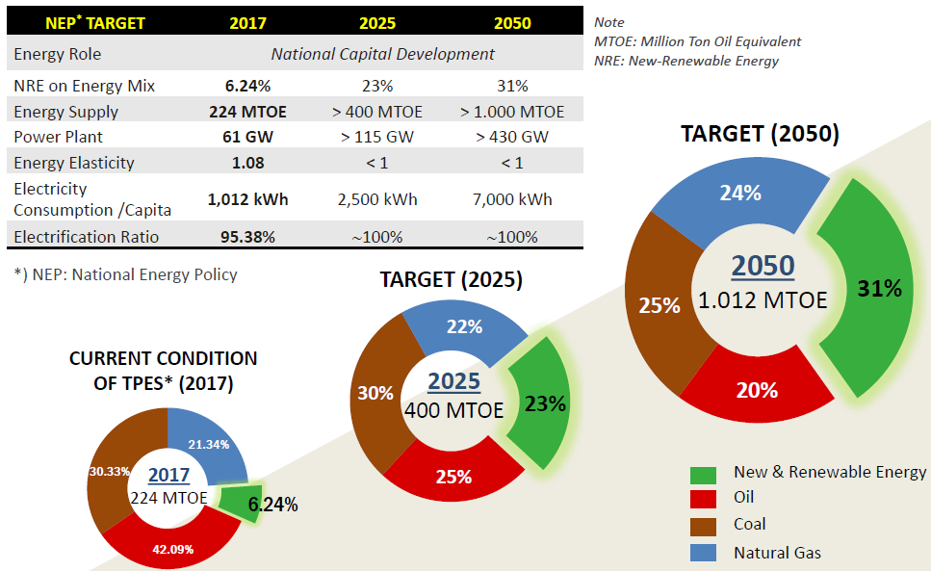
In the energy sector, Indonesia has embarked on the development of clean energy sources as a national policy. In Regulation No. 79/2014 on National Energy Policy, the Government has set out the ambition to transform, by 2025 and 2050, the primary energy supply mix with shares as follows: a) new and renewable energy at least 23% in 2025 and at least 31% in 2050; b. oil should be less than 25% in 2025 and less than 20% in 2050; c. coal should be a minimum of 30% in 2025 and a minimum of 25% in 2050; and d. gas should be a minimum of 22% in 2025 and a minimum of 24% in 2050.
Box 33 NEP and NDC targets

National Energy Policy (NEP)

NDC target:
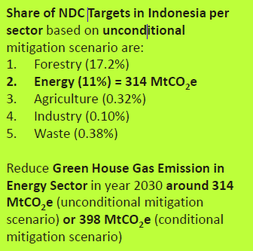

Energy Policy:
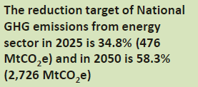

Source: PowerPoint by MEMR “National Energy Policy Indonesia”, Workshop NEXTEP – UNESCAP (Bangkok, 2019)

The development of clean power generation has been advancing slowly. Renewable energy only accounted for about 12% of the power generation mix until 2018. The Indonesian government has set a target of a high portion of renewable energy, of approximately 27% by 2030, including geothermal, wind, biomass, and solar energies. However, at the same time, the government has also accelerated the construction of coal-based power plants to match fast-growing economic growth. Currently, the coal power plant accounts for 60% of Indonesia’s power generation mix. In the General Plan of Electricity Provision (RUPTL) 2019-2028, coal will still dominate with 48% until 2028. The vision is to have a high share of renewable energy of 27% by 2030.
Box 34 CO₂ emissions of ICE and electric vehicles

BEV are often hailed in the press as ‘zero-emission’ vehicles, but that depends on what emissions one is talking about.
Well-to-wheel (WTW) emissions include:
- Tailpipe (or tank-to-wheel, TTW) emissions result from the rest products off of internal combustion engines (ICE) that leave the tailpipe and from leakage of hydrocarbons in the fuel tank. Per definition, these are zero for full electric vehicles (BEV and FCEV).
- To these must be added, the upstream (or well-to-tank, WTW) emissions. For oil products these are extraction, refining and distribution. For biofuels, they include the emissions that come from growing the biofuels feedstock, transforming it into a biofuel and transporting it to the fuel pump (and account for other co-products made in the process). For electricity, they comprise the emissions incurred in generating the electricity, including line losses, as well as in charging the vehicle. In the case of hydrogen, WTT emissions are incurred by producing, transporting and dispensing the hydrogen to the vehicle.

Life-cycle emissions not only take into account the well-to-wheel emissions, but add the emissions also come from sourcing, altering and incorporating materials into the final product (i.e., the car, its engine and drivetrain, or battery and/or fuel cell), as well as from the end-of-life (i.e., disposal, reuse and/or recycling). A recent IEA publication mentions that, based on global average energy intensity, BEV had the lowest specific WTW GHG emissions (i.e., on a per kilometre basis) among the cars evaluated, at around 95 grammes of CO2-eq per kilometre (g CO2_{-eq}/km). The average battery electric car emits about 60% less CO_{2-eq} per kilometre than gasoline ICE vehicles and 40% less than the average hybrid cas. However, due to the large variability in the carbon intensity of electricity generation in electricity systems and across countries, the GHG mitigation potential of BEVs can vary considerably, as is indicated in the figure below.

The range indicates the variability of WTW GHG emissions for each car at the country level. For ICE vehicles, HEVs and PHEVs, the range is determined considering the minimum and maximum fuel-economy values across countries. PHEVs are assumed to drive 60% of their annual mileage on electric drivetrain and 40% on gasoline engine. For PHEVs and BEVs, the 2018 carbon intensities of electricity generation at country level correspond at minimum to a vehicle charging in Iceland (0.1 g CO_{2-eq}/kWh) and at maximum to a vehicle in South Africa (1 002 gCO_{2-eq}/kWh). FCEVs, the minimum is calculated considering production of hydrogen from dedicated renewables, the maximum corresponds to hydrogen production from electrolysis considering electrolysis in China (the country with the most FCEVs in operation and with the highest carbon intensity of electricity generation) and the world average is based on steam methane reforming (8.8 kg CO_{2-eq}/kg hydrogen).

Note that the accounting of GHG emissions measure not only CO2 emissions, but also other greenhouse gases and normalise these to a global warming potential of 100 years (GWP100), to report on a CO_{2-equivalent} basis. Source: Global EV Outlook 2020 (IEA)

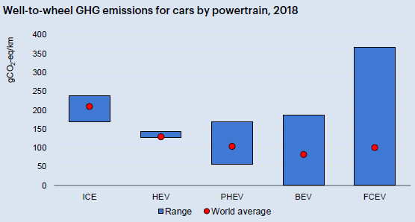
The peak of daily electricity demand still occurs at a certain time (evening to midnight), causing a large gap between peak and valley in the load profile. The difference between peak and off-peak becomes an oversupply problem that can threaten the electricity market between power producers and transmission system operators. The utilization of EVs together with the adoption of renewable energy and feed-in tariffs (FIT) in power grid management are estimated to increase the popularity of the vehicle-to-grid (V2G) concept. In the V2G concept, electric vehicles communicate with the power grid to sell demand response services by either returning electricity to the grid or by throttling their charging rate. Batteries represent excellent energy storage, having high energy efficiency and a fast response time. BEVs have generally a significantly larger battery capacity than other EVs. Thus, EVs can provide power to help balance loads by "valley filling" (charging at night when demand is low) and "peak-shaving" (sending power back to the grid when demand is high), making use of the battery storage capacity of the EVs.

The adoption of renewable energy in power grids has had a positive impact on emissions reduction. However, it also potentially leads to a significant problem due to instability, as most renewable energies have unpredictable fluctuations. In the V2G concept, the large-scale use of electric vehicles could buffer renewable power sources (such as solar or wind power for example) by storing excess energy produced during sunny or windy periods and providing it back to the grid during high load periods, thus effectively stabilizing the intermittency of wind power. Some see this application of vehicle-to-grid technology as an approach to help renewable energy become a baseload electricity technology and thus allowing a higher penetration of RE into the power grid system.

- GEF core indicators; Demonstration projects and GHG emission reduction

  - Demonstration activities

Purpose of the demonstration
Presidential Regulation Number 55 of 2019 has stipulated a clear policy regarding the Acceleration of the Battery Electric Vehicle Program for Road Transportation as an effort to increase energy efficiency, energy security, and energy conservation for the realization of clean energy, clean energy quality as well as for Indonesia's commitment to reduce greenhouse gas emissions. Therefore, Output 2.3, the GEF-supported demonstration of BEV charging stations and battery swap stations in pilot regions selected provinces, and cities, is very important to be carried out as a learning tool for related stakeholders as well as a promotional event for the benefits of using BEV for the community, so that it can be replicated in other provinces.

The Project will target 4-wheeled vehicles with long distances (270-300 km/day) such as Blue Bird Taxis and ride-hailing companies (Grab and Gojek) as well as vehicles with typical short distances (about 50 km/day). Monitoring of two-wheeled BEV will be carried out at selected battery swap stations, covering both ride-hailing motorcycles (135-150 km/day) and short-distance two-wheelers (25 km/day). Additionally, the two-wheeled demonstration is also expected to be done in converting ICE vehicles to BEV. The short distance targeted vehicles, both 4-wheeled and 2-wheeled, are owned by ministries such as the Ministry of Energy and Mineral Resources (MEMR), the Ministry of Transportation, and others, as well as state-owned enterprises, and the three provincial governments (DKI Jakarta, West Java, and Bali). However, the demonstration for 4-wheeled BEV will only take place in DKI Jakarta Province.

Organization
Guiding the ENTREV and EV-related enabling framework and promotional activities, in general, will be a local “Committee for BEVs Acceleration”. For example, in DKI Jakarta this will be formed by the Provincial Government, chaired by the Head of Regional Development Planning Agency (Bappeda) DKI Jakarta. The Committee is proposed to include vertical agencies, related regional officials, law enforcement institutions, academics, regional banks, non-governmental organizations, area management authorities, entrepreneurs, community leaders. The demonstration consists of three main tasks: a) installation of charging station and battery swap station infrastructure development, b) test run and monitoring of the BEV (both supported by the ENTREV Project), and c) procurement of BEVs that belong to the respective institutions (taxi companies, ride-hailing companies, ministries, state-owned enterprises, and local governments) and will be considered as part of the co-financing of the participating organizations.

Selection of target areas and cities
The selection of DKI Jakarta Province as one of the provinces for the Demonstration for BEV E is related to the commitment of the DKI provincial government to improve its air quality by providing various fiscal and non-fiscal incentives as well as infrastructure and facilities for BEV users. Related to the pilot demonstration are other activities that will also be supported by ENTREV, namely 1) drafting of regulations (prohibiting the use of ICE motorcycle on the main route, fiscal and non-fiscal incentives and financial support for retiring ICE scooter, restriction on the sale of ICE motorcycle (Outputs 2.2 and 2.4), 2) local policies and regulations developed to stimulate BEV infrastructure investment (Output 2.1), 3) promotions to the general public (by local clearinghouses, Output 2.3), and 4) local training and capacity building (Output 3.1).

A) Demonstration – fast charging of 4-wheeled vehicles in hybrid grid-solar systems

The fuel consumption specification for ICE taxis is 0.0896 liters per km, while the electricity consumption specification for BEV taxis is 0.123 kWh per km. ICE and BEV taxi vehicles are considered to operate with an annual mileage of 98,550 km, while other service vehicles run 18,000 km per year. The type of gasoline consumed by ICE taxis has Research Octane Number 92 (RON-92) with an emission factor of 2.153 kg of CO2/liter, while the emission factor from the electricity network in the Java-Bali system (Jamali) is 870 kg CO2/kWh with transmission and distribution losses of 9%, giving an emission factor of 956 kgCO2/kWh. It should be noted that the calculation in the Box does not only take into account the emissions associated with driving (tank-to-wheel), but also but also well-to-tank (GHG emissions associated with the production and transport to the filling station of the gasoline consumed) and the GHG emissions in battery manufacturing (in case of EVs), as explained in Box 34. Thus, one can calculate that a typical taxi will reduce 7.18 tCO₂ per year and a service vehicle 1.74 tCO₂ per year.
Box 35 Overview of pilot and monitoring activities supported by ENTREV

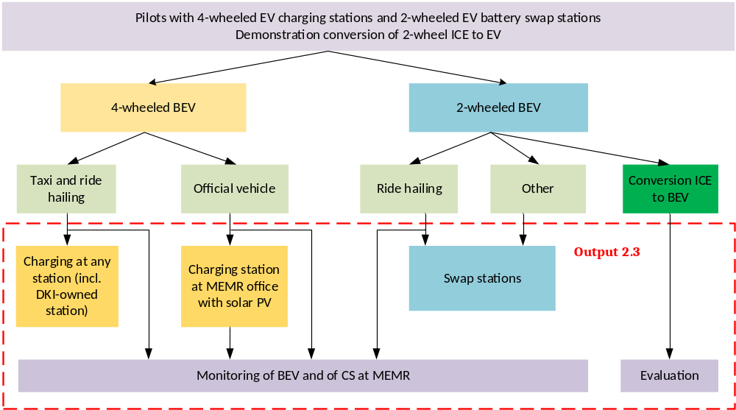

However, part of the energy in one EV charging station (at MEMR, for official cars) in Jakarta will be partly provided by solar energy. The ENTREV activities will facilitate the financing of the construction of 2 units of fast charge charging stations, of which one will; be placed will be placed at a MEMR building and another at a public place in Jakarta (gas station or other location approved by ENTREV stakeholders). The potential location candidates for the fast charge at MEMR offices. These locations can take advantage of the electricity production generated by solar power that is already available at all three buildings. Solar PV Rooftop plant at DG Electricity Office Soemantri Brodjonegoro I building (SB I) 5 x 10 kW and 2 x 25 kW and Soemantri Brodjonegoro II building (SB II) 1 x 30 kW. If we take an average of the two buildings (100 kW and 20 kW), i.e. 65 kW, the energy supply (average for the two buildings) by solar is about 20%, as indicated in Box 36. Thus, the emission reduction will be higher. In this case, a typical official (service) vehicle will reduce 1.74 tCO₂ per year (compared to 1.26 tCO₂ per year for a BEV fully powered by grid electricity). More details on the solar component in the MEMR demo is presented in Box 39. Apart from the MEMR building, the possible EV CS location without being equipped with a PV Roof Top is located at the CNG Station owned by the DKI Jakarta Government on Perintis Kemerdekaan Street, which is operated by PT JUP as a subsidiary of PT Jakarta Propertindo which is engaged in energy supply. It is assumed that taxis will charge at this or similar (non-solar) stations.

Box 36 CO₂ emissions reduction and cost estimates of reduction with charging 4-wheeled vehicles in hybrid grid-solar charging stations

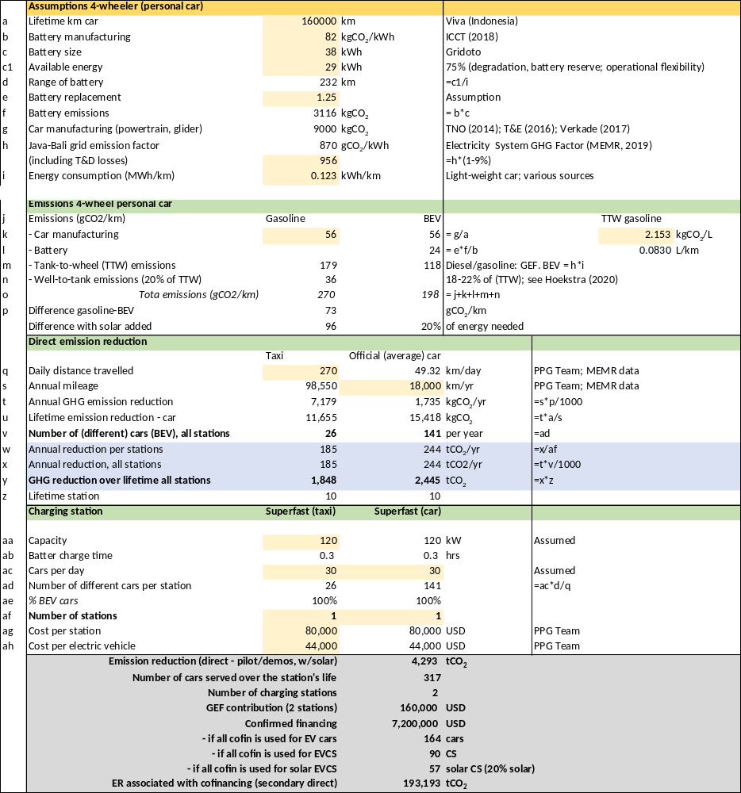

However, in the ENTREV the unit (of GEF-supported) investment is not the vehicle as such, but the charging station. Box 36 gives the details of a modern fast-charging station for the 4-wheelers. One superfast charging station will be able to charge 30 vehicles a day (depending on their daily mileage, this implies in the calculation that 37 different taxi vehicles or 201 service cars visit the station). In the end, the emission reduction per station is the same, namely 185 tCO₂ per year (this depends on the station’s capacity to charge = expected GHG emission reduction per car per mileage * times mileage of the car) in the case of grid-charged stations. In the case of the official vehicles in the project, the energy needed is 20% generated by solar, the emission reduction is 244 tCO₂ per year. Thus, the total emission of the two charging stations (one with solar; one without) over their lifetime (of 10 years) is (1,848+2,445=) 4,293 tCO₂.

Co-financing
The proposed locations have the advantage of the electricity production generated by a solar power facility that is already available. Thus, no cost is required for the procurement of the solar power plant infrastructure. GEF funds are proposed to provide funding for the investment in the two fast-charging stations. The two stations will be able to service 167 different 4-wheelers per year. For project purposes, it is assumed that the co-financing is USD 7.2 million, which is available or for the procurement of vehicles (at USD 44,000 per EV this implies up to 164 cars) and/or to install more charging stations (up to 90 at USD 80,000 per station) or a combination thereof.

B) Battery swap stations with 2-wheelers

Calculations of the potential reduction in GHG emissions are also carried out for two-wheeled vehicles. The millage for long-distance motorcycles (ride-hailing) is assumed 150 km a day with a 90% availability factor (or 135 km/day) or 49,275 km annually. The fuel consumption specification for ICE motorcycles is 0.033 liters per km, while the electricity consumption specification for BEV is 0.033 kWh per km. Similar to the 4-wheeled vehicles, the 2-wheeled vehicles are also assumed to use gasoline with RON-92 and using the Jamali system for the electricity supply of the BEVs. With the same calculation approach as for 4-wheeled vehicles, the potential for GHG mitigation on the utilization of 2-wheeled BEV is 2.47 tCO₂ tons of CO₂ per year (ride-hailing). The CO₂ emission reduction per year (0.40 tCO₂) for other 2-wheelers is lower because the mileage is assumed to be less (22 km a day or 8,000 per year). The technical data related to specific energy consumption, emission factor, transmission, and distribution network losses are the same for both short and long-distance vehicles as is the lifetime in terms of mileage (45,000 km). Thus, this leads to the result that the lifetime emission reduction for short-distance and long-distance 2-wheeled BEVs is the same, namely 2.25 tCO_{2.}

Again, in the ENTREV Project the unit (of GEF-supported) investment is not the vehicle as such, but the charging station. Box 37 gives the details of possible emission reduction and cost calculation for battery swap stations. SPBKLU (public battery swap station) will be installed specifically for electric motorcycles. One cabinet unit of SPBKLU contains 12 batteries. It is planned that 36 swap cabinets will be distributed, financed from the GEF budget, i.e., 36 battery swap station locations (SPBLKU), powered by normal chargers. One unit of SPBKLU contains 12 batteries cabinets. It is planned that 72 swap station locations, of which 50 @ 12 batteries cabinets in DKI Jakarta Province, 12 swap station locations each consisting of @ 12 batteries cabinets in West Java Province, and 4 swap station consisting of @ 10 batteries cabinets in Bali Province.

So, one battery swap station will be able to charge 48 electric 2-wheelers a day (depending on their daily mileage, this implies in the calculation that 11 different ride-hailing e-motorcycles/scooters or 70 other 2-wheelers visit the station). In the end, the emission reduction per station is the same, namely 28 tCO2 per year (this depends on the station’s capacity to charge = expected GHG emission reduction per car per mileage * times mileage of the car) in the case of grid-charged stations. Thus, the total emission of the 36 battery charging stations over their lifetime (of 10 years) is 10,048 tCO₂.

Co-financing
GEF funds are proposed to provide the funding for the investment in the 36 BSS. The total of 36 stations will be able to service 1,458 different 2-wheelers per year. GEF is requested to contribute USD 234,000. An additional co-financing of USD 6.20 million has been committed for either the procurement of 2-wheeled EVs (at USD 1,240 per EV this implies 5,000 EVs) and/or to install more BSS (954 at USD 6,500 per station) or a combination thereof by public and private sector entities. Total co-financing is USD 6,200,000.

Box 37 CO₂ emissions reduction and cost estimates of reduction with charging 2-wheeled vehicles in battery swap stations

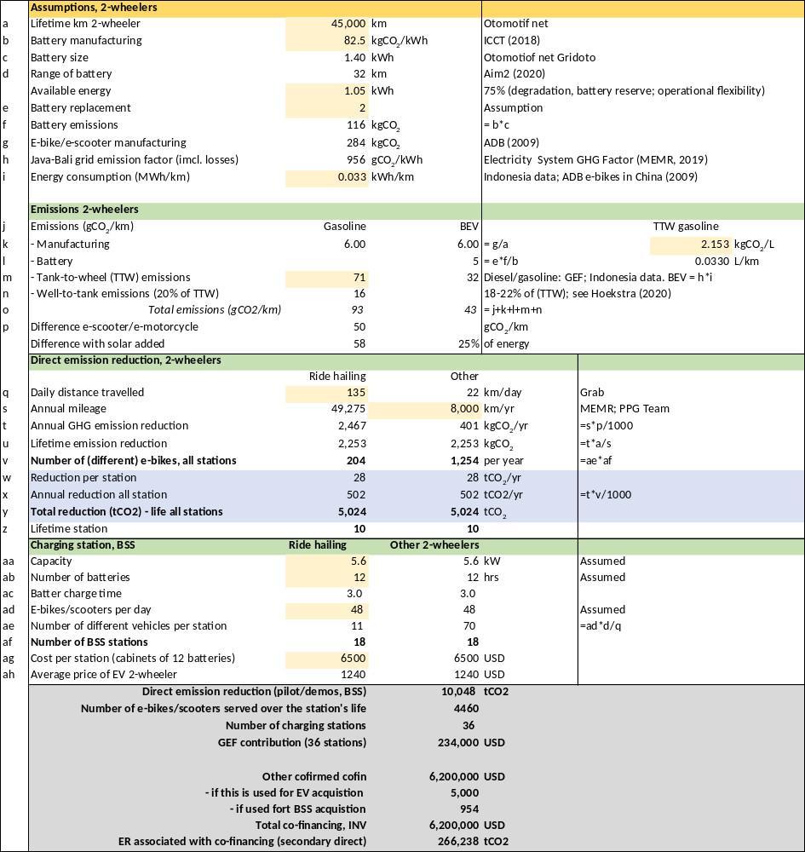

C) Monitoring

As described above, all BEVs, both four and two-wheeled, will be monitored for technical conditions in order to obtain information about the benefits of BEV. The main result of the monitoring will be measurements of reduction in consumption of gasoline and diesel oil, increase in electricity consumption, and resulting avoided GHG emissions. The monitoring and verification can provide the necessary real-life data on which such assessments and future replication can be based. With the results of the test run evaluation publication, it is expected it will encourage public interest in purchasing and using BEV.

The test runs are intended to obtain real-time data for the use of BEV, both e-car and electric 2-wheelers (that are used by personal from the central/regional government and SOEs/ROEs or as passenger transportation). Such monitoring is urgently needed as so far little monitoring yielding primary data has taken place. With the results of the test runs and monitoring, it is expected that the evaluation publication will encourage public interest in purchasing and using BEV. It also requires a set of systems and hardware to do online monitoring, as well as the operational costs of such a system. The amount of cost needed for the procurement of a set of software and hardware is (budget for monitoring). However, online monitoring activities can only be carried out if the owner of the vehicle is willing to be monitored as it is related to data confidentiality. Therefore, a joint agreement is required between the owner and UNDP regarding this issue. As stated earlier, vehicles with loggers installed will get a discount when charging the battery. It is also necessary to think about how to track the charging data. Software about electricity supply in charging and battery swap stations are available, but they could not provide enough data to support ENTREV activities. This requires the active participation of the vehicle owner such as taking a photo of the vehicle odometer for each charging and then sending it to the special software that will be developed in ENTREV activities. The software can, in principle, also be used for owners of electric motorcycles who charge the battery at home.

d) Conversion of 2-wheeled ICE to BEV

In addition, P3TEK KESDM has developed a pilot on the conversion of ICE motorbikes to BEV with a capacity of around 110 cc. The results of the pilot conversion will provide the basis for the elaboration of an “ICE to BEV Motorcycle Conversion Guidebook”. For this reason, P3TEK will provide training and certification to conversion workshops. P3TEK is expected to become a Certification Body for the conversion of ICE motorcycles to BEV. The requirement for the owner to participate in the conversion pilot will be the Motor Vehicle Ownership Book (BPKB) and Vehicle Registration Certificate (STNK). The pilot will include measurements of maximum torque, fuel consumption, and emissions test data. In the conversion the battery pack, BLDC, BLDC - PM controller, Speed regulator, MCB DC, DC converter 72 V to 12 V, motor mount will be added and information will be compiled in an “ICE motor to BEV converting document”. Also, P3TEK still needs to do several tests for its pilot, such as endurance tests, motorcycle safety tests in extreme conditions such as floods and heavy rain and adjustment to EV standards (SNI, ISO and IEC Standard) and second test on 2W modification without CVT transmission. ENTREV will provide technical assistance to the demonstration of 2-wheel ICE to BEV conversion. The total converting fee is around IDR 14,505,000 (about USD 1,000). Assuming 400 ICE 2-wheelers are converted, co-financing is about USD 400,000.

Cost estimate of solar-powered fast charging station

One of the demonstration fast-charger facility (at MEMR building) is powered by solar PV. The solar PV is already installed as rooftop in the building, but it is instructive to see what the additional cost would have been, based on the assumption that the solar PV provides 20% of the energy for an 18 kW superfast charger needed during the day (when the sun shines, eliminating the need for an expensive battery pack).

Total cost of ownership of 2-wheeled and 4-wheeled electric vehicles vs ICE alternative

Another instructive analysis is the comparison of the lifetime cost of electric 2-wheelers and 4-wheelers (personal cars) versus the conventional vehicle (powered by an ICE, fueled by gasoline. The results are given in Box 39. The ‘back-of-the-envelope’ analysis concludes that over their lifetime an electric e-motorcycle/scooter is already competitive, in large part due to the higher maintenance cost of the gasoline bike. In the case of electric personal cars, the higher purchase price (at least 1.5 times more) still makes these more expensive in terms of lifetime cost.
Box 38 Budget for monitoring of ENTREV-supported charging infrastructure

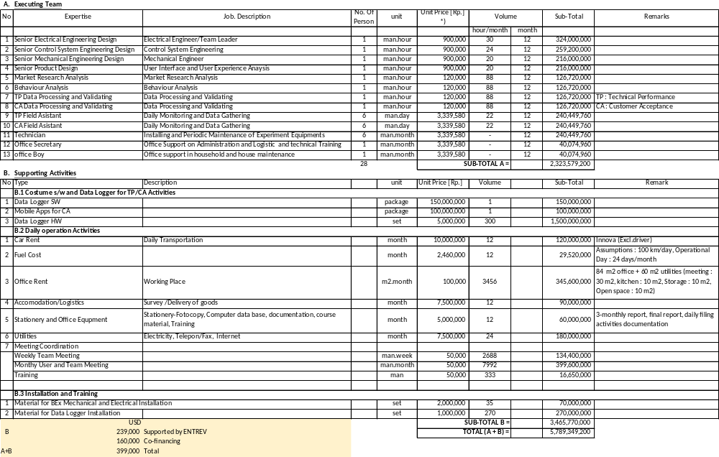

Box 39 Estimate of cost of hybrid solar-grid fast charging station

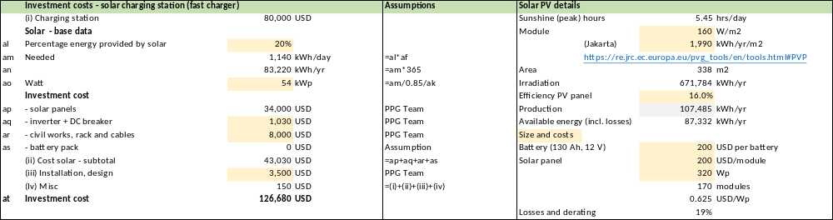

Box 40 Cost of ownership and operation of electric vehicles versus ICE

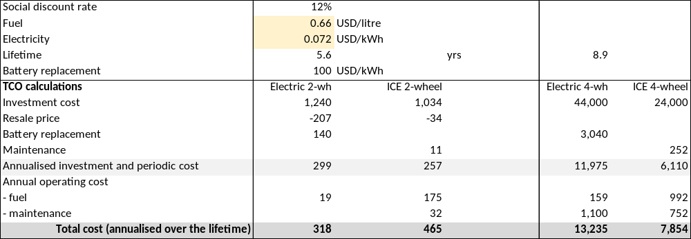
Note:
The analysis is based on info provided in websites:
- http://b2tke.bppt.go.id/index.php/en/258-motor-listrik-vs-motor-skutik-eng
- https://www.globalpetrolprices.com/Indonesia/gasoline_prices/
- https://www.globalpetrolprices.com/Indonesia/electricity_prices/
and reports:
- Total cost of ownership and its potential implications for battery electric vehicle diffusion, by Hagman et.al in Research in Transportation Business & Management 18 (2016) 11–17
- Estimating the total cost of ownership (TCO) of electrified vehicle in Indonesia, LPEM-FEBUI Working Paper – 043, by Riyanto et.al. (January 2020)

  - Estimations of direct and consequential GHG emission reduction

Definition of direct and indirect greenhouse gas emission (GHG) reduction

- The total direct emission reductions are achieved in GEF projects where these projects lead to less GHG-emitting investments than a no-project situation would have achieved, typically from pilot or demonstration activities that have been realized (or at least construction initiated) in the project implementation period, supported by GEF (INV) or co-financing investments. In the case of this Project, these are investments in the charging stations (CS, SPKLU) and battery swap stations (BSS, SPBKU). Two types of direct emission reduction (ER) are distinguished here:
  - Direct emission reduction, associated with the 2 CS and 36 BSS supported by GEF budget, resulting from the emission reduction due to the use of 4-wheeled and 2-wheeled BEVs in comparison with the baseline gasoline-powered internal combustion engine (ICE);
  - Secondary emission reduction, is associated with CS, BSS and/or BEV acquired as part of the co-financing committed to the ENTREV project
- Indirect (or consequential) emission reduction is a consequence of the various technical assistance (TA) activities of the Project aimed at removing socio-economic, policy-regulatory, financial and other barriers.
  - The top-down (TD) approach assesses indirect impacts by estimating the combined technical and economic market potential for the technology in 2035 (ten years after the end of the project) based on the projected sales in Indonesia of 4-wheelers and 2-wheelers as projected in the Ministry of Industry’s EV Roadmap. To be conservative, only part of the emission reduction in the national market can be attributed to the GEF intervention, so a correction by means of a causality factor (CF) is applied. In this case a CF = 35% is used, in other words it is assumed that 35% of sales of BEVs can be indirectly attributed to the project’s influence.
  - The bottom-up (BU) approach assesses the likely effectiveness of a project’s demonstration and triggering effects. The direct and direct post-project impacts of a project are simply multiplied by the number of times (the replication factor, RF) that a successful investment under the project might be replicated after the project’s activities have ended. As the Project in Output 3.2 plans to prepare the scaling-up of activities to 6 more cities (in addition to the 3 pilot/demo cities supported in Component 2) a replication factor of RF=2 is used,

A summary of the direct emission reduction (as a result of the pilot and demo activities) and secondary direct emission reduction (as a result of the associated co-financed investment) is given in the table below. The figures are a summary compilation of the direct emission calculation presented for 4-wheelers in Box 36 and 2-wheelers in Box 37.

Box 41 ENTREV direct emission reduction

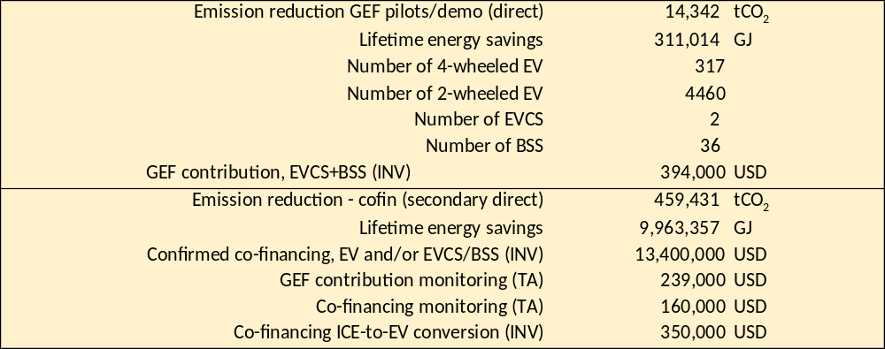

The impact of ENTEV will go beyond 2025 and the direct emission reduction associated with the 36 BSS and 2 EVCS that receive GEF support. This consequential emission reduction (indirect) is resulting from indirect replications that are stimulated by the project policy support, technical and non-technical capacity building, awareness stimulation, and finance strengthening activities. The replications generating indirect reductions are those that do not receive any direct support from the project, either as TA or investment, and thus may be called “indirect” replications.

A summary of the estimates is given in Box 42. The estimates are based on the maximum scaling-up potential for 4-wheelers can be defined as the total number of LCEV (low-carbon vehicles), as indicated in the Transport Ministry’s Roadmap of Low Carbon Emission Vehicle (2019), which is 30% of the 2.5 million vehicles sold in 2035 = 750,000 LCEVs.

Box 42 ENTREV consequential (indirect) emission reduction calculation

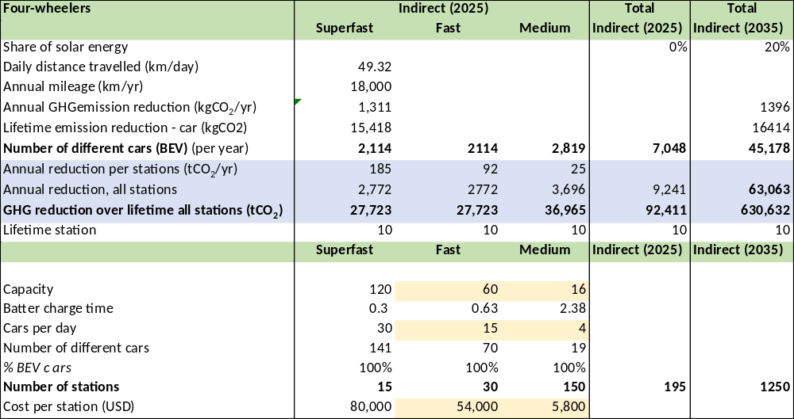
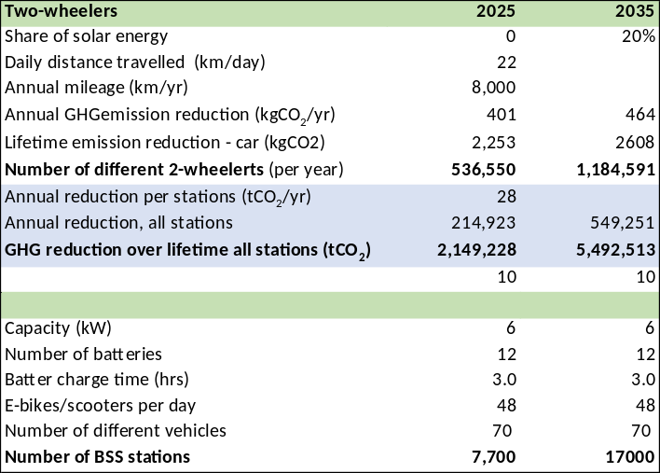
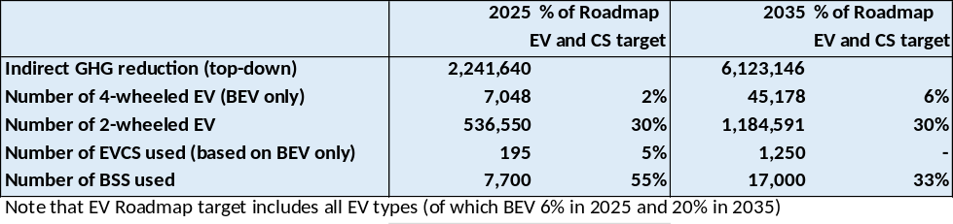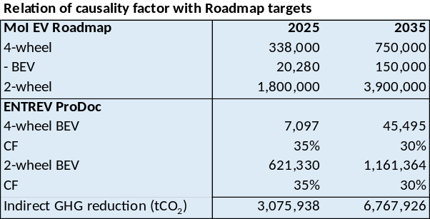

Assuming that 18% of the LCEVs in 2035 are BEV (based on Box 20, this implies a maximum sale of 150,000 BEV by 2035). Similarly, the Roadmap aims at sales of 3.9 million 2-wheelers, of which 30% electric by the year 2035. Of course, the eventual realization of these targets cannot be fully attributed to the ENTREV project but will also be the result of national efforts (and those of other development partners). Therefore, we apply a conservative causality factor. In the case of 4-wheeled EVs: CF=30% of 150,000 BEV by 2035 = 45,178 EVs. For 2-wheelers, CF=30% of 3,900,000 by 2035 = 1,184,9514 e-motorcycles/scooters. A general assumption in the top-down GHG emission reduction calculation is an increased penetration of solar energy of 20% by 2035 in the power supply of CS and BSS.
Comparison with earlier estimates of direct and indirect emission reduction

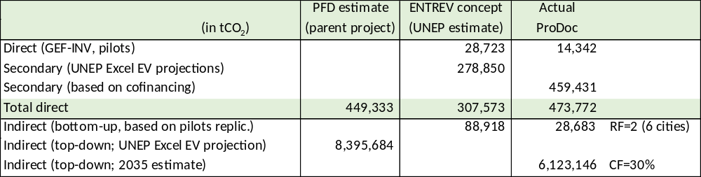

References in this Annex

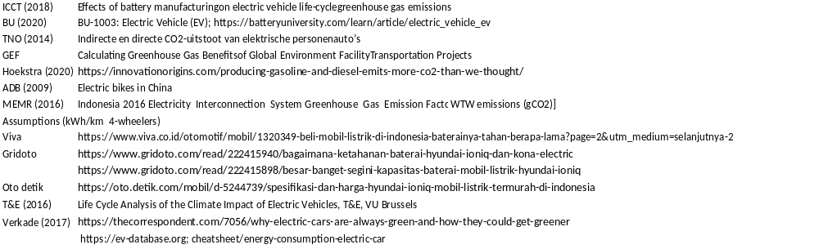

  - GEF core indicators

Project Core Indicators |  | Expected at CEO Endorsement  (as referred to in PFD)
6.2 | Greenhouse Gas Emissions Mitigated (metric tons of CO2e)  - Direct (pilot/demos)  - Secondary direct  - Indirect (top-down) | 14,342  459,431  6,123,146
6.3 | Energy saved  - Pilot projects with EVCS and BSS (GEF and co-financed)  - Secondary direct (co-financed interventions)  - Indirect | 311 TJ  9,963 TJ  132,788 TJ
11 | Number of direct beneficiaries disaggregated by gender as co-benefit of GEF investment | 321,612  (women: 87,851)

Calculation of number of beneficiaries

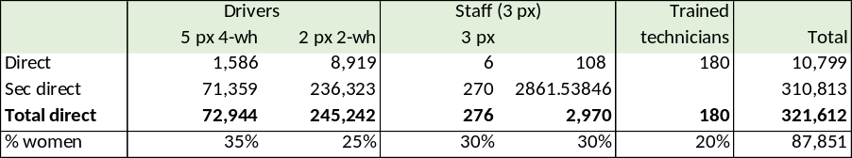
Assumptions:
4-wheel: five potential passengers (incl. driver) per vehicle; 2=wheelers: two passengers (one driver) per vehicles. At least 3 persons work at CS or BSS.

- overview of Project staff and technical consultancies

Key project staff

National Project Manager (NPM)

Full time (192 weeks over 4 years). Recommended at SC 9 level.

Description of responsibilities:

- Manage and supervise the project team to ensure effective implementation and achievement of results:
  - Oversees the day-to-day project implementation and ensure achievement of targets as outlined in the project work plan;
  - Leads and supervises project team, builds team coherence and establishes clear roles and responsibilities among team members;
  - Mobilizes goods and services and other project inputs, including preparing ToRs for expert consultants, meetings, and workshops;
  - Ensures that the quality of project inputs meet the expected standards and are sufficient to produce project outputs and targets;
  - Takes overall responsibility for the project and performs oversight roles for project compliance against the relevant government and UNDP regulations for project management;
  - Develops the project standard operating procedures in line with the government and UNDP’s regulations; seeks the board’s approval; and takes responsibility for updating and revising it as necessary;
  - Manages critical issues, troubleshoots problems and develops solutions to the overall processes of project implementation;
  - Consults with the project board through the National Project Director for any issues that require their attention, including issues related to deviation from the approved work plans and its tolerance (e.g. deviation from the approved target, and/or budget); and
  - Performs project management duties on UNDP’s ERM (ATLAS) in line with the NIM manual and as outlined in the delegation of authority for Project Manager.
  - Ensures effective monitoring of project performance, and the preparation of high quality and results-oriented progress reports.
- Ensure the linkages between results from Component 1, Component 2 and Component 3 thereby creating synergies and ensuring avoiding overlaps in discussing policies, regulations, incentives and financing schemes:
- Monitoring progress in all components and sharing input between components among technical specialists and key stakeholders involved in the project;
- Monitoring progress in all components in order to convey technical messages to all key stakeholders involved in the project;
- Ensuring up to date information from stakeholders is conveyed to the technical specialists and among stakeholders.
- Ensure effective planning, budgeting, and implementation of the project
  - Prepares project’s annual and quarterly work plans and organizes project board meetings to obtain their approval;
  - Implements project work plan and ensures that the project remains within the tolerance level of the approved work plan;
  - Conducts regular monitoring to ensure achievement of targets in line with the annual work plan and that project implementation at all levels complies with the approved project SoP;
  - Prepares quarterly project reports, in line with the standard template and presents it to the project assurance team on a timely manner;
  - Provides additional inputs and data for external project reports as necessary and required by the project assurance team;
  - Organizes regular project board meetings and reports to the project board the project’s progress together with any issues that may require project board decisions; and
  - As required and directed by the project board, liaises with UNDP’s Planning, Monitoring and Evaluation Unit (PMEU) to initiate project review and evaluation processes, and supports the conduct of such exercises under the overall management of the task manager as designated by PMEU;

- Create and nurture strategic partnerships and support to the implementation of resource mobilization
  - Coordinate with the Technical Working Groups on climate change of the Government of Indonesia
  - Establishes and maintains good working relationships with the relevant public and development partners who are the principal counterparts for the project;
  - Initiates and maintains partnerships with development partners, government institutions, private sector, civil society and other stakeholders to contribute to the achievement of project results;
  - Builds project reputation for quality design, reliable delivery as well as integrity and accountability;
  - Identifies and works with key partners/stakeholders to ensure synergies with other projects/initiatives and to avoid duplication of activities among actors;
  - Identifies opportunities for mobilizing resources for the project, and prepares substantive briefs on possible areas of cooperation; and
  - In coordination with UNDP’s Communication unit and other relevant counterpart communications department, strengthens the communication of the project in order to communicate results, deepen stakeholder knowledge and buy-in to the project, and to facilitate resource mobilization for the project.
- Facilitate knowledge building and management for and from the project implementation (Component 3 of ENTREV)
  - Identifies best practices and lessons learnt from the project and from other initiatives that can be helpful to the project in achieving its goals and objectives;
  - Maintains contacts with Global Program on e-Mobility and participates in events and workshops;
  - Supervises capacity building and activities and other timely delivery of project outputs;
  - Identifies policy issues for codification and info sharing for local information clearinghouses
  - Leads in generating knowledge products such as best practices and lessons learned for knowledge sharing; and
  - Contributes to knowledge networks and communities of practice.

Recruitment qualifications:
Education | Master degree in project management, public administration, business, geography, transport or other relevant fields of study.
Experience: | - Minimum 10 years of professional experience of city planning, transport, or energy efficiency  - Minimum 5 years of experience in project management and coordination in the development context, working with ministries, national or provincial institutions that are concerned with transport and vehicle management.  - Good technical knowledge in the fields related to public transport, vehicle technologies, climate change, energy efficiency, institutional development or regulatory aspects
Language requirements: | - Fluency in written and spoken English is an absolute necessity;  - Fluency in written and spoken Bahasa Indonesia is required
Other requirements: | - Demonstrated strong familiarity with development projects and UNDP programs in Indonesia.  - Effective interpersonal and negotiation skills proven through successful interactions with all levels of project stakeholder groups, including senior government officials, financial sectors, private entrepreneurs, technical groups and communities. S/he should have ability to effectively coordinate a complex, multi‐stakeholder project and to lead, manage and motivate teams to achieve results.  - Full-time availability for project management duties is essential.  - Knowledge of UNDP project implementation procedures, including procurement, disbursements, and reporting and monitoring will be an added advantage  - Experience in the implementation of gender action plans within projects will be an advantage.  - Up-to-date computer skills required.

Technical specialist in transport planning, e-mobility and economics

Full-time contract: 192 weeks over 4 years. Recommended at SC-8/level.

Description of responsibilities:

The incumbent will be responsible for implementation of the Outcome 1, including assistance to mobilize all component resources, and supervision of consultants and sub‐contractors. Under the direction of the PM, the TS‐1 will liaise with the national and local governments, UNDP, and all stakeholders involved in Outcome 1. She/he will be specifically responsible for:
(a) Overall management of Component 1
(b) Provide technical guidance on policy and regulations on e-mobility at national (component 1) and local level (output 2.1)
(c) Provide technical guidance on incentives and financing schemes (component 1 and output 2.3)
(d) Provide technical support on business models and economics of charging stations and battery swap stations
(e) Estimate of indicators for monitoring, reporting and evaluation of component 1, in cooperation with TS‐2.
(f) Ensuring the coordination of policy and regulatory activities of component 1 and output 2.1, in collaboration with the PM and TS-2
(g) Supporting transport operators in the preparation of business plans on the deployment of electric mobility
(h) Organize and conduct key actions for data and information collection and stakeholder consultations in the BEV ecosystem
(i) Assisting in mobilizing all component inputs in accordance with UNDP procedures and GEF principles.
(j) Drafting ToR for consultants and subcontractors and coordinating with the PM for recruitment, procurement and contracting. Supervising and coordinating the work of all component staff, consultants and sub‐contractors related to component 2.
(k) Supervise social and environmental safeguards and monitoring and evaluation (non-technical) work
(l) Ensuring management of component funds consistent with UNDP requirements, and budget planning and control.
(m) Assisting the PM in the submission of progress reports and key‐issues reports to the Project Board.
(n Undertaking other activities as assigned by the PM.
Recruitment qualifications:
Education | Bachelor degree in Geography, City Planning, Economics Engineering, Environmental Sciences, or other relevant discipline with at least five (5) years of professional experience.
Experience: | - Extensive experience on urban transport planning and management and in legal regulations for urban transport management  - Experience with the deployment of e-mobility in public policies
Language requirements: | - Good capacities for strategic thinking, planning and management and excellent communication skills in both Bahasa and English are essential.
Other requirements: | - Effective interpersonal and negotiation skills proven through successful interactions with all levels  - of project stakeholder groups, including senior government officials, financial sectors, private entrepreneurs, technical groups and communities;  - Ability to effectively coordinate a complex, multi‐stakeholder project and to lead, manage and motivate teams to achieve results  - Knowledge of UNDP project implementation procedures, including procurement, disbursements, and reporting and monitoring will be an added advantage.

Technical specialist in electric vehicles and social-environmental safeguards

Full-time contract: 192 weeks over 4 years. Recommended at SC-8/level

Description of responsibilities:

The incumbent will be responsible for implementation of the Outcome 2, including assistance to mobilize all component resources, and supervision of consultants and sub‐contractors. Under the direction of the PM, the TS‐1 will liaise with the national and local governments, UNDP, and all stakeholders involved in Outcome 2 of the project. She/he will be specifically responsible for:
(a) Overall management of component 2.
(b) Provide technical guidance on planning of the pilot and demonstration projects (Output 2.2), also in line with the Environmental and Social Management Framework (ESMF)
(c) Provide technical guidance on environmentally battery recycling and disposal (Outputs 2.2 and 3.1)
(d) Provide technical support on the selection, procurement and operation of electric vehicles.
(e) Organize and conduct key actions for data and information collection and stakeholder consultations in the BEV ecosystem
(f) Estimate of indicators for monitoring, reporting and evaluation of component 2, in cooperation with TS‐2.
(g) Ensuring the coordination of technical, legal and institutional aspects of component 2, collaboration with the PM and TS-1.
(h) Assisting in mobilizing all component inputs in accordance with UNDP procedures and GEF principles.
(i) Drafting ToR for consultants and subcontractors and coordinating with the PM for recruitment, procurement and contracting. Supervising and coordinating the work of all component staff, consultants and sub‐contractors related to component 2.
(j) Supervise d monitoring and evaluation of pilot/demo activities of Component 2
(k) Ensuring management of component funds consistent with UNDP requirements, and budget planning and control.
(k) Assisting the PM in the submission of progress reports and key‐issues reports to the PB.
(m) Assisting the PM in the submission of progress reports and key‐issues reports to the PB.
(m) Ensuring the implementation of the Gender Action Plan
(n) Ensuring the development and implementation of Environmental Impact Assessment for EVCSs following from the Environmental and Social Management Framework (ESMF)
(o) Ensuring the site selection for EVCSs follows the Environmental and social assessment and due diligence requirements as specified in the ESMF
(p) Ensuring the operationalization of the Grievance Redress Mechanism (GRM)
(q) Undertaking other activities as assigned by the PM
Recruitment qualifications:
Education | Bachelor degree in Engineering, vehicle technology or other relevant discipline, with at least five (5) years of professional experience
Experience: | - Experience in vehicles technologies, or energy, with a focus on electric mobility, including the planning cycle, transport economics and business  - Extensive experience on climate change mitigation and the urban environment  - Experience with environmental and social safeguards and impact assessment
Language requirements: | - Good capacities for strategic thinking, planning and management and excellent communication skills in both Bahasa and English are essential.
Other requirements: | - Effective interpersonal and negotiation skills proven through successful interactions with all levels of project stakeholder groups, including senior government officials, financial sectors, private entrepreneurs, technical groups and communities.  - Ability to effectively coordinate a complex, multi‐stakeholder project and to lead, manage and motivate teams to achieve results

Project assistant (administrative/financial)

One full-time position (total: 192 weeks over 4 years). Recommended at SC-5 level (administrative)
One full-time position (total: 192 weeks over 4 years). Recommended at SC-6 level (financial)

Description of responsibilities:

1. Support the project team to ensure effective project planning, budgeting and implementation focusing on achievement of the following results:
  - Assists in the coordination of project planning and preparation work for project initiatives.
  - Compiles, summarizes, and presents basic information/data on specific project and related topics or issues.
  - Reviews project documents, especially cost plans/budgets, for completeness and compliance with relevant rules and procedures prior to submission for final approval and signature; identifies inconsistencies; distributes project documents to relevant parties upon approval.
  - Implement project standard operating procedures in line with the government and UNDP’s
2. Provides administrative support to the Project Management Unit focusing on achievement of the following results:
- Serves as a focal point for coordination, monitoring of project implementation activities, involving liaison with all the working groups within the Project Management Unit and with the relevant stakeholders to initiate requests, prepare standard terms of reference against project objectives, obtain necessary clearances, process and follow-up on administrative actions and resolve issues related to project implementation, e.g. recruitment and appointment of personnel, travel arrangements, training/study tours, authorization of payments, disbursement of funds, procurement of equipment and services, security compliance, etc.
- Provision of general office assistance such as response to complex information requests and inquiries; reviews, logs and routes incoming correspondence; establishment of filling system and maintenance files/records; organization of meetings, workshops; routine administrative tasks, including maintaining attendance records, assessing telephone billing, etc.
- Drafts correspondence on budget-related issues, periodic reports, briefing notes, graphic and statistical summaries, accounting spreadsheets, etc.
- Provision of secretariat services to working groups; drafts and circulates agenda notes to members/participants; compiles background documentation; drafts minutes of the meeting; monitors follow-up actions, etc.
- Support the project team in preparation of formal closures of projects, final budget revision, transfer of equipment, clearance, publication and distribution of final reports.
- Performance of general user in ATLAS.
- Effective monitoring of budgetary commitments, including verification of charges and obligation documents for all financial transactions; lead periodic budget revisions and ensures appropriate resource allocations; finalize reconciliation of accounts with amended budget; evaluates trends of financial implementation and makes necessary recommendations to line manager.
3. Support strategic partnerships, communication and support to the implementation of resource mobilization
- Updated database of the relevant public and development partners private sector, civil society and other stakeholders who are counterparts for the project;
- In coordination with UNDP’s Communication unit and other relevant counterpart communications department, support documentation of the project activities as a tool to communicate results, deepen stakeholder knowledge and buy-in to the project, and resource mobilization for the project.
4. Supports knowledge building and knowledge sharing focusing on achievement of the following results:
  - Synthesis of lessons learned and best practices in project support management function.
  - Contributions to knowledge networks and communities of practice.
Recruitment qualifications:
Education | Bachelor degree in Accounting, Finance, Business, Public Administration, Economics, Political Sciences, Social Sciences or other relevant fields of study would be desirable, but it is not a requirement
Experience: | • Minimum 4 years of professional experience, preferably in the field of accounting, and finance, in the context of development work for candidates with a Bachelor Degree  • Good coordination ability and team working spirit  • Good organizational skills, with strong experience in organizing and facilitating meetings, workshops, and writing reports  • Excellent ability to write project reports particularly for internationally funded project and to make presentation
Language requirements: | • Fluency in written and spoken English is a necessity;  • Fluency in written and spoken Bahasa Indonesia is required
Other requirements: | • Demonstrated familiarity with UNDP development projects in Indonesia.  • Knowledge of and experience in supporting administration of development projects will be highly desirable. Strong knowledge and experience in project management support are essential as well as ability to draft correspondence on budget- related issues, briefing notes, graphic and statistical summaries, accounting spreadsheets, etc.  • Good inter-personal skills.  • Availability for project management support duties is essential as per final Terms of Reference  • Familiar with Government and UN/UNDP procedures would be desirable  • Up-to-date computer skills required, knowledge of spreadsheet and database packages  • Experience in handling of web-based management systems would be preferable.  • Knowledge on transport sector issues is a plus

Short-term contracts - individuals

The table below gives an overview of short-term staff and subcontracts hired with UNDP-managed GEF funding. International consultants at USD 550/day; national consultants at USD 225/day and translator/IT experts at USD 125/day. Fees are guidelines.

Consultants | Inter-national | National | Main tasks
Consultants | (person.weeks) |  | Main tasks
Electric vehicles | 5 |  | Provide comments on detailed work plan for ENTREV and participate in Inception Workshop. Provide advice on measures to reduce the cost of doing business in Indonesia for foreign investors in the BEV and BEV component industry
Battery disposal and recycling | 3 |  | Provide advice on international experiences with retiring of BEV batteries, optimizing retired battery value, and minimizing environmental impacts
M&E | 8 | 8 | National and international consultants (2) for independent mid-term review and final evaluation
Business models for charging infrastructure |  | 4 | Advice on appropriate financing and business models for charging and battery swap stations
Conversion ICE-BEV and BEV manufacturing |  | 6 | Assess issues and option in conversion of ICE to BEV; Manufacturing of BEV: issues and options (e.g. production with or w/o battery of 2-wheelers)
Gender and social safeguards |  | 4 | Provide practical support to finetuning and implementation of the gender action plans and ESMF
Scale-up and replication |  | 7 | Promotion of project (and demo pilot) results and identification of six priority cities for post-project replication; advice on EV demand stimulation and local incentives
Clearinghouses |  | 6 | Assist in the formulation of business for the local information clearinghouses in the three focus cities/provinces

Short-term contracts – companies

Contract | Value  (USD) | Description
Budget for monitoring of ENTREV-supported charging infrastructure | 239,000 | Monitoring of pilot and demo activities, as described in detail in Annex G  (Output 2.2)
Supply side: business models, financing and incentives for charging infrastructure | 30,000 | Assessment of status, issues and options for further action on charging station and battery swap business with suggested improvements in legal-regulatory and incentives framework with practical recommendations for implementation at national and local level (Outputs 1.1, 1.2 and 2.1)
Demand side: CO analysis and EV demand stimulation and financial schemes | 50,000 | Carry our TCO (total cost of ownership assessment) for types of BEVs and advice on options assessed for purchase and trade-in, preferential loans, and second-hand market for four and two-wheelers (Outputs 1.4). Based on national-level analysis, make recommendations on demand stimulation measures and financial schemes at local level in three pilot regions (Outouts 2.1 and 2.4)
Manufacturing of BEV and local components | 15,000 | Assessment of issues and option in the development and implementation of new and existing policies that directly incentivize domestic manufacturing of all-electric BEVs and their components (Output 1.3)
Technical capacity | 20,000 | Assessment of capacity building needs and draft capacity building program (ToT courses at universities, TVET) – Output 3.1
Awareness enhancement | 25,000 | Development and implementation of promotion of the use of BEV in various media (Output 3.2)
Battery recycling and disposal | 15,000 | Assessment of issues and options of environmentally sound battery recycling and disposal (Output 3.3)
Progress indicator measurement | 6,500 | Design and suggestions for measurement of results framework indicators
Total | 400,500

- Gender analysis and action plan

  - Gender mainstreaming analysis

Introduction

The role of gender in the electric vehicle industry and electric vehicle policymakers is still limited. Therefore, we need policies that can promote gender equality starting from the level of policymakers to users of electric vehicles. A gender-sensitive architecture needs to be built in relevant institutional structures, ranging from the management board, strategy committee, management committee, human resources, department, sectoral division, safeguards desk, coordination group, network, to the focal point. The Project is marked as GEN 2.

This assessment aims to provide an overview of the state of gender equality in Indonesia and identify gender gaps, challenges and opportunities for UNDP and Government partners through the ENTREV project. This assessment illustrates how gender equality can be advanced through the transformation of Indonesia’s Battery Electric Vehicle (BEV) market. The assessment was based on available data from global and Indonesian studies, donor agencies and interviews. ENTREV aims to support Government of Indonesia and key stakeholders in policy, institutional and technical readiness to transition towards electric mobility and to demonstrate innovative business models in transport sector that will lead to GHGs emission reduction.

Gender equality in Indonesia: contextual analysis

Status of gender equality in Indonesia

Vast inequalities between men and women persist in Indonesia, at every level of society. In 2021, Indonesia ranked 101st out of 156 countries in the World Economic Forum’s Global Gender Gap Report, scoring 0.688. This reveals a gap for female legislators, senior officials and managers. Indonesia has a Gender Inequality Index value of 0.480, ranking it 107 out of 189 countries in the 2020 index. The GII reflects gender-based inequalities in three areas: reproductive health, empowerment, and economic activity.

According to the National Labour Data in Indonesia’s national labour survey (SAKERNAS) in 2020, women’s labour force participation rates 53.13% as opposed to 82.41% for men. When compared to previous years, the data reveals that over the last ten years, there is an increase of tertiary educated young women gaining meaningful wage work in the formal sector, mostly in urban areas. However, women in poorer families are becoming more likely to resort to informal work to make ends meet. This inequality gap is reflected in the increasing GINI coefficient of 0.385 in Indonesia. As of August 2020, the working age population affected by Covid-19 in total 29.12 million people, which is grouped into four components, namely a) Unemployment in total 2.56 million; b) Potential labor force that has stopped working during February-August 2020 in total 0.76 million; c) Labor who temporarily lay offed in total 1.77 million; and d) Labor whose working hours are reduced in total 24.03 million. Conditions c) and d) are the impact of the Covid-19 pandemic experienced by those who are currently still working, while conditions a) and b) are the impact of the Covid-19 pandemic on those who have stopped working. In terms of gender, the male population of working age who is affected by Covid-19 (17.75 million people) is greater than that of women (11.37 million people). Meanwhile, based on the area of residence, the working age population in urban areas affected by Covid-19 is 20.56 million people, while in rural areas there are as many as 8.56 million people. The average labor wage in August 2020 was 2.76 million rupiah per month. The average wage for male workers is 2.98 million rupiah and the average wage for female workers is 2.35 million rupiah.

Women are underrepresented in positions of leadership in every sector in Indonesia. Particularly at the political level, indicators surrounding progress in female political participation has shown both progress and need for change. There has been an increase in women representation in national parliament from 17.32 to 20.5 per cent in 2019. In the 2018 regional election, only 31 women out of a total of 342 people elected as regional heads and deputy regional heads (9.06%). In the 2015 regional election, only 8.7% of women won. Meanwhile, in 2017, only 5.90% of women won. Recapitulation of the three simultaneous regional elections (from 2015 – 2018), a total of 92 female heads and deputy regional heads (8.49%). They are scattered in 91 regions (four provinces, 69 districts and 18 cities) out of the 542 that held regional elections. This confirms the unequal participation of women in the simultaneous regional elections. If we look at the background, the 31 women regional leaders (14 as regional heads and 17 as deputy regional heads) are dominated by those who have family networks (17 out of 31, 54.84%), former members of the legislature (13 out of 31, 41.94 %), and incumbents (9 out of 31, 29.63%). They were selected with a voted average of 46.84%. In his second round for 2019 - 2024, President Joko Widodo has been appointing five women in his cabinet of 34 ministers. Minister of Finance Ms. Sri Mulyani is selected as Finance Minister of the Year for East Asia Pacific by Global Market Magazine in 2020.

Legal and administrative framework protecting women and promoting gender equality

At the international leveI, Indonesia has shown commitment to advancing gender equality. In 1984, it ratified the Convention on the Elimination of All Forms of Discrimination against Women (CEDAW) which committed nation states to harmonizing domestic laws with international law. The Government of Indonesia has committed to achieving 17 Sustainable Development Goals (SDGs), all of which have specific indicators related to gender in addition to Goal 5 for Gender Equality. Gender mainstreaming is an approach public and private sectors are more commonly utilizing to achieve the SDGs, and in particular the Government of Indonesia’s agenda through special regulations on Gender Mainstreaming and Gender Responsive Planning and Budgeting. Specifically, Gender mainstreaming has become national policy since the year of 2000. The commitment to integrate gender equality into national development was confirmed by Presidential Decree No. 9/2000 on “Gender Mainstreaming in National Development” regulating that all government sectors, at national and sub-national level, including the Commander of the Armed Forces, the Chief Police, and the Supreme Attorney, shall integrate a gender mainstreaming policy and strategy into its respective tasks and functions. All sectors shall report the implementation of the policy to the Ministry of Women’s Empowerment and Child Protection annually which reports the progress of gender mainstreaming to the President.

To find out the implementation of gender mainstreaming strategy through Gender Responsive Budgeting Planning (PPRG), since 2010 a Gender Responsive Budget (ARG) has been marked. ARG marking is part of the implementation of the Minister of Finance Decree (PMK) Number 119 / PMK.02 / 2009 on Guidelines for Preparation and Review of Ministries' Work Plans and Budgets, which confirms that Ministries / Agencies compile budget plan to make a Gender Budget Statement (GBS). GBS is also known as a Gender Responsive Budget Sheet (ARG Sheet), in which a gender perspective accountability document prepared by government agencies to inform that an activity has been responsive to existing gender issues, and whether adequate funds have been allocated to related activities to address these gender issues. In this PMK, budget marking for ARG is applied to 7 ministries, namely: the Ministry of National Education, the Ministry of Public Works, the Ministry of Health, the Ministry of Agriculture, the Ministry of Finance, the Ministry of National Development Planning / Bappenas, and the State Ministry for Women's Empowerment and Child Protection. While there is strong commitment to the Gender Mainstreaming Regulation in Indonesia, there are still challenges in its implementation such as lack of mindset and political will for gender-responsive budgeting as well as the lack of investment in sex-disaggregated data. Further to this, improving institutional knowledge, and strengthening monitoring and evaluation, and gender-related accountability mechanisms are necessary for gender mainstreaming at policy and implementation levels.

Women and transportation

In transportation especially, women have a different travel pattern than men and characterized into inequality. Women have less access to transportation compared to men. Mobility is experienced differently by men and women due to gendered roles. Further economic, social and livelihood status greatly influence the mobility of men and women. Literature indicates that mobility patterns of women are more complex, have inferior access to transportation, and carry a higher travel burden than men. Women not only contribute to the formal economy but provide fundamental services which are generally unrecognized. Poverty and not having education push women to work in informal sectors and earn lower wages. Women, sometimes, have to search for jobs as paid labor in their neighborhoods while looking after children. A bad situation in transport will increase the risk to the health and safety of women and children. Given the opportunity for better health, education, employment, etc., women contribute to the well-being of their communities and the nation at large.

Also, women have different transport modes. A recent study in Semarang (2016) shows, there is a tendency that men and women have different mode preference, regardless of influencing factors such as destination, distance, route, and with whom to travel. Most of women respondents have a high dependence on public transport. Women use public transportation regularly for their daily activities, i.e., for working, studying or shopping. Only few of female respondents do not use public transport. Those who do not use public transportation usually choose a motorcycle / car as a mode of transportation. In contrast to women, no man uses public transportation regularly.

The Semarang study concludes that “In term of purpose for doing travel, both women and men have various purposes but men travel purposes are dominated for working. Women still have strong relation to domestic roles that is represented by shopping. Most of women are treated unequally. Even though some of women are working but responsibilities related to domestic affair are still on them. The role on child caring that generated travel demand i.e., bring child to school, is no longer dominated by women. In term of travel distance, men construct distance more far than how women perceive distance. Men tend to use motor bike for very short until very far distance while women use various mode (walk, motor bike, and public transportation). Women prefer to use public transportation for near until very far distances. In term of time to travel, most of women reject to travel at night due to security, availability of public transportation, and taboo reasons. Women who travel at night are associated with „naughty‟ women. In term of route and with whom to travel, men and women are similar. Based on the pattern, women preference gives implication to less energy consumption and therefore less GHG emission. Women have higher dependency to public transportation than men because their less access to own and use transportation mode.

Transportation and gender pattern in Semarang:
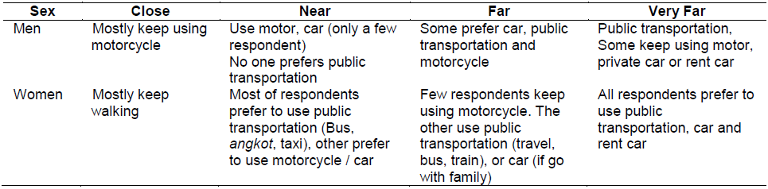
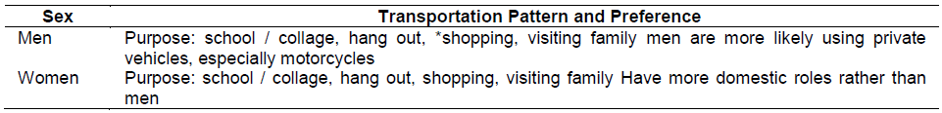
Source: Gender Assessment in Urban Transportation Case Study: Semarang City, Indonesia, by Budiarti, R. and Nurhadi, M. in Indonesian Journal of Planning and Development, Volume 2 No 1, February 2017, 39-50

Ride-sourcing (also known as ‘on-demand-rides’ or ‘ride-hailing’) is one of the most popular forms of smart mobility. However, there have been some considerable safety setbacks because cases of drivers sexually assaulting female passengers have emerged. Given the emerging demand for safe transport services for women, women-only ride-hailing services (exclusively women drivers and passengers) have been launched in many countries. In Indonesia, where people often hitch rides, two women-only, motorcycle ride-hailing services, LadyJek and Sister Jek, have been launched and in Aceh, Ojek Syari

Gender and battery electric vehicles

Battery electric vehicle

Within transport and urban studies, there is a vast literature on the car as a means of transportation and its role in the city and urban life. Here, the issue of automobility and environmental harm is salient, with some studies arguing that women prefer to employ more sustainable travel modes than men. It is found that men drive more and longer distances, primarily for work, while women use cars less and use them predominantly for duties related to household and family. Also, women are more likely to see the car as more of a practical device than men. In sum, women are considered more likely than men to adapt to a sustainable transportation system and to constitute positive change agents for a more sustainable transport sector.

Research on BEVs has mainly focused on the dimension of sustainability. For instance, lifestyles and identities influence consumers’ decisions to adopt environmentally friendly technologies, it is correlated between commitment to environmentalism and adoption of EVs. EV users modify their travel behavior, opting for more efficient travel practices, possibly contributing to more sustainable future mobilities. Additionally, from a sociotechnical perspective, the adoption of EVs increases awareness of energy consumption, spurring pro-environmental values more generally. The practice of driving electric cars alters user habits by making transportation needs more noticeable, while also raising the technological competence of users and awareness of their energy consumption.

Based on UNDP interviews with several 2-wheeler taxi drivers from Gojek regarding driver’s preferences for electric motorbikes, several male drivers said that what is attractive for them to use an electric motorbike is low price, low credits and small down payment or no down payment at all. Several male drivers also conveyed the importance of an electric motor that is robust, can carry loads and can also be used to carry their family. Meanwhile, female driver prefers an electric motorbike as a backup vehicle, if the ICE motorbike cannot be used, while waiting for the infrastructure to support the electric motorbike to become available. Several male drivers have also suggested a trial use of this electric motorbike with a rental system. Furthermore, the involvement of other vulnerable groups, such as people with disabilities and low-income groups, will be assessed during project implementation, particularly in the design, safety, and affordability of electric vehicles.

Battery industry

"Indonesia must become a major player in the electric vehicle industry," said President Joko Widodo when delivering his opening speech at a limited meeting discussing the acceleration of electric motor vehicle program at the Presidential Palace, in January 2019.
Therefore, in March 2021, an electric battery company called the Indonesian Battery Company (IBC) was formed as a holding to manage the integrated electric vehicle battery (EV) industry ecosystem from upstream to downstream. IBC is a mining industry holding with a joint share of MIND ID, Antam, Pertamina and PLN with a share composition of 25% each. IBC will also work with third parties who can bring in investment along the value chain process, mastering technology and global markets. The goal is to form a cooperation along the value chain for the EV battery industry, from nickel processing, precursor and cathode materials, to battery cells, packs, energy storage systems (ESS), and recycling. Indonesia has abundant nickel reserves and controls about 27% of the global market. According to the Ministry of Energy and Mineral Resources (ESDM), throughout 2019, Indonesia became the largest nickel producer in the world with nickel production of 800,000 tons. In 2019, Indonesia was also listed as the second largest nickel exporter for the steel industry in the European Union countries. In addition, nickel is also one of the largest metals used in the manufacture of electric batteries. The Indonesian government has banned raw nickel exports as of January 2020. This ban on raw mineral exports refers to the Minister of Energy and Mineral Resources Decree No. 11 Year 2019 on the Second Amendment to the Minister of Energy and Mineral Resources Decree No. 25 Year 2018 on Mineral and Coal Mining Business.

Based on research by Sunaria Taslim (2020) on the Socio-Economic Life of Women Workers at PT Weda Bay Nickel Mining Company in Central Halmahera District, female mining workers in which less than 10% of total employee at the company are having two lives, in which work life and family life. In work life, recruitment, work activities, and work shifts are general (gender-neutral), although there are specific policies for women related to reproductive health and not working on night shifts, this is based on the Manpower Law. As women who work in a shift system, women workers try to balance their work activities and household activities with the help of their husbands and other family members (such as their parents). In the workplace, although the involvement of women as heavy equipment operators is relatively acceptable among male workers, harsh criticism is directed at them, starting from their resilience to survive in the mining sector and company policies that are specific to women. By working as female workers, women feel a change in their lives, namely that they become more cared for by their families, are involved in decision making, can help the family economy and improve the family's social status. Although families (especially husbands) accept their family members (or wives) to work as female workers, criticism has come from the surrounding community, especially regarding childcare because it is considered as wife's duty, rather than as a joint duty between husband and wife. As a result, when something happens to the child, the wife becomes the most potential person to be blamed (socially blamed).

Representation of women in the science, technology, engineering and mathematic (STEM) industry

International commitments on climate change have integrated gender issues into mitigation and adaptation actions, starting with CoP 20, in 2014 on “The Lima Work Program on Gender” which invites countries to advance gender equality and pursue gender responsive climate change policies. This commitment was continued in Decree No. 21 from CoP 21 in 2015, concerning "Gender and Climate Change" and Decree No. 3 on the "Establishment of Gender Action Plan" which was produced at the CoP 23 in 2017.

Responding to gender integration in the climate activity, the Indonesian government has also started to integrate gender into the climate change activity budget in each sector. In 2020, UNDP conducted a Gender Responsive Climate Change Financing Study in Indonesia. The results showed that in 2020 – 2024 budget the Ministry of Energy and Mineral Resources has integrated gender into its activities, namely planning for development and monitoring of new, renewable energy infrastructure and energy conservation with expected output of energy efficiency equipment. In this activity, gender integration is aimed at optimizing the potential of women as change agent in the energy-saving movement, as well as increasing the contribution of men in managing the household.

Gender integration in government programs is also expected to increase female professional workforce in the Science, Technology, Engineering and Mathematic (STEM) industry. According to a study from UNESCO (2015), the low level of female workers' participation in mechanical engineering is mainly due to the perception that the work environment in the STEM industry is the domain of male workers who involve physical work and therefore are not attractive to female workers. The latest data (as of February 2017) from the Central Statistics Agency (BPS) shows that there are approximately 131.55 million workers available in the domestic labor market. Based on gender comparisons, the participation rate of women is around 55% or lower than men (83.19%). In addition, only 37.4% of female workers work in the formal sector compared to male workers (62.6%). Especially for jobs in the STEM industry, it is recorded that only about 30% of workers are women. One example of woman that works in the STEM Industry is Moorissa Tjokro, who is one of six Autopilot Software Engineers who work for the Tesla (Electric Vehicle) company in California. Moorissa is the only woman and Indonesian who carries out this task. It is true, this kind of profession is rarely occupied by women.

Lack of female professional workforce in STEM fields is mainly due to their educational backgrounds. Based on data from the Center for Data and Statistics Education (PDSP) Ministry of Education in 2015, students in Vocational High Schools that study on STEM (Cooling & Air Conditioning, Engineering, Light Vehicle Engineering) were only 2% compared to male students who were almost 98% for grades 10, 11 and 12. The low number of female students in STEM-based Vocational High Schools reaffirms gender disparities nationally. Thus, Infrastructure and market transformation projects such as ENTREV provides the opportunity to promote new skills, training, increased employment, and entrepreneurship opportunities for women, as well as more equitable benefit-sharing at the community level.

Conclusion

ENTREV presents unique opportunities to strengthen women’s participation in the energy efficient electricity sector along the entire value chain, from pilot, installation, maintenance, technology conversion, and business models. However deeper gendered assessments need to be conducted in order to illustrate how women and men interact with the local economy differently. Energy sectors are primarily male dominated in Indonesia and globally, however women are an untapped resource, as key beneficiaries of lighting technologies, and consultants on how to raise awareness most effectively about new lighting technologies. Finally, addressing gender gaps at leadership, policy and industrial levels in the electricity sector is an opportunity to advance gender equality, and the economy of Indonesia at large.

  - Gender action plan (GAP)

The project is also aiming to reduce the gap between men and women. As much as possible, outputs in the various components are gender-sensitive, facilitating the access of women to the jobs associated with elements of EV (as drivers) and other elements of the EV ecosystem. The project will endeavor to encourage key players in the urban transport services to incorporate women either as operators, entrepreneurs, etc. The project includes actions to facilitate access to EV‐related jobs through training, and a revision of recruitment strategies, taking advantage of the appeal of EV technologies for potential workers (so that they are skilled in maintenance and repair of e-motor scooters, e-bicycles, and all-electric cars, as well as in the conversion of ICE motor scooters and bicycles into e-two wheelers. The project also takes benefit of the new technology to accelerate the integration of women.

Proposed activities

The introduction of electric vehicles (EVs) can be taken as an opportunity to foster women participation in jobs by giving priority to women for accessing the new jobs linked to EV (driving, maintenance and management; operation of charging stations) in the government entities and private companies associated with the project pilots. The project will facilitate further streamlining of policies to facilitate the access of women to jobs in the transport sector based on these pilots and replication activities throughout government offices and taxi and ride-haling companies as well as charging station operations in the six scale-up cities.

Furthermore, the project will support the participating government entities and public/private companies in the revision of their current job descriptions and working environments, in order to facilitate the integration of women, taking into consideration international evidence and good practice. It is expected that the participating partners will be able to mainstream gender elements in their business plans regarding EV fleet and EV infrastructure to increase the percentage of female employees, integrating these aspects within the business plans to be developed within the project and to be implemented after the project’s conclusion. This also include a gender-sensitive approach in the EV charging infrastructure pilot/demos, for example, for flexible working hours, priority setting at parking places, bike-sharing and public taxi plans. These considerations can be discussed with employees and executive officers in private companies and public institutions, since the first activities at each site are undertaken.

The following activities addressing gender issues have been included in the project:

Gender aims | Action | Additional indicators for GAP | Responsible institution
Overall project objective:
Support the Government of Indonesia and key stakeholders in policy, institutional & technical readiness to transition towards electric mobility and to demonstrate innovative business models in the transport sector that will lead to GHGs emissions reduction
Gender-sensitive indicators in logframe:
3) Number of direct project beneficiaries disaggregated by gender (individual people) [GEF core indicator]
Active participation of women and men in capacity building trainings throughout the project | Require and encourage active participation of women and men in capacity building trainings throughout the project | - Cumulative number of women and men participating in capacity building trainings throughout the project  - Ratio of women and men participating in capacity building trainings throughout the project | PMU  MEMR/DGE
Outcome 1
Institutional framework and strategy for battery vehicle industry and charging infrastructure ecosystem
Gender-sensitive indicators in logframe:
4) Statistics updated including gender-disaggregated data on EV use (per type of transport, private, taxi, 2-wheeler) and employment in EV ecosystem
Enhanced gender balanced employment in the energy sector | Encourage company that includes in the BEV ecosystem (investor for charging station, swap battery and battery manufacturers) to increase the number of female interns.  Contracting professional female workers as consultant, financial adviser, technicians, engineer, and customer service, as appropriate | - Ratio of women and men interns in several BEV related companies  - Ratio of women and men employed through jobs created from the project (40/60) | PMU  MEMR/DGE  MEMR/DG  PMU  UNDP
Women and men employees in relevant government institutions have an active role to develop policy and enforce BEV ecosystems | Require and encourage active participation of women and men in trainings, workshops and focus group dialogues | - Ratio of women and men participating in stakeholder consultation meetings on policy and regulation development | PMU  MEMR/DGE
Outcome 2: Demonstration of early BEV market development

Enhanced gender balanced employment in the energy sector | Contracting women in consultancy, financial adviser, engineer, technicians, and customer services, as appropriate  Require and encourage contractors to employ women, as appropriate | - Ratio of women and men employed through jobs created from the project | PMU  MEMR/DGE  UNDP
Equal participation of women and men in stakeholder consultation meetings on installation of charging station in pilot areas | Require and encourage active participation of women and men in stakeholder consultation meetings for the public on installation of charging station in pilot areas  Ensure that stakeholder consultation meetings are held at times and locations convenient for women | - Ratio of women and men participating in stakeholder consultation meetings in pilot areas | PMU  MEMR/DGE
Women and men in pilot areas are benefiting from BEV technologies equally | Collect information on number of beneficiaries and their level of satisfaction through periodic market surveys, monitoring visits etc. | - Cumulative number of women and men benefiting from BEV and its infrastructures as influenced by the project  - Ratio of women and men benefiting from BEV and its infrastructures influenced by the project  - Women’s and men’s level of satisfaction with BEV and its infrastructures provided by the project (reliability, affordability, convenience, efficiency) | PMU  MEMR/DGE
Active participation of women and men in the regular market surveys | In the design of periodic market surveys on EV charging stations, incorporate gender preference questions  In the design of periodic market surveys on battery manufacturer, specifically address women’s needs, preferences and habits in acquirement, consumption, and disposal of battery products  Ensure that periodic market surveys conducted amongst the beneficiaries of the BEV conversion from ICE are also targeting women. | - Ratio of women and men participating in the periodic market surveys | PMU  MEMR/DGE
Outcome 3: Knowledge products and capacity building for scaling up and environmental-friendly battery use
Gender-sensitive indicators in logframe:
14) Number of people (disaggregated by gender) sensitized by the awareness campaigns through different media and implementation of project activities;
16) Capacity enhancement of local technicians on EV repairing service, accessories business, and environment-friendly buttery reuse or recycling (incl. % women)
Enhanced gender balanced employment in the energy sector | Require and encourage to increase the percentage of women staff in repair shop and training institution for conversion ICE vehicle to BEV  Require relevant government institutions to increase the number of women interns involved in assignments related to energy efficiency  Contracting women in consultancy, financial and customer services, as appropriate | - Ratio of women and men certified for converting ICE to BEV  - Ratio of women and men interns in government institutions engaged in assignments related to energy efficiency  - Ratio of women and men employed through jobs created from the project | PMU  MEMR/DGE  UNDP

- Stakeholder engagement plan

Project preparation

During the project preparation (PIF and PPG stage), consultations were held with stakeholders with the objective of informing project design, validating project activities and ensuring interventions are as inclusive as possible, as well as in line with international best practice, the existing relevant national policies, and electric vehicles initiatives.

Project inception and implementation

The project will effectively engage the stakeholders involved in the project to get their support and guide the project implementation to achieve higher results.
- Project outreach proposed includes project website, media (print/audio visual), workshops, trainings, etc.
- The PMU and the Project Board will ensure that the Gender Action Plan recommended by the project is pursued and implemented. The various groups especially women will be engaged during the consultation meetings, prioritized to avail the program, and be included in the different capacity building programs. The project will also ensure that it is closely coordinated with other initiatives supported by development partners on electric mobility
- Meetings, monitoring visits, surveys, and written communications will be used to receive feedback to continue the ongoing dialogue as well as during implementation.
- The project will follow a participatory approach in decision making by engaging all the relevant stakeholders. The Government agencies, NGOs, CSOs, and the private sector actors will be actively involved during the project implementation.

The table below presents the Stakeholder Engagement plan and summarizes different categories of stakeholders, which are described in Section 4.2. Key indicator for the engagement of each group of stakeholders is their practical involvement in implementation and dissemination. Partnership with private sectors will be pursued upon approval of the due diligence process by UNDP.

Stakeholder group or organization | Roles and responsibilities | Relation to project outcomes
MEMR  Directorate General for New and Renewable Energy and Energy Conservation (DG-NREEC) | - The project will work closely with the DG of New and Renewable Energy and Energy Conservation (DG-NREEC) of Ministry of Energy and Mineral Resources (MEMR. As the poject’s Implementing Partner, MEMR will provide overall leadership and strategic direction and guidance to the project; Review the project’s progress in monthly meetings held.; Chair the PSC for making consensus-based strategic, policy & management decisions for the project. MEMR will provide a senior official as the National Project Director (NPD)  - MEMR contributes with cash and in -kind co-financing of USD 15,966,000 | All Components
Other ministries  (MoI, MoT, MOEF) | - Directorate-General for Metal, Machine, Transportation Equipment, and Electronics Industry is responsible to develop a standard for BEV  - Directorate-General for Land Transport is responsible for BEV testing  - Directorate General for Climate Change on mitigation reporting from BEV development  - Directorate for Transportation of Bappenas is responsible for deciding national priority programs to be included in national mid-term development planning | Component 1
Regional governments | - The project will work closely with DKI Jakarta government (Bappeda) to develop a demonstration project of BEV in Jakarta and with local government of West Java and Bali. The West Java Provincial Government has confirmed cash and in-kind co-financing of USD 1,600,000 | Component 2
Local/ national and international NGOs | - The project will work with NGOs with sustainable transport interests on on cooperation and information exchange regarding EV and EV infrastructure and experiences on the ground | Component 3
State companies (utilities); private companies (taxis, ride hailing) | - PT PLN is responsible for determining charging tariff, the establishment of charging stations, and electricity supply. PPT PLN will technically and financially support the establishment of charging stations (with in-kind and cash co-financing of USD 800,000)  - PT Pertamina has the mandate to develop batteries y for BEVs and battery swap station in Indonesia  - PT IBC will pilot and develop the battery swap business  - Bluebird, Grab and Gojek fleets have the potential to use BEV  - Ezyfast is planning to cooperate with DKI Jakarta Government to install a battery swap station  - PT JUP is going to build several charging stations in Jakarta | Component 1  Component 2
National research institutes and universities | - Research and background studies on EV and EV ecosystem  - Provide training and education on EV-relevant subjects  - P3TEW (Research and Development Center), a government agency under MEMR, will lead the activities on enhancement of technical capacities in conversion of conventional two-wheelers to the battery-based electric motorcycle (contributing USD 457,436 in cash and in-kind co-financing) | Component 3
Indonesian Conservation and Energy Efficiency Society (MASKEEI) | - Involve in the policy discussion on accelerating transition to EVs  - Involve in policy advocacy to Government | Component 1
Society Renewable Energy Women (SRE Women) | - Involve in awareness raising on EVs among youth and women  - Provide input for gender-specific intervention in pilot demonstration design  - Involve in impact assessment to women employment due to transition to EVs | Component 2  Component 3

Responsibilities
The PMU is primarily responsible for carrying out the specified stakeholder engagement activities. The stakeholders will be engaged while carrying out various assessments and studies, training, and workshop events.

Grievance mechanism
People concerned with or potentially affected by the project can express their grievances for consideration and redress. The Project Management Unit will receive grievances and will try to resolve at the PMU level if possible. If not possible then the issues will be referred to the Project Board that will try to settle the issues amicably. In the event the party is not accepting the decision then he/she can put the case to Arbitration. The design of the Grievance Redress Mechanisms (GRM) will be elaborated at project inception and operationalized prior to the initiation of activities. Any person or group of persons affected by a UNDP-supported project can make a claim to the UNDP Social and Environmental Complains Unit (SECU) and the SRM (Stakeholder Response Mechanism) through https://undp.tnwreports.com and by e-mail (https://undp.tnwreports.com).

Monitoring and reporting
The project stakeholders would be engaged at various levels to carry out the monitoring activities. Then the PMU will laisse with relevant Government agencies and other partners and collect data and monitor the activities on a regular basis. The PMU will report back the results to the stakeholders at the earliest through letters or conduct meetings both individually as well as through engagement of all relevant agencies.
Communication plan

The Project will also emphasize strong communications with a broader range of stakeholders. Key elements of the project’s communication strategy are outlined in the table below:

Key element | Relevant group | Means
1. Project governance meetings; PSC meetings; Working Group meetings | All stakeholders that are members of the PSC or its Working Groups or are invited to attend | Meetings
2. Seminars/workshops and training events, including the Inception workshop, and final project workshop | National and sub-national government officials  Private sector; NGOs and CSOs | Workshop, meeting, seminar, training  On-the-job training
3. Project documents, thematic reports and publications; Technical and other reports | Government departments and decision-makers at the national and subnational level;  Development partners  Research institutes and academia; individual experts; NGOs | Direct dissemination (e.g., email or hard copy/ USB-drive)  Access via website to reports and documents and database and info systems
4. Project knowledge capturing and info dissemination | Government officials  Financial and private sector  Development partners;  NGOs and CSOs | Online access;  Printed materials  Media

- UNDP Social and environmental safeguards procedure (SESP)

Project Information

Project Information
- Project Title | Enhancing Readiness for the Transition to Electric Vehicles in Indonesia (ENTREV)
- Project Number | 6333
- Location (Global/Region/Country) | Indonesia
- Project stage (Design or Implementation) | Design
- Date | 19/09/2022
Part A. Integrating Overarching Principles to Strengthen Social and Environmental Sustainability

QUESTION 1: How does the project integrate the programming principles in order to strengthen social and environmental sustainability?
Briefly describe in the space below how the Project mainstreams the human-rights based approach

From a human-rights-based approach, it is the right of every individual to enjoy a clean and safe environment. The proposed project will help to realize this human right based on replacing the polluting internal combustion engines (ICE) with electric vehicles which have no vehicular tailpipe emissions like Nitrogen oxides (NOx), Hydrocarbons (HC), Sulphur dioxide (SO2), Particulate matter (PM10), Ozone (O3) and less overall emissions compared to ICE vehicles. Therefore, it is envisaged that by promoting electric mobility, the contribution of the transport sector to air pollution in major Indonesian cities will, in the long run, be reduced. Hence, there will be an improvement in the quality of life in urban areas. Furthermore, a human-rights-based approach calls for protecting the most vulnerable persons in the community. The proposed project aims at enabling a conducive and affordable market for electric vehicles. Therefore, by easing the entry of electric vehicles into the Indonesian market, environmentally-conscious consumers of private vehicles will have the choice of buying electric vehicles – a choice currently not readily available. During project implementation, all key stakeholders will be engaged during the consultation process (e.g. by means of Focus Group Discussions).

Briefly describe in the space below how the Project is likely to improve gender equality and women’s empowerment
It is anticipated the project will contribute to improving the quality of life for all urban dwellers in the long run through improved air quality as well as through the provision of a safer, quieter, and more affordable transportation option. A significant proportion of urban women rely on public transportation, namely buses and motorcycle taxis. Therefore, by enhancing the way these services are delivered – through electric mobility, it is expected that all users will enjoy improved services with less exposure to air pollution. Furthermore, it is expected that during the Project, special consultations will be made with women groups in order to obtain their needs. Furthermore, opportunities for women empowerment will be identified, especially in form of increased participation of women in the provision of the currently male-dominated transportation service. It is envisaged that gender action will encompass the entire EV ecosystem, and consider increasing participation of women: i) as users of EVs, ii) in customer care services, iii) in operations & maintenance services, iv) in value-added services in and around charging stations, and v) for billing. During the project preparation grant (PPG) phase, the project has come up with indicators to further assess project impact on both genders using suggested methodologies (see Annex H on gender analysis), which will be mainstreamed into project preparation and subsequently its implementation.
Briefly describe in the space below how the Project mainstreams environmental sustainability and resilience
The project is geared towards promoting and supporting electric vehicles as among the key elements for the satisfactory achievement of the energy and clean air environment and development agenda of the country. This means that environmental sustainability is at the heart of the Project, which acts as an accelerator for the adoption of electric vehicles, thereby helping to achieve a reduction in GHG emissions nationally, as well as reducing air pollution especially in urban areas where the urban population may otherwise depend on emission heavy sources such as diesel and gasoline for transportation.
The proposed initiative will contribute to a longstanding environmental sustainability impact, especially in larger cities such as Jakarta. This is because the project aims at addressing a fundamental air quality problem plaguing Jakarta and other major cities in Indonesia. The predominant contributor to air pollution in the aforementioned cities is tail-pipe emissions from ICE-based vehicles. Previous attempts to address this issue include reducing the number of vehicles entering the city. However, the very high number of vehicles calls for a fundamental change in the approach. Therefore, by encouraging the shift to electric vehicles, a decline in tail-pipe emissions is anticipated and will thereby promote urban environmental sustainability. The proposed project is expected to contribute to a reduction of 14.3 kilotons of CO2e, secondary direct emission reduction of 395.0 ktCO2 and indirect reduction of 6,123.1 kilotons of CO2e. Environmental sustainability will be assured through the synergistic integration of energy- transport that the project aims to develop and the higher chances of scaling up of the entire EV supply chain, thus reducing fossil fuel emissions.
Briefly describe in the space below how the project strengthens accountability to stakeholders
The project will effectively engage the stakeholders involved in the project to get their support and guide the project implementation to achieve higher results, by a) project outreach proposed includes project website, media (print/audiovisual), workshops, training, etc; b) the PMU and the Project Board will ensure that the Gender Action Plan recommended by the project is pursued and implemented (the various groups especially women will be engaged during the consultation meetings, prioritized to avail the program, and be included in the different capacity building programs), c) meetings, monitoring visits, surveys, and written communications will be used to receive feedback to continue the ongoing dialogue as well as during implementation, d) the project will follow a participatory approach in decision making by engaging all the relevant stakeholders.

QUESTION 2: What are the Potential Social and Environmental Risks?  Note: Complete SESP Attachment 1 before responding to Question 2. | QUESTION 3: What is the level of significance of the potential social and environmental risks?  Note: Respond to Questions 4 and 5 below before proceeding to Question 5 |  |  | QUESTION 6: Describe the assessment and management measures for each risk rated Moderate, Substantial or High
Risk Description | Impact (I) and Likelihood (L) (1-5) | Significance  (Low, Moderate, Subst., High) | Comments | Description of assessment and management measures as reflected in the Project design. If ESIA or SESA is required note that the assessment should consider all potential impacts and risks.
Risk 1: Potential for safety risks related to the operation of unregulated Electric Vehicle Charging Stations (EVCS).*)  Standard 3. | I = 2  L = 1 | Low | As EVCS are relatively complex systems that operate at significant voltage levels, they need to be regulated through formal registration in accordance with the law. | This risk of unregulated EVCSs is low. First, state utilities like PLN will run charging stations and will comply with government instructions on safety. Second, the risk will be managed through the design of the project, with management measures integrated into the project’s relevant outputs. Additional management measures will be considered, as needed, as specified in the Environmental and Social Management Framework.  Construction of the EV charging stations (EVCS) and battery swap stations are considered small infrastructure. It requires about 2x2 meter square area per station and according to existing Minsitry of Environment’s regulation, EVCS impact to environment is not significant.
Risk 2: Inappropriate location of Electric Vehicle Charging Stations (EVCS) could be exposed to impacts of adverse climate change and therefore harmful to people and/or the environment *)  Standard 2. | I = 3  L = 3 | Moderate | The selection of the location of the charging stations has to be carefully done to avoid locations considered to be: flooding/water logging prone areas; landslides prone areas; and, ecologically sensitive areas. | Environmental and social assessment and due diligence will inform selection of demo/pilot sites to avoid placement of EVCS in hazardous locations or locations that present other environmental and social risks. Requirements for site selection are further specified in the project ESMF.
Risk 3: Risk of limited participation of women in the program *)  Principle 2. | I=3  L=3 | Moderate | A target of the proposed project is the public transportation (taxi) sector which is predominantly male-dominated. There is a risk that this trend might continue even after the project is implemented., To this can be added, that few women (if at all) work as technician/manager in workshops, filling stations, or charging facilities. Women are not usually engaged during the consultation meeting. Therefore, their participation is encouraged under the program and included in the different capacity building programs. | Gender analysis has been undertaken and a Gender Action Plan has been prepared with the aim to get both women and men involved in the various activities, without discrimination. However, while the project will endeavor to encourage key players in the urban transport services to incorporate women either as operators, entrepreneurs, etc., the duration of the project may not be long enough to break the socio-cultural dynamics that impede women from participating in the sector.
Risk 4: Potential direct and indirect environmental impacts from battery production and disposal.  Potential direct and indirect environmental impacts from battery production and disposal. This includes direct environmental risk related to handling batteries that have reached their end-of-life. Also, indirect risk of increased impacts related to the resource extraction needed for the batteries (however: the Project will not directly be involved in battery manufacturing)  Standard 8. | I = 4  L = 3 | Substantial | Electric vehicle batteries are produced from rare earth metals some of which are not environmentally friendly. Therefore, the disposal of unrecyclable material from battery manufacturers must be handled properly. In addition, when batteries have reached their end-of-life, they also need proper disposal to minimize environmental impact and exposure to society. | During the project, an assessment of existing standards, laws, and regulations will be undertaken in order to determine the gaps that the project will fill in terms of delivering draft regulations and standards to govern the disposal of batteries and waste from battery manufacturing processes. These will be an important step towards strengthening environmental safeguards. During the Project, the option of “extending” the life of the batteries will be examined for possible inclusion in the aforementioned standards and regulations. The project will include the development of policy guidelines/regulations for the collection, safe disposal/waste management, and recycling of the batteries (see Output 3.3.). A strategic assessment of social and environmental impacts of BEV in Indonesia will be conducted, looking at the life-cycle of batteries (including resource extraction). This strategic assessment will inform relevant decision-making, policies, guidelines, e.g. through assessment of technical and economic aspects of retired BEV battery use including the potential impact of discarded batteries (if not reused/ recycled), re-manufacturing, secondary use of retired BEV batteries (such as for off-grid power), and recycling after the secondary use life is exhausted as well as human rights, environmental issues related to the extraction of raw materials for the batteries. Requirements for the strategic environmental and social assessment are clarified further in the project ESMF and aligned with UNDP’s SES and related guidance.  In addition, potential direct environmental impacts related to the EVCS demonstration pilots, anticipated to be of limited scope and scale and managed through best practice measures (consistent with UNDP’s definition of Moderate Risk) will be addressed through a simplified ESMP to be prepared for the demonstration pilots prior to their initiation.
Risk 5: Potential occupational health and safety risks associated with electric vehicle repair and decommissioning of battery banks and/or vehicles. (indirect impact associated with activity 3.3.3) *)  Standard 3 and 7. | I = 4  L = 2 | Moderate | Battery Electric Vehicles (BEVs) operate at 3-phase high voltage. Consequently, they must be maintained by properly trained technicians. As expected, most of the existing crop of vehicle repair technicians were trained at a time when electric vehicles were unheard of. Therefore, retraining will be required for the technicians involved in electric vehicle repair or decommissioning. | While project labour will not be involved in EV repair or decommissioning, this is identified as an indirect risk of the project. Therefore, as part of project implementation, a capacity assessment of the existing stock of automotive mechanical and electrical technicians will be undertaken in order to incorporate in the proposed project a component for building the capacity of technicians to enable them to handle the repair and decommissioning of electric vehicles. In addition, the project will be designed to include a component for public awareness which will be useful to impress on the general public who will own electric vehicles, the need for taking them to repair shops that have the appropriate equipment and training to handle such cars. The training requirements will also be assessed and training provided to ensure that the operators of the Charging Stations are sensitized about the risks and safety protocols (component 3). It is expected that electric vehicle dealers will also provide thorough end-user training to avoid accidental injury due to electric shock. The strategic environmental and social assessment will also look at OHS risks related to battery production, maintenance and disposal to inform safeguards and best practice OHS measures in the EV sector.
Risk 6: There could be other unforeseen unintended impacts arising from new standards/ regulations to be developed during the project implementation *)  Standard 3. | I = 2  L = 1 | Low | There is a small chance that unforeseen unintended impacts both positive and/or negative may arise from the new standards/ regulations. | It is expected that during project implementation, the risk assessment (as presented in this project document) will be re-examined on a regular basis. During the start of project implementation, the scope of including a Grievance Redress Mechanism (GRM) at various levels will also be discussed with the Government of Indonesia. Requirements for subsequent social and environmental screening, assessment, management as well as design of the project GRM will be detailed in the project ESMF. This risk will also be addressed through the SESA that the project will support to inform the framework and strategy for BEV in Indonesia.
Risk 7: Vulnerable or marginalized groups, might not be involved in project design and implementation and therefore not engaged in, supportive of, or benefitting from project activities;  Principle 1 | I = 2  L = 2 | Low | The engagement of all key stakeholders is required to ensure that the needs and concerns of everyone, especially the vulnerable and marginalized communities, are voiced. | A comprehensive Stakeholder Engagement Plan was developed during PPG that will be updated during project implementation, as needed, to ensure that all key stakeholders are involved during project implementation, in particular NGOS/CSOs that work with vulnerable or marginalized groups. In addition, the strategic environmental and social assessment process will ensure meaningful stakeholder engagement.
Risk 8: Wide adoption of BEV may trigger key mineral mining activities for batteriesy, i.e., nickel, leading to indirect social and environmental impacts.  Standard 3, 6, 8. | I = 2  L = 1 | Low | The direct project locations for installing charging station will be based in urban areas and do not involve mining sites. However, since the project promotes market adoption of BEV, there are potential indirect environmental and social risks related to potential increase in mining activities of the key mineral for battery production. However, because the project has no decision making or direct influence over mining activities, the potential impact from the project on mining is identified as Low but is noted to ensure the project can identify opportunities to support partners in considering these indirect risks of BEV expansion. | While the project would not be involved in mining activities or activities at mining sites, this indirect risk would be addressed through the SESA process that the project will support. This will include consultations with Nusantara Indigenous Community Alliance (AMAN) and other affected peoples to build understanding on the BEV value chain and potential risk of key mineral mining activities for EV battery due to increase market demand for BEV. This will be fundamental to the project’s support in helping develop a framework and strategy for BEV in Indonesia. The project will also promote implementation of social and environmental compliance standards in mining areas in cooperation with MoEF.
Note:
*) Unlike EVCS, BSS are more of a “service provided” within an existing infrastructure. There may only be risk of battery disposal, this is covered under Risk 4

Part B. Identifying and Managing Social and Environmental Risks

 | QUESTION 4: What is the overall Project risk categorization?
 | Select one (see SESP for guidance) |  | Comments
 | Low Risk | ☐ | Three low risks have been identified
 | Moderate Risk | ☐ | Four moderate risks have been identified
 | Substantial Risk | X | One substantial risk has been identified
 | High Risk | ☐
 | QUESTION 5: Based on the identified risks and risk categorization, what requirements of the SES are triggered? (check all that apply)
 | Question only required for Moderate, Substantial and High Risk projects
 | Is assessment required? (check if “yes”) | ☐ |  |  | Status? (completed, planned)
 | if yes, indicate overall type and status |  | x | Targeted assessment(s) | Assessment needed per EVCS on potential location hazards and impacts and safety, waste handling measures (planned to address Risks 2 and 5).  Gender assessment to address Risk 3 (status: completed in Annex I)
 | if yes, indicate overall type and status |  | ☐ | ESIA (Environmental and Social Impact Assessment)
 | if yes, indicate overall type and status |  | X | SESA (Strategic Environmental and Social Assessment) | Assessment of battery manufacturing and recycling (planned under activity 3.3.3)
 | Are management plans required? (check if “yes) | ☐
 | If yes, indicate overall type |  | ☐ | Targeted management plans
 | If yes, indicate overall type |  | X | ESMP (Environmental and Social Management Plan which may include range of targeted plans) | Simplified ESMP will be developed for each of EVCS location and included as part of business plan, by considering existing country’s regulation for EVs charging station and battery swap station.
 | If yes, indicate overall type |  | X | ESMF (Environmental and Social Management Framework) | Completed:  An ESMF for the project has been developed prior to project approval.  Planned:  Recommendation of framework to inform environmental and social safeguards in battery production, maintenance/recycling, and disposal, as result from assessment conducted under activity 3.1.1.
 | Based on identified risks, which Principles/Project-level Standards triggered? |  | Comments (not required)
 | Overarching Principle: Leave No One Behind
 | Human Rights | ☐
 | Gender Equality and Women’s Empowerment | x
 | Accountability | ☐
 | 1. Biodiversity Conservation and Sustainable Natural Resource Management | ☐
 | 2. Climate Change and Disaster Risks | x
 | 3. Community Health, Safety and Security | x
 | 4. Cultural Heritage | ☐
 | 5. Displacement and Resettlement | ☐
 | 6. Indigenous Peoples | ☐
 | 7. Labour and Working Conditions | x
 | 8. Pollution Prevention and Resource Efficiency | x
Final Sign Off

Signature | Date | Description
QA Assessor  Verania Andria  Senior Advisor for Sustainable Energy | 19/09/2022 | UNDP staff member responsible for the Project, typically a UNDP Programme Officer. Final signature confirms they have “checked” to ensure that the SESP is adequately conducted.
QA Approver |  | UNDP senior manager, typically the UNDP Deputy Country Director (DCD), Country Director (CD), Deputy Resident Representative (DRR), or Resident Representative (RR). The QA Approver cannot also be the QA Assessor. Final signature confirms they have “cleared” the SESP prior to submittal to the PAC.
PAC Chair |  | UNDP chair of the PAC. In some cases PAC Chair may also be the QA Approver. Final signature confirms that the SESP was considered as part of the project appraisal and considered in recommendations of the PAC.

SESP Attachment 1. Social and Environmental Risk Screening Checklist

Checklist Potential Social and Environmental Risks
INSTRUCTIONS: The risk screening checklist will assist in answering Questions 2-6 of the Screening Template. Answers to the checklist questions help to (1) identify potential risks, (2) determine the overall risk categorization of the project, and (3) determine the required level of assessment and management measures. Refer to the SES toolkit for further guidance on addressing screening questions.
Overarching Principle: Leave No One Behind - Human Rights | Answer  (Yes/No)
P.1 Have local communities or individuals raised human rights concerns regarding the project (e.g. during the stakeholder engagement process, grievance processes, public statements)? | No
P.2 Is there a risk that duty-bearers (e.g. government agencies) do not have the capacity to meet their obligations in the project? | No
P.3 Is there a risk that rights-holders (e.g. project-affected persons) do not have the capacity to claim their rights? | No
Would the project potentially involve or lead to:
P.4 adverse impacts on the enjoyment of the human rights (civil, political, economic, social or cultural) of the affected population and particularly of marginalized groups? | No
P.5 inequitable or discriminatory impacts on affected populations, particularly people living in poverty or marginalized or excluded individuals or groups, including persons with disabilities? | No
P.6 restrictions in availability, quality of and/or access to resources or basic services, in particular to marginalized individuals or groups, including persons with disabilities? | Yes
P.7 exacerbation of conflicts among and/or the risk of violence to project-affected communities and individuals? | No
Gender Equality and Women’s Empowerment
P.8 Have women’s groups/leaders raised gender equality concerns regarding the project, (e.g. during the stakeholder engagement process, grievance processes, public statements)? | No
Would the project potentially involve or lead to:
P.9 adverse impacts on gender equality and/or the situation of women and girls? | No
P.10 reproducing discriminations against women based on gender, especially regarding participation in design and implementation or access to opportunities and benefits? | Yes
P.11 limitations on women’s ability to use, develop and protect natural resources, taking into account different roles and positions of women and men in accessing environmental goods and services?  For example, activities that could lead to natural resources degradation or depletion in communities that depend on these resources for their livelihoods and well being | No
P.12 exacerbation of risks of gender-based violence?  For example, through the influx of workers to a community, changes in community and household power dynamics increased exposure to unsafe public places and/or transport, etc. | No
Sustainability and Resilience: Screening questions regarding risks associated with sustainability and resilience are encompassed by the Standard-specific questions below
Accountability
Would the project potentially involve or lead to:
P.13 exclusion of any potentially affected stakeholders, particularly marginalized groups and excluded individuals (including persons with disabilities), from fully participating in decisions that may affect them? | No
P.14 grievances or objections from potentially affected stakeholders? | No
P.15 risks of retaliation or reprisals against stakeholders who express concerns or grievances, or who seek to participate in or to obtain information on the project? | No
Project-Level Standards
Standard 1: Biodiversity Conservation and Sustainable Natural Resource Management
Would the project potentially involve or lead to:
1.1 adverse impacts to habitats (e.g. modified, natural, and critical habitats) and/or ecosystems and ecosystem services?  For example, through habitat loss, conversion or degradation, fragmentation, hydrological changes | No
1.2 activities within or adjacent to critical habitats and/or environmentally sensitive areas, including (but not limited to) legally protected areas (e.g. nature reserve, national park), areas proposed for protection, or recognized as such by authoritative sources and/or indigenous peoples or local communities? | No
1.3 changes to the use of lands and resources that may have adverse impacts on habitats, ecosystems, and/or livelihoods? (Note: if restrictions and/or limitations of access to lands would apply, refer to Standard 5) | No
1.4 risks to endangered species (e.g. reduction, encroachment on habitat)? | No
1.5 exacerbation of illegal wildlife trade? | No
1.6 introduction of invasive alien species? | No
1.7 adverse impacts on soils? | No
1.8 harvesting of natural forests, plantation development, or reforestation? | No
1.9 significant agricultural production? | No
1.10 animal husbandry or harvesting of fish populations or other aquatic species? | No
1.11 significant extraction, diversion, or containment of surface or groundwater?  For example, construction of dams, reservoirs, river basin developments, groundwater extraction | No
1.12 handling or utilization of genetically modified organisms/living modified organisms? | No
1.13 utilization of genetic resources? (e.g. collection and/or harvesting, commercial development) | No
1.14 adverse transboundary or global environmental concerns? | No
Standard 2: Climate Change and Disaster Risks
Would the project potentially involve or lead to:
2.1 areas subject to hazards such as earthquakes, floods, landslides, severe winds, storm surges, tsunami or volcanic eruptions? | Yes
2.2 outputs and outcomes sensitive or vulnerable to potential impacts of climate change or disasters?  For example, through increased precipitation, drought, temperature, salinity, extreme events, earthquakes | No
2.3 increases in vulnerability to climate change impacts or disaster risks now or in the future (also known as maladaptive or negative coping practices)?  For example, changes to land use planning may encourage further development of floodplains, potentially increasing the population’s vulnerability to climate change, specifically flooding | No
2.4 increases of greenhouse gas emissions, black carbon emissions or other drivers of climate change? | No
Standard 3: Community Health, Safety, and Security
Would the project potentially involve or lead to:
3.1 construction and/or infrastructure development (e.g. roads, buildings, dams)? (Note: the GEF does not finance projects that would involve the construction or rehabilitation of large or complex dams) | Yes
3.2 air pollution, noise, vibration, traffic, injuries, physical hazards, poor surface water quality due to runoff, erosion, sanitation? | Yes
3.3 harm or losses due to failure of structural elements of the project (e.g. collapse of buildings or infrastructure)? | No
3.4 risks of water-borne or other vector-borne diseases (e.g. temporary breeding habitats), communicable and non-communicable diseases, nutritional disorders, mental health? | No
3.5 transport, storage, and use and/or disposal of hazardous or dangerous materials (e.g. explosives, fuel, and other chemicals during construction and operation)? | Yes
3.6 adverse impacts on ecosystems and ecosystem services relevant to communities’ health (e.g. food, surface water purification, natural buffers from flooding)? | No
3.7 influx of project workers to project areas? | No
3.8 engagement of security personnel to protect facilities and property or to support project activities? | No
Standard 4: Cultural Heritage
Would the project potentially involve or lead to:
4.1 activities adjacent to or within a Cultural Heritage site? | No
4.2 significant excavations, demolitions, movement of earth, flooding, or other environmental changes? | No
4.3 adverse impacts to sites, structures, or objects with historical, cultural, artistic, traditional, or religious values or intangible forms of culture (e.g. knowledge, innovations, practices)? (Note: projects intended to protect and conserve Cultural Heritage may also have inadvertent adverse impacts) | No
4.4 alterations to landscapes and natural features with cultural significance? | No
4.5 utilization of tangible and/or intangible forms (e.g. practices, traditional knowledge) of Cultural Heritage for commercial or other purposes? | No
Standard 5: Displacement and Resettlement
Would the project potentially involve or lead to:
5.1 temporary or permanent and full or partial physical displacement (including people without legally recognizable claims to land)? | No
5.2 economic displacement (e.g. loss of assets or access to resources due to land acquisition or access restrictions – even in the absence of physical relocation)? | No
5.3 risk of forced evictions? | No
5.4 impacts on or changes to land tenure arrangements and/or community based property rights/customary rights to land, territories and/or resources? | No
Standard 6: Indigenous Peoples
Would the project potentially involve or lead to:
6.1 areas where indigenous peoples are present (including project area of influence)? | Yes
6.2 activities located on lands and territories claimed by indigenous peoples? | No
6.3 impacts (positive or negative) to the human rights, lands, natural resources, territories, and traditional livelihoods of indigenous peoples (regardless of whether indigenous peoples possess the legal titles to such areas, whether the project is located within or outside of the lands and territories inhabited by the affected peoples, or whether the indigenous peoples are recognized as indigenous peoples by the country in question)?  If the answer to screening question 6.3 is “yes”, then the potential risk impacts are considered significant and the project would be categorized as either Substantial Risk or High Risk | No
6.4 the absence of culturally appropriate consultations carried out with the objective of achieving FPIC on matters that may affect the rights and interests, lands, resources, territories, and traditional livelihoods of the indigenous peoples concerned? | No
6.5 the utilization and/or commercial development of natural resources on lands and territories claimed by indigenous peoples? | No
6.6 forced eviction or the whole or partial physical or economic displacement of indigenous peoples, including through access restrictions to lands, territories, and resources?  Consider, and where appropriate ensure, consistency with the answers under Standard 5 above | No
6.7 adverse impacts on the development priorities of indigenous peoples as defined by them? | No
6.8 risks to the physical and cultural survival of indigenous peoples? | No
6.9 impacts on the Cultural Heritage of indigenous peoples, including through the commercialization or use of their traditional knowledge and practices?  Consider, and where appropriate ensure, consistency with the answers under Standard 4 above. | No
Standard 7: Labor and Working Conditions
Would the project potentially involve or lead to: (note: applies to project and contractor workers)
7.1 working conditions that do not meet national labor laws and international commitments? | No
7.2 working conditions that may deny freedom of association and collective bargaining? | No
7.3 use of child labor? | No
7.4 use of forced labor? | No
7.5 discriminatory working conditions and/or lack of equal opportunity? | No
7.6 occupational health and safety risks due to physical, chemical, biological, and psychosocial hazards (including violence and harassment) throughout the project life-cycle? | Yes
Standard 8: Pollution Prevention and Resource Efficiency
Would the project potentially involve or lead to:
8.1 the release of pollutants to the environment due to routine or non-routine circumstances with the potential for adverse local, regional, and/or transboundary impacts? | No
8.2 the generation of waste (both hazardous and non-hazardous)? | Yes
8.3 the manufacture, trade, release, and/or use of hazardous materials and/or chemicals? | Yes
8.4 the use of chemicals or materials subject to international bans or phase-outs?  For example, DDT, PCBs, and other chemicals listed in international conventions such as the Montreal Protocol, Minamata Convention, Basel Convention, Rotterdam Convention, Stockholm Convention | No
8.5 the application of pesticides that may have a negative effect on the environment or human health? | No
8.6 significant consumption of raw materials, energy, and/or water? | No

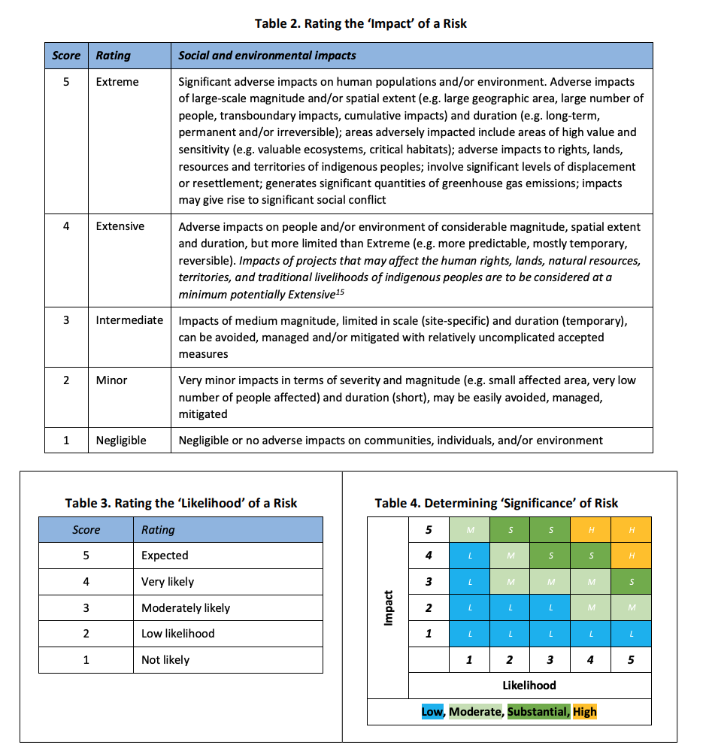

Background information on risk analysis

The government’s support for the use of BEVs is because Indonesia has a large potential market for BEVs supported by abundant reserves of minerals as raw materials for the manufacture of batteries. Therefore, infrastructure development for BEVs is an important link in the national BEVs industry chain that stretches from upstream to downstream. The development of a national BEVs industry from upstream to downstream will certainly experience various ocial, environmental and gender-related risks. It is necessary to carry out a risk analysis so that the impact of developing the national BEVs industry on social, environmental, and gender can be minimized.

In general, the national BEVs industry supply chain starts from raw material extraction, manufacturing battery and manufacturing BEVs, charging stations and battery swap stations, use of BEVs, reuse and remanufacturing, and waste. Within these chains, 7 different potential risks have been identified regarding the ENTREV activities. The solutions must be sought for these seven risks so that the development of the national BEVs industry can run optimally.

Box 43 BEV supply chain
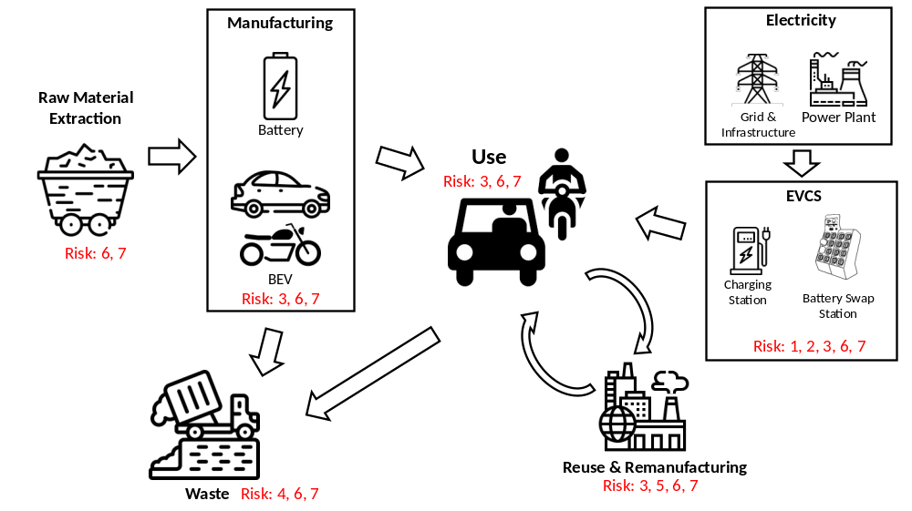

The seven potential risks include the following:
- Risk 1: Potential for the operation of unregulated Electric Vehicle Charging Stations (EVCS)
- Risk 2: Inappropriate location of Electric Vehicle Charging Stations (EVCS) could be exposed to impacts of adverse climate change and therefore harmful to people and/or the environment.
- Risk 3: Potential limited participation of women in public transportation supply chain.
- Risk 4: Potential environmental hazards associated with waste generated during the manufacture of electric vehicle batteries as well as handling batteries that have reached their end-of-life.
- Risk 5: Potential occupational health and safety risks associated with electric vehicle repair and decommissioning of battery banks and/or vehicles.
- Risk 6: There could be other unforeseen unintended impacts arising from new standards/ regulations to be developed during the project implementation.
- Risk 7: Vulnerable or marginalized groups, including indigenous people, might not be involved in project design and therefore not engaged in, supportive of, or benefit from project activities.

- Raw material extraction

Based on the U.S. Geological Survey 2020, Indonesia occupies the first position as a country that has the largest nickel ore reserves in the world, reaching 21 million tons or around 24% of the total nickel ore reserves in the world. Nickel is formed from the weathering of bedrock. The bedrock has certain conditions, namely having high iron (Fe) and aluminum (Al) content. Mafic and ultramafic igneous rock are types of rocks that have this content. Weathering of rocks is controlled by meteoric water, i.e. water derived from precipitation, falling below the surface. This water makes the nickel element move and settles down to the bottom of the water table. The method of nickel ore mining is carried out in open mining such as coal mining. The nickel layer will be taken and the overburden layer will be disposed of at the prepared location. This mining process must meet environmental criteria in accordance with applicable laws and regulations.

The location of nickel ore deposits has the potential to be in protected forest areas or national parks. Nickel ore mining in the area can come into contact with isolated or remote tribal communities (risk 7). The entry of mining companies will change the lives of isolated tribes, therefore more detailed monitoring of the social life around the mine is needed. Mineral mining can also disrupt the lives of fishermen in the vicinity due to the traffic of barges transporting mineral products to the domestic industry. Besides, forest destruction due to mining has the potential to destroy water resources. During the production process, nickel ore deposits have the potential to cause environmental damage due to wastewater treatment that does not meet environmental quality standards. This can lead to turbidity in coastal waters, massive sedimentation, and contamination of surface water.

- Manufacturing of Battery and BEVs

The government is encouraging the acceleration of the downstream development of the lithium battery raw material industry which will support the development of electric vehicles in Indonesia. Downstream efforts for the domestic battery raw material industry have been carried out which include:
- Ferronickel (FeNi) and nickel pig iron (NPI)
The process is carried out through pyrometallurgical (smelting) technology using high-grade nickel ore (saprolite) to produce ferronickel (FeNi) and nickel pig iron (NPI) which will then be processed into stainless steel. This process is the most common in Indonesia.
- Nickel matter
The process is almost the same as the first process, carried out through pyrometallurgical (smelting) technology using high-grade nickel ore (saprolite) to produce nickel matte (nickel sulfide) which can be used to produce pure nickel metal and stainless steel, and nickel sulfate compounds (raw materials for manufacturing nickel-based lithium-ion batteries).
- Nickel-sulfate compounds
The process is carried out through hydrometallurgical (leaching) technology using low-grade nickel ore (limonite). Products that can be produced are in the form of pure nickel metal and nickel sulfate compounds (raw materials for manufacturing nickel-based lithium-ion batteries). Pure cobalt metal and cobalt-sulfate compounds can also be produced (raw materials for manufacturing nickel-based lithium-ion batteries). This process will be used in Morowali Regency.

The development of the lithium battery raw material industry has started in 2019 in Morowali Regency, Central Sulawesi Province, covering an area of ​​120 ha. This raw material industry will produce new energy materials from nickel laterite to meet the raw material demand of second-generation lithium batteries. This industry produces high purity nickel-cobalt compounds for rechargeable batteries, which absorb direct labor of 2,000 people and indirectly during the construction of this factory for at least 30,000 people, including foreign workers. Therefore, the Ministry of Industry facilitates the construction of the Morowali Metal Industry Polytechnic to eventually replace existing foreign workers.

The BEVs industry has 4 (four) main components, including batteries, motor controllers, regenerative braking, and drive systems. Currently, there are several BEVs industries in Indonesia, including the GESITS electric motorcycles (a collaboration of PT Wijaya Karya Industri and PT Gesits Technologies Indo) which has a motorcycle factory in Cileungsi Bogor, and Hyundai which has just built an electric car factory in Cikarang.

In general, the development of the battery industry and BEVs will need local skilled workers. Therefore, the government needs to prepare various infrastructures that can support local workers, including marginalized groups and indigenous people to have skills related to the battery and BEV industries so that social inequality does not occur (risk-7).

Apart from the government, the battery industry and BEV must be able to have a positive impact on vulnerable or marginalized groups, including indigenous people. Therefore, battery and BEV industry stakeholders need to carry out Corporate Social Responsibility (CSR) activities which are not only in the form of financial assistance but also activities that can encourage the improvement of the welfare of the surrounding community.

- Charging station and battery swap

The charging system for BEVs battery is divided into charging stations (CS) and battery swap stations (BS). CS facilities are generally used to charge 4-wheel vehicles and buses, while BS facilities are generally used to replace batteries of 3-wheel and 2-wheel vehicles. Battery swap for 4-wheel and/or bus’ battery is possible but impractical due to its size and weight.

The length of time to charge the battery depends on the type of CS used, e.g., slow charging, fast charging, or ultra-fast charging. This also applies to the battery swap station. The choice of CS and battery swap types depends on their economic value. Currently, there are several types of nozzle for charging the battery in CS and BS. The type of nozzle for CS is relatively limited to the standard of BEVs manufacturers from several countries, such as Europe, the United States, and China. However, for BS, there are currently 11 different nozzle types for 2-wheel BEVs. This variety is caused by the absence of a national standard for 2-wheel battery production.

Following existing regulations, in the early stages, PLN is assigned to prepare CS and BS infrastructure. In its implementation, PLN can collaborate with business entities with a profit-sharing system. However, there is a potential for business entities to run CS and BS that may not be (fully) in accordance with applicable regulations (risk 1). For this reason, supervision by regulators regarding business licenses is required.

CS and battery swap businesses might not involve vulnerable or marginalized groups, including indigenous people in design, venture capital, and labor. So that it does not have a positive impact on this group. Therefore, CS and battery swap business stakeholders need to carry out CSR activities, not only in the form of financial assistance but also activities that can encourage the improvement of the welfare of the surrounding community.

Related to global warming, the impacts of climate change can occur which can damage various infrastructures, including BEVs infrastructure. This requires climate change analysis on mitigation and adaptation efforts in determining the location of CS and battery swap stations. The analysis includes potential vulnerability (climate and social), flood hazard, landslide hazard, and sea-level rise hazard.

- Utilization of BEVs

In general, users express positive experiences when using BEVs because the performance feels more powerful with better comfort, a quieter engine, less vibration, and higher fuel efficiency. The time to charge the battery is also getting faster along with the development of charging station technology. However, one of the obstacles in increasing the utilization of BEVs is the still limited number of CS and BS, especially outside the major population centers.

Batteries maintenance is quite easy. BEVs owners need to avoid parking the vehicle in a location with high temperature and direct sunlight. Also, BEVs owners are required to keep the battery capacity at a moderate condition (should not be empty) and also are not advised to keep the battery in full condition for a long period. To prolong the battery’s life, owners are advised to use a normal or slow charging system and minimize the use of a high-current fast-charging system unless necessary. Usually, BEV manufacturers will provide a warranty for several years or thousands of kilometers, according to the service manual book.

The acceleration of the use of BEVs in the early stages is carried out in big cities with the consideration of the availability of electricity infrastructure and potential consumers of BEVs. Therefore, vulnerable or marginalized groups, including indigenous people, might not be involved in project design and therefore not engaged in, supportive of, or benefitting from project activities (Risk-7). The success of ENTREV activities is expected to encourage the growth and development of national BEVs industries and consumers so that marginalized communities also benefit from project activities such as access to electricity and improvement of transportation infrastructure.

- Reuse and remanufacturing

Used batteries can still be reused as generator batteries for emergency conditions. In addition, the battery can also be processed with a hydrometallurgical process to produce new cathode materials. However, the components of batteries of BEVs are dangerous and damaging to the environment. For this reason, it is necessary to process used lithium batteries in a location far from residential areas. Reuse and remanufacturing of BEVs, especially the battery, requires more advanced technologies and expertise. If the battery disassembly is not following the procedure, there is a chance of an explosion that can endanger the people around it (risk-5).

The use of sophisticated technology in the reuse and remanufacturing of BEVs also made the opportunities for direct involvement of marginalized communities are limited (risk 7). Therefore, it is necessary to make efforts so that the reuse and remanufacturing industry can benefit the marginalized communities, such as through capacity building. The industry also needs to carry out CSR activities which are not only in the form of financial assistance but also activities that can encourage the improvement of the welfare of the surrounding community.

- Waste

Battery electric vehicles are predicted to be the future driving solution, especially in cities because they do not produce air pollution and have the potential to reduce greenhouse gases. However, if the battery life has run out (usually between 6-10 years, depending on the number of charging cycles it undergoes), the used battery will become waste. Battery waste is dangerous and damages the environment. Battery waste contains heavy metals and hazardous substances such as mercury, manganese, lead, nickel, and lithium which can pollute water and soil and can harm the human body (risk 4). Therefore, the disposal of electric vehicle batteries must be considered very carefully. Electric vehicle battery waste falls into the category of electronic waste. There needs to be a regulation prepared so that battery waste from electric cars does not become a new problem.

Maybe up to 70% of used lead acid batteries are recycled in the informal sector. In Indonesia, more than 200 illegal used lead acid battery (ULAB) smelters are currently operating, of which about 70 in the Jakarta greater area. About 90% of lead may be recovered by battery recycling smelters but the remaining lead and other metal particulates are emitted into the air through the chimney which can be carried downwind and deposited in soil. This deposition is important because lead is relatively persistent and immobile in the environment and may accumulate at the soil surface where people may be exposed. This may have various health effects, such as problems with physical development of children, Elevated blood pressure, hearing loss, and interference in the ability to make red bloods, kidney problems, nerve damage, etc.

Indonesia wants to become a global hub for producing and exporting electric vehicles (EVs) to Asia and beyond. From an environmental point of view, the government has to carefully consider many environmental factors, from power plant energy sources, capping nickel exploitation, to the definition of solid battery disposal and recycling policy and planning. Handling battery waste from BEV must be conducted by recycling or waste management. Waste management will be implemented by parties who have obtained a license to manage battery waste. Battery recycling industry is needed to avoid negative impacts of spent batteries landfilling, such as fire hazards due to overheating, or soil and groundwater supplies
contamination due to leaching of lithium or other metals. Battery waste treatment requires sophisticated technology so that the opportunities for direct involvement of the informal sector is limited (risk 7). Therefore, it is necessary to make efforts so that the waste processing business can benefit the informal sector, for example, by involving these in the battery collection process in an environmentally sound way.

Right now, there is one large battery recycling company in Indonesia, PT Indonesia Puqing Recycling Technology from China.
The company has established a facility in Morowali, Central Sulawesi, and is ready to apply its technology to produce battery-grade materials through the recycling process of used batteries. The company already has recycling technology to yield up to 12,000 tons of nickel-cobalt-manganese hydroxide per year. However, Indonesia currently generates only 16.7% of that (2,000 tons/year). Therefore, the company has to import used batteries as additional inputs. However, Government Regulation No. 101/2014 on Hazardous Waste Management prohibits the import of hazardous waste, including waste batteries. The Government is now planning to issue a new rule to allow the import of used lithium battery components to be recycled into new batteries in Indonesia.

Apart from the risks described above, there could be other unforeseen impacts arising from new standards and regulations to be developed during the ENTREV project implementation (risk-6). Several regulations that are still needed to support the acceleration of the use of national BEVs include standardization of swap batteries, transfer of fuel subsidies to electricity subsidies, carbon taxes, motorcycle ICE-to-EV conversion, BEV service and repair shops, and various incentives for both industry and consumers that support the economic competitiveness of BEVs to ICE vehicles. These regulations also need to consider gender equality.

- Procurement plan

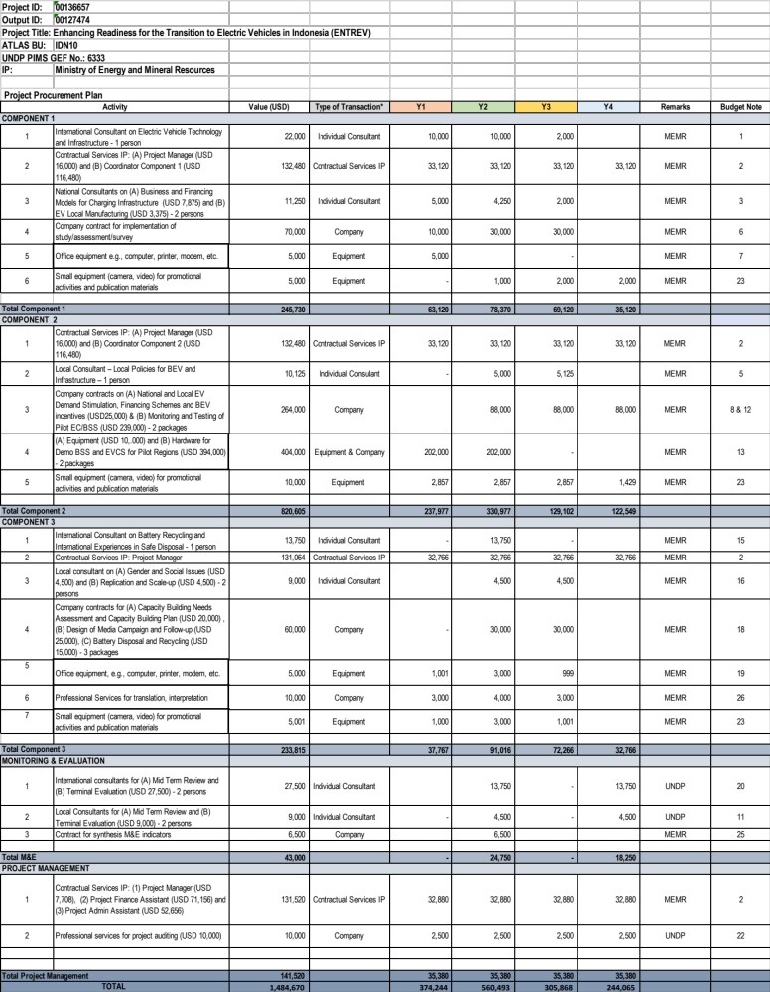
- Agreements (co-financing letters)

The co-financing letters can be accessed HERE

Co-financing source | Co-financing type | Co-financing amount (USD) | Included in project results
MEMR, Directorate General of Electricity (DGE) | in-kind | 2,600,311 | No
MEMR, Directorate-General of New and Renewable Energy and Energy Conservation (DG-NREEC) | in-kind | 4,384,000 | No
 | Public investment | 11,582,000 | No
MEMR, Research and Development Center for Electricity, New and Renewable Energy, and Energy Conservation Technology (P3tek-KEBTKE) (P3TEK) | in-kind | 50,000 | No
 | grant | 407,436 | No
West Java Provincial Government | in-kind | 222,000 | No
West Java Provincial Government | grant | 1,378,000 | No
Indonesia State Electricity Company (PLN) | in-kind | 200,000 | No
Indonesia State Electricity Company (PLN) | Public investment | 600,000 | No
UNDP | Grant | 50,000 | No
GRAB | Equity Investment | 10,000,000 | No
TOTAL |  | 31,473,747

- GEF 7 Taxonomy

Level 1 | Level 2 | Level 3 | Level 4
Influencing Models | Transform policy and regulatory environments  Strengthen institutional capacity and decision-making  Convene multi-stakeholder alliances  Demonstrate innovative approaches  Deploy innovative financial instruments
Stakeholders | Private sector | Capital providers  Financial intermediaries and market facilitators  Large corporations  SMEs (workshops)  Individuals/Entrepreneurs
Stakeholders | Civil society | NGOs  Academia
Stakeholders | Type of engagement | Info dissemination  Partnership  Consultation  Participation
 | Communication | Awareness raising  Education  Public campaigns  Behaviour change
Capacity, Knowledge and Research | Capacity development  Knowledge generation and exchange  Knowledge and learning | Knowledge management  Innovation  Capacity development  Learning
Gender Equality | Gender mainstreaming | Beneficiaries
Focal Area/Theme | Climate change | Climate change mitigation | Sustainable urban systems & transport

The table is based on the detailed GEF Taxonomy Worksheet (see Annex G of the CEO Endorsement/Approval Request document).

- Environmental and sOCIAL MANAGEMENT FRAMEWORK (ESMF)

The Draft of ESMF can be accessed HERE.

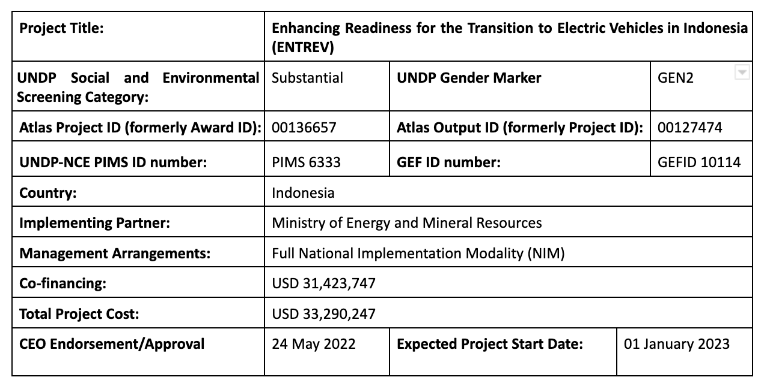



- HACT MICRO ASSESSMENT

The full HACT Micro Assessment Report (2022) can be accessed HERE

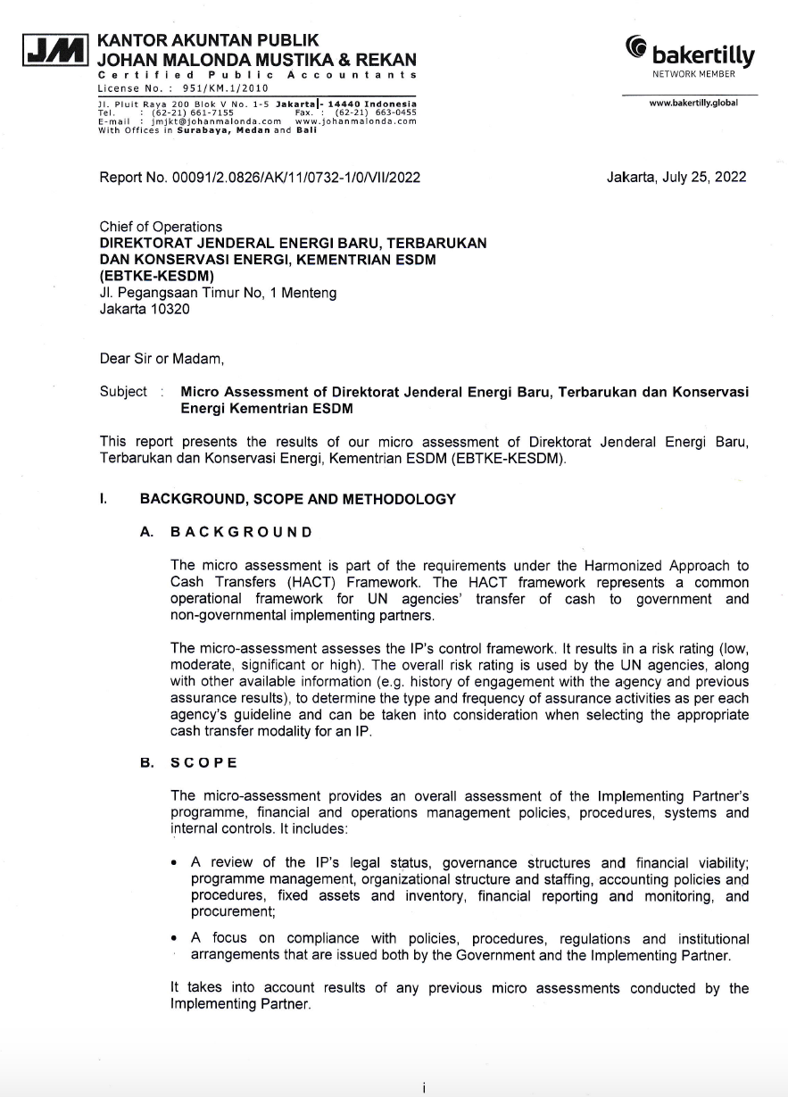

PARTNER CAPACITY ASSESSMENT

[STEP 1] PARTNER PRE-REQUISITES

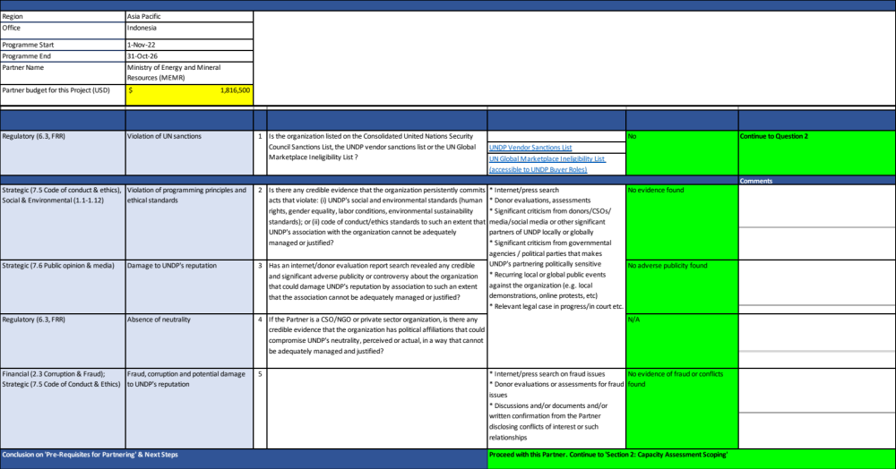

[STEP 2] CAPACITY ASSESSMENT SCOPING

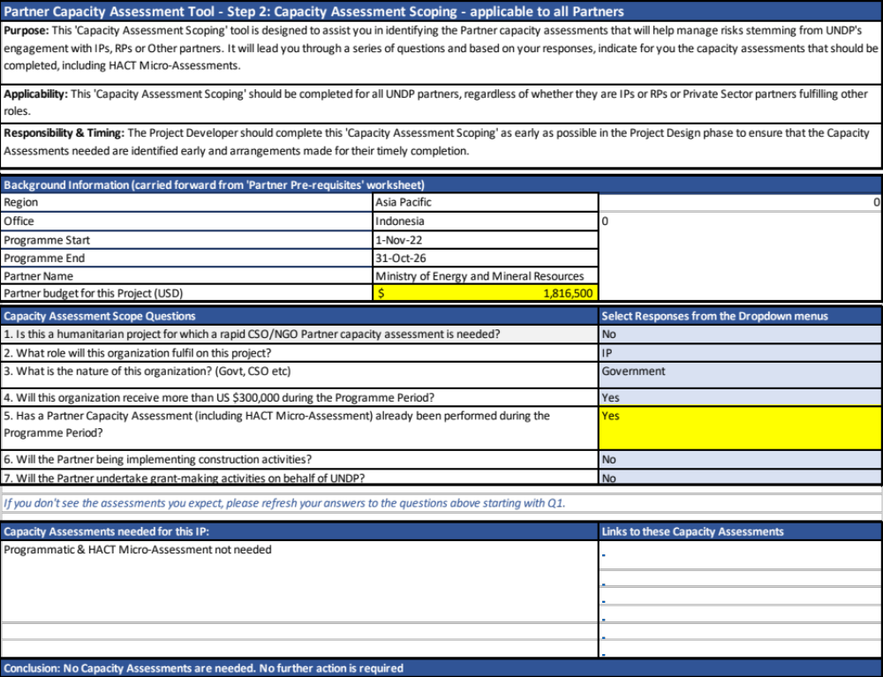

[STEP 3] CAPACITY ASSESSMENT CONCLUSIONS

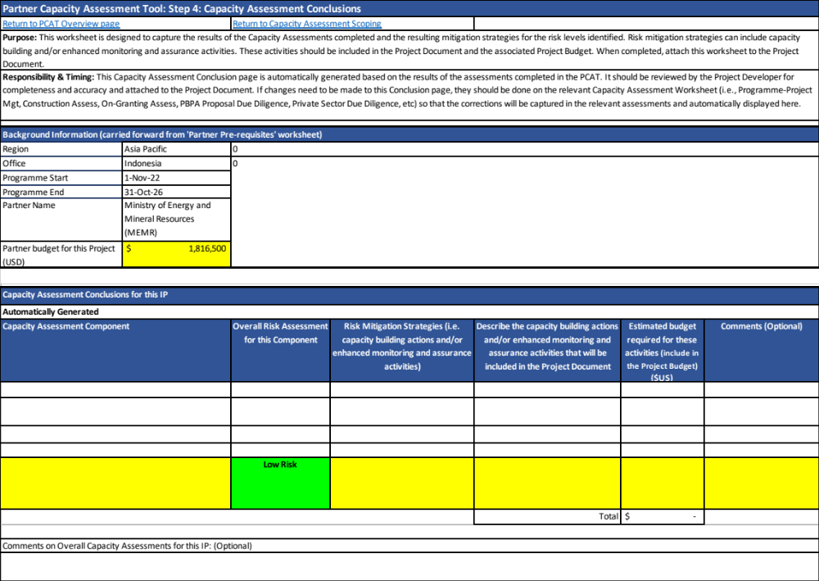

- GEF BUDGET TEMPLATE

The GEF budget template can be accessed HERE

- PROJECT QUALITY ASSURANCE (PQA) DESIGN AND APPRAISAL STAGE

The PQA Design and Appraisal Report can be accessed HERE

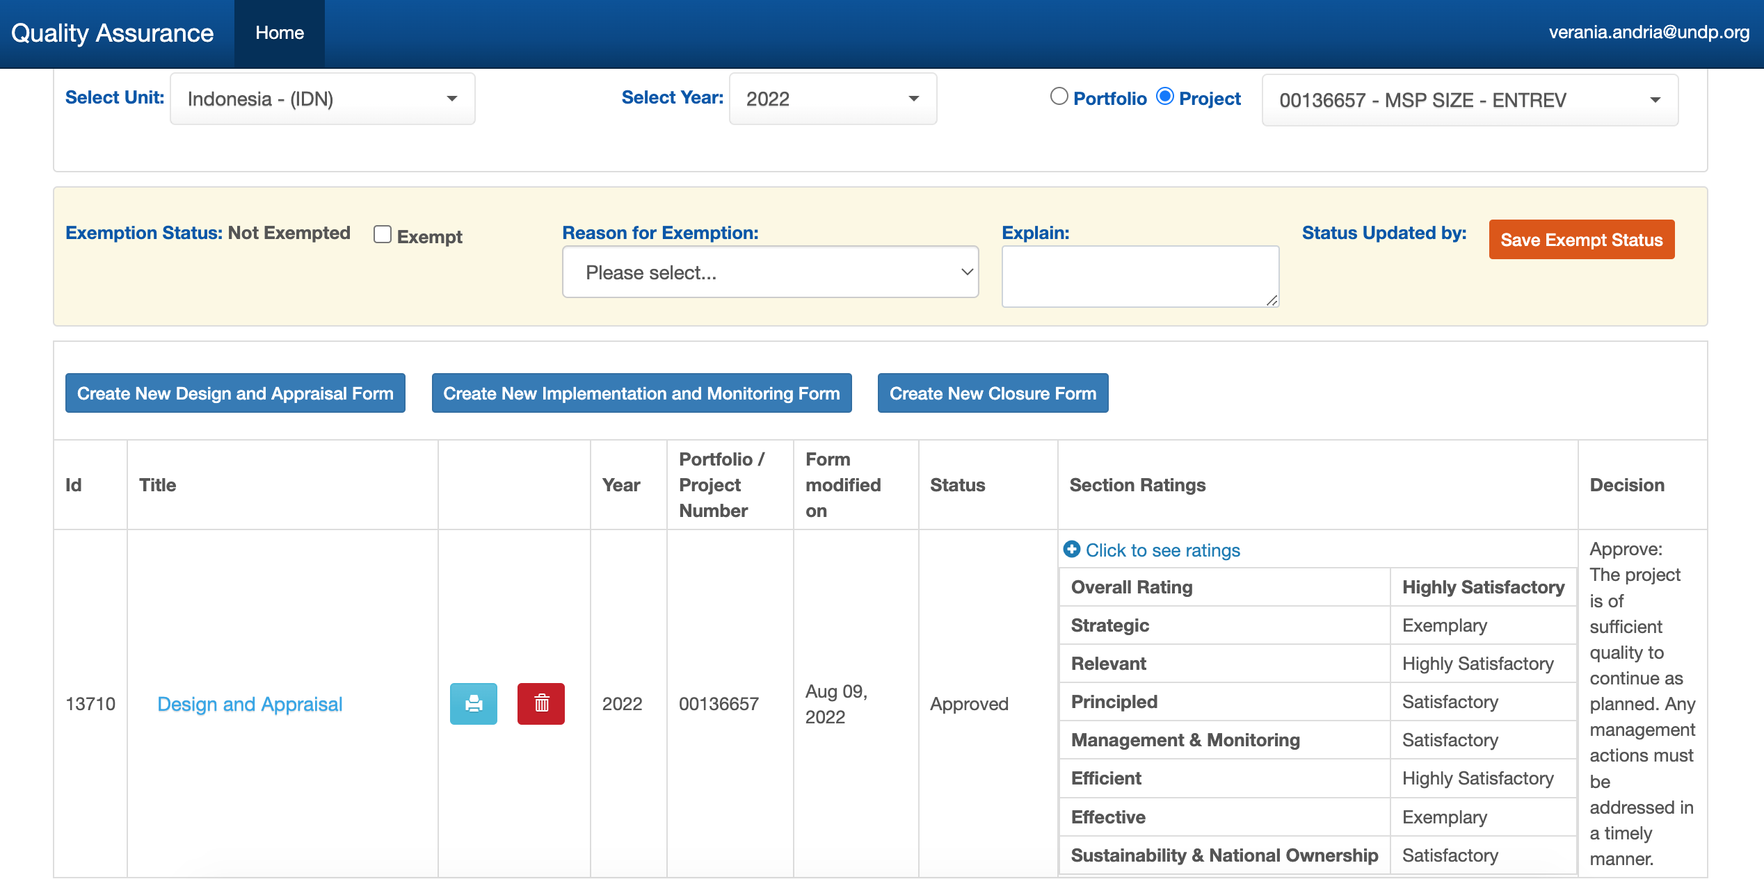

BPS (2021)
Ibid.
2020 Handbook of Energy & Economic Statistics of Indonesia
PM_{2.5:} (< 2.5 µm in aerodynamic diameter), of which of about 2/3 attributable to vehicles. Source: A global snapshot of the air pollution-related health impacts of transportation sector emissions in 2010 and 2015, International Council on Clean Transportation (ICCT, 2019)
Assessment of Urban Air Quality in Indonesia, in “Aerosol and Air Quality Research”, 20: 2142–2158, 2020. Ambient Air Polllution, WHO (2016)
Noise levels of 67-71 dB (Semanggi, Sudarman areas). Model of Noise Propagation in Urban Area A Case Study in Jakarta; Prasetyo et al./ OIDA International Journal of Sustainable Development 09:02 (2016)
Hybrid electric vehicle (HEV), plug-in hybrid electric vehicle (PHEV), battery electric vehicle (BEV), fuel cell electric vehicle (FCEV)
Including HEV, PHEV, full electric vehicles (BEV and FCEV) and flexy engine cars (running on ethanol or biofuel blends)
The Indonesia Automotive Manufacturing: An Update (June 2020), Gaikindo); Indonesia Energy Transition 2021 (IESR)
Source: MEMR presentation, draft of BEV public Launching, 3 December 2020. Until April 2021, a total of 122 charging stations have been built in 83 locations such as public oil-fuels stations, public natural gas stations, offices, hotels, shopping centers, parking areas, and rest areas along the toll roads (https://www.esdm.go.id/en/media-center/news-archives/indonesia-to-accelerate-ecosystem-of-battery-electric-vehicles-says-energy-minister)
https://www.thejakartapost.com/news/2020/10/15/consumers-concerns-hamper-electric-vehicle-adoption-in-indonesia-experts.html.
The charging tariff of SPKLU is included in the special service category, with rates ranging from IDR 1,644.52 to IDR 2,466.78 per kWh. Source: https://www.esdm.go.id/en/media-center/news-archives/indonesia-to-accelerate-ecosystem-of-battery-electric-vehicles-says-energy-minister
With GEF INV support, two BEV charging station in Jakarta (in coop. MEMR and DKI Jakarta) and 36 BSS in Jakarta, West-Java and Bali
¹⁵ The proposed location has the advantage of the electricity production generated by a solar power plant that is already available. Thus, no cost is required for the procurement of the solar power plant infrastructure. GEF funds will fund the charging station itself.
Co-financing for INV (in-cash) for EV, charging and battery swapping stations of USD 13,400,000 (MENR: USD 11,422,000; PLN: USD 600,000 and W-Java: USD 1,378,000), of which USD 7,200,000 available for the purchase of up to 164 EV 4-wheelers and/or up to 90 charging stations, and USD 6,200,000 for the acquisition of up to 5000 2-wheelers and/or up to 954 battery swap stations (based on estimates presented in Annex G).
Climate change also has an impact on increasing the height and extent of flooding, and sea level rise. For this reason, the location and distribution of charging station and electrical substation needs to be carefully selected with a climate change adaptation analysis taking into account long-term vulnerability and climate risks per region
The EV ecosystem may implicate a reduction in the workforce in many industries such as automotive industry, petroleum industry (less fossil fuel use), and vehicle repair services (as maintenance needs of EV in general are less than of conventional vehicles). Therefore, the use of electric vehicles needs to be regulated to avoid massive layoffs of workers. The closure of various business due to the use of electric vehicles will also result in a reduction in national income, especially from the petroleum industry and vehicle service services. On the other hand, the assembly of electric vehicle for domestic sales and export will boost new employment opportunities.
Risk analysis and planned management countermeasures have considered, among other risks, response to the Covid19 crisis. The COVID 19 pandemic can impact the project implementation in different, to some extent opposite, ways. On the one hand BEVs will require fast promotion and awareness-raising activities to attract users. However, the COVID-19 pandemic limits social interaction and restricts community activities. This situation may hinder proposed project activities, mainly involving public participation such as demonstration trials of BEVs, exhibitions, and other promotional events. The economic impact of COVID-19 may also shift investment priorities of the individual, government, and companies towards preventing uncertainties. Thus, having a relatively higher cost of ownership, purchasing BEVs may not be prioritized by those potential markets. In addressing the unwanted impact of COVID-19, the proposed project will need to build an innovative promotional strategy that complies with health protocols. Covid19 has been a major disruptive event in the Indonesia public transport sector – similar to other countries – wherein demand for public transport has reduced significantly since the onset of the pandemic, due to fear of infection on public transport. This could impact communities’ perceptions of public transport and create a shift to the use of individual 2 and 4-wheelers. An opportunity of the project is the possibility to meet this demand with E-Mobility, and hence enabling post-Covid green recovery. The risk of continued impact of the COVID 19 pandemic on project implementation progress is reflected under Risk 18.
From EV and PLN roadmaps (see Annex F, Box 25) and ENTREV indirect emission estimate (see Annex G): a) about 13,000-20,000 4-wheel EV in 2025 and 600,000-2 million electric 2 wheelers by 2025 (domestic), b) Production = domestic + export of 4-wheelers: 84%+26%; 2-wheelers: 89% +11%, based on Roadmap, Box 25); c) realized 460% in e-bike/scooter and 40% in e-car
In Indonesia’s policymaking and planning setup, the Coordinating Ministry of Maritime and Investment has the responsibility for formulating action plans, resolving obstacles, and supervising the acceleration of EV and for coordinating several technical ministries, including MEMR, MoT, MoE, and MoEF
See https://www.thegef.org/gef/policies_guidelines
See http://www.undp.org/content/undp/en/home/operations/transparency/information_disclosurepolicy/
See https://www.thegef.org/gef/policies_guidelines
The costs of UNDP CO and UNDP-GEF Unit’s participation and time are charged to the GEF Agency Fee.
See https://popp.undp.org/_layouts/15/WopiFrame.aspx?sourcedoc=/UNDP_POPP_DOCUMENT_LIBRARY/Public/ PPM_Project%20Management_Closing.docx&action=default.
Climate change also has an impact on increasing the height and extent of flooding, and sea level rise. For this reason, the location and distribution of charging station and electrical substation needs to be carefully selected with a climate change adaptation analysis taking into account long-term vulnerability and climate risks per region
The EV ecosystem may implicate a reduction in the workforce in many industries such as automotive industry, petroleum industry (less fossil fuel use), and vehicle repair services (as maintenance needs of EV in general are less than of conventional vehicles). Therefore, the use of electric vehicles needs to be regulated to avoid massive layoffs of workers. The closure of various business due to the use of electric vehicles will also result in a reduction in national income, especially from the petroleum industry and vehicle service services. On the other hand, the assembly of electric vehicle for domestic sales and export will boost new employment opportunities.
IEA Global EV Outlook 2020
Battery improvements will bring cost down from levels of around USD 350/ kWh to USD 15/ kWh in the future (IRENA, 2017)
Publicly accessible chargers accounted for 12% of global light-duty vehicle chargers in 2019, most of which are slow chargers. Globally, the number of publicly accessible chargers (slow and fast) increased by 60% in 2019 compared with the previous year, higher than the electric light-duty vehicle stock growth. China leads in the rollout of publicly accessible chargers, particularly fast chargers, which are suited to dense urban areas with less opportunity for private charging at home (IEA, 2020)
Hidayat, Ali Akhmad Noor (2018-03-29). "Menperin: Industri Otomotif Sumbang 10,16 Persen ke PDB". Tempo (2020) and "Indonesian Automobile Industry Data". files.gaikindo.or.id (2019). In 2018, exports were 264,000 units (CBU, completely built up, i.e. imported as fully finished assembled unit) and 82,000 CKD (completely knocked own, i.e. imported in parts and assembled locally) and 87 million component pieces.
Main car manufacturers are Toyota, Daihatsu, Suzuki, Mitsubishi, Honda, Nissan
Apart from these brands, Kia, Mazda, GM, Ford, Hyundai, Mercedes-Benz, BMW, Fuji Industries and VW have a presence in Indonesia. Source: The Automobile & Motorcycle Industry in Indonesia, MUFG (2015)
https://www.statista.com/statistics/978944/indonesia-number-of-motorcycles-use/; https://www.trade-off.id/2020/01/29/motorcycle-sales-stagnant-in-local-market-hike-in-export/
For example, the government has announced a tax holiday that allowed 100% corporate income tax exemption for 5 to 20 years, based on the investment value and an additional 50% tax discount for two years beyond the expiration of the above tax holiday. https://www.globenewswire.com/news-release/2020/09/18/2095767/0/en/Indonesian-Electric-Vehicle-EV-Market-Analysis-Growth-Opportunities-Fuel-the-Growth-Pipeline-Engine.html
Contribution of the automotive industry on national income growth. PowerPoint, Ministry of Finance, 14th Gaikindo Automotive Conference (July 2019);
Indonesia Energy Transition Outlook (2021)
Growth Opportunity Analysis of the Indonesian Electric Vehicle (EV) Market (1019) https://www.globenewswire.com/news-release/2020/09/18/2095767/0/en/Indonesian-Electric-Vehicle-EV-Market-Analysis-Growth-Opportunities-Fuel-the-Growth-Pipeline-Engine.html
Indonesia Energy Transition Outlook 2021 (IESR, 2021). Examples: Jakarta: PLN Disjaya, Senayan City, Aeon Mall and PLN Pusat; Denpasar (Bali): PLN UID; and in Bandung. Source: PowerPoint, Electrifying Road Transportation in Indonesia, PLN (Nov 2019)
The charging time at a regular SPLU takes 4-6 hours. As for the fast SPLU, it takes 2 hours, while superfast SPLU only takes 15-45 minutes. Source: https://indonesiaexpat.biz/featured/pln-to-develop-charging-stations-for-electric-buses-in-jakarta/
The C40 Cities Finance Facility is supporting Jakarta to implement an operational trial fleet of 100 e-buses in the network of TransJakarta, which will contribute to Jakarta’s target of promoting public transport mode share to 60% as well as to 100% electrify TransJakarta’s fleet in 2030. See https://www.c40cff.org/projects/jakarta-electric-bus
https://www.thejakartapost.com/news/2020/12/29/transjakarta-wants-10000-electric-buses-in-service-by-2030.html
https://www.electrive.com/2019/10/22/indonesia-moves-on-ev-development-and-infrastructure/
25 units of BYD e6 and 4 units of Tesla Model X 75 D. Pricing is an issue. The BEV taxis mentioned costed about USD 40-50,000. More towards the lower end, a BEV would be about USD 32,000. With the incentives of about 33% (PB 73/202, Permendagri No 8/2020 as well as Pergub DKI Jakarta No 3/2020) the cost would be about USD 25,000, while a comparable ICEV model would be available at USD 15,000.
As part of the pilot, users were interviewed on what they see as obstacles. 54% of 4-wheel users feel that the current EVCS network is not yet sufficient; 43% of twee-wheel users are concerned about vehicle quality and limited mileage and 7% are concerned regarding the issues of battery charging/swapping network availability.
Reportedly, Singapore-based Grab Holdings Inc. and ride-hailing and payment operator PT Go-Jek Indonesia are having merger discussions (Dec 2020); https://www.spglobal.com/marketintelligence/en/news-insights/latest-news-headlines/tesla-open-to-buying-a-legacy-carmaker-grab-gojek-said-to-near-merger-61545834
Indonesia Energy Transition 2021, Institute for Essential Services Reform (IESR)
NNA Business News, https://english.nna.jp/articles/1370 (Augusr 2019)
Bea Balik Nama Kendaraan Bermotor (Transfer of Motor Vehicle Title Fee)
Source: First Nationally Determined Contribution (NDC), 2016
Boxes 33 and 34 provide information on the sources of information and/or way of calculation
http://hdr.undp.org/en/2020-report
https://www.bps.go.id/pressrelease/2020/11/05/1673/agustus-2020--tingkat-pengangguran-terbuka--tpt--sebesar-7-07-persen.html
http://perludem.org/2018/08/01/potret-perempuan-kepala-daerah-terpilih-di-pilkada-2018/
https://sustainabledevelopment.un.org/memberstates/indonesia
Addressing the Linkages between Gender and Transport in Low- and Middle-Income Countries (Priya Uteng & Turmer), in: Sustainability (2019),11, 4555
https://www.sciencedirect.com/science/article/pii/S1361920918303092
https://otomotif.bisnis.com/read/20190114/275/878442/jokowi-ingin-indonesia-jadi-pemain-utama-kendaraan-listrik
https://industri.kontan.co.id/news/erick-thohir-bentuk-indonesia-battery-corporation-ibc-produksi-140-gwh-di-2030
https://www.wartaekonomi.co.id/read171541/jumlah-perempuan-di-industri-stem-masih-minor
https://www.goodnewsfromindonesia.id/2021/01/02/moorissa-tjokro-wanita-indonesia-di-balik-fitur-tertinggi-autopilot-mobil-tesla
Prohibited grounds of discrimination include race, ethnicity, sex, age, language, disability, sexual orientation, gender identity, religion, political or other opinion, national or social or geographical origin, property, birth or other status including as an indigenous person or as a member of a minority. References to “women and men” or similar is understood to include women and men, boys and girls, and other groups discriminated against based on their gender identities, such as transgender and transsexual people. ainst their will of individuals, families or communities from the homes and/or land which they occupy, without the provision of, and access to, appropriate forms of legal or other protection. Forced evictions constitute gross violations of a range of internationally recognized human rights.
The EVCS will be constructed in already built environment that is, existing offices (such as MEMR buildings) or taxi and two-wheelers service stations, so no ecosystem will be newly affected by EVCS infrastructure
See the Convention on Biological Diversity and its Cartagena Protocol on Biosafety.
See the Convention on Biological Diversity and its Nagoya Protocol on access and benefit sharing from use of genetic resources.
The EVCS will be constructed in already built environment that is, existing offices (such as MEMR buildi9ngs) or taxi and two-wheelers service stations, so the EVCS will not affect new cultural sites ort with historic religious importance
The EVCS will be constructed in already built environment of which legal ownership is already settled long time ago, such as offices (including MEMR buildi9ngs) or taxi and two-wheelers service or repair stations.
Forced eviction is defined here as the permanent or temporary removal against their will of individuals, families or communities from the homes and/or land which they occupy, without the provision of, and access to, appropriate forms of legal or other protection. Forced evictions constitute gross violations of a range of internationally recognized human rights.
EVCS and BSS will be operating in main urbanized areas. However, wide adoption of BEV may trigger key mineral mining activities for battery, i.e. nickel, that could affect areas where indigenous communities are present.
The Project is not involved in mining activities of battery raw materials that could possibly take place in such geographical areas
https://duniatambang.co.id/Berita/read/1088/Mengulas-Teknologi-Hilirisasi-Nikel-Di-Indonesia
https://kemenperin.go.id/artikel/20108/Industri-Bahan-Baku-Baterai-Kendaraan-Listrik-Terpancang-di-Morowali
Lead exposure is a significant environmental health threat to children in Indonesia. More than half of the children in the country (45.5 million) have blood lead levels (BLLs) ≥ 5 µg/dL. A recent study in the capital Jakarta found that 47% of children had BLLs ≥ 5 µg/dL and 9% had BLLs ≥ 10 µg/dL. Prihartono et.al. (Prevalence of Blood Lead among Children Living in Battery Recycling Communities in Greater Jakarta, Indonesia) in: International Journal of Environmental Research and Public Health 2019, 16, 127
Lead exposure from battery recycling in Indonesia, by Budi Haryanto, January 2016, in Reviews on Environmental Health 31(1)
Indonesia Energy Transition 2021 (IESR)

